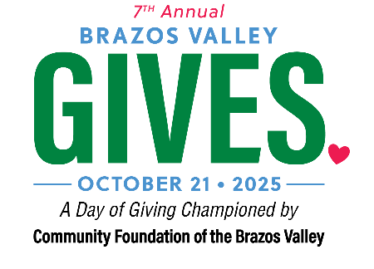

**EXAMPLE #1**

**LETTER ENCOURAGING YOUR FRIENDS TO HOST A PEER-2-PEER FUNDRAISING PAGE**

Dear [Board member, volunteer, staff, donor],

This year, on Tuesday, October 21, 2025, [*organization name*] will be participating in Brazos Valley Gives, championed by the Community Foundation of the Brazos Valley.

Brazos Valley Gives is a month-long community giving initiative that culminates in   
18-hours of on-line giving on Tuesday, October 21. Brazos Valley Gives brings the region together on one day and as “one community” to raise critical funding and awareness for area nonprofits like us. The event takes place online at www.BrazosValleyGives.org between 5:00 a.m. and 11:00 p.m.

Proceeds raised from this event will be used for [*your core mission –e.g., homeless youth, health services – the service you provide*!]. Last year, because of donors like you, we were able to [*what did you do with the money?*].

**Here’s how you can make a difference!** We need help spreading awareness for our giving day campaign. We want to raise [$$$] on Brazos Valley Gives Day to reach our goal of [*describe your goal; e.g., fostering 100 kittens, feeding 20 kids etc.*]

**There are two things you can do to help us:**

1. **Share our campaign page** [[www.BrazosValleyGives.org/yourpagesURL](http://www.BrazosValleyGives.org/yourpagesURL)] using your favorite social media channels. Whether it is Facebook, Instagram or Twitter, the more people in your network that are aware of our work, the more [*who benefits*] can be helped.
2. **Create your own fundraiser campaign online** at [[www.BrazosValleyGives.org/yourpagesURL](http://www.BrazosValleyGives.org/yourpagesURL)]. When you create your fundraiser page, you can share a picture and **tell a story about why YOU give and why giving now matters most!** Telling your story can inspire friends and social media followers to make a difference in the community you call home on Brazos Valley Gives Day!

*Did you know it only cost* [*$$ amount to xxxxxxx*]*?* That means if you raise [$$$] you   
 and your friends can [*save 100 cats, vaccinate 30 dogs, etc.*].

Can’t wait to get started? Great, create your fundraiser page by clicking here [[www.BrazosValleyGives.org/yourpagesURL](http://www.BrazosValleyGives.org/yourpagesURL)]

Thank you,

[Name, Title]

*8-1-2025*

**EXAMPLE #2**

**EMAIL ENCOURAGING YOUR FRIENDS TO HOST A PEER-2-PEER FUNDRAISING PAGE**

We need your help! [*your nonprofit’s name*] has set a goal to raise [$$$] on **Brazos Valley Gives Day, Tuesday – October 21, 2025.**

Proceeds raised from this event will be used for [*your core mission –e.g., homeless youth, health services – the service you provide!*]. Last year, because of donors like you, we were able to [*what did you do with the money?*].

**Here’s how you can make a difference**:

* 1. **Spread the word!** Share our nonprofit page [[www.BrazosValleyGives](http://www.EastTexasGivingDay.org/yourpagesURL).[org/yourpagesURL](http://www.EastTexasGivingDay.org/yourpagesURL)] using your favorite social media channels. Whether it is Facebook, Instagram or Twitter, the more people in your network that are aware of our work, the more [*who benefits*] can be helped.
  2. **Create your own personal fundraiser page** [*organization name*]online at [[www.BrazosValleyGives.org/yourpagesURL](http://www.brazosvalleygives.org/yourpagesURL)]. When you create a fundraiser page, you can share a picture and tell a story about   
     why **YOU** give and why giving now matters most! Telling your story can inspire friends and social media followers to make a difference in the community we call home on Brazos Valley Gives Day!
  3. **Make a donation**! Every dollar to our campaign is helpful. Make your donation before 11 p.m. on October 21, 2025, and as a bonus, we could win a cash prize! [[www.BrazosValleyGives.org/yourpagesURL](http://www.brazosvalleygives.org/yourpagesURL)]

If you need assistance or have questions, do not hesitate to call [*your telephone #*] or email [*your email address*].

*8-1-2025*