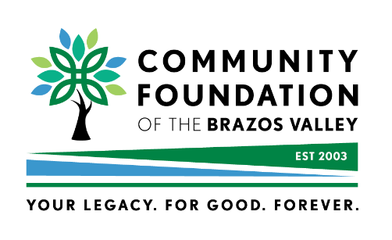
MAKING A DONATION TO
2025 BRAZOS VALLEY GIVES
FROM A DONOR-ADVISED FUND

This form should be used in confirming a donation from a DONOR-ADVISED FUND to a nonprofit[s] participating in Brazos Valley Gives, championed by the Community Foundation of the Brazos Valley.
Date:_____________________________ [must be received no later than 5:00 p.m. on 10/21/2025]

Dear Community Foundation of the Brazos Valley:

Please be advised that I have directed the custodian of my donor-advised fund to make a gift to a 501c3 nonprofit organization(s) that is participating in the 7TH ANNUAL BRAZOS VALLEY GIVES. I have chosen to use my donor-advised fund to make this gift. My account’s administrator, __________________________, will soon be transferring $____________ directly to the Community Foundation of the Brazos Valley – BRAZOS VALLEY GIVES. [EIN# 32-0073943]

When you receive this gift from my donor-advised fund, please send me a written acknowledgement confirming receipt of this donation.
Please use this donation from my donor-advised fund to benefit the following nonprofit[s] that is/are participating in the 7th ANNUAL BRAZOS VALLEY GIVES:

- NAME OF NONPROFIT:________________________________________ $_______________

- NAME OF NONPROFIT:________________________________________ $_______________

- NAME OF NONPROFIT:________________________________________ $_______________

- NAME OF NONPROFIT:________________________________________ $_______________
TOTAL DONATION $_______________

I look forward to hearing from you. If you have any questions or need to contact me, I can be reached at the
telephone # or address below.

Sincerely,

Name of Donor[s]:_________________________________________________________

Mailing Address:__________________________________________________________

City/State/Zip:____________________________________________________________
Telephone:_______________________________________________________________

Email:___________________________________________________________________
Date of Birth: ___________/_____________/_____________ 6/1/2025

- CHECK SHOULD BE MAILED TO: Community Foundation of the Brazos Valley, PO Box 2622, Bryan, TX 77805-2622

- THIS SIGNED LETTER/FORM SHOULD BE SENT TO: president@cfbv.org
For questions, please contact Patricia Gerling, President/CEO – Community Foundation of the Brazos Valley,
979.589.4305; president@cfbv.org

