Acts 2 Journey Cohort
Retreat 2 Handout
Pastor and Vision Team Guide


Use the QR code to visit the Retreat 2 resources page.
Here, you’ll find video segments of the teaching, along with guidance on how to complete discussion activities and assignments prior to Retreat 3.

TABLE OF CONTENTS

REVIEW…………….………………………………………………………………………….2
FIVE LEVELS OF LEADERSHIP…..…………………………………..……………….4
McINTOSH GRID……………………………………………………………………………6
INTRODUCTION TO CORE VALUES……………………………………….…..….....8
CORE VALUES VS. PERSONAL PREFERENCES…………………………….......9
CONSTRUCTING CORE VALUES……………………...……………….……………11
ASSIGNMENTS PRIOR TO RETREAT 3……………………………………….…..13
“Transformation is not a destination. For congregations it is not a place of arrival where the transformation journey can be declared as over. It is an ongoing journey. Congregations do not transform once. They are continually transforming.”
—George W. Bullard Jr., “Seven Enduring Principles for Transforming Your Congregation”

Mission: Review
The Acts 2 Church process directs the local church to grasp foundational teachings that will fulfill its mission. The mission of the church is the objective of the church—who we are and how we should operate. The Acts 2 Church has the Great Commission as its spiritual direction and the Great Commandment as its guide for love-directed behavior.

The Great Commission focuses on the system which Christ taught.

“Go therefore and make disciples of all nations, baptizing them in the name of the Father and of the Son and of the Holy Spirit, teaching them to observe all that I have commanded you. And behold, I am with you always, to the end of the age” (Matthew 28:19–20, ESV).

The Great Commandment focuses on the system which Christ modeled.
“While a compelling vision can certainly get the flywheel going, it takes successful progress toward the realization of the vision to keep it turning, and at an ever-increasing pace.”
—Bud Wrenn, Innovative Planning: Your Church in 4-D
And he said to him, “You shall love the Lord your God with all your heart and with all your soul and with all your mind. This is the great and first commandment. And a second is like it: You shall love your neighbor as yourself” (Matthew 22:37–39, ESV).

Biblical Functions: Review
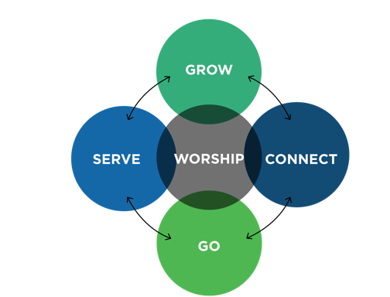
In the last retreat, we shared the five biblical functions of the first-century church described in detail in Acts 2:42–47. These five functions are actually the Ministry Model for the New Testament Church. In Retreat 3, we will focus on the dynamics of this Ministry Model.

- Fellowship (Connect)
- Discipleship (Grow)
- Gift-Oriented Ministry (Serve)
- Evangelism (Go)
- Worship

Vision: Review
Vision takes the mission and the biblical systems of the church and articulates them toward a preferred future.
Vision communicates where the church is going.

- Vision is courageously exploring possibilities.
- Vision answers “Where?” and “Why?”
- Vision unites people around a common cause.
- Vision gives clear focus on an intended destination.
- Vision is memorable, inspiring, ambitious, and relevant.
- Vision is bigger than your ability to achieve.
If you cannot positively answer these questions, the possibility of your vision being effective in producing the desired outcomes greatly diminishes. Additionally, there are three reasons why vision fails.

- Poor communication
- No strategic plan
- No implementation process
In reviewing your congregational vision:

- Does it contain the biblical functions from Acts 2?
- Is it clear and understandable?
- Can your congregation make it happen?
- Is it vital and urgent to your church?
- Is it future focused?
- Does it require faith to fulfill?
- Does it matter?
- Will it take you to the next level?
Make sure everyone on your team agrees on the vision statement.

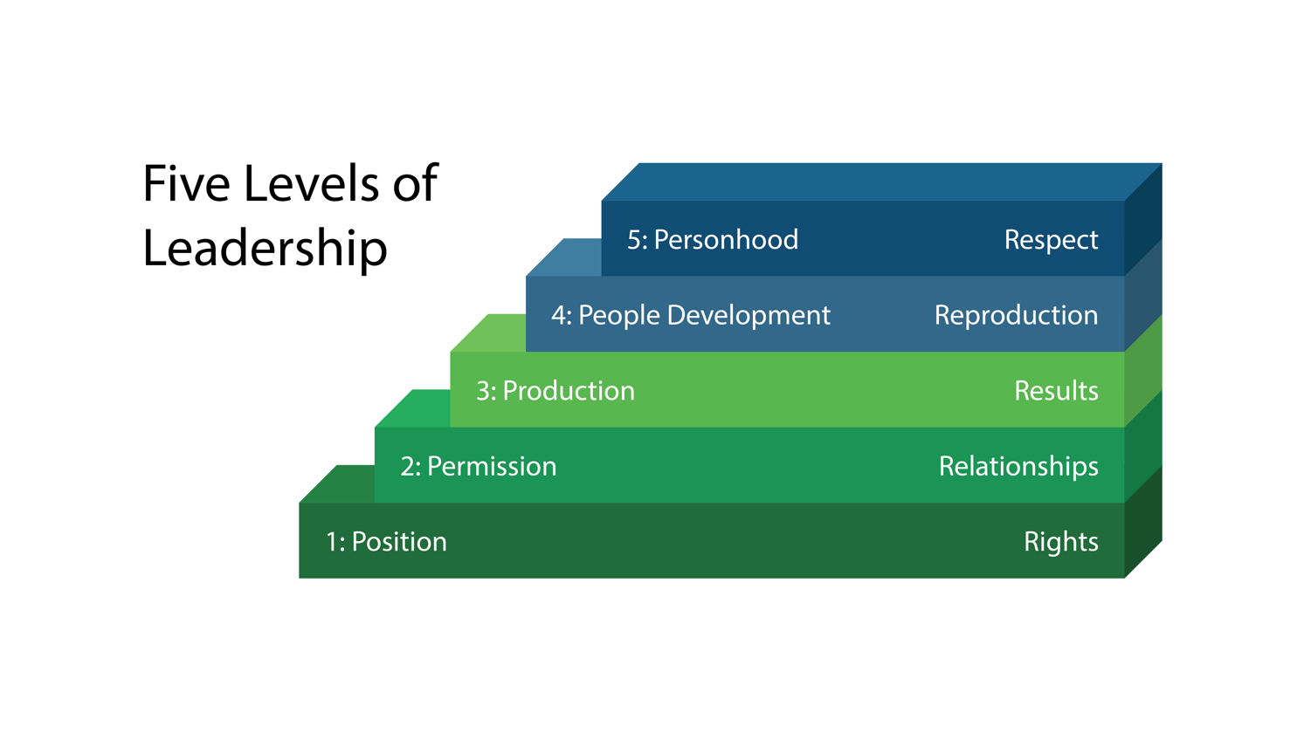

Leadership as Influence: Five Levels of Leadership
In Developing the Leader Within You, John Maxwell defines leadership as influence and outlines five levels of leadership that must be mastered to achieve the highest level of influence.

Level 1: Position (Rights)
- People follow the leader because they have to.
- The pastor’s influence is based on the authority of the pastor’s position or title.
- People will do no more than is required.
- Activity at this level can be self-centered.
- You can’t lead change at this level.

Level 2: Permission (Relationships)
- People follow the pastor because they want to.
- The pastor’s influence grows as trust and respect deepen.
- People believe the pastor is competent and believe the pastor cares.
- Activity at this level can be fellowship centered.
- You will struggle to lead change at this level.

Level 3: Production (Results)
LEADING TRANSFORMATION

To move from LEVEL 1 to LEVEL 2:
- Demonstrate competence.
- Grow spiritually, physically, and relationally.
- Do not use force to control.

To move from LEVEL 2 to LEVEL 3:
- Build a solid leadership team.
- Create a shared vision and a plan of action.
- Acquire and allocate resources.

To move from LEVEL 3 to LEVEL 4:
- Put people over programs.
- Intentionally invest in developing others.
- Be willing to make tough calls.

To move from LEVEL 4 to LEVEL 5:
- Be consistent.
- Share knowledge and wisdom.
- Create a succession plan.
- People follow the pastor because of what is being done for the church.
- The pastor’s influence expands as the pastor accomplishes church goals.
- The pastor communicates vision, and the congregation sees fruit.
- Activity at this level can be task centered.
- You can successfully initiate and lead change at this level.

Level 4: People Development (Reproduction)
- People follow the pastor because of what is being sown into individuals.
- The pastor’s influence soars as people are empowered.
- The pastor intentionally invests in developing and mentoring leaders.
- Activity at this level can be program or meeting centered.

Level 5: Personhood (Respect)
- People follow the pastor because of who the pastor is and what the pastor stands for.
- The pastor’s influence extends beyond the pastor’s lifetime.
- The pastor is honored and respected because of his or her commitment and consistency over many years.
- Activity at this level can be succession centered.

Where Most Pastors Start: Level 1
Many pastors have the authority to lead, but at this level they do not have the respect or buy- in necessary to lead a major change initiative.

Where Most Pastors Get Stuck: Level 2
When pastors are accepted and well liked, they believe their role is to make everyone happy; they ultimately sacrifice progress for peace and become more interested in delivering good news than truth.

Where Pastors Must Be to Lead Transformation: Level 3 and Beyond!
It is only when pastors reach at least level 3 leadership that they have the skills, influence, “wins,” and courage necessary to lead a successful transformation effort.

The McIntosh grid describes the differences between small, medium, and large churches.

Factors | Small Church | Medium Church | Large Church
Size | 15–200 worshipers | 201-400 worshipers | 401+ worshipers
Orientation | Relational | Programmatical | Organizational
Structure | Single Cell | Stretched Cell | Multiple Cell
Leadership | Resides in key families | Resides in committees | Resides in select leaders
Pastor | Lover | Administrator | Leader
Decisions | Made by congregation; driven by history | Made by committees; driven by changing need | Made by staff and leaders; driven by vision
Staff | Bivocational or single pastor | Pastor and small staff | Multiple staff
Change | Bottom up through key people | Middle out through key committees | Top down through key leaders
Growth Patterns | Attraction model through relationships | Program model through key ministry | Proclamation model through word of mouth
Growth Obstacles | - Small-church image  - Ineffective evangelism  - Inadequate programming  - Downward momentum  - Ingrown fellowship | - Inadequate facilities  - Inadequate staffing  - Inadequate financing  - Poor administration  - Increasing complexity | - Poor assimilation  - Increased bureaucracy  - Loss of vision  - Lack of member care
Growth Strategies | - Renew a sense of purpose  - Begin new ministries  - Cultivate evangelism  - Celebrate victories  - Start new groups/classes  - Involve new people | - Develop distinct identity  - Add additional staff  - Use facilities multiple times  - Offer multiple worship services  - Write a long-range plan  - Improve the quality of ministry | - Renew the vision  - Design assimilation plan  - Streamline procedures  - Offer need-based events  - Adjust leadership roles  - Increase number of small groups

Values-Based Culture
Church culture can be defined as the style, substance, and shadows of a given church.
Style: how the church thinks and acts
Substance: the priorities and behaviors that the church’s leaders model to the congregation
“Culture eats strategy for breakfast.”
– Peter Drucker

Shadows: the priorities and behaviors that the church’s leaders exhibit behind closed doors

Insights from Craig Groeschel

- Multiple create culture.
- More than environment
- More than a feeling/atmosphere
- Healthy culture never happens by .
- Culture is a combination of what you and what you .
- Culture is created and by leaders.
Culture can be positive and life-giving or toxic and deadly. Restaurants and other organizations (airlines, stores, etc.) can have cultures that will either attract you or repel you. In his book, Culture Eats Strategy for Lunch, Curt Coffman writes:

- People are loyal to culture, not to .
- Culture is more than strategy.
- A brittle culture can doom even a great organization.
- When strategy and culture collide, will always win.
- Cultural miscues are more damaging than strategic miscues.
- Culture will have a significant impact on your future bottom line.

Introduction to Core Values
A church’s core values give its members direction for what matters most in the life of the church. They drive priorities, shape attitudes and actions, direct processes, govern relationships, and articulate what the church stands for. More than mission or vision, core values tell those inside and outside the congregation what is distinctive and important.
- Core values are the of the church.
- Core values behavior. They direct how the congregation acts based on what it believes about itself, the world, and its role as part of God’s mission in and to the world.
In Ministry Nuts and Bolts: What They Don’t Teach Pastors in Seminary, Aubrey Malphurs expands this idea by observing:
“Core values are fundamental to all that the organization does. They are ministry defining and have everything to do with a ministry’s distinctiveness. . . . If an individual’s core values align with the ministry’s, that individual is more likely to invest his or her life in that ministry. Values communicate what is important—the organization’s bottom line. Thus, core values define what you believe is God’s heart for your ministry or church.
- Core values determine and actions on a daily basis and in times of celebration and conflict.
- Core values are the in the ministry programming for the future vision.
- Core values are to be shared and to new members.
- Core values are protected by the staff and key leaders.
- Core values are used to all ministry programs for spiritual effectiveness, financial commitment, and achievement of purpose.
- Core values are to be lived out in the of the congregation.
- Core values represent the core identity of the church and reflect how the congregation will live into its preferred future. They create boundaries for church life and must be identified and communicated for the church to reach its full Kingdom potential.

Core Values vs. Personal Preferences
Some elements can often seem like core values when they are something completely different. While many people in our churches may not understand core values, they do understand convictions. Biblical convictions are Spirit-directed boundaries for our core values. However, when core values become disconnected or wrongly derived from Scripture, unhealthy convictions take over.

Some convictions are not as connected to the Holy Spirit as people suppose. Unhealthy convictions can stem from personal issues or hurts that are masked by insisting that the issue in question is a spiritual conviction. When leaders fail to discern the difference between biblical convictions and more personal, dominant ones, the church’s vision can be redirected and influenced in unhealthy directions.
Biblical absolutes:
Acts 4:12; John 14:6

Community standards:
Choices we live by within our group.

Personal convictions: choices I have made for my own life.

From Scripture, we know of three levels of conviction:

These conviction levels begin with scriptural directives and move toward the beliefs and behaviors people choose in their own spiritual growth. Discerning the differences in these categories affects not only individuals but the church.

However, when core values are not established and lived out, people within the church will create a fourth level called
.

Personal preferences are deeply ingrained beliefs that have developed over the lifespan of a person’s Christian journey, are rarely questioned by anyone, are not written down, and are invisible to others in the church until conflict or vision-casting occurs.

Where personal preferences are accepted as biblical absolutes, conflict always erupts.
And when personal preferences become core values, church leadership cannot provide for and protect the congregation. When people’s preferences become core values, efforts become focused on making people happy, giving in to what is unhealthy, and allowing immature Christians to dictate the leadership direction of the church.

Identifying Negative Values
Examples of present behaviors that hinder growth are listed in the form of statements below.

- “ is more important than fruitfulness.”
- “New people should fit into our ways.”
- “Our memories are bigger than our dreams.”

GROUP ASSIGNMENT
Continue working as a team to determine those hidden values that might be holding your church back. Use the QR code on the first page of this handout or visit tinyurl.com/a2jvalues to view the accompanying video.

What behaviors is your church embracing today that hinder growth and health?
These are often unwritten and unspoken.

Constructing Core Values

PRIORITIES + BEHAVIORS = CORE VALUES

In other words, our core values are those things we believe are important and are demonstrated in our behaviors. Therefore, our true core values are those things we regularly speak and practice.

See pages 123-126 in A Spirit-Empowered Church.

Priorities | Behaviors

There are different ways to structure core values.
GROUP ASSIGNMENT
Continue working with your team to finalize core values prior to Retreat 3. Use the QR code on the first page of this handout or visit tinyurl.com/a2jvalues to view the accompanying video on Constructing Core Values.
- Core values can be one word
Examples: Integrity; Forgiving; Relevant; Serving
- Core values can be two words, as in the above exercise.
Examples: Intentional Discipleship; Passionate Worship; Global Missions; Scriptural Fluency
- Core values can be a short, memorable statement.
Examples: Culture of honor; Every soul matters to God; The Bible is our guidebook to living; Equipping and empowering people; Committed to excellence

Core values should also include a definition or descriptor. Below are some examples:
- Intentional Discipleship
To help all ages grow in their knowledge of the Bible and in their relationship with Jesus Christ
- A Welcoming Culture
To help all feel valued and to connect people quickly into our church family
- Relevant
We strive to communicate biblical truth in a simple, understandable way

Next Steps

Group Assignment
- As a vision team, use the suggested meeting assignments below as a vision team to finalize your vision statement and clarify your core values statements, which should include 5–9 congregational values.
- Finish writing a one-sentence explanation of each of your core values.
- Read and discuss chapters 10–11 in A Spirit-Empowered Church: An Acts 2 Ministry Model by Alton Garrison (available in English and Spanish).
- As a vision team, commit to fast and pray for wisdom and discernment.

Personal Assignment
- Continue praying daily for your vision team members and the work you are doing together.
- Develop a statement of values for your life and family.
  - Identify those priorities you believe to be most valuable.
  - Talk to family members about these values and discuss how they are evident in your life together.
  - Discuss how you can bring even greater emphasis to these essentials.
- Look for opportunities to discuss your personal values with others.
- If you’re not already involved in personal Bible study, read the Book of Proverbs before the next retreat and record fifteen new spiritual insights.

Resources
• A Spirit-Empowered Church
Alton Garrison
• Developing the Leader Within You
John C. Maxwell
• A Spirit-Empowered Life
Mike Clarensau
• There’s Hope for Your Church: First Steps to Restoring Health and Growth
Gary McIntosh

Scripture quotations marked ESV are taken from The Holy Bible, English Standard Version Copyright © 2001 by Crossway Bibles, a publishing ministry of Good News Publishers.

Meeting 1: Priorities and Behaviors: Aligning Values with Vision

In this exercise, take time to consider the priorities and behaviors your church must embrace to become the church of your vision. Some of these priorities and behaviors might be things you’re already demonstrating. Other priorities and behaviors you identify might aspirational; that is, they might be things your team must agree to begin demonstrating in the future in order to become the church of your vision.

WHAT WE SAY  Stated values | WHAT WE DO  Demonstrated values | WHAT WE WANT TO DO  Aspirational values | PLAN FOR ALIGNMENT  Behavior change
Example  “We are a welcoming church.” | We have no plan for reaching out to the community or following up with guests when they attend. | We want to be a church where guests feel the love of Jesus through our members. | Modify the Acts Grow Track template for our church to use as a detailed assimilation plan.  Train hospitality team.

In the next meeting, you’ll use these lists to begin developing your church’s core values.

Meeting 2: Developing Core Values

For video instruction, use the QR code on the first page of the handout or visit tinyurl.com/a2jvalues.

There are different ways to structure core values.
- Core values can be one word
Examples: Integrity; Forgiving; Relevant; Serving
- Core values can be two words, as in the above exercise.
Examples: Intentional Discipleship; Passionate Worship; Global Missions; Scriptural Fluency
- Core values can be a short, memorable statement.
Examples: Culture of honor; Every soul matters to God; The Bible is our guidebook to living; Equipping and empowering people; Committed to excellence

Core Value 1:
Core Value 2:
Core Value 3:
Core Value 4:
Core Value 5:
Core Value 6:
Core Value 7:
Core Value 8:
Core Value 9:

Meeting 3: Clarifying Core Values

The core values you develop should also include a definition or descriptor. While your church might value each of the five functions, simply listing them without descriptions or definitions does not provide enough information. Below are some examples:
- Intentional Discipleship
To help all ages grow in their knowledge of the Bible and in their relationship with Jesus Christ
- A Welcoming Culture
To help all feel valued and to connect people quickly into our church family
- Relevant
We strive to communicate biblical truth in a simple, understandable way

Core Value | Descriptive Sentence

Gary McIntosh, One Size Doesn’t Fit All (Grand Rapids: Fleming H. Revell, 1999).

