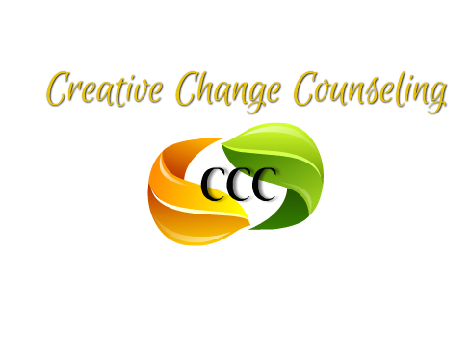
668 Main Street
Lumberton, NJ 08048
PH: 609-668-4719 FAX: 609/746-0146

Job Title:  Direct Support Professional | Status:  Part Time (Non-Exempt) | Program:  IDD
Primary Purpose of Job:
Creative Change Counseling, Inc. (CCC) is a dedicated group of behavioral health providers committed to offering comprehensive support and treatment for individuals facing emotional, behavioral, and mental health challenges. Our evidence-based practices ensure that clients receive the highest quality of care in a nurturing environment. Now Hiring: Direct Support Professional Primary Purpose of Job: The Direct Support Professional (DSP) provides individualized, community-based support services to adults with intellectual and developmental disabilities (IDD). This role focuses on helping individuals achieve their personal goals, enhance their independence, and promote community inclusion. Services are delivered in accordance with each individual's Person-Centered Plan and the guidelines outlined in the DDD Supports Program Policy Manual.
Pay: $21.00 - $24.00 per hour
Principle Duties & Responsibilities:
- Individualized Support
- Implement of person-centered support plans tailored to each individual's needs and goals.
- Assist individuals in developing skills related to daily living, communication, socialization, and community participation. Assist participants with ADLs including hygiene, mobility, and meals.
- Provide support in accessing community resources, recreational activities, and social events. Maintain participant dignity and confidentiality. Maintain cleanliness and safety of the program space.
- Monitor and support individuals' health and well-being, reporting any concerns to appropriate parties.
- Implement strategies to ensure safety in various environments, adhering to established protocols.
- Assist with medication administration and health-related tasks as authorized and trained.
- Documentation and Compliance
- Maintain accurate and timely documentation of services provided, including progress notes and incident reports.
- Ensure compliance with DDD regulations, agency policies, and ethical standards.
- Participate in regular training and professional development activities.
Reports To: Director

Direct Reports: None

Location: Hamilton

Qualifications:
- High school diploma or GED required; Associate’s or Bachelor’s degree in a related field preferred.
- Minimum of 1 year of experience supporting individuals with IDD.
- Valid driver’s license, reliable transportation, and insurance.
- Strong communication, problem-solving, and interpersonal skills.
- Ability to work independently and manage a flexible schedule.
- Completion of required DDD training and background checks.

Physical Requirements:
Must be able to walk, stand, and move about for extended periods (up to 6– 8 hours per day), including during community outings or recreational activities.
• Capable of assisting individuals with mobility challenges, including guiding, lifting, or providing physical prompts as needed (up to 50 lbs with assistance).
• Must be able to bend, kneel, twist, or reach to assist with tasks such as personal care, community-based learning, or implementing behavior plans.
• Must be comfortable driving a vehicle and potentially transporting individuals using a agency-owned vehicle.
Benefits:
• 401(k)
• Dental insurance
• Health insurance
• Paid orientation
• Paid sick time
• Paid time off
• Paid training
• Professional development assistance
Disclaimer Statement: The above information on this description has been designed to indicate the general nature and level of work performed by employees within this classification. It is not designed to contain or be interpreted as a comprehensive inventory of all duties, responsibilities, and qualifications required of employees assigned to this job.

Employee’s Signature: | Date:
Supervisor’s Signature: | Date:
Corporate Human Resources Signature: | Date:

