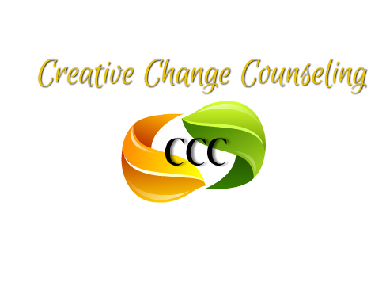

950 S. Chester Avenue
Delran, NJ 08075
Phone: (609) 667-7353 Fax: (609) 667-7944

Job Title:  SUD Support Tech | Status:  Part-Time (Non-Exempt) | Program:  Substance

Position Summary:
The Substance Use Disorder Tech helps with the day-to-day functioning of the SUD program. The SUD Tech reports directly to the Program Director and works in collaboration to fulfill the needs of the clients.
Pay: $20.00 Hourly

Key Responsibilities:
- Providing transportation to and from treatment facility for current clients
- Maintaining company vehicles including filling gas tank, cleanliness of the vehicles and alerting director of any issues with the vehicles
- Collecting and documenting urine drug screens
- Greeting new clients upon entrance of the facility
- Initiating intake paperwork for new clients as they arrive
- Monitoring clients when onsite ensuring all program rules are being followed and clients are where they are supposed to be
- Cleanliness of overall facility
- Stocking/restocking kitchen and supplies as needed
- Informing director when supplies is needed
- Managing front office and directing guests as they enter the facility
- Other tasks as assigned by director

Qualifications:
High School Diploma
Basic knowledge and understanding of substance use disorders
Experience working with the addiction population is a plus
Valid NJ driver’s license
Clean driving record
CPR/First Aid Certified
Narcan trained

Employee’s Signature: | Date:
Supervisor’s Signature: | Date:
Corporate Human Resources Signature: | Date:

