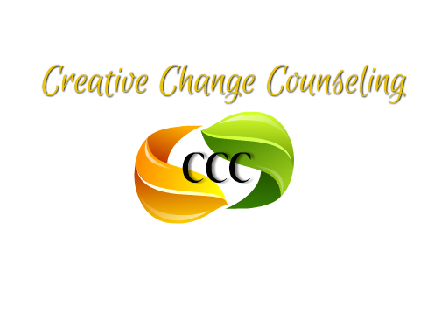
950 S. Chester Ave. Bldg. A, Delran, NJ 08075
Phone: (609) 667-7353 Fax: (609) 667-7944

CCC It Is Our Responsibility Scholarship Fund
Donation Form
Donor Name:
Address:
City: |  | State: | Zip
Phone Number:
Email Address:

Please designate your pledge donation level:
☐ $1,000 ☐ $750 ☐ $500 ☐ $250 ☐ $100 ☐ Other:
☐ Employee Monthly Donation*:
By signing below, you authorize CCC It Is Our Responsibility Scholarship Fund c/o Creative Change Counseling to automatically process your donation as a direct debit transaction from your paycheck. You also understand that if you pledge to make a direct debit transaction from your paycheck, you will uphold your commitment to CCC It Is Our Responsibility Scholarship Fund. All Contributions are final. There will be no refunds regardless of employment status.
I am making my donation by:
☐ Check (payable to: CCC I.I.O.R.S.F.)

☐ Credit Card Transaction (Go to: www.creativechangeinc.org. click on the credit card icon in the upper right side of the screen.)
☐ Direct Debit (only available for Employee Payroll Deductions in the form of 20 equal payments. Please email kcunningham@creativechangeinc.org for more information.)

I HAVE READ, UNDERSTOOD, AND ACCEPT THE TERMS OF THIS AGREEMENT:

Signature:

Thank you for your tax-deductible donation!

