The Episcopal Church of St. Peter by-the-Lake
Morning Prayer – Rite II
The 20th Sunday after Pentecost
October 11th, 2026

Prelude Music & Lighting of the Candles

Opening Sentence BCP 78

The Confession & Absolution BCP 79

The Invitatory BCP 80

Canticle 13: A Song of Praise (Anglican Plainchant) BCP 90

The First Lesson: Exodus 32: 1-14

The Gospel Lesson: Matthew 22: 1-14

The Sermon: The Rev. Dr. Ron Taylor

The Lord’s Prayer BCP 54

Suffrage ‘A’ BCP 97

The Collect of the Day BCP 97

Prayers of Intercession & Thanksgiving

The Grace BCP 59

‘Sanctuary’ (sung)

The Blessing & Dismissal

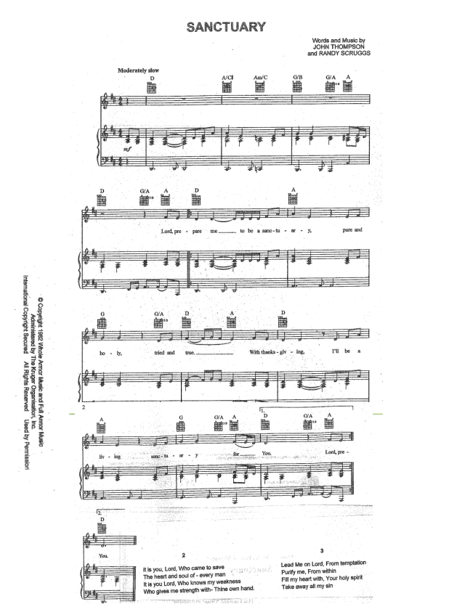

SPBTL NEWS AND EVENTS
CENTERING PRAYER 10AM, Meets in the parlor every Wed. Please join us!
COFFEE HOUR Sign up in Fotinos Hall or call the office.

MUSIC MINISTRY: Choir practice Wednesday nights at 7pm. Handbell Choir rehearsals Wednesday nights at 6pm.

CPR Classes at SPBTL The Mission Outreach Team will be hosting CPR classes on Nov 7th.
These classes are fundraisers for a local non-profit organization called “Eyes of Ian Project”. For background, in 2011, Ian Maddox was an 8yr old student at Pumpkin Center who died because he didn’t get CPR quickly enough. So Lincoln County residents Kevin Johnson and his wife started “Eyes of Ian Project”.
The project supports a group of American Heart Association instructors who volunteer their time to offer classes for staff at all Lincoln County Schools. The course offering is free of cost for the school system. Staff are taught and demonstrate proper technique in performing compressions, giving breaths, using an AED, and choking prevention. Upon completion, staff are certified in Basic Life Support Skills.
To offset costs, Kevin and his wife offer an abbreviated (non-certification) class to community organizations such as churches, businesses, and scouts groups at a nominal fee/donation of $10/person. These are the classes to be offered at SPBTL on Nov 7th.
Two hour-long classes will be held, one at 2pm and another at 3pm. Each class has a maximum of 15 participants. If you are interested, sign up using this link CLICK HERE
Or Contact Pat Racz or Kate at the office to sign you up. Please contact Pat Racz with any questions at pat.racz01@gmail.com or 704-748-3327.


The altar flowers are given to the glory of God by Brittany Seminara
In honor of Jack Seminara’s 1st Birthday.

At the Liturgy:
Officiant: The Rev. Dr. Ron Taylor
Filming: Kate D’Amato

