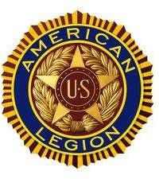

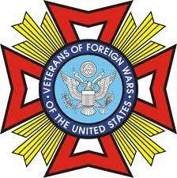
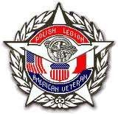
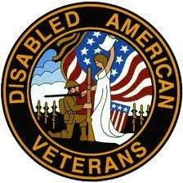
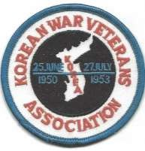
The City of Euclid and Veterans of Euclid
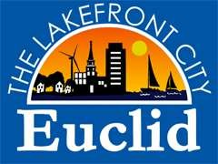
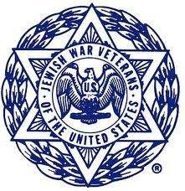

AMERICAN LEGION EUCLID POST 343 VETERANS OF FOREIGN WARS POST 1056 EUCLID VETERANS ASSOCIATION POLISH LEGION OF AMERICAN VETERANS POST 31
JEWISH WAR VETERANS SHORE POST 712 KOREAN WAR VETERANS LAKE ERIE CHAP 112

The City of Euclid and the Veterans of Euclid welcome you or your organization’s participation in the City of Euclid’s Memorial Day Parade, Monday, May 25, 2026, starting at 10:00 am. Our theme is: Honoring the past, Inspiring the future! Memorial Day is dedicated to war Veterans who have died for their country. All Veterans are welcome and encouraged to march or ride in the parade.

Enclosed is a paper copy of the parade entry form. To participate in the parade, please apply online at bit.ly/EUCMEM, or fill out the enclosed form completely and return to:
Euclid Memorial Day Parade Coordinator, 291 East 222nd St., Euclid, OH 44123. You may also scan the completed form and email to lkidder@cityofeuclid.gov

Once your application has been approved, you will be notified by email with further instructions. Veterans and their groups applications are automatically approved.

Don’t delay, submit your parade entry today! If you are no longer the leader of your group or organization, please pass this application to the new leader.

Feel free to contact us if you have any questions. Thank you for your interest and participation!

The City of Euclid and Veterans of Euclid Memorial Day Committee Laura Kidder Zack Golden
Parade Coordinator Assistant Parade Coordinator 216-289-8578 216-289-8578
LKidder@cityofeuclid.gov ZGolden@cityofeuclid.gov

AMERICAN LEGION EUCLID POST 343 VETERANS OF FOREIGN WARS POST 1056 EUCLID VETERANS ASSOCIATION POLISH LEGION OF AMERICAN VETERANS POST 31 JEWISH WAR VETERANS SHORE POST 712 KOREAN WAR VETERANS LAKE ERIE CHAP 112

2026 EUCLID MEMORIAL DAY PARADE ENTRY FORM

Name of Organization Address City Zip Contact Person Phone Email Type of Organization Please indicate the type of unit(s) marching and approximate number of participants

Please describe how you will honor our Veterans

PLEASE BE PREPARED TO SUBMIT VIDEO OR PICTURES OF MARCHING UNIT BY EMAIL TO: LKIDDER@CITYOFEUCLID.GOV
This parade is dedicated to war veterans who have died for their country; please, no private themes.
Will your unit(s) be handing out candy or prizes along the parade route?
(Please do not throw items) No promotional items please.
RELEASE OF ALL CLAIMS AND DEMANDS – EUCLID MEMORIAL DAY PARADE
I, of
Name in full (type or print legibly) Name of organization
release and discharge the Euclid Joint Veterans Council, the City of Euclid, its agents, servants, successors, administrators, and assigns from all debts, claims, demands, damages, actions, and causes of action whatsoever which may arise from or out of injuries received during participation in said City's Memorial Day Parade.

Date Signature Title
All applications will be reviewed upon receipt. You will receive an email notifying you of your approval to participate once this review has been completed. Approximately one week prior to the event, you will receive information regarding your assigned placement in the parade, parking and other details via email.
Mail-in Applications: Must be received/postmarked by May 16. Online Applications: open until May 21.

Mail to: Euclid Memorial Day Parade / Parade Coordinator 291 East 222nd St. Euclid, OH 44123
or scan and email to lkidder@cityofeuclid.gov
Submit an application online by scanning the QR code or visiting bit.ly/EUCMEM

