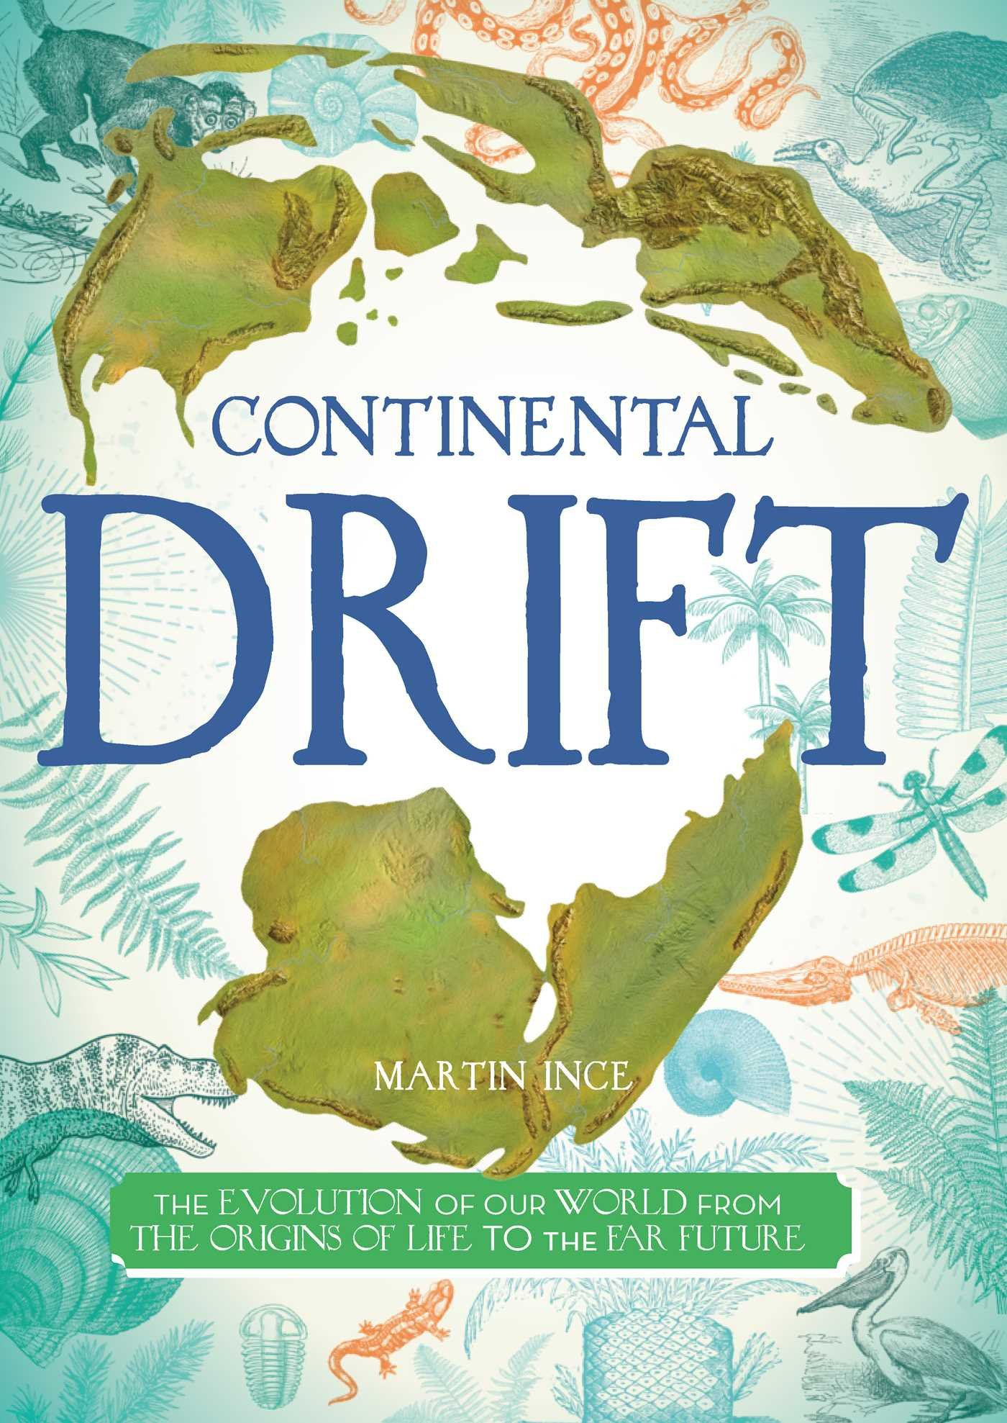
Continental Drift
By Martin Ubce

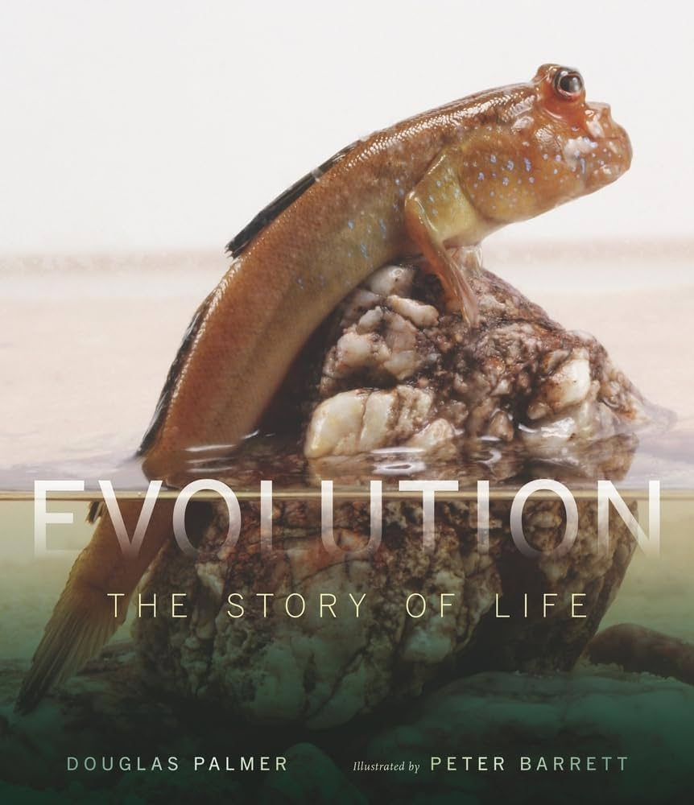
Evolution: The Story of Life
By Douglas Palmer, Illustrated by Peter Barrett

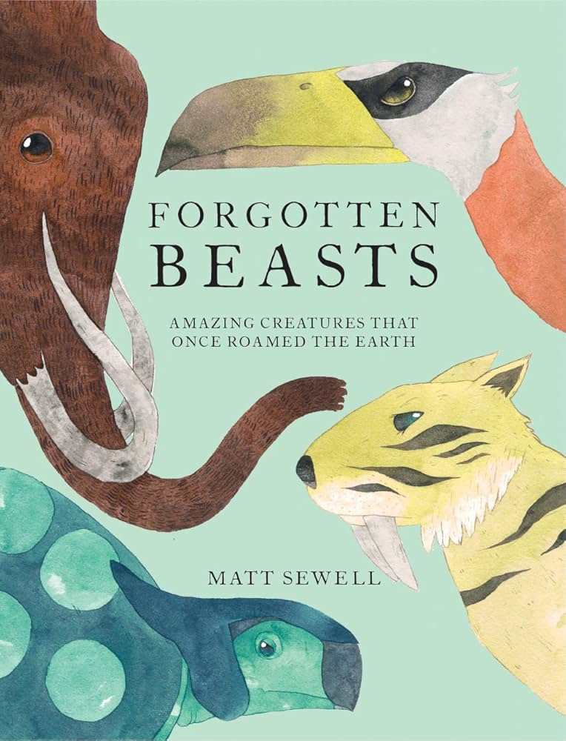
Forgotten Beasts
By Matt Sewell
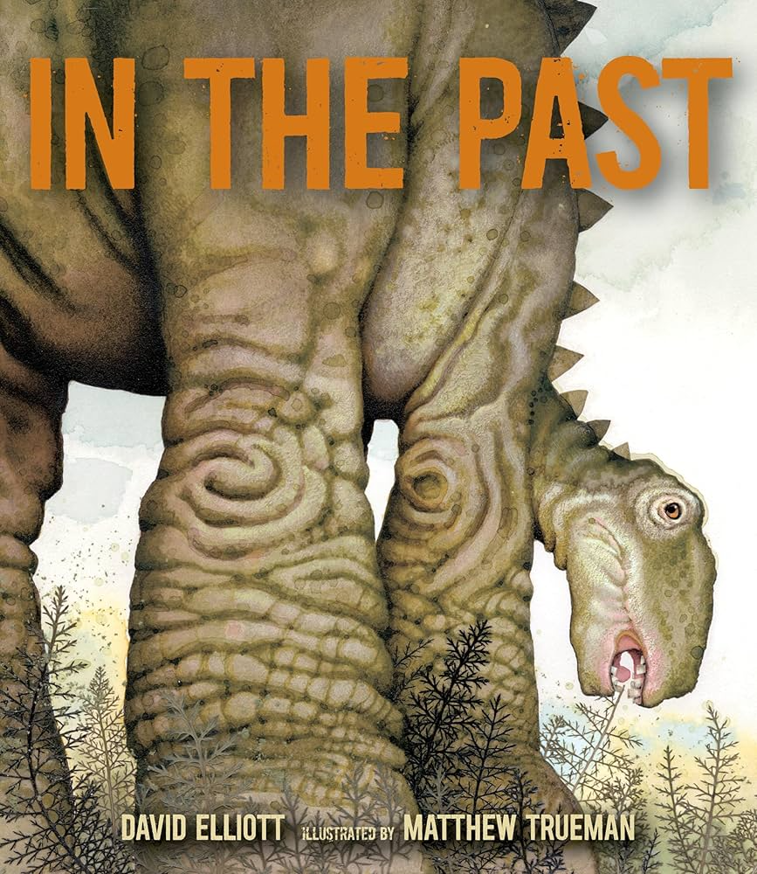
In the Past
By David Elliott, Illustrated by Matthew Trueman

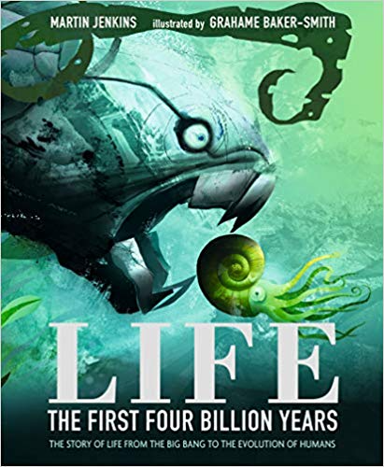
Life: The First Four Billion Years
By Martin Jenkins, Illustrated by Graham Baker-Smith

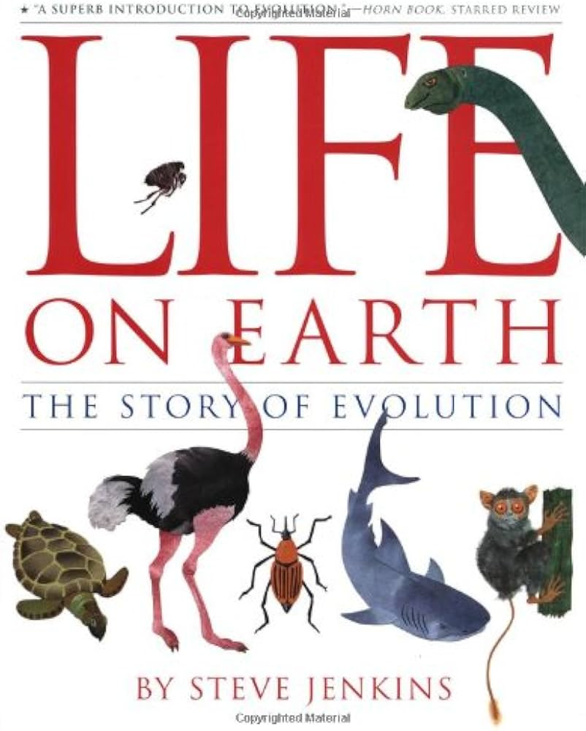
Life on Earth: The Story of Evolution
By Steve Jenkins

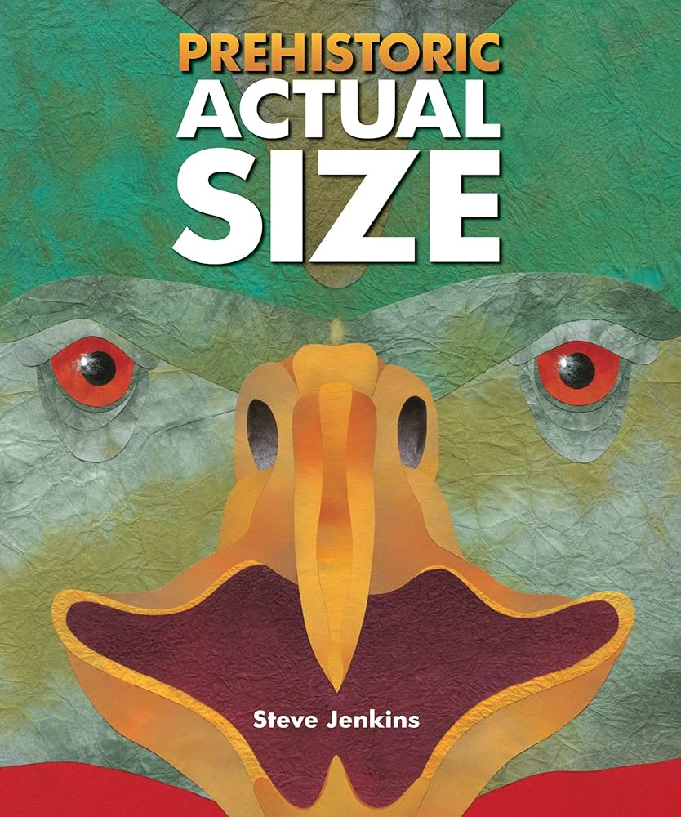
Prehistoric Actual Size
By Steven Jenkins

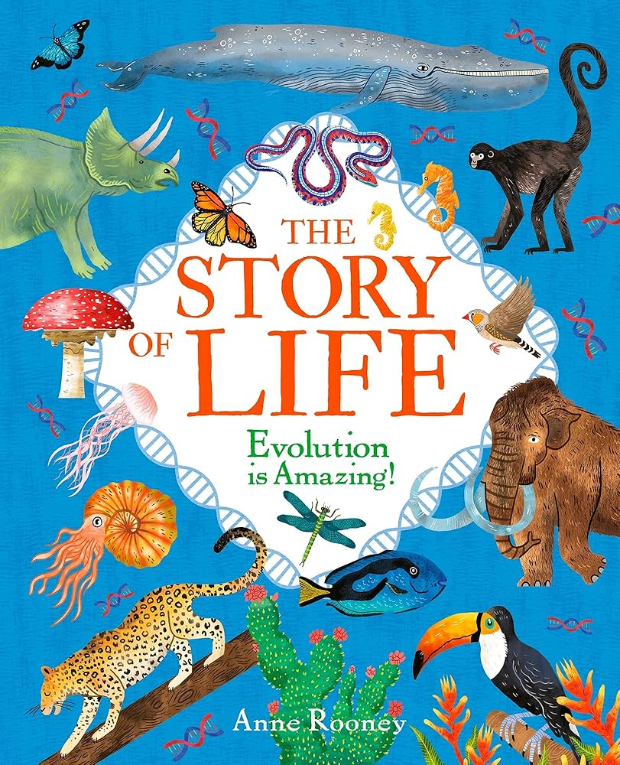
The Story of Life
By Anne Rooney, Illustrations by Nat Hughes

