Village of marshallville

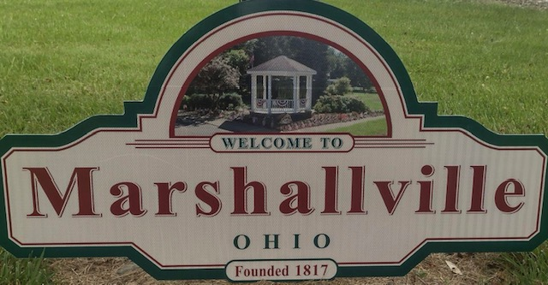

**Spring/Summer 2025**

# website:

Check out the Village of Marshallville Website: [www.VillageofMarshallville.org](http://www.VillageofMarshallville.org)

You are able to pay utilities, taxes and tickets online. Please note that there is a 3.5% credit card processing fee to use this feature.

You can also download and print out utility, tax, Klusch Hall rental forms and zoning permit.

# mayor’s office

I usually arrive at the office between 5:25 and 5:30 pm each afternoon to check messages and take care of paperwork. Please call the town hall and leave a message if you have a question or concern, or email me at [marshallvillemayor@zoominternet.net](mailto:marshallvillemayor@zoominternet.net) and I will contact you next day I am in.

**CONTACT US**

**Village of Marshallville**

**7 N. Main St  
Marshallville, OH 44645**

**330-855-2491**

**Utilities: 330-855-5985**

**Park Pavilion Rental: Lynn Martin at 330-601-4074**

**Fiscal Officer Dave Govern: 216-235-9037**

**Police Dispatch (NONEMERGENCY):330-264-3333**

**Emergency: 911**

**Mayor’s Court with Judge William Rickett is held the**

**fourth Monday of each month at the town hall at 7:30 PM**

[www.villageofmarshallville.org](http://www.villageofmarshallville.or#g).

|  |
| --- |
| Important Dates  Town wide yard sales: July 16-17 8AM-6 PM  Lions Chicken Barbecue: July 31 noon. Presale orders only. Call 330-855-2871 to order by July 26h  Historical Days: August 27-28th  Trick Or Treat: Thursday, October 28 - 6-7:30 PM |
|  |
|  |

[Click here to add a caption]

# UTILITY NEWs

The New Water Plant is just about finished and we are hoping to be up and running soon.

We have highly motivated, knowledgeable and personable employees that are an asset to our community. If you have a question regarding your utilities, or need a building permit, please call them at **330-855-5985**.

**To:**

Marshallville Mayor

**Date:**

Monday, October 30, 2023 6:00:05 PM

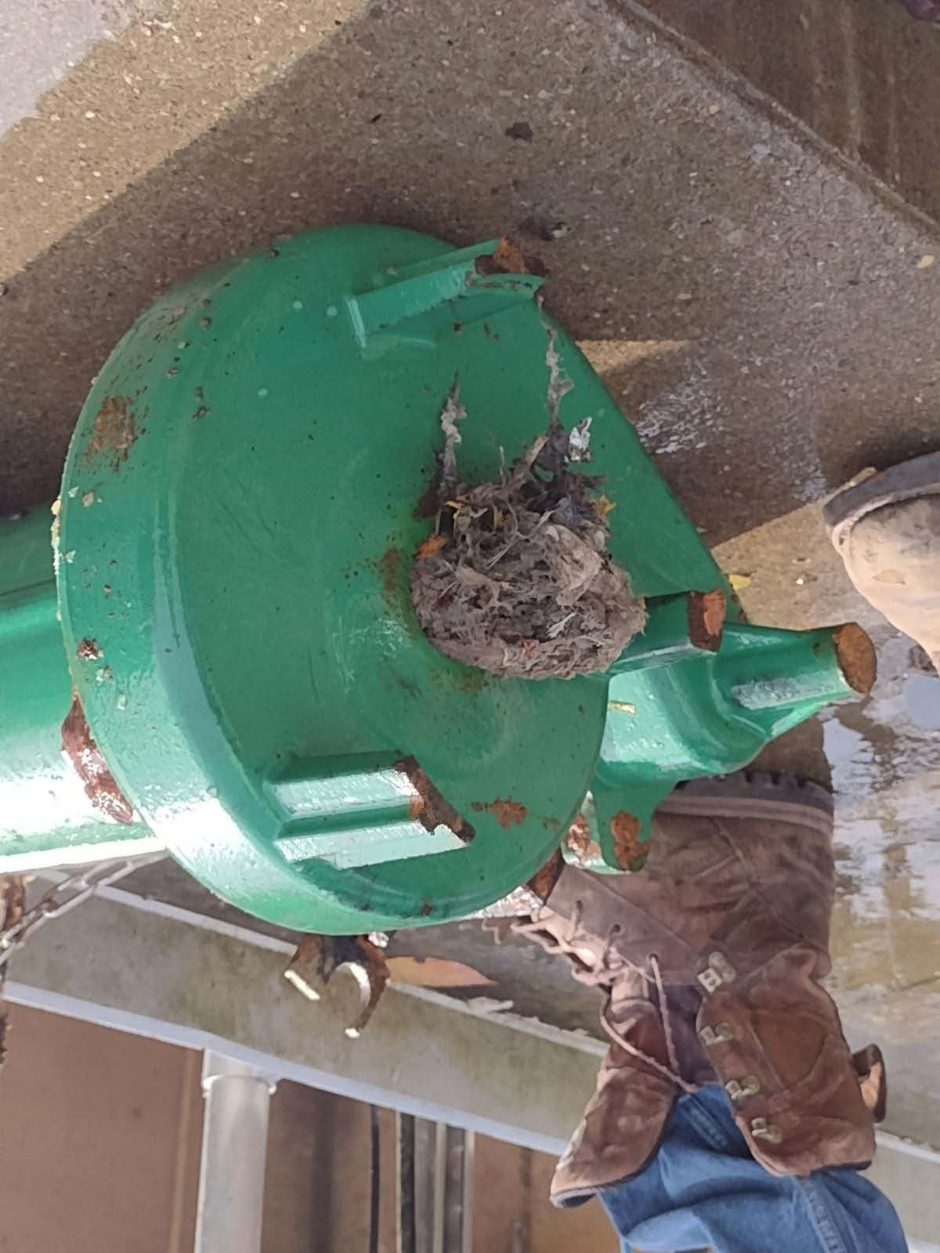

Please do not flush non-flushable items down the toilet, **this includes wipes that are marked “flushable**”. Those types of wipes wreak havoc in the system. We have mentioned this before, **but each week we remove a wheelbarrow full of cloth rags and other items that should not be flushed. This clogs up our treatment facility, and again increases our costs.**

This is a picture of a clogged EQ pump. It took our employees two days to clean it out and re-assemble it. All other projects get put on hold when this happens. **DO NOT FLUSH RAGS AND WIPES DOWN YOUR TOILET.**

Please be aware that your electric and water meters need to be accessible to be read. Please trim any obstructing bushes, remove obstacles, or any other obstructions that make it difficult or unsafe to read your meters. If meters cannot be easily accessed your monthly bill will be estimated. Thank you for your cooperation.

**\*Utility Payments may be made on line by mail or in person at Farmer’s State Bank. Remember they are always due on the 15th of each month, and delinquent bills are shut off on the 26th of the month.**

**The website to pay utilities online is** [**www.villageofmarshallville.org**](http://www.villageofmarshallville.org)**. There is a 3.5% service fee to pay them this way.**

**\* Please plan accordingly as utilities are due the same day each month.**

* **If you do not receive your bill by the 5th of the month please contact the utility office 330-855-5985**.

**\*Please note utility payments may be dropped off at the bank’s night deposit box. *****Our utility workers do a great job keeping the village up and running. However, one job that no one likes is delivering shut off notices for nonpayment of utilities. Our workers do not have to put up with threats of violence, foul language, etc. They are doing their jobs. All threats will be referred to law enforcement.**

**ELECTED OFFICIALS-**

**Mayor**: **Ron Hatfield** –Term ends 12/31/2027

**Council:**  **Board of Public Affairs**:

**Jackie Hatfield** President Pro Tem,  **Mark Hartzler**, President

Term ends 12/31/2025 Term ends 12/31/2025

**Rick Peters-**term ends 12/31/2027 **Mike Auck-** term ends 12/31/27

**Heather Lessiter-**term ends 12/31/2025  **Tom Rocker Jr-** term ends 12/31/2025

**Kathy Auck**- term ends 12/31/2025

**Rachel Stoll**-term ends 12/31/2025

**Todd Musser**-term ends 12/31/2025

**MEETING DATES**

**Board of Public Affair meetings** are held the second Monday of the month at 5:45 p.m. at the town hall.

**Council meetings** are held the second Monday of the month at 6:30 p.m. at the town hall. There is a citizen’s comment item on the agenda every meeting that is open to the residents of the Village of Marshallville. *Reminder- You will have a maximum of 5 minutes unless you asked to be scheduled on the agenda for a specific item. Complaints about personnel will not be heard in open council.

# Important phone numbers:

Please note if you are trying to report some type of incident that is a non-emergency, but would like an officer to respond please call the Wayne County dispatch at 330-264-3333. They can contact our officers and will inform them of the call. Many times we will find messages on our town hall answering machine that are urgent, but the **answering machine is not** in the police department, and therefore the messages can’t be handled in a timely fashion. Please use dispatch to handle urgent, non-emergency needs. If you have an emergency please call **911.**

# ZONING PERMITS

Want to build a shed? A fence? Add on to your house? You will need to contact our zoning inspector at 330-855-5985 to get a zoning permit or go to our village website and print the permit. This permit is necessary to get a building permit or to properly install a shed or fence. Failure to do this will result in the Wayne County Building Department declining your request for a building permit, or you may be required to move or remove a structure. Be safe and call to see if your project requires a zoning permit.

# OFTEN ASKED QUESTIONS

***What are the setbacks needed for building a shed*?**

A shed or any other building needs to be 10 feet off the side and rear lots in most cases.

***I have vermin (groundhogs, raccoons, squirrels, mice, etc) at my house causing problems. Do you take care of this for us?***

No, vermin are the property owners issue to deal with in a legal way. Firearms are prohibited from being fired within the Village.

***Is there an ordinance about setting out trash cans?***

Yes, the Village has an ordinance that sets the amount of time a trash receptacle can be at the curb. Basically, the receptacle may be set out the day before pickup and should be removed from the curb no later than 24 hours after pick up. The curb is not a storage site for your trash cans.

Please be a good neighbor and pick up any residual trash that may escape after pick- up. This is especially important if you don’t bag your trash before putting it in the containers. Also, please make sure your container(s) are turned the correct way and accessible for the trucks for pick up.

***What are the rules about having a campfire in town?***

Camp fires must be limited to clean burning wood and the fuel source may not be larger than 3’x3’x2’. **Burning grass, leaves, trash, or any other refuse is not acceptable.** Also, please keep your fire from producing excessive smoke. It has been noted some residents are burning fuels other than wood. Please be respectful and burn only clean, seasoned wood. Please also be aware if there is a statewide burn ban.

***What are the rules about my neighbor’s collection of stuff?***

A complaint that is becoming more frequent is “my neighbor is collecting all kinds of “_____”. (Fill in the blank with words like: junk, stuff, trash, etc.) What can be done?” First, try talking to your neighbor. They may not be aware that their stuff is an eyesore causing negative effects to the area’s property values. We also enforce a state ordinance which defines litter to include rubbish, ashes, cans, bottles, wire, paper, cartons, boxes, parts of automobiles, wagons, furniture, glass, oil of an unsightly or unsanitary nature, or anything else of an unsightly or unsanitary nature. **Please be aware of how you can affect an area by having these things on your property.**

Marshallville is one of Wayne County’s hottest real estate markets. Please keep our community looking nice.

# ATV’S

Marshallville has an ordinance prohibiting the operation of these vehicles on the streets and public property. This includes the Rail-to Trails owned property, farmers’ fields and The Nature Reserve. Use of these vehicles on these properties is considered trespassing unless written permission is first obtained. Please call dispatch @330-264-3333 to have an officer address any complaints.

# BARKING DOGS (AND CROWING ROOSTERS)

If you own a dog (or a crowing rooster) please remember it is the owner’s responsibility to keep the dog quiet and properly restrained. A barking dog may not bother you, but your neighbor may have a different opinion. **Also, there have been some dogs (and chickens) roaming the village**. Be sure your pet is properly restrained on **your property** and licensed. Dog complaints will be handled by the police department at 855-2491 or call dispatch at 264-3333.

# BOIL WATER ALERTS, SNOW PARKING BANS, and OTHER ITEMS

If an emergency arises in the Village we notify you by the REACH ALERT system. To enroll for REACH ALERT, please go to our village website and scroll to the bottom and click on REACH ALERT. Will 100% of the citizens hear it? The answer is “No”. However, it is the hope that in a town the size of ours your neighbors, friends, or family will alert you to the news item. In the case of a “boil alert”, it is a precaution we are required to issue in the event of a water break. If water is deemed to be unsafe you will receive a notice on your door to alert you of the issue.

**Update on the emergency siren**: The Siren is now working and it is being dispatched by the County. It is tested the first Monday of each month at noon.

# INCOME TAX

Income tax forms will be sent out to village residents the first week of January. If you have earned income you are required to file an income tax return. Please remember to use **Box 5** on your W-2 for the taxable amount. **Also, we only credit ½% paid to other municipalities. In essence, if you paid taxes to another town you still owe ½% to Marshallville**. If you have questions please call Fiscal Officer Dave Govern at 216-235-9037 or the town hall. Our website also has tax forms and extra forms are at the post office if you need one.

# WHERE TO DROP OFF YARD WASTE

Grass, Leaves, Branches, Stumps, Shrubs, Sod, Christmas Tress (no tinsel)  
**Unacceptable Materials**: Lumber, Pallets, Railroad Ties, Wooden Furniture

**There is now a charge to** drop off yard waste materials at the following community drop off locations. Contact **800-678-9839** for more information.

|  |  |  |
| --- | --- | --- |
| Paradise Lawn Care | 6203 Akron Rd, Smithville | Mon-Fri, 9am-5pm (year-round) |

**If you have other questions as to where to recycle different items go to this website:http://www.timetorecycle.org/ to find where to take items such as motor oil, electronics, etc.**

# Community Involvement

If you have been wondering how to get involved, here are a few of the opportunities to do so.

Marshallville Historical Society

The Marshallville Historical Society is a community-driven organization dedicated to preserving the rich history of Marshallville, Ohio, while fostering a sense of connection among residents. The Society is always looking for new members and volunteers to help with its various activities and initiatives, offering a great opportunity to become more engaged with the Marshallville community. Whether you’re interested in local history, event planning, or simply getting to know your neighbors, the Historical Society is an excellent way to contribute to the town’s growth and heritage.

Upcoming events hosted by the Marshallville Historical Society include a variety of fun and family-friendly activities. On April 19th at 2pm, the Society will host a Community Easter Egg Hunt at the park. Starting in May and running through September, the Marshallville Markets will take place on the second Saturday of each month, offering a vibrant marketplace for local vendors. The much-anticipated Historical Days event will take place August 22nd-23rd, showcasing the town’s history with activities and displays. In October, the Bucket and Beans Car Show on October 18th is sure to be a hit, followed by a Trick or Treat event on October 30th. The year will wrap up with a festive Community Christmas event on December 13th. All are welcome to join these gatherings and enjoy the fellowship of Marshallville residents.

If you’d like to become more involved, the Historical Society holds meetings on the first Saturday of each month at 8:30am. These meetings are held either at the American Legion when their breakfast is in session or at Gigi’s Restaurant when it is not. Membership dues are $25 annually for individuals, $50 for families, or a lifetime membership for $200. While all are welcome to attend the meetings, becoming a member provides a more direct way to support the ongoing preservation efforts and community-building activities of the Society.

Don’t forget to follow the Marshallville Historical Society on Facebook for more updates and information.

American Legion

The American Legion in Marshallville, Ohio, is a vibrant community hub dedicated to supporting veterans and their families. Membership is open to those with military service, as well as their descendants and supporters. The cost for a regular Legion membership is $40, while a social membership is also available for $40. For women with ancestors who served in the military, the Auxiliary membership is $34, and for younger members, the Auxiliary Junior membership is $10. The Sons of the American Legion (SAL), open to those with military ancestors, has a membership fee of $20, with the SAL Junior membership available for $10.

Meetings for the Legion and Auxiliary are held on the 4th Thursday of each month at 7pm, while the SAL meets on the 1st Wednesday of each month at 7pm. The Legion Club is open to members and guests with hours on Wednesday from 3pm to 8pm, Thursday from 3pm to 9pm, Friday from 3pm to 10pm, and Saturday from 2pm to 10pm.

The Legion also offers rental opportunities for its facility. Members can rent the space Monday through Saturday for $75, while non-members pay $100. Sunday rentals are available for $100 for members and $125 for non-members. Additionally, the kitchen can be rented for $25. On the first Saturday of each month, the Legion hosts a breakfast for just $8, available year-round (except for June, July, and August). The American Legion is a key part of the community, offering support, fellowship, and a place for members to connect.



The Marshallville Lions Club is a local chapter of Lions International, the largest non-profit service organization in the world. It has no religious or political affiliations.  Our club was founded in May 1956, and we currently have 22 members. We strongly embrace the Lions Club International Five Pillars of Service: Vision, Hunger, Diabetes, Cancer, and Environment. Our local club’s beliefs include service, community involvement, and ethical standards.

Service

**Self-less service**

Lions believe in serving others in need in their communities without personal gain.

* **Disaster relief**

Lions provide immediate assistance and long-term support to communities affected by natural disasters.

Community involvement

* **Civic engagement**: Lions promote good citizenship and government, and take an active role in the community's social, cultural, and moral welfare.
* **International relations**: Lions work to create understanding among people of different countries.

Ethical standards

* **Fair treatment**: Lions believe in mutual respect, diversity, and trust.
* **Open discussion**: Lions encourage open discussion of public issues but prohibit debate of partisan politics and religion.
* **High ethical standards**: Lions encourage efficiency and high ethical standards in business, industry, and public service.

The Marshallville Lions have had many past and current projects:

* We hold three chicken barbecues each year as fundraisers for our projects.
* We give a scholarship each year to a graduating Smithville High School Senior who shows a commitment to community service.
* We created and maintain Memory Park as a place to honor those who have passed and to have community minded activities.
* We’ve assisted in the creation of the Marshallville Trail Head on Euclid St.
* We assist in providing glasses and eye exams for those in need.
* Members assist in many civic causes that improve the Village of Marshallville.
* The Club supports many other local civic organizations that have asked for and accepted our help.
* The Club has also donated funds to many civic organizations to help with their projects.
* The Club holds several special events and activities each year to build fellowship among members.

The Marshallville Lions Club holds their meetings on the first and third Thursdays of each month. The meetings are held at Marshallville American Legion Post 718 at 6:30 PM. A meal is served at each meeting followed by a short business meeting. The Club is always looking for new members with a desire to serve the community and put time into civic activities. Dues are $25 semi-annually. Lion Alan Martin maintains a Marshallville Lions Facebook page for those wishing to get more information on the Club. The motto for all Lions clubs is “We Serve”

|  |  |  |
| --- | --- | --- |
| **VILLAGE OF MARSHALLVILLE**  7 N. Main St  Marshallville, OH 44645 | |  | | --- | | PRSRT STD  ECRWSS  US POSTAGE  PAID  EDDM Retail |   **Local Postal Customer**  Marshallville, OH 44645 |

**MARK YOUR CALENDERS:**

**American Legion: Breakfast 8-11 the first Saturday of each Month. Cost is $8.00**

**Easter Egg Hunt:****April 19 @ 2pm at the park**

**The Market: May thru September, 2nd Saturday of each month 9am-12pm at the park**

**Historical Days: August 22-23 at Historical Building area**

**Bucket Of Beans: October 18 Historical Building area Starts @ 12:00**

**Trick or Treat: Oct 30 6:00-7:30**

**Santa in the Village: December 13 @ 7:00pm**