Prophetic Table Talk April 12th, 2026

4/9Former SOCOM Employee Arrested for Leaking Classified Info
FBI Director Kash Patel announced the arrest of Courtney Williams, a former Special Operations Command employee accused of leaking classified national defense information over multiple years.
Williams reportedly held a Top Secret clearance and is accused of sharing sensitive details about military tactics, operations, and procedures with unauthorized individuals, including a journalist. Investigators say this included extensive communication, with information that later appeared in public reporting and a published book.
She has been charged under the Espionage Act.
Officials are framing this as a serious breach that could have put American warfighters at risk, especially given the timing alongside recent military operations involving Iran

4/9With a forceful denial and a surprise call for Congressional hearings, First Lady Melania Trump is breaking her silence on the Epstein files—but do you think her demand for "total transparency" will finally put the rumors to rest? irst Lady Melania Trump finally broke her silence on the Jeffrey Epstein files… Cleared her name. Then walked off like a boss. It’s the walk off for me. That walk-off said more than a thousand press conferences. "I have never had any knowledge of Epstein abuse of his victims. I was never involved in any capacity. I was not a participant, was never on Epstein's plane and never visited his private island."

4/9California man pleaded guilty on Monday to stealing millions of dollars in taxpayer funds through his participation in a prescription drug fraud scheme, the Department of Justice reported.
Paul Richard Randall, a 66-year-old man from Orange County, has admitted to submitting nearly $270 million in fraudulent claims to Medi-Cal, California’s version of the federal Medicaid program, from May 2022 to April 2023. As part of his plea agreement, Randall confessed that he and his alleged accomplices took advantage of Medi-Cal by exploiting a policy change. The government program suspended the requirement for health care providers to obtain prior authorization before delivering services and medications for reimbursement while transitioning its prescription drug program to a new payment system.
Randall billed Medi-Cal millions of dollars each month for dispensing high-reimbursement, non-contracted, generic drugs through a pharmacy, including some pain medications. One such medication was Folite tablets, a vitamin available over the counter.

4/10$6.3 Billion in Fraud Flagged — And This Is Just What They Found
The Trump administration is starting to uncover what looks like a very real, very large problem inside the federal contracting system.
Vice President JD Vance’s anti-fraud task force has identified approximately $6.3 billion in federal contracts tied to nearly 400 businesses that are now being questioned for legitimacy. This includes 895 contracts across 392 entities, and many of these companies are now being asked to prove something basic that should have been verified upfront, that they are real, operating businesses with actual physical locations.
Those entities have been given 30 days to provide documentation, and if they can’t, contracts will be terminated and funds will be recovered where possible. What makes this even more significant is that roughly $3 billion of that money has not yet been paid out, which means this effort is not just about cleaning up past mistakes, it is actively preventing additional losses from happening in real time.
This also lines up with what we’ve been seeing in other areas like healthcare, where large-scale fraud has already been exposed.

4/10 Vance Heads Into Iran Talks After Pressure Forced Movement
Vice President JD Vance is now leading direct negotiations with Iran in Pakistan, stepping into one of the most important diplomatic moments in this entire conflict.
These talks are not happening randomly. They are happening after weeks of sustained military pressure from the United States and its allies. That detail matters because it completely changes the context of the negotiations. This is not a situation where the U.S. is trying to convince Iran to cooperate. This is a situation where Iran is being pushed to the table.
At the same time, Iran has not fully backed down. They are still attempting to maintain leverage, particularly around critical areas like shipping routes and regional influence. That means while talks are happening, there is still a very real possibility of escalation if those negotiations break down.
4/11 Artemis II Mission Successfully Returns — A Huge Step Forward
NASA just pulled off something historic.
The Artemis II crew safely returned to Earth after a 10-day mission that sent humans farther into space than we’ve gone in over 50 years. The four astronauts traveled around the far side of the Moon and reached distances of over 250,000 miles from Earth before making their way back.
The re-entry alone is wild to think about. They came back into Earth’s atmosphere at nearly 25,000 miles per hour, dealing with temperatures around 5,000°F, and still landed almost perfectly in the Pacific Ocean.
All four astronauts made it back safely and are in good condition.
4/11In a decisive strike, Secretary of War Pete Hegseth has ENDED the DoD’s outrageous reliance on Chinese labor for critical cloud services, a dangerous Obama-era program that left a DECADE-LONG security nightmare wide open! This move ends the massive espionage fears.
4/11: The US DID NOT reach an agreement with Iran, JD Vance says it's "bad news" for IRAN "They have chosen not to accept our terms." "We've been at it for 21 HOURS. We've had substantive discussions...bad news is, we have not reached an agreement."

4/11President Donald Trump blasted his former allies Tucker Carlson, Megyn Kelly, Candace Owens, and Alex Jones on Thursday, calling the podcasters “nut jobs and troublemakers” over their comments on Trump’s recent actions.
Trump published a nearly 500-word post on Truth Social blasting his former supporters for their attacks on the administration, which have gained the attention of legacy media outlets and leftists.
“I know why Tucker Carlson, Megyn Kelly, Candace Owens, and Alex Jones have all been fighting me for years, especially by the fact that they think it is wonderful for Iran, the Number One State Sponsor of Terror, to have a Nuclear Weapon — Because they have one thing in common, Low IQs. They’re stupid people, they know it, their families know it, and everyone else knows it, too!” Trump wrote.
All four of the commentators have become increasingly critical of the president over his decision to launch “Operation Epic Fury” and attack Iran. Earlier this week, Carlson urged U.S. military members to refuse Trump’s orders and claimed that Trump was considering using a weapon of mass destruction “on the population of Iran.” Kelly said on Wednesday that Trump was “bamboozled” by Israeli Prime Minister Benjamin Netanyahu and blasted the president as “too weak” and “too gullible” to push back on Netanyahu’s argument to attack Iran.
On Sunday, Owens called the Trump administration “satanic” and said, “satanic Zionists occupy the White House and Congress.” She also called for “Mad King Trump” to be removed from office. Jones has similarly called for Trump to be removed from office through the 25th Amendment.
“Look at their past, look at their record. They don’t have what it takes, and they never did!” Trump said of the four podcasters. “They’ve all been thrown off Television, lost their Shows, and aren’t even invited on TV because nobody cares about them, they’re NUT JOBS, TROUBLEMAKERS, and will say anything necessary for some ‘free’ and cheap publicity. Now they think they get some ‘clicks’ because they have Third Rate Podcasts, but nobody’s talking about them, and their views are the opposite of MAGA — Or I wouldn’t have won the Presidential Election in a LANDSLIDE.”

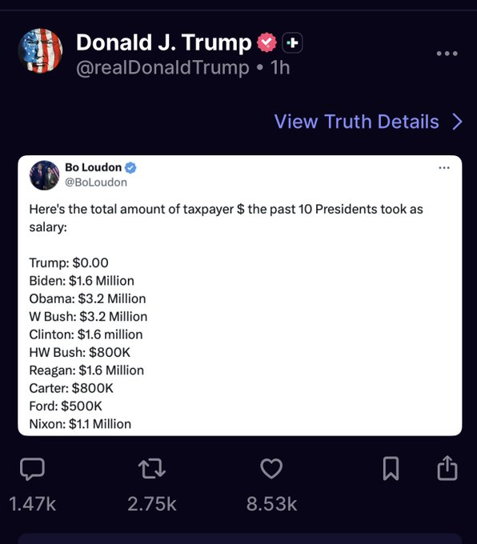
4/11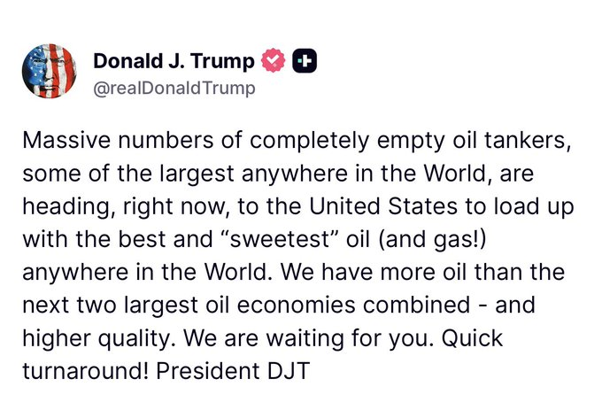

Amamda Grace:: US/Iran Showdown equals Biblical Point April 10,2026

1. Prophetic Alignment: Exodus Pattern Now
Direct Quote:
“The book of Exodus is running parallel to what we are seeing now… Passover this year should align with modern-day events from the book of Exodus.”
Explanation:
- Current global events are being interpreted as mirroring biblical patterns.
- Just as Purim aligned with Esther, Passover is seen as aligning with:
  - Deliverance
  - Judgment
  - Confrontation between powers
- Emphasis: History is repeating prophetically, not randomly

2. The “911 Window” Timing
Direct Quote:
“We are in a 2-year window… that equals 911… within the 8-day period of Passover.”
Explanation:
- Dates 4/5–4/7 are interpreted numerically as “911”
- This symbolizes:
  - Crisis
  - Sudden escalation
  - National/global alert moments
- Seen as a prophetic time marker, not coincidence

3. Iran Parallel to Egypt (Pharaoh System)
Direct Quote:
“Just as Egypt was broken at Passover, so shall Iran be.”
Explanation:
- Iran is compared to:
  - Egypt (oppressor system)
  - A nation resisting God’s purposes
- The Ayatollah’s fall is seen as:
  - Parallel to Pharaoh being judged
- Expectation:
  - Further shaking
  - Possible release (like hostages in Exodus)

4. Strait of Hormuz = Red Sea Parallel
Direct Quote:
“We witnessed a showdown… over a body of water… just like the Red Sea.”
Explanation:
- The Strait of Hormuz is viewed as a modern Red Sea moment
- Symbolism:
  - A place of confrontation
  - A place where God demonstrates power
- Suggests:
  - Another major event could still happen there
  - Not the final confrontation yet

5. Warning of a Second Confrontation
Direct Quote:
“Pharaoh… conceded… then hardened his heart one more time.”
Explanation:
- Current ceasefire is seen as:
  - Temporary
  - Not final resolution
- Expectation:
  - Iran may reverse course
  - Another escalation could follow
- Pattern:
  - Concession → hardening → final judgment

6. “Golden Age” and “Golden Apple” Prophecy
Direct Quote:
“There is your Golden Apple forming… an attempt to resurrect the Ottoman Empire.”
Explanation:
- “Golden Age of the Middle East” is tied symbolically to:
  - Historical Battle of Vienna (1683)
- “Golden Apple” represents:
  - Strategic/global power centers
- Interpretation:
  - A global power shift attempt
  - Possible revival of old empires (spiritually/politically)

7. The Golden Calf Warning (Post-Deliverance Trap)
Direct Quote:
“After deliverance… the golden calf incident happened.”
Explanation:
- Warning to people/nations:
  - After breakthrough comes temptation to idolize
- Modern application:
  - Trusting:
    - Money
    - Power
    - Political systems
- Key message:
  - Victory can lead to spiritual compromise if not guarded

8. 45-Day Window to Pentecost
Direct Quote:
“We are now entering a 45-day window to Shavuot… Pentecost.”
Explanation:
- Time between Passover and Pentecost is highlighted as:
  - A critical prophetic transition period
- Associated with:
  - Law (Shavuot)
  - Spirit (Pentecost)
- Suggests:
  - Decisions made in this window are highly significant

9. Nehemiah 6 Warning (Political Trap)
Direct Quote:
“Come, let us meet… but they were planning to harm me.”
Explanation:
- Applied to international negotiations (Pakistan meeting)
- Warning signs:
  - Being drawn onto enemy territory
  - Negotiations not on equal footing
- Spiritual insight:
  - Not every meeting is safe—some are strategic traps

10. Territorial Spiritual Warfare
Direct Quote:
“There is a great territorial war in the realm of the spirit over Iran.”
Explanation:
- Conflict is framed as:
  - Not just political
  - Spiritual (principalities, control systems)
- Parallel:
  - Egypt’s spirit resisting release of Israel
- Emphasis on:
  - Prayer
  - Discernment
  - Intercession

11. Baal vs. God Parallel (False Gods Judged)
Direct Quote:
“The Lord was calling out Baal at the Red Sea.”
Explanation:
- Red Sea miracle = judgment of false gods
- Strait of Hormuz linked to:
  - Another false deity system (sky/authority gods)
- Message:
  - God is confronting:
    - False authority
    - False worship systems globally

12. Prophetic Patterns in Numbers
Direct Quote:
“There were 10 plagues… now a 10-point peace plan… do you see the pattern?”
Explanation:
- Repeating numbers (10, 47, 911) seen as:
  - Divine patterns, not coincidence
- Examples:
  - 10 plagues → 10-point agreements
  - 47th president → timing alignment
- Emphasis:
  - God speaks through patterns and timing

13. Call to Watch and Pray
Direct Quote:
“Be on high alert… pray… be watchmen.”
Explanation:
- Core instruction of the message:
  - Stay spiritually alert
  - Do not trust appearances
- Focus areas:
  - Leadership
  - Nations
  - Key locations (like Florida, New Jersey, Middle East)
- Role of believers:
  - Intercession
  - Discernment
  - Awareness of unfolding events

Hank Kunneman Prophetic Word April10th, 2026

Summary of Prophetic Message (Hank Kunneman)
This prophetic message centers on Israel, divine protection, judgment on enemies, spiritual warfare in the nations, and a coming global reversal where God both judges evil and preserves His covenant people.

✨ 1. God’s Covenant Protection Over Israel
“This affliction shall not rise a second time.”
- Declares Israel will not experience repeated destruction or total defeat
- Emphasizes God’s covenant protection and preservation
- Frames current conflict as something God is actively restraining
“There is a covenant with Me that preserves Israel and shall preserve them now and going forth.”
- Reinforces that Israel’s survival is tied to divine promise, not human strength
- Suggests ongoing supernatural protection over the nation

🛡️ 2. Divine Shield and Supernatural Defense
“There is a shield around about you, Israel, in the spirit realm.”
- Describes spiritual covering over Israel beyond natural defense systems
- Implies unseen protection operating alongside military and technology
“You will see through technology… I have revealed plans to bring about a shield.”
- Suggests modern defense systems may reflect divine inspiration or timing
- Blends spiritual interpretation with technological advancement

⚔️ 3. Judgment on Israel’s Enemies
“The enemies… shall be greatly shaken, embarrassed, stripped of their power.”
- Predicts destabilization of opposing forces
- Indicates loss of influence and leadership collapse
“I will plunder them. I will implode the tunnels and expose them.”
- Speaks of hidden systems (symbolized as tunnels) being uncovered and destroyed
- Represents exposure of secret strategies and underground operations
“Great conflict shall arise among even Iran.”
- Suggests internal instability within nations aligned against Israel
- Points to division within leadership structures

🌪️ 4. Sudden Upheaval and Visible Signs
“Watch very closely for a great wind shall arise…”
- Symbolizes rapid change and unexpected events
- Could represent natural or geopolitical disruption
“You will think it’s a sandstorm… but it is My chariot.”
- Interprets natural events as spiritual activity
- Frames global shaking as divine intervention, not random chaos

🌐 5. Global Reversal: Judgment + Restoration
“All hell is being dealt with… and all heaven is breaking loose.”
- Presents a dual reality:
  - Evil systems collapsing
  - Divine breakthrough expanding
“To loose the captives… to bring great reversals, removals, restorations.”
- Highlights deliverance and justice occurring simultaneously
- Emphasizes restructuring of nations and leadership

🕊️ 6. Two Sides of God’s Action (Justice & Mercy)
“Which side of the cloud are you on?”
- Refers to Exodus imagery (pillar of cloud/fire)
- Represents two dimensions of God’s activity:
  - Judgment on oppression
  - Preservation of covenant people
“My right hand is victory… My left hand is judgment.”
- Symbolizes God operating justice and protection at the same time
- Warns against interpreting events with fear alone

🇮🇱 7. Strong Emphasis on Israel’s Deliverance
“Israel shall be preserved and protected… delivered quickly as in a day.”
- Compares current events to the Exodus deliverance
- Suggests rapid divine intervention in modern conflict
“Yeshua… will be cried in the streets.”
- Anticipates spiritual awakening in Israel following deliverance
- Connects crisis to revival and recognition of God

🔥 Core Message in One Line
God is actively protecting Israel, exposing hidden enemy systems, shaking nations, and bringing both judgment and global restoration simultaneously.

.

