Prophetic Table Talk 1/4/26

1/3 U.S. Special Forces Capture Maduro and Wife in Caracas Raid
Last updated 25 minutes ago
Operation Absolute Resolve saw U.S. forces grab Venezuelan President Nicolás Maduro and Cilia Flores from Caracas, flying them to a U.S. base near New York where they face narco-terrorism and corruption charges. President Trump praised the bloodless mission—no Americans died—and pledged temporary U.S. oversight to sell oil reserves for reconstruction and guide a democratic shift after disputed 2024 elections. Jubilant crowds waved flags in Caracas and exile communities worldwide, though 40 Venezuelans died in related strikes, and world leaders divided between cheers from Argentina and France and condemnations from Mexico, China, and Russia.

1/3 Colombian President Gustavo Petro: "A clan of pedophiles wants to destroy our democracy. To keep Epstein's list from coming out, they send warships to kill fishermen & threaten our neighbor with invasion for their oil." While Massive crowds have taken to the streets of Venezuela to celebrate President Trump’s capture of dictator Nicolás Maduro.

1/3 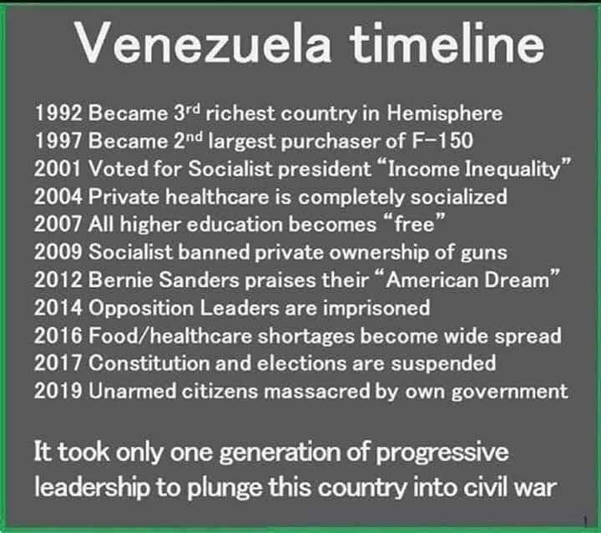

1/3
Bo Polny
RIGHT ON SCHEDULE!!
EXACTLY as Prophesied by Kim Clement… “THEY FALL in FALL”.
Fall ENDS December 21
December 21 JULIAN CALENDAR (True Calendar) ends January 3… BOOM💥💥💥 VENEZUELA!!! Kim also PROPHESIED thank about 2 O’CLOCKS… YOU’VE BEEN LOOKING at the WRONG CLOCK!!

1/3 Iran Protests Spread Nationwide as Regime Loses Control
Iran is facing one of the most expansive protest waves in years as demonstrations that began with economic grievances in Tehran’s Grand Bazaar have spread to at least 17 provinces.
What started as anger over inflation and currency collapse has evolved into open political dissent, including chants against the regime and clashes with security forces. Protests have reached cities typically loyal to the government, including Qom, a major religious center.
At least seven deaths have been reported, with dozens arrested. Government buildings have reportedly been stormed or burned in multiple locations. The regime has responded with force, internet restrictions, and warnings of harsher crackdowns.
The unrest highlights growing internal instability amid sanctions, economic decline, and declining public confidence in the Islamic Republic’s leadership.

`1/3 FBI Reports Record Counterintelligence Arrests in 2025
FBI Director Kash Patel announced that the Bureau made 85 counterintelligence-related arrests in 2025, a more than 40% increase from the prior year.
Highlighted cases include:
- An active-duty U.S. soldier charged with attempting to transmit classified tank data to Russia
- A major North Korean IT infiltration scheme that generated $17 million through fraudulent remote work
- Chinese-linked corporate divestments ordered by President Donald Trump following FBI and CFIUS intelligence
Patel emphasized record document transparency to Congress, increased espionage arrests, and a renewed focus on dismantling foreign intelligence networks tied to China, Iran, and North Korea

1/3 Zohran Mamdani was sworn in as New York City's mayor in a historic ceremony at the Old City Hall subway station, marking significant firsts for the city.
Historic Swearing-In Ceremony
On January 1, 2026, Zohran Mamdani took the oath of office just after midnight in a private ceremony held at the abandoned Old City Hall subway station. This location, which has been closed to the public since 1945, was chosen to symbolize the importance of public transit and the city's historical ambitions. Mamdani, who is the first Muslim, first South Asian, and first African-born mayor of New York City, emphasized the significance of the subway station as a testament to the city's legacy and future aspirations.
Unique Aspects of the Ceremony
Mamdani was sworn in using a Quran, marking the first time a New York City mayor has used this text during the oath-taking. He held his grandfather's Quran and a historic copy from the New York Public Library,
Public Inauguration and Celebration
Following the private ceremony, a public inauguration was scheduled for later that day at City Hall, where U.S. Senator Bernie Sanders was set to administer the oath again. This event was accompanied by a block party celebration in Lower Manhattan, known as the "Inauguration of a New Era

1/3 Bernie Sanders claims Zohran Mandani isn't a communist. Here's what Mamdani has called for: "Abolition of private property" "Seizing the means of production" "Single-payer system" for healthcare

Mayor Zohran Mamdani announces 3 Executive Orders:
The city will intervene if your landlord doesn’t manage your property well
Creation of a LIFT Taskforce (Land Inventory Fast Track)
Creation of a SPEED Task Force (Streamlining procedures for equitable development)

1/3 DHS Audits Citizenship Files Amid Minnesota Fraud Fallout
The Department of Homeland Security confirmed it is auditing naturalization files from Somalia and 18 other high-risk countries following massive fraud cases tied to Minnesota social services.
The review focuses on potential fraud during the citizenship process, including false representations and marriage scams. Officials stress that denaturalization remains rare and requires a high evidentiary bar.
The move follows expanded federal investigations into childcare, Medicaid, and nutrition fraud schemes involving hundreds of millions in taxpayer losses.

1/2 Five States Begin Restricting SNAP Purchases
New SNAP rules took effect January 1 in Indiana, Iowa, Nebraska, Utah, and West Virginia, prohibiting the use of food assistance benefits to purchase items like soda, candy, and certain energy drinks.

The changes were approved through USDA waivers and are part of the Trump administration’s Make America Healthy Again initiative, which aims to steer taxpayer-funded benefits toward healthier food choices and reduce diet-related disease costs.

Eighteen states are expected to implement similar restrictions throughout 2026. Supporters say the policy aligns benefits with nutritional goals, while critics argue it adds complexity for retailers and recipients.

1/2 SBA Suspends Nearly 7,000 Minnesota Borrowers Over Pandemic Fraud
Small Business Administration Administrator Kelly Loeffler announced the suspension of 6,900 Minnesota borrowers after a review of pandemic-era PPP and EIDL loans flagged widespread suspected fraud.
According to the SBA, those borrowers were approved for roughly 7,900 loans totaling about $400 million. All have been banned from future SBA loan programs, and cases are being referred to federal law enforcement for prosecution and repayment.
Loeffler said this is just the beginning, calling Minnesota the first state in a broader enforcement effort targeting pandemic loan abuse. The fraud uncovered in Minnesota didn’t just expose one broken program. It triggered a wider reckoning.

Once federal investigators started pulling threads in child care, nutrition, and Medicaid fraud, they didn’t stop there. They went back and reviewed pandemic-era relief programs that were rushed out with minimal verification. That’s how you end up with thousands of PPP and EIDL loans being reexamined, borrowers suspended, and entire networks cut off from future federal funding.

1/2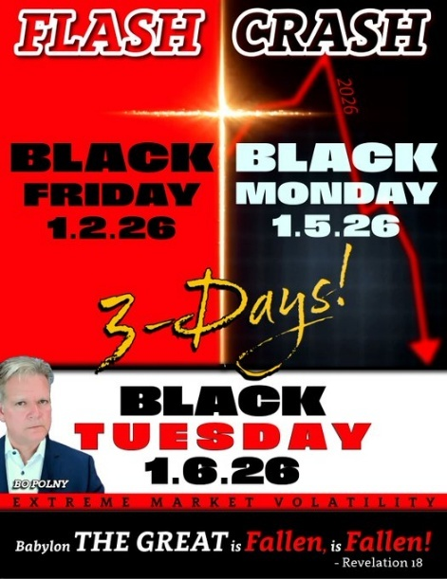

Prophetic Alert: 2026 War Time and Reversals
January 2nd, 2026
by Amanda Grace
Incoming NYC Mayor Zohran Mamdani to be sworn in at abandoned subway stop on NYE New York City Mayor-elect Zohran Mamdani will be sworn into office at an abandoned subway stop below City Hall on New Year’s Eve to pay tribute to the “lifeblood” of the Big Apple.
I want you to pay close attention to the symbolism and words being used
Midnight 12 ABANDONED he is being sworn in in an abandoned place think about the prophetic symbolism of that with what has just happened in NYC They have abandoned the Lord they have entered spiritually speaking a time of abandonment.
LIFEBLOOD- The term "lifeblood" originated in the 1580s, combining the words "life" and "blood" to refer to blood that is essential for life. It later took on a figurative meaning, representing something vital or essential for existence or function. So the subway system is the LIFEBLOOD I would say intercede and pray against a major attack on the NYC subway system because the two are being connected with a Muslim socialist becoming mayor even the enemy knows there is power in the blood its just not the blood of Jesus Christ. The enemy is after the LIFEBLOOD to power altars that are in NYC The lifeblood is where the power lies.

Leviticus 17:14 “For in regard to the life of all flesh, its blood is [the same] as its life

Now I'm going to show you something quite sobering because what is hidden within details is really the plan that is looking to be executed. I'm going to show you what is hidden within the details of the swearing in Zohran Mamdani (HAMAN).

Zohran Mamdani Officially Sworn in on a Quran Full of Symbolism Incoming New York City Mayor Zohran Mamdani is making history not only as the city's first mayor to take the oath of office on a Quran but also as the first Muslim, South Asian, and African-born mayor. Incoming Mayor Zohran Mamdani took his midnight oath of office on a centuries-old Quran, marking the first time a mayor of New York City uses Islam’s holy text to be sworn in and underscoring a series of historic firsts for the city.

The 34-year-old Democrat became mayor in a long-closed subway station beneath City Hall, the first Muslim, first South Asian and first African-born person to hold that position. He is sworn in on 1/1 two ones as in twins as in the area where the twin towers fell. As in Rosh Hashanah the feast of trumpets beginning on 9 11, 2026 the day the towers fell.
This happens at midnight, 12 having to do with government and rule, biblically speaking the enemy seeks to change the TIMES and SEASONS. This is about seizing a time and ushering in a hostile takeover before its time. This word hostile takeover you ill hear this more and more publicly said to when it comes to Zohran Mamdani and Ishmael. AG Latisha James Swears Him in Pay Close Attention to this because she thinks she has gotten away with it and she now has someone in the city that can help her keep her seat and in fact this is not going to be a blessing to her but a curse because whether she realizes it or not she made a covenant with the God of the Quran which is not Almighty God. That smirk is going to be wiped of Latisha James face when she feels the full effect of the foolishness then her face will turn pale and she will have no way out of the crisis that is coming. And the Quran has now become the document upon which NYC is led because what these foolish short sighted spiritually dry people of NYC don’t realize is that at midnight a covenant was made with a god that is not Almighty God and a false birthright and covenant was now put in place which means any covering that was over NYC has shifted and NYC is beholden to a ruler of the darkness now.

It’s the same as how Haman in the book of Esther has the king make a covenant with him and a false god to send out a decree of destruction against the people of God had the Lord not intervened the king would of fallen because of that covenant that is why a reversal went forth which spared the King from the wrath of Almighty God. He is sworn in between 2 blood moons both marking Purim 2025 and Purim 2026. Purim having to do with the book of Esther, Haman being elevated to a prestigious political position sends out a decree of
destruction against the people of God to destroy them and divine reversals then going forth and people of God being positioned within the palace to overturn the schemes of Haman and the kingdom of darkness and deliver the people of God.
I'm telling you decrees of destruction are going to go out from that
man's office. Now spiritually speaking when the enemy has an agenda he will brings
groups of people together to accomplish that agenda by hiding it within events and circumstances even names because the kingdom of darkness hides and conceals while the kingdom of God exposes and reveals. What I'm about to show you proves this and that the enemy brings people together in a sequence to accomplish this: LATISHA JAMES, BERNIE SANDERS, KATHLEEN HOCHUL, ZOHRNA MAMDANI

Amanda Grace Dream from 8.22.2024: “I’m at a birthday party and Tim Walz is there, however, he looks like the Mad Hatter, he had on fake huge eyes, and black spikey hair sticking out from what appeared to be a top hat. He took the costume on and off.”
The Mad Hatter hosted a tea party, the scene in the dream was a birthday party. However, their tea party is eternal; they are forever stuck at 6 o’clock, always on an unbirthday. 6 and a birthday party, like for children, like Tim Walz the Mad Hatter at a gathering having to do with children, say like daycare, and the number 6.
It was the 6th month, June 14 2025, Melissa Hortman after being the deciding vote and voting against her own party to stop illegal handouts. The Mad Hatter is often interpreted as a symbol of rebellion. The Hatter tells Alice how he once always had time on his side, but explains that now they have argued – they are always having tea because when he tried to sing for the foul-tempered Queen of Hearts. She sentenced him to death for “murdering the time”, but he escapes. In retaliation, now time (referred to as “he” by the Hatter) will not do a thing for the Hatter, keeping him trapped at 6:00 pm (a.k.a teatime). When Alice arrives at the tea party, the Hatter is characterized by switching places on the table at any given time, making short, personal remarks, asking unanswerable riddles, and reciting nonsensical poetry, all of which eventually drives Alice away. The Hatter appears again in “Chapter Eleven – Who Stole the Tarts?”. The character also appears briefly in Carroll’s 1871 Through the Looking-Glass, the sequel to Alice’s Adventures in Wonderland. Under the name of “Hatta”, the Hatter was in trouble with the law once again. 6:11.
Which is interesting because that is the time exactly they attempted to assassinate President Trump in Butler Pennsylvania, July 13, 2024. While Tim Walz was the VP candidate.

Carry the Red Cape of My Blood
Voices: Anne Tate, Chuck Pierce, Keevy Phillips, Keith Pierce, Tobias Lyons
Date Given: December 28, 2025
View Transcript
Chuck Pierce – The Lord says, “This is a year ahead where you will carry the red cape of my blood. I say for many bull fights will be in your path, but I say some you will stir up and others you will put down, so I say to you, get ready to stir your path ahead, and get ready to put away those things that have tried to gorge you in days past. I say to you, this is a year where you will take authority in your ring,” sayeth the Lord.
Keith Pierce – And the Lord will say to you, “Do not enter into the arena unless you’re ready for the fight. I placed in your hand the red cape, but know that the bull fight’s not over ’til the matador spits. If you’re not willing to face your opponent to the end and spit on him, stay out of the arena because this is a year that war will occur, turbulence will happen, but I am looking for those that will grab the red cape and not step back from the war until it’s time to spit, because when you spit, you will find the new healing and the new miracles that you are looking for.”
Chuck Pierce – All right, that’s a shout Right there.
Keevy Phillips – The Lord spoke to me last… I didn’t even know Chuck was gonna release this word, He kept saying to me, “Red is for blood. Red is for blood,” and He had me intercede for the midterm elections now, and the Lord said this is going to be the most tumultuous midterm election in this nation’s history, but if my people will rise up and, covered in the blood, they will already have prayed who’s supposed to be seated and unseated. I sa y this is going to be a time of great turmoil, great division, but the Lord says I’m in the middle of the dividing out right from left, don’t think politics, right side of thinking and left side of thinking, and the Lord said, “A double-minded man is unstable in all his ways,” the Lord said, “It is time for my bride to become stable in her faith. I say, if you’ll pray now, if you will intercede now, you will ride above the tumultuous time to come in November in 2026,” says the Lord.
Anne Tate – And the Lord says is, “If you will stand in righteousness, not in Republican or Democrat or independent, if you will stand in my righteousness and pray what I want, I will deliver you from the enemy. You will carry the blood and it won’t be in vain, it will be effective in every place that you speak what God says.”
Tobias Lyons- I wanna read the passage of scripture that all of these words are coming from, because this is what the Lord woke me up with this morning. James 1, “My fellow believers, when it seems as though you are facing nothing but difficulties, see it as an invaluable opportunity to experience the greatest joy that you can, for you know that when your faith is tested, it stirs up in you the power of endurance, and then, as your endurance grows even stronger, it will release perfection into every part of your being until there is nothing missing and nothing lacking, and if anyone longs to be wise, ask God for wisdom and he will give it, he won’t see your lack of wisdom as an opportunity to scold you over your failures, but he will overwhelm your failures with his generous grace, just make sure you are empowered by confident faith without doubting, that you will receive, for the ambivalent person believes one minute and doubts the next. Being undecided makes you become like the rough seas, driven and tossed by the wind, you’re up one minute and tossed down the next. When you are half-hearted and wavering, it leaves you unstable, can you really expect to receive anything from the Lord when you’re in that condition?” Now, I wanna share something, for 15 years, I have been waiting for a breakthrough, two weeks ago, the Lord took me to the piano one night and He said, “Will you just worship with me right now in this moment?” Now, I don’t play piano very well, but I knew that meant that there’s something that needed to come out of my spirit in faith out of worship, so I sat down at that piano, and immediately, the Lord gave me two lines, and those lines said, “I can sense a breakthrough’s coming even though it’s felt delayed. My time is not my own, so I’ll keep on having faith.” Now, I sang that over and over…
Chuck Pierce – Wow, say that again… We gotta get it. We gotta get that.
Tobias Lyons – “I can sense a breakthrough’s coming even though it has felt delayed. My time is not my own, so I’ll just keep on having faith.” I rehearsed it for three hours that night, I woke up singing it in the morning, and by that afternoon, I got an email that that thing I had been waiting 15 years for broke and there was freedom that was established after 15 years of waiting. Now, I’m not here to say those 15 years weren’t hard, but what I know is that if you will continue to persevere and if you will continue to, step by step, say, “Lord, I don’t know that I understand this, but I don’t have to because all you’ve said is ‘It is finished,'” and if I can put my faith in the words “it is finished,” then I can live in the reality that it is finished, regardless of what it looks like, regardless of what the day looks like, I can live in the future of “it is finished.”
Kevin Huang Financial Markets

The trap has been set. The countdown has begun. And in just a matter of days, the largest force-liquidation event in the history of the silver market will begin. I am not speaking in hyperbole, and I am not exaggerating for dramatic effect. I am sharing the language of major financial analysts and strategists — the very institutions that influence the flow of capital across global commodity markets.
They are stating plainly that, during an upcoming short window in early January, an enormous volume of silver will be forcibly sold on the futures exchange. A significant share of the total open interest in silver contracts will be liquidated in that brief period. They warn that the selling pressure will be so intense, so concentrated, and so overwhelming that the thin liquidity conditions following the holiday season could magnify price movements and trigger what they themselves describe as a dramatic repricing to the downside.
This is not a warning from an obscure commentator working out of a basement. This is not speculation from an online message board. This is formal analysis issued by one of the largest financial institutions in the United States — and their message is clear: prepare for impact.
But here is what they are not telling you. Here is what the mainstream financial media has chosen to overlook. Here is the other side of the story — the part that turns what appears to be a looming disaster into one of the greatest buying opportunities of this decade.
While the Western financial system prepares to dump massive quantities of silver onto the paper market, China has effectively locked down its physical supply. While index funds are being compelled to sell off their silver positions to satisfy mechanical rebalancing rules, Beijing has imposed some of the strictest export controls on silver seen in modern times. As the paper price is poised to be driven sharply lower, the real-world availability of physical metal is about to become rarer than ever.
We are witnessing the collision of two opposing forces. We are watching the decisive clash between paper-market manipulation and tangible, physical reality. And I am going to walk you through exactly what is unfolding, why it is happening, and how you can position yourself to respond wisely to the chaos ahead.
He gives lots of information and goes on to say

The paper price is being pushed around by a mechanical process that has nothing to do with true market fundamentals. The reality in the physical world is that silver is scarcer than ever. Industrial demand is stronger than ever. Monetary demand is rising as confidence in fiat currencies continues to erode. Every foundational factor points higher.
The rebalancing pressure is temporary. The larger trend is enduring. Hold your ground. Accumulate during weakness. Trust the underlying fundamentals.
When the smoke clears from this rebalancing cycle, many will look back and recognize that this moment marked the dividing line between those who understood what was happening and those who did not. The informed capital is accumulating. Automated systems are dumping. Choose your position with care.
This is a convergence of powerful forces. The paper market is preparing to release a massive quantity of silver, while the physical supply remains tightly constrained and largely inaccessible. The clash between these dynamics will generate intense volatility — but for those who are prepared, volatility becomes opportunity.
You now understand what is unfolding. You understand why it is happening. You understand how to respond. What remains is the discipline to act.
The coming period will test resolve. It will test understanding. It will reveal who has weak hands and who has strong hands. Stand firm. Be the one who buys when others are rushing to sell. Be steady in the center of the storm.
The price may fall. Headlines may sound alarming. Automated systems may trigger selling waves. But the fundamentals remain unchanged — and the fundamentals point to a far stronger future for silver.
On the far side of this rebalancing, many will recognize that a rare opportunity was placed in front of them. Make sure you are ready when it appears.

