The Europoort Port System

This chapter describes how the Europoort Port System came into being, took a step forward and a step sideways, but also collapsed surprisingly quickly. Appendix II shows the boxes and sets that have been released over the years.

The first edition
In 1972, less than a year after the introduction of the E10 Road System, the Europoort Harbour System came onto the market. The first version of the system consists of a ferry, two bridges, two jetties with a crane, and a warehouse with a quay and lanes. Four different models that together form a Dutch harbour landscape.

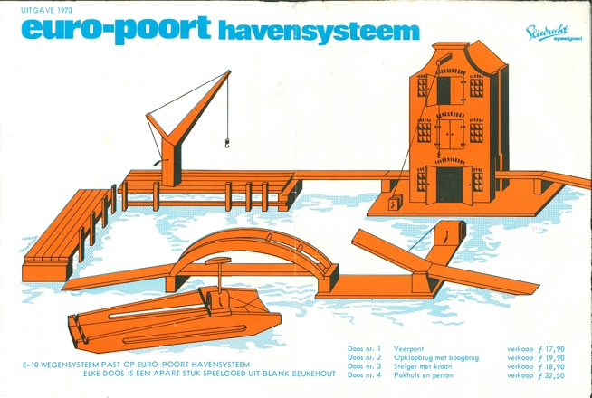

brochure/price craving from 1973

The boxes themselves resemble the E10 boxes in terms of design. The lid is colorfully illustrated, and once again, the cars and trucks are missing. The box itself is universal for all models, and only the stamped number on the side indicates the contents. The hook connection from the first two editions of E10 Wegen-Systeem has been carried over to boxes 2, 3, and 4.

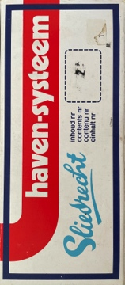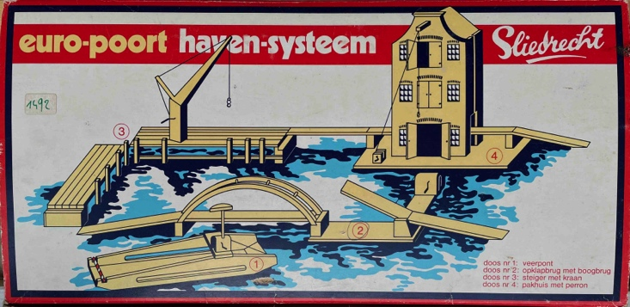

Haven system universal boxes (R) with a faint stamp on the side (L)

What stands out is that the designers paid little attention to scale and, consequently, to playability. The warehouse and the jetty form a single unit. The same can be said of the drawbridge and the arch bridge. However, the clearance heights of the warehouse, the arch bridge, and the ferry are so low that many Dinky Toys could not pass underneath. Another similarity with the E10 system is that these models feature an on- or off-ramp with a beveled road surface on the underside.
The orange/blue leaflet (April 1973) states that the Europoort Harbour System was chosen as Toy of the Year by the expert jury. It is not made clear that the E10 and the Harbour System received this award *together*. This leaflet also states that the E10 Road System fits the Europoort Harbour System.
That is 'true', with all the ifs and buts. But still? Yet the image of the port isn't quite right. What is missing are containers, which have been so characteristic of major ports and road transport since 1955. It looks static, and without trucks and cargo, that is exactly what it is.
The second edition
In that same year, 1973 (or earlier), work began on expanding the Europoort Port System. Three models were added: a gantry crane, a container ship, and a container truck (truck with two semi-trailers). Everything fits into the newly designed universal box on which the photographed models are now displayed. The number on the side clarifies the contents of the box.

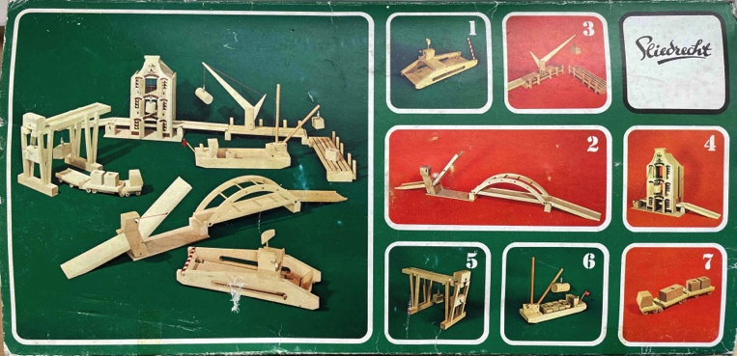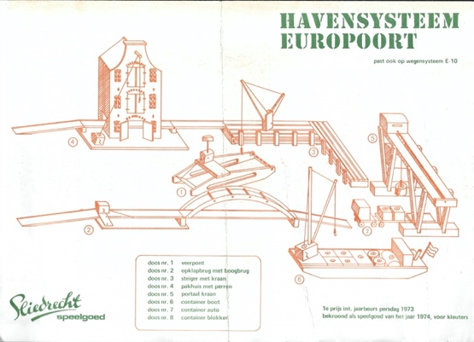

the new box and the new package leaflet/leaflet (without prices) from 1973

There is a bit more to say about three models. The containers, whether included or not, are round or rectangular. The blocks are made of the same wooden staff material as the blocks in the large block boxes that were part of the Sliedrecht assortment in the late 1960s. The buyer may be surprised by the composition (rectangular or round) and the types of wood.

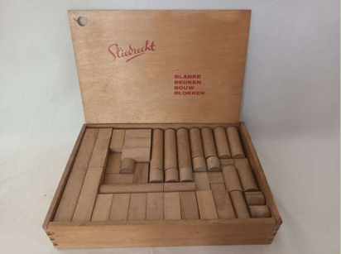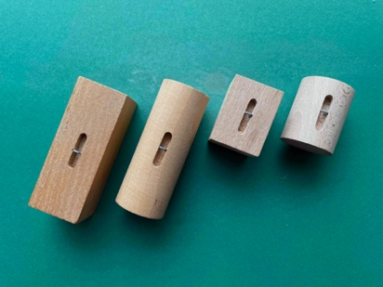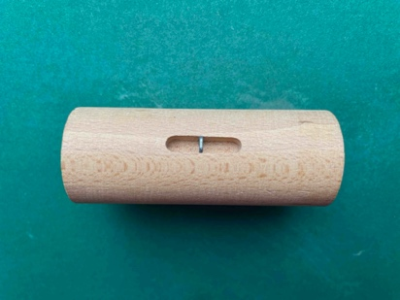

large block set (circa 1965) two shapes, two sizes detail ' lifting eye '

A small slot has been milled lengthwise into each block. A rectangular steel staple has been shot into the slot. This creates a sort of lifting eye . It must be said: everything is neatly centered, and the load hangs almost horizontally. With that, the harbor landscape is almost complete. Almost, because the containers, which can also be used with the warehouse, the scaffolding crane, the gantry crane, and the truck with semi-trailers, are not for sale separately.

The E10 Road System and the Europoort Port System are once again receiving a joint leaflet. It mentions another new product: a set of loose container blocks. The container truck and the set of containers are packaged in folded cardboard with an elastic net around it. Seven models in total, plus the set of container blocks (which may vary in composition). Time to play!

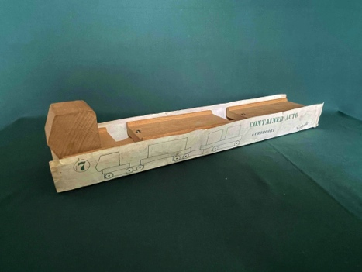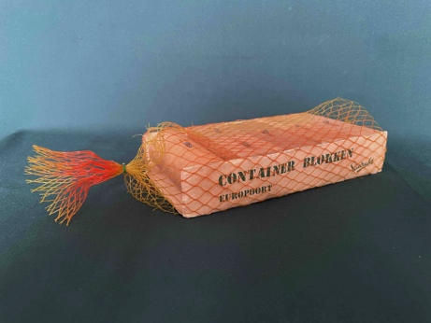

the container truck without a net and the container blocks with an elastic net

All seven models together form a fine ensemble; it is time to take a closer look. The ferry and the gantry crane feel to be on the wrong scale: both turned out small. The container boat, on the other hand, fits in nicely with the jetties and the warehouse. The most striking piece, however, is undoubtedly the container truck, consisting of a truck with two semi-trailers. This one turned out so large that, although the vehicle can stand under the gantry crane and just barely fits on the lanes, it is too wide and too high for the arch bridge, the ferry, and the underpass of the warehouse. Incidentally, at that time, two semi-trailers were not yet permitted on public roads. Nevertheless, the Europoort Harbour System was named Kindergarten Toy of the Year 1974 ⁸ .

⁸ source: Algemeen Dagblad December 6, 1973

Construction. In chapter four, it has already been outlined that in production, the design and the best or cheapest way to produce it coexist. This has led to a certain product innovation and many small differences.

- The front of the warehouse features a brown print of windows, stones, and the text Europoort. This was done using a screen printing technique. Two versions have been spotted on Marktplaats. The original warehouse has "Founded 1850" high on the gable. In the later version, this was replaced by Europoort and by E10 as the house number. The explanation is simple: when the screen printing stencil wore out, a new one was made, with small adjustments being made each time. And speaking of Marktplaats: the warehouse is also being offered there as a dollhouse.
- Five versions of the gantry crane have been spotted on Marktplaats.nl. There may well be more. The trolley from which the hoisting hook hangs is driven by a spindle. Well, a spindle? To save material, weight, and money, a long, stiff spring with a coarse pitch (displacement per revolution) was chosen. The trolley is connected to the spindle with a steel staple (a long rivet). There are models with the staple at the bottom of the spindle, as well as models with a larger steel staple running across the spindle. The spindle itself is available in plain steel—meaning rusted steel by now—and there is a spindle with an orange coating. It makes little difference: the transmission is stiff and only works when a human hand comes to the rescue. Various versions of the crane housing at the head end have also been spotted. This concerns both the connection between the crane housing and the bridge and the cranks (handles) used to operate the screw spindle and the hoisting hook.

Just as with the E10 System, it is striking that numerous variations appear in the finish. No pattern can be discerned. Correct. The sawing and fiddly work, such as sawing, sanding, and assembling, was outsourced to sheltered workshops in and around Waddinxveen. Sliedrecht BV had no control over this. These uncertain modifications to the models may have contributed to intermediaries such as Hausemann & Hötte seeing this as a reason to exclude Sliedrecht BV's toys from their range.
Construction Company Delta . It is 1974. Sliedrecht BV launches Construction Company Delta , a series of six beautiful beechwood models. The series consists of a pile driver, a construction crane, a sand grab, a loader, and a dump truck with a sand hopper.

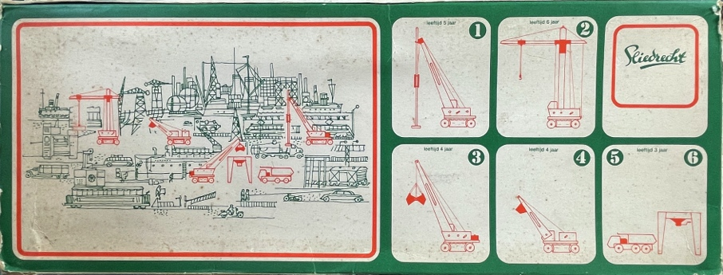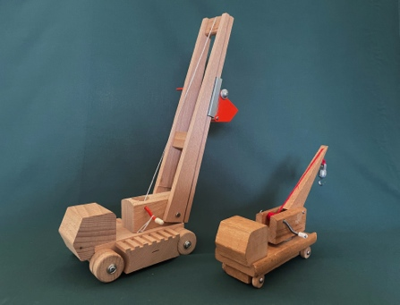

construction company Delta box and the excavator, next to the crane truck of the Europoort Port System
The hand of designer Jaap de Jong can be seen in this. The models are made of beech wood combined with metal parts featuring an orange epoxy coating. The six large models are packed in standard soft cardboard boxes with orange/green printing, all in the style of the original Europoort Harbour System. The sand hopper and the dump truck are later placed together in a single shrink wrap ^{PS} .

On the side of the Bouwbedrijf Delta boxes it states: “ This series is a supplement to the blank beech toy harbor system EUROPOORT”. However: the models, with an approximate scale of 1:35, are at least twice as large as the Europoort Harbor System and are therefore seriously oversized.

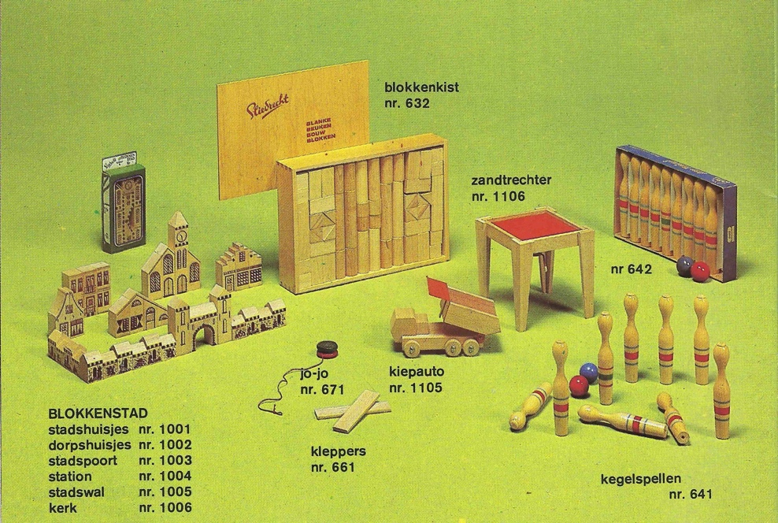

page from the full- color Sliedrecht product overview

The retail chains do not include these large models in their toy catalogs. Only the local shops test the market with a single model ^{9.} No commercial success. Production of four models is discontinued. The two popular models (the dump truck, number 1105) and the sand hopper (number 1106) are included in the Sliedrecht product overview for a few more years. After two years, these models also disappear from the ^{PS} range .
The grand story of Delta Bouwbedrijf is included in the December 2025 Newsletter (Ed. Ellen-Wien Augustijn edition). All models are described in detail therein.

⁹ Source: advertisement Children's Paradise , Nieuwsblad van het Noorden (November 18, 1975)

The dismantling . In a small full- color Sliedrecht product overview (from after 1977), the Europoort is no longer mentioned . Port system . The arch bridge with drawbridge has disappeared. Six models and the set of container blocks remain. That product overview holds another surprise: a series of four separate commercial vehicles has been added to the battered port system: a container truck, a crane truck, a stake truck, and a tow truck.
Four commercial vehicles (with the same article number 909) which, upon closer examination, consist of a 15 cm lane, equipped with a chassis with wheels, a standard cab, and a functional body.

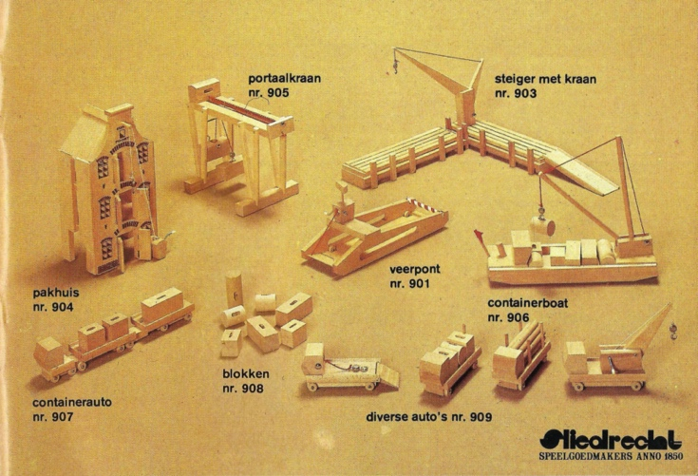

page from the full- color Sliedrecht product overview

The arch bridge, but without the bascule bridge, has been included in the E10 Autobaan (editions 3, 4, and 5). The warehouse has also been modified: the floor slab and the ramps have been removed. As a result, the underpass has been widened. The problem of cars (907 and 909) being too tall and too wide for the bridges and the warehouse has thus been partially resolved.

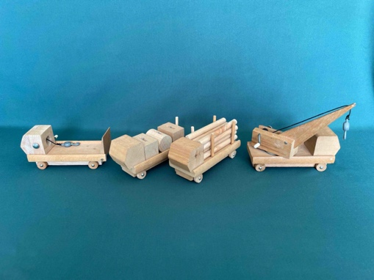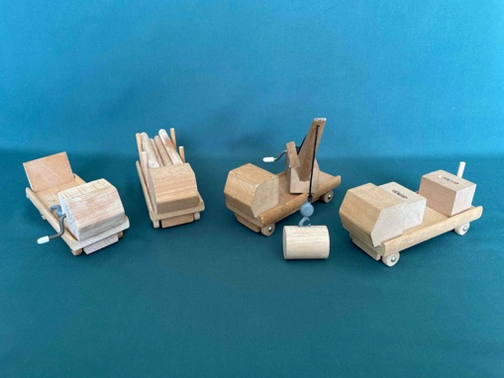

the four company vehicles: the container truck, the crane truck, the stake truck with posts, and the tow truck

The Europoort Harbour System no longer appears on the 1984 price list. The models are no longer mentioned either. An inglorious end to an appealing and award-winning concept.

****

©2026 Copyright & Disclaimer of the article The Europoort Port System

This article is made available free of charge to the enthusiast of vintage toys. The intellectual property of this article concerning the beechwood harbor landscape of the Sliedrecht toy factory rests with me, Peter Duijff. The derived copyright and image rights also rest with me. These rights entail that the enthusiast may use the content for personal use. However, nothing from this article may be reproduced, edited, stored, or made public without the prior permission of the rights holder, author, or photographer. Where possible and meaningful, sources have been cited. I have made every effort to determine whether there are rights holders other than myself and any mentioned author, photographer, draftsman, or illustrator. Nevertheless, it is possible that this investigation is incomplete. Anyone who believes that their interests have been violated as a result is requested to submit this to me with the aim of reaching a solution.

Peter Duijff
Schalkhaar, May 2026

