Toy Factory Sliedrecht

Research
Ko Verzuu, a recognized Dutch toy designer, gave his wooden toys the brand name ADO, which stands for Arbeid Door Onvolwaardigen (Work by the Disabled). This touches upon a sensitive point in the history and position of toys. Toys are for children. They are not full-fledged products . Manufacturers and their employees are not taken seriously. The trade journal Gemengde Branche from 1950 contains a retrospective of the period 1910-1950. Public opinion is expressed as follows: 'toys come from abroad. In times of war, the toy industry is justifiable, but this industry disappears when normal circumstances return' ¹ .

It can get even worse: children's books are not regarded as literature. The highest attainable qualification for an author is: " also wrote for children ." In that light, it is not so strange that little or nothing is found during source research in archives regarding the major Dutch manufacturers of wooden toys. If it concerns Waddinxveen specifically, consider the following. There are a few hundred postcards of old Waddinxveen. Many streets, churches, and some industry. The firms Alblas (wood), Boonstoppel (paint), Dobbelman (soap), and Verheul (buses) dominate. No postcard has been found of the three major toy manufacturers Okkerse/OKWA, Plomp, and Sliedrecht. Just turn ADO around. Then it reads ODA , for example, *Judgment by Others*. That is just how it is.

Introduction
Playing is timeless. Wooden toys, imported from Germany, are hundreds of years old. The first documented piece of Dutch toy, a sled carriage, dates from 1789. This does not rule out the possibility that woodcarvers were active much earlier. The original view was that wooden toys originated from domestic crafts. In an extensive article on Waddinxveen toys ² Lourens Bas demonstrates that this is a misconception. Willows, a white and easily carveable type of wood, grew abundantly in the peaty soil near Gouda.
The woodworking industry originated there in the seventeenth century. It involved furniture and small toys. Names of toy manufacturers known in the nineteenth century include Bremmer, Gebroeders Plomp, Hoogendoorn, and Okkerse (later OKWA). Their toys had three things in common: the drawbridges, carriages, etc., were almost always unbranded, they were nearly identical, and featured strongly similar decorations.

Box 1: Broek, de Gouwe and Waddinxveen

The municipality of Broek, bordering the Gouwe, was one of the four Lordships southwest of Gouda until the beginning of the nineteenth century. In 1811, these Lordships were added to Gouda. In 1870, the hamlet of Broek was added to the municipality of Waddinxveen under the name Zuid Gouwenkade. During the municipal reorganization of 1965, Broek and the surrounding area returned to the municipality of Gouda. It is now known as the beautiful walking area 't Weegje.

The Gouwe, a peat stream in the twelfth century. Through the excavation of peat, it became a canal-like river, connected to the Hollandsche IJssel by an artificial structure (sluice), with Gouda as its major city. Originally, there were floodplains along the Gouwe. To control the water level, dikes were constructed along the Gouwe. Towpaths were established on the dikes on both sides of the Gouwe. The Zuidplas, west of the Gouwe, in the nineteenth century, at nearly 7 meters below sea level, became the lowest place in the world after the construction of dikes, a ring canal, and drainage by windmills. On the western bank of the Gouwe, between the Zuidplas and the Gouwe, there are now three communities: Noord-Waddinxveen, Zuid- Waddinxveen, and Zuid Gouwekade. The names Noordkade and Zuidkade speak for themselves. The three communities grew together, and in 1870 they formed the municipality of Waddinxveen (source: Wikipedia, edited by PD).

In the strip of land between the North and South Quays and the ring canal lay the Alpherwetering running parallel; a wide ditch designed to drain seepage from both waterways to a dedicated pumping station. Later, this canal fell into disuse. All in all, the terrain was marshy and only partially passable. At the South Quay, near a bend in the Gouwe, ships dumped their cargoes of timber into the water awaiting processing at the Alblas sawmill and planing mill. Popularly, this spot became known as Balkenhaven. Due to canalization and narrowing, this location disappeared, and the South Quay became accessible to trucks along its entire length. The development along the South Quay was extended into the Wilhelminakade. The toy factories of Bremmer and Okkerse established themselves along these quays. Waterborne freight transport remained possible for both toy manufacturers. With that, the infrastructure of what would now be called an industrial estate was complete.

For the past 150 years, Waddinxveen has resisted plans to merge with one of the many surrounding cities. And successfully so. Waddinxveen currently has over 35,000 inhabitants. When it comes to infrastructure, Waddinxveen is on every map, with the Gouwe, the A12, and three NS train stations.

This article (story) concerns the rise and fall of the sports and toy company Sliedrecht BV in Waddinxveen, framed by wooden toys. Attention is paid to people and products, but also to conviction, considerations, and decisions.

The years of Bremmer (1850-1910)

Not everything has been researched, but just this anyway. It is plausible that the Bremmers originate from Overijssel, the Dalfsen area, and settled in North Waddinxveen and South Waddinxveen, to be precise in the former Lordship of Broek (Bloemendaal district) SM . The religion column lists Dutch Reformed.
In any case, it concerns Gerrit Bremmer, a peddler by profession. For other Bremmers, the profession of carpenter or woodturner is usually listed. Gerrit Bremmer owned a number of meadows in Waddinxveen (known in the cadastral records under numbers D236, D237, and D238) situated on the Zuidkade, the raised western bank of the Gouwe. Small houses against the dike, and behind them marshy pasture. Jan Bremmer (Broek, 1820), as noted, comes from a family of carpenters and woodturners. SM follows his name. Initially, his profession was listed as 'carpenter's assistant'. Around 1850, he founded his toy factory. In 1862, he registered himself as a toy maker SM . He later established his business in the outskirts of Waddinxveen-Zuid on one of the Gerrit Bremmer plots.

The making of wooden toys, such as yo-yos, spinning tops, and even children's wheelbarrows, was a thriving cottage industry at the time, especially in the winter. The toy factory was a family business, small-scale in design with much work outsourced to woodcarvers in the immediate vicinity. Much of the toys in those years were made from wood from the local area: willow, poplar, or ash, because these wood types grew quickly and were easy to carve after drying. Based on the research by Lourens Bas ^{2,} it is plausible that the Bremmers opted for light oak, a more expensive and durable type of wood, perhaps to keep the competition at bay. In the subsequent years, the company grew at a steady pace, partly by employing these woodcarvers. This mostly involved farm toys—goods and tools from the farmyard, but in miniature.

From the Midden-Holland regional archive, it can further be recorded that the Bremmers were a strong lineage in both the male and female lines. Many passed the age of 80, but child mortality also occurred. Jan Bremmer became a father at the somewhat late age of 34. His son and intended successor was named Cornelis (1854). Two more sons followed: Daniël (1857) and Pieter (1858). Cornelis and Daniël were both registered as toy manufacturers , ^{while} Pieter is listed as a woodturner. The Bremmer and Sons family business was thus established. The intended successor, Cornelis, remained unmarried for a long time and was past fifty when his son Jan Bremmer (1905) was born. The elder Jan Bremmer was then 74 years old. The younger Daniël had already married first and 'started' the family with four girls who were stillborn or died young ^{. Marius Daniël Bremmer} was not born until 1894 . Jan Bremmer, the founder, passed away in 1909. He was the namesake and grandfather of young Jan for only two years. Business success on the one hand, and worry and sorrow on the other, are well known in the small towns of Waddinxveen North and South, and certainly among members of the Dutch Reformed Church . It is plausible that Willem Adrianus Sliedrecht and his wife Jannetje Staat were involved in this circle and community, and were considering what is now called a business takeover.

Box 2: Wooden toys
Playing is timeless. Round stones like marbles or stones in a board game, pieces of wood transformed into figures after being worked. Wooden toys are therefore also timeless. Wooden toys are found in graves in all parts of the world. Wood has a practical advantage. Wood can be chopped, sawn, and cut with a sharp object. Wood is easy to sand and paint. In short, technological advantages. But wood is more than that. Wood lasts a long time (durable), feels soft and warm to the touch, and therefore has educational value. It should also be mentioned that anyone can express themselves on a piece of wood, meaning woodworking can lead to art. And that working can have a therapeutic effect. It should be noted, however, that not all types of wood lend themselves to this. The wood of the linden, poplar, birch, alder, and willow carves well and remains in good condition for years afterwards. These are the softer types of wood. Cherry and walnut wood have a bit more color and grain. Untreated beech is an inferior type of wood: it shrinks and quickly shows signs of decay. Not suitable for toys.
In the mid-19th ^{century} , woodcarvers and toy makers opted for the stubborn and considerably more expensive plain oak ^{1.} The reason is unknown. The experienced woodcarver could work reasonably well with this oak: it was hard, strong, and durable, but unfortunately less suitable for detailing.
According to expert L. Bas, industrial woodcarving originates from Germany. Big names in wooden toys include Hans Beck (PlayMobil), Ole Kirk Christiansen (Lego), Kay Bojesen, the German pedagogue Fröbel, and the Swiss Antonio Vitali. There are, of course, many more. The Dutch Rokus and Corry Van Blokland (SIO), Maurice Doorduyn, Pieter van Gelder, Floris Hovers, Piet Marée, Jan de Melker, Phemia Molkenboer, Jan Rinke, Ko Verzuu (ADO), and BW Wierink are in the national hall of fame. Some well-known brands of wooden toys made in the Netherlands are ADO, Bruynzeel, HoZa, Janbibejan, Jumbo, Kapla, Little Dutch, Nooitgedagt, Olanda, Okkerse/OKWA, Simplex, SIO, Sliedrecht, and Thedo. Here too, the rule applies: there are *many* more.

1881
It is plausible that, starting in 1875, founder Jan Bremmer involved his sons Cornelis and Daniël, both in their twenties, in the company's operations. These two Bremmers gradually took over the management. Pieter Bremmer's involvement is unknown. Daniël Bremmer started his own wood products factory in Waddinxveen Noord in 1881. For both companies, succession in the male line must have been a point of concern. Jan Bremmer's grandchildren were still young, too young to play a role in either family business. Stopping was not an option; continuing and making plans was. At that time, manual labor and mills were commonplace. Steam power was commonplace along the industrial Zuidkade. Electricity was available, but adjustable and safe electric motors were still under development. In 1909, the toy factory received a Nuisance Act permit for the installation of a gas-fired woodworking machine. This indicates that Bremmer en Zonen continued and likely led the way in automation and innovation. At that time, there was no state pension yet, and a collective company pension did not exist either.
Selling the toy factory was an option to provide for old age. It was eventually sold to merchant Willem Adrianus Sliedrecht and his older brother, the carpenter and toy maker Hendrik Willem Sliedrecht. It is plausible that the seller and buyers, both with family in Waddinxveen and Boskoop, knew each other from the Dutch Reformed Church . The sale (deal) took place in 1908. The settlement and practical transfer of the J. Bremmer toy factory to the Sliedrecht brothers took place in the period 1909-1910.
Cornelis Bremmer withdrew from the toy factory and went to work for his brother Daniël. Together with his brother Pieter, they purchased the wood products factory D. van Dulken Pzn (Pieter's son). After two years, Cornelis left the wood products factory, and Daniël Bremmer became the sole director. In 1914, the firm was converted into the limited liability company Waddinxveense Houtwarenfabriek, formerly D. Bremmer Jz (Jan's son). The company grew into a supplier to the wood and metalworking industry in South Holland and, after the Second World War, merged into the timber giant Houtex on the Noordkade in Waddinxveen.

The years of Willem Adrianus Sliedrecht (1910-1958)

1910
Pieter Sliedrecht can be seen as the founding father in this story about the toy factory. He, the father of Willem Adrianus Sliedrecht (1882-1961) and other sons, moved from Boskoop to IJsselmonde (Rotterdam) in the mid-nineteenth century. There, on the corner of Dordsteweg and Smeetlandsedijk, he started a business for carpentry and clogs. Above it was Café Sociëteit , later named De Vergulde S ^{BS.} run by his wife Trijntje Hendrika de Jong. Pieter Sliedrecht died in 1903; the corner building was demolished in 1905. Hendrika died in 1936 after years of care by her daughter Jaante. In their final years, they lived on the money left behind by their son Gijsbert upon his death (1919) from the Spanish flu. This Gijsbert had acquired wealth and prestige through his nursery in Boskoop and trade with England. He was one of the first private individuals in South Holland to own a car.
Hendrik Willem Sliedrecht, another son of Pieter Sliedrecht, worked as a carpenter for his father. This Hendrik Willem, the older brother of Willem Adrian us, can be regarded as the first Sliedrecht man to make toys for sale in a traditional, artisanal manner.

In IJsselmonde, son Willem Adrianus met Jannetje Staat (daughter of Teunis Staat and Gerrigje Euser), who was ten years younger. Perhaps encouraged by his young wife, they wanted to live better for themselves as well as for a future family. It is therefore logical to change jobs and places of residence. By that time, Waddinxveen already had nine artisanal toy manufacturers. with three to thirty employees. Willem Adrianus produced and sold the wooden toys from his parents' home. In addition, he was known as a trader among the other toy manufacturers in the Waddinxveen region.

It was known that the succession in the male line of the Bremmer toy factory was at stake. It is quite conceivable that his young wife Jannetje, at that time 17 or 18 years old, suggested taking over the Bremmer toy factory and subsequently moving to Waddinxveen. In other words, back to the wood business and also back to the birthplace of his father and family. And so it happened. Willem Adrianus borrowed money from his older brother Gijsbert ^{WB} . Together with his brother Willem Hendrik, he started a toy factory in Waddinxveen in 1908. In 1908, they bought the toy factory on the Zuidkade in Waddinxveen from Cornelis and Daniël Bremmer. A year later (1912), he married Jannetje Staat in IJsselmonde. Even at that time, the Bremmer/Sliedrecht firm was already considered one of the largest ^{LB, BW} . The following should not go unmentioned: in those years, the circular saw, the band saw, the drill press, and the lathe were operated by the ^{foot via a rope and seesaw} . Toys were painted by hand. Kerosene stoves provided the lighting as well as keeping the glue liquid.
There are few or no sources that clearly indicated what was produced in these early years. It is plausible that WA Sliedrecht continued Bremmer's products: wooden toys derived from the farmyard, such as small yokes and spades, rakes, mangles, spinning tops, and small vehicles. However, work was also done with papier-mâché . The working drawing of a milk cart from 1917 shown below is illustrative of the assortment as well as the level of detail that Sliedrecht applied to the toys.

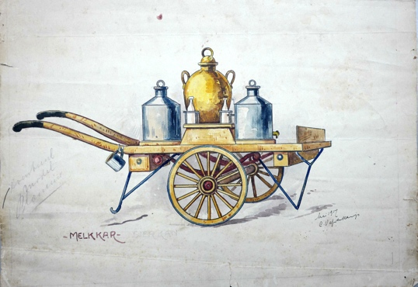

working drawing milk cart (1917) ^{BS}

With beach wagons, carriages, horse-drawn trams, and drawbridges, the assortment shifted ever further towards elite toys. Quality toys, beyond dispute, but also toys that were indistinguishable, if at all, from the many competitors.

The collaboration between these Sliedrecht brothers was evidently showing signs of wear and tear. In 1922, Hendrik Willem left the factory, settled as a carpenter/builder in Rotterdam, and Willem Adrianus Sliedrecht continued alone ^{SS} .
In 1923, the firm was (obligatorily) registered with the regional Chamber of Commerce.

1928
In the early 1920s, Waddinxveen was connected to the electricity grid of Gouda. The Sliedrecht company was one of the first in the village to receive an industrial connection. The factory invested by constructing a new factory hall (1930) and installing band saws and circular saws, machines that were noisy at the time and far from safe for the employees. Willem Adrianus and Jannetje went to live upstairs in the factory, a place that soon acquired the nickname “de Til”.

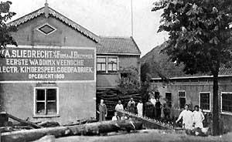

premises and staff at Zuidkade 229 (and 230) in Waddinxveen ^{FS}

The facade read : WA Sliedrecht formerly firm J. Bremmer, First Waddinxveen Electric Children's Toy Factory, founded 1850. During that same period and the early 1930s, the demand for (wooden) toys rose steadily. To meet this demand, production lines were set up in the factory.
Production lines where employees performed specialized operations such as machine sawing, drilling, and milling, as well as painting and assembling. Traditional craftsmanship transitioned to automation . Electricity for power and light was indispensable in this process.

At both Sliedrecht and Okkerse/OKWA ^{XX,} there was a shared conviction that good toys represent strength, repairability, and passability on to the next generation. The word 'sustainable' was not yet known at the time. The combination of production lines and sustainability meant that the artisanal woodcarving and painting, characteristic of early wooden toys, had to make way for robust, rectangular, uniform models. The charm of handmade toys was traded for efficiency, necessary for growth and survival. Unfinished oak gives way to steamed beech.

Box 3: Beechwood
The European beech reasonably yields wood of poor quality. The fibers are uniform, yet shrinkage of up to 15% occurs during drying. Untreated beech wood is not durable and unsuitable for construction. No, oak and ash wood were used for woodcarving.
It was known from early shipbuilding that wood could be bent after heating and retained its new shape after cooling. However, heat treatment drastically alters all the inherent properties of that same beech wood. In a so-called autoclave, beech wood is heated while humidity and temperature are closely monitored. Pressure plays no role in this process. Duration, however, does: the heat must penetrate to the core, so thick planks and beams lie in the autoclave for a few hours. After cooling, beech wood shrinks hardly at all, and the fibers lie stretched in the same direction. Most striking is the change in color: the wood, which was initially somewhat pale, is now light orange with gray lines. Moreover, the wood has become hard through a chemical process. So hard that when drilling, milling, planing, or sawing with a blunt chisel and at high speeds, scorch marks appear or a fire may occur. Steamed beech wood can be found in door sills, furniture, and children's toys because it is splinter-free. And it is said that beech wood absorbs the moisture from children's hands, creating that familiar warm feeling.
Over the years, the Sliedrecht firm has built up expertise in steaming soft, mildly toxic beech wood into grey-orange, human-friendly hard beech wood, as well as the subsequent machining. They referred to this as technical wood. By this, they meant the use of wood in composite structures. Composite, in this context, means: together with other wood species, such as in panels, or combined with steel or aluminium.
A wood processing company always has a point of concern: spontaneous combustion of wood residues and sawdust (wood dust), with the risk of explosion and fire due to overheating or a short circuit. Many wood processing companies have had to deal with this. The most well-known customer was timber merchant and window frame factory Houtex (Waddinxveen): they produced wooden window frames, while Sliedrecht supplied the accompanying beech wood sills.

In the late 1930s, the Great Depression began, better known as the crisis years. Toy sales declined, but the Sliedrecht firm managed to stay afloat thanks to the production of small household goods. That is how the factory, with its seven employees, managed to survive. And when the firm was left with a large consignment of yo-yos, the State of the Netherlands came to the rescue : a shipload went to Batavia ^{AS} . A gesture the government also made for the publishers of schoolbooks ^{PD} . A kind of development aid?

Even in those years, it was believed that a piece of wood should never simply be thrown away. After all, you need very little wood for a spinning top or a yo-yo. Father and the three Sliedrecht sons designed the toys themselves in the evenings and immediately figured out how they could be made. The first homemade machine dates from that time: a rotating drum with a kind of ecoline to color the ^{wood} .

Before the Second World War, toys distinguished themselves by their high quality, or call it design. Farm wagons, stagecoaches, dollhouses, drawbridges—everything large and executed to perfection. The finest products, such as farm wagons and coaches, were displayed in their own showcases and, above all, cherished. More ostentation than toys.

Director WA Sliedrecht had three sons: Pieter (1913-1976), Teunis (1922-1992), and Gijsbert (1925-2009). They all grew up in and around the factory and thus learned the habits now known as management skills. But even for them, there was little to do during the crisis years.

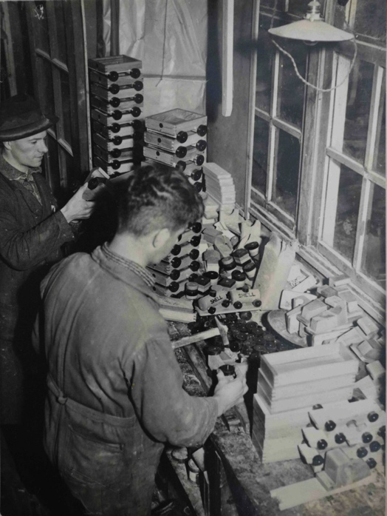
Pieter Sliedrecht at 'competitor' Plomp ^{FA}

To gain experience and perhaps also to save costs, Pieter worked for some time in the toy factory of the Plomp brothers. During the mobilization in 1939, Pieter was stationed in Noordwijk. There were no combat operations there. At the beginning of the Second World War, he returned to the ^{BS business} . All three sons went to work for the Sliedrecht firm, received a salary, and rose to managerial positions within the company over the years.

During the war years, sales declined and the availability of electricity was a cause for concern. Sliedrecht BV was allocated a clog quota, was thereby able to keep its machines running, and a threatened downsizing or closure of the factory was prevented ^{AS} .

It was known in small circles that work was being done in the partially dormant factory on a mahogany sailboat of the type BM16m ^{2 PS} . Not so strange, because even in wartime, alongside daily life, there was recreation on the water.

1942
In 1942, the then twenty-year-old Teunis was authorized by the subdistrict court through 'emancipation' to conduct purchase and sales transactions on behalf of the Sliedrecht firm ^{7.} This documented that he was of economic importance to the company. In all likelihood, this prevented him from receiving a call-up for the Arbeitseinsatz.

It should not go unmentioned that in those years the view was that the eldest son would become the new director. This was also the case at the Sliedrecht firm. It was not a topic of discussion that only the male members of this family business had control over the present and the future.

1945

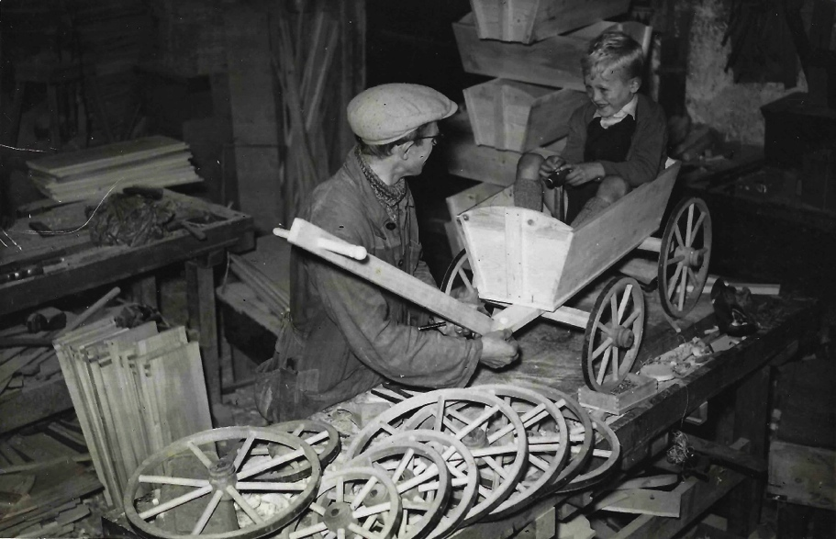

technical wood: the wagon, wooden wheels with a steel hoop ^{FA}
(source: Sliedrecht family archive)

Two or three years after the Second World War, the material shortage came to an end. Manufacturers and consumers discovered the possibilities of electricity and plastics. Working Nederland was confronted with what is now called leisure and recreation. And thus, there was interest, time, and money for technical toys. The Sliedrecht firm tapped into the home and recreation market with countless new products: shovels, wagons, beach chairs, camping tables and folding chairs, bridge tables, shuffleboards, billiard cues, often a combination of wood and metal. In addition, there was a wide range of equipment for the gymnasium, such as hoops, rings, sticks, and clubs. Despite lathes and milling machines, much of the work was done by hand: the wooden clog buckets, for example, were turned mechanically, sanded piece by piece, and dipped in a mixture of chalk and glue to make them colored and waterproof. Production time 50 minutes per item . In any case, the company grew and needed more space for production and storage. The fallow land behind the factory up to the ring canal offered prospects for this expansion.

1950
To mark the centenary, a series of carriages and farm wagons was put on the market. Handmade models, each one intended for a display case.
The same applies to one's own parlor.
Note: Unfortunately, the ceremonial room with all its models and the working drawings were lost in the fire in 1963.

Box 4: Site and factory
J. Bremmer established his company at Zuidkade 229 in Waddinxveen. The plot containing the factory and the house was of normal width and, above all, depth. The plot sloped downwards from the Gouwe to the Ringvaart. Approximately halfway along, the plot was crossed by the former Alpherwetering. A homemade wooden bridge connected the two parts. The old factory hall stood with its rear side, including the foundation, practically in this dead-end waterway . There was ample room for expansion. The hall for rough woodworking and the Romney storage shed were located on the opposite side of the site, right up against the Ringvaart. Internal transport of the wood and products was carried out using a trolley between the Zuidkade location and the Ringvaart. It is certainly worth mentioning: the Sliedrecht cousins loved playing with this trolley outside working hours because the sloping terrain allowed them to pick up speed . Who went the furthest?

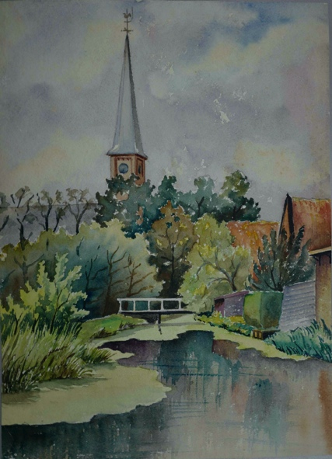

Alpherwetering (watercolor, Pieter Sliedrecht ^{BS} )

Standing on the bridge, the view to the right (north) showed the Catholic church. To the left, the grounds were empty. Well, empty? Cows and horses roamed around there. Later, a sawmill established itself there. New construction was needed for the expansion and modernization of the company. This new building arose behind the old factory and St. Jorisstraat and consisted of, among other things, a sawmill, metalworking department, paint shop, assembly hall, and space for offices and staff. When the municipality of Waddinxveen grew in the 1950s and needed space for the newly built St. Victorwijk, the waterway was narrowed somewhat and the drainage increased. The first part of the new housing estate was completed in 1957. The municipality of Waddinxveen purchased a strip of land from the Sliedrecht firm to extend St. Victorstraat to the south. This gave the second phase of the new housing estate its own connection to the Zuidkade.

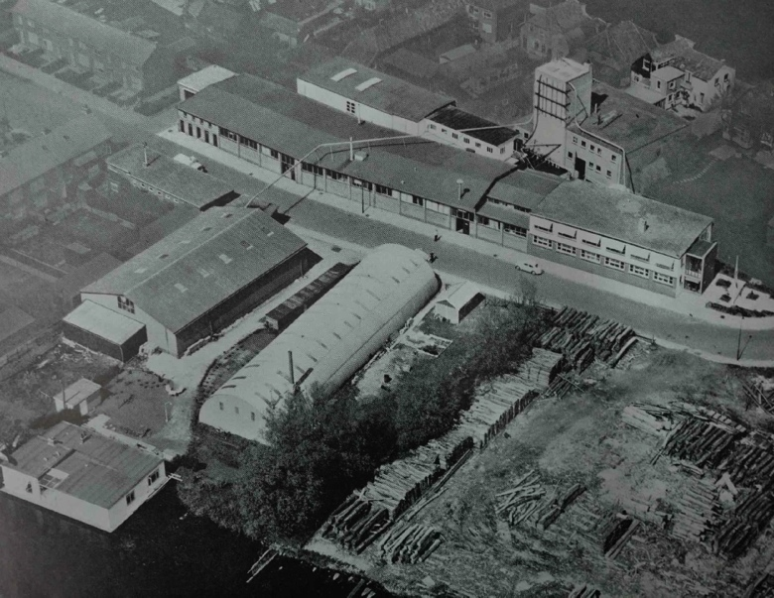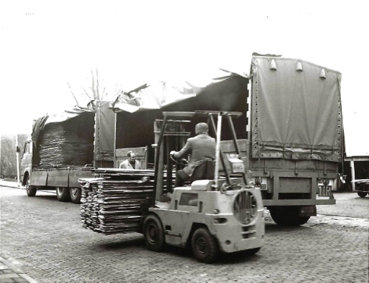

aerial photo of the company premises ( source BE, FA) loading and unloading in St. Victorstraat ^{FA}

St. Victorstraat thus cut through the company grounds. Consequently, the Sliedrecht firm gained a rear entrance. The trolley track disappeared; internal transport was handled by forklifts. Pipes across the road ensured the transport of sawdust, wood dust, and wood shavings to the silos on the old site. An oven for heating the entire factory stood there. St. Victorstraat became the new address for employees, suppliers, couriers, and buyers. From that moment on, St. Victorstraat 54 appears on all documents. Space became available in the old building for the drawing office, the archive, and the collection of proprietary models. Erve WA Sliedrecht continued to reside in the house at Zuidkade 229.

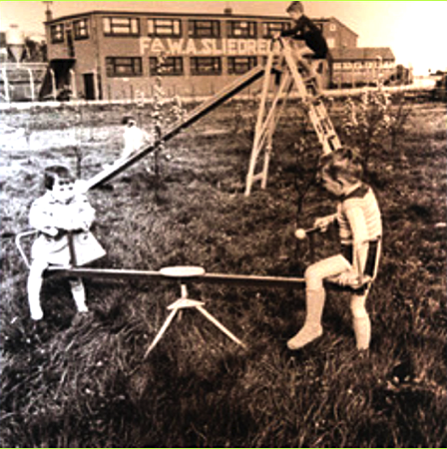
Sliedrecht playground equipment ^{FA}

Contact with the neighborhood and the neighbors was good: Teunis and Gijsbert made swings and other playground equipment for the playground association. In the 1960s, the Sliedrecht firm was one of the largest manufacturers of wooden toys in the Netherlands, with 30 to 50 employees (on peak days).

1953
registered with the Chamber of Commerce as WA Sliedrecht, Sportspeelgoedfabriek , CoC number 22256, with the designation 'founded in 1850'. The postal address is Zuidkade 229-230 , telegram address Sliedrecht, telephone (K1828) 393 with as Banker T. (Tobias) Goedwaagen and Sons (Gouda), founded as a broker/bank in 1849 ^{AS,FA} . Waddinxveen did not yet have a major bank in those days. It is plausible that WA Sliedrecht went to 'contemporary and regional peer' Goedewagen to arrange a loan or credit for the new construction. This bank was taken over by the Rotterdamsche Bank in the early 1950s and, in turn, ended up as ABN AMRO Bank (1991) via the AMRO Bank (1964).

1955
In the early 1950s, outdoor recreation began to develop cautiously . Tents on campsites became larger. Campers wanted to sit at a table on chairs, just like at home. Lightweight metal furniture, easily foldable and unfoldable for both adults and children. The Sliedrecht company saw opportunities in this growing market and adapted its product range and production methods. That sounds simple, as aluminium is a malleable metal, but the reality is different. Hollow tubes collapse when bent due to a lack of support. Gijsbert Sliedrecht devised machines, tools, and molds to bend hollow tubes and flat rods without severe deformation or breakage. In 1955, the Sliedrecht company launched its first series of garden chairs. Given the Sliedrecht company's tradition in woodworking, this can be considered a top-tier innovative achievement.

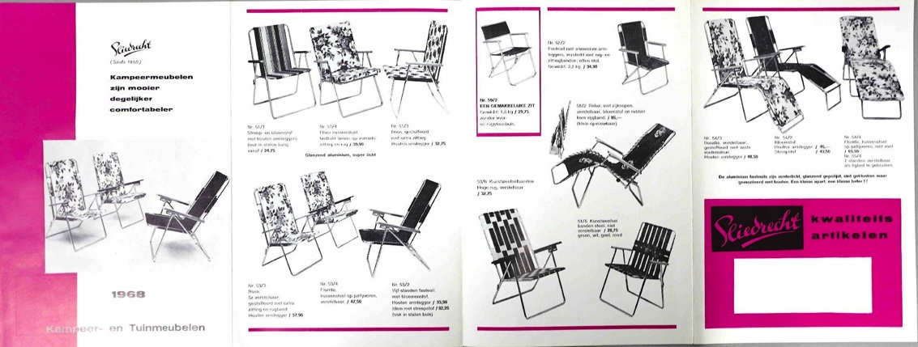

Folded brochure with camping, beach, and garden furniture ^{BS}

The assortment consisted of tables and chairs for the garden, camping, and the beach, a cot, a cooking table, etc. The weight is stated in the 1968 brochure. Some furniture fits in an aluminum carrying case.

However, when it comes to the metal industry, one country in Europe reigns supreme: (West) Germany. Before and during the Second World War, that country had gained experience in the industrialized smelting, casting, rolling, and bending of both steel and aluminum for its weapons. After the war, the Marshall Plan was put into effect in (West) Germany. The machinery and experience were utilized to expand the automotive industry. The construction of aircraft was and remained prohibited. The mechanical production of aluminum profiles and their incorporation into furniture must be viewed in this light as the relaunch of a dormant industry. Soon, (West) Germany brought affordable and easily formable aluminum to the market. Steel and aluminum products flooded Europe. It was inevitable: (West) Germany became the market leader in the European metal industry. Despite all its own inventions, the Sliedrecht firm could not withstand this competition. By the late 1960s, turnover had dropped significantly, and the Sliedrecht firm had to look for alternatives. But what? More toys?

1957
In 1957, a manufacturer of wooden toys in Billund (Denmark) launched a new construction toy: Lego. Red and white bricks on a grey baseplate. Many boxes, suitable for small and large constructions. As soon as teething problems such as drying out and discoloration were overcome and wheels were added to the system, Lego began its conquest of the toy world. Initially, Dutch toy manufacturers, toy chains, and toy stores paid little attention to this newcomer. Importer and wholesaler Hausemann & Hötte included one page of Lego in its door-to-door toy brochure in 1958. A year later, they began scaling down their wooden toys.

In Waddinxveen, however, everything revolved around the processing of beech wood, supplemented where necessary with metal and plywood. Management and staff held a strong conviction: conceive it ourselves, make it ourselves, and sell it ourselves. That is best for all of us. Everyone, family and employees alike, was proud of their company, their work, and their products. Children, nephews and nieces—everyone did paid holiday work at the ^{BS,PS} factory .

The years of Pieter, Teunis and Gijsbert Sliedrecht (1958-1981)

1958
The first change in management occurred in the late 1950s. The health of the founder, WA Sliedrecht, began to decline from the mid-1950s onwards. During that period, his sons Pieter ( 1914–1976), Teunis (1922–1992), and Gijsbert (1925–2009) took over the leadership and divided the tasks and responsibilities. Pieter, the commercial man, handled sales and the field service. Teunis, the man of wood, acted as operational director. Gijsbert was the man of creation and solving technological problems.

1961
WA Sliedrecht passed away in 1961. There was no doubt that the family business had to be continued, stating that there was confidence in the way the three Sliedrecht brothers were making the company grow and flourish year after year.

After the war, Sliedrecht BV had built up the necessary contacts with small and large suppliers of wooden toys in the Eastern Bloc countries. One of the major ones was Lorenz from Neukirchen (GDR), a manufacturer of wooden toys. The company still exists and is a supplier of, for example, Baufix and building block sets with small wooden cars.
Pieter Sliedrecht made an agreement during purchasing that the toys would arrive in the Netherlands unbranded and sometimes without boxes. In Waddinxveen, the toys were packaged and provided with a Sliedrecht logo in a specific way. A rough estimate is that 20% of the turnover was generated in this manner. ^{PS} . Back to Pieter Sliedrecht. From the spring onwards, he often drove to the beach accompanied by one of his children or nephews to first go with the pavilion- to update holders, and then—typical of his entrepreneurship—to take the order for beach chairs ^{BS,PS} .

Box 5: Transport
The first boxes were made using a screen printing technique. Large toys were packed and shipped in an unprinted box. Later, Sliedrecht also adopted full-color offset and cardboard packaging technology. The contents of the early toy boxes were illustrated with drawings; later, boxes featuring photographs of toys and playing children appeared. The management maintained a certain tradition in this regard. When management changed, at least the color of the logo was adjusted.

Both the E10 road system and the Europoort port system were for sale in all department stores and toy shops. Shops could place their orders directly by telephone at any time of the week. At the end of the year, with snow, and during Sinterklaas and Christmas, this could rise to a thousand orders per week. Sliedrecht had a large warehouse for the winter products. Transport companies/couriers such as Doelemans and Van Gent en Loos picked up the orders daily and arranged for delivery to the toy shops. ^{PS} competitor and colleague Okkerse/OKWA had its factory on the Wilhelminakade, the extension of the Zuidkade. It had its own fleet of vehicles for distribution.

The wooden Davos-type sleds were produced in East Germany, arrived by train at Waddinxveen station in the summer, and were transported to the warehouse by carrier Doeleman. Together with the company's own steel models, the sleds were stacked all the way to the rafters of the warehouse. And if there was snow, then this was a bestseller. Such a seasonal product, just like handcarts, had a problem: unfavorable weather and sales stagnated. No cash flow, but a drain on the company's ^{capital} .

1963 The Great Fire
The first major fire on February 19, 1963 , destroyed the stocks of packaged toys and cardboard. Unfortunately, it also destroyed the upper floor containing the offices and the family business's archives. The production halls and machinery could be saved. The damage amounted to several hundred thousand pounds. The grief over the loss of the company's own collection of wagons, coaches, warehouses, etc., was immense. In short, it was the pride of the company. But the archive containing the drawings and molds had also been lost. The company as a whole suffered a heart attack. The Sliedrecht brothers tackled the resuscitation with vigor.

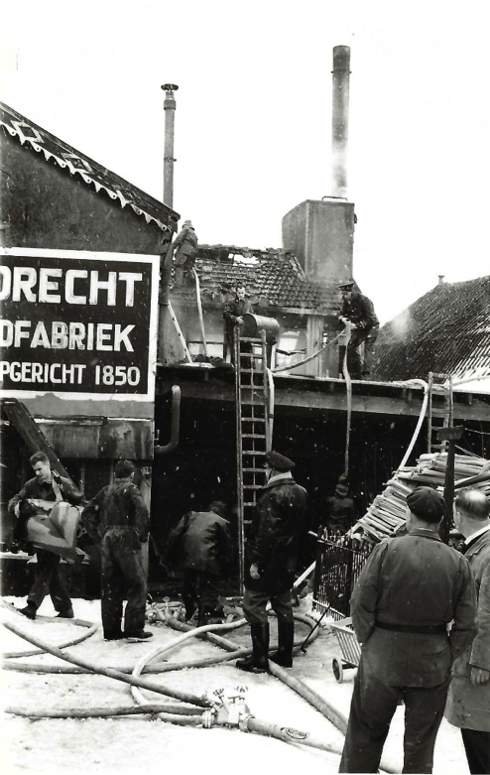

extinguishing the major fire in 1963 ^{FA}

Production could continue. At the new location, St. Victorstraat 54, diagonally behind the building at Zuidkade 229, a new office was built and furnished next to the existing warehouse. Through endless research and the necessary man-hours, the in-house collection of carriages was restored to its former glory as best as possible.
It was a crucial moment: the Sliedrecht firm went back in time, only to pick up where it left off: engineering wood, carriages, and beechwood toys. Crucial because precisely this moment—with the benefit of hindsight—could also have been used for innovation of the product range, similar to fellow manufacturer Brio. In the so-called sample room, where representatives and customers were received, display cases stood with salvaged and reconstructed wooden models. The glory was back, briefly.
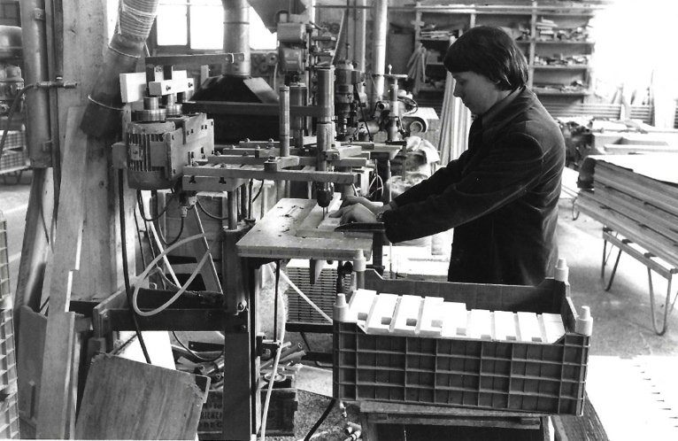

processing of steam-dried beechwood ^{FA}

In its heyday, the Sliedrecht firm employed thirty or more people, depending on the season. The atmosphere in the company was good; there was respect and cooperation, and the Sliedrecht cousins walked around freely. They often performed tasks and earned some pocket money in this way. On the other hand, this allowed them to grow up within the atmosphere and traditions of the company, as well as the Christian norms and values of management and staff.

As mentioned, the core of the company was engineered wood. This refers to wood that is used industrially 'somewhere' after drying and processing. For instance, thousands of beech wood thresholds were produced annually for the timber trade company Houtex. Another customer for engineered wood was Fisher Price. The Sliedrecht firm made the printed walls for their wooden dollhouses. ^{PS} .

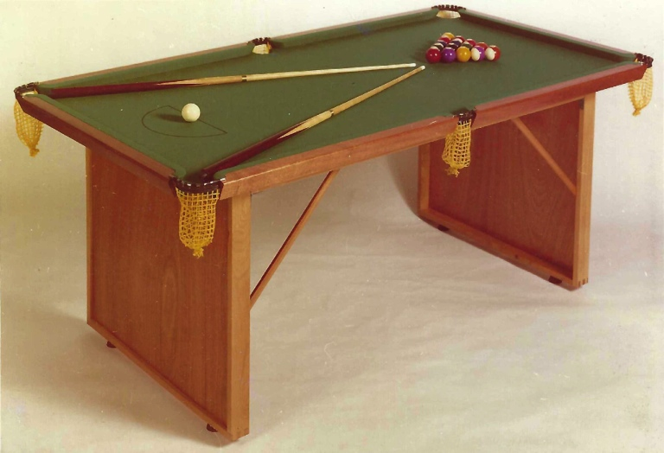

snooker table ^{FA}

Successful in-house products included beach chairs, shuffleboards, table billiards, and bridge tables, often made of wood in combination with aluminum. The commercial importance of toys was small, but it cannot be denied that there was a soft spot for toys within the management. Consequently, the toy assortment continued to grow steadily, all according to their own ideas and through their own efforts, admittedly. On the other hand, intricate (craft) work was outsourced to sheltered workshops in the surrounding area and the penal prison in Scheveningen. Materials for the gymnasium were manufactured in Scheveningen, including rope ladders. Curious, and this consequently led to questions in the Provincial Council of the ^{House of Representatives} .

1964
Given that the family business also provides a place for employees facing some barriers to employment, the decision to continue in this manner is understandable. However, conviction also played a role. The conviction that the company consciously chooses beech wood, a natural product for sustainable toys—or, you could say, for a better world. A world that you may leave to your children and grandchildren —stewardship according to the view of the Reformed Church.
Lego and Brio's switch from wooden toys to plastic did not change their minds. The Sliedrecht firm continued with beechwood. There was no reason for a change of course: according to the auditor's report by Dijker & Belt for 1963, the year of the great fire, the firm WA Sliedrecht Sport-Speelgoedfabriek had its finances in order ^{BS} . But a low doctor's bill is not a declaration of health. Studying the figures for 1962 and 1963—and that in the national perspective of economic prosperity—paints a different picture. Production costs are high, market share is declining, and the scope for investment and innovation is small. It appears that the Sliedrecht firm is on the verge of dropping out ^{PD} .

Box 6: Toy books
Most toy manufacturers had their own leaflet or brochure containing an overview and prices of their products. Hausemann & Hötte (Amsterdam) was a manufacturer, importer, and supplier of many European brands. In 1956, they were the first to produce *Het speelgoedboek* , a brochure that included all the brands they manufactured and represented. The brochure was distributed door-to-door in the larger cities during the month of November. Toys they did not represent were not included. Sliedrecht toys did not appear in their toy booklet. The house brand Jumbo was on almost every page. In any case, it was a treat for the children. It was as simple as that, and other booklets were welcome too.

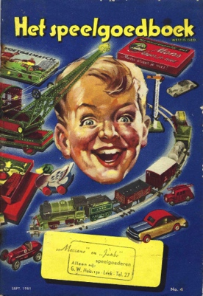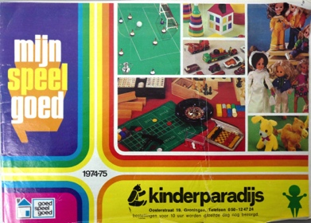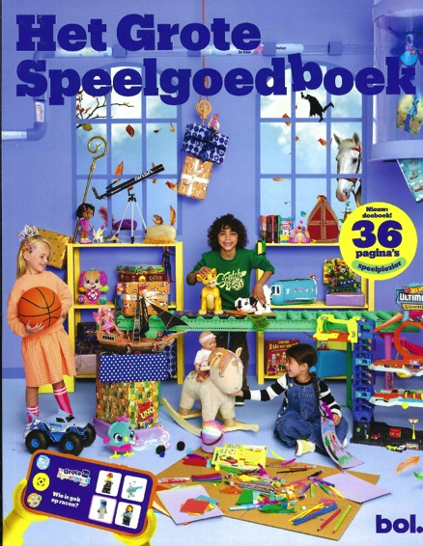

toy books from Hausemann & Hötte (1951), the Kinderparadijs and BOL.com (2025)

Other chains such as De Bijenkorf, Kinderparadijs, De Speelboom, Vedes, V&D, Wigwam, and later Bart Smit and Intertoys followed this model, yet differently. Suppliers had to pay for advertising space. Partly due to high rates, the toy chains gained a key position in what children could see and adults could buy. Moreover, with this invisible formula, the toy chains were able to profile their brochures and stores as traditional or contemporary. In doing so, they successfully seized power within the distribution channel. The many toy brochures placed side by side and one after another unequivocally show that the share of wooden toys declined after 1964. By the end of the 1970s, wooden toys had disappeared from the brochures.
Sliedrecht BV participated in this form of promotion for many years, but when the price became too high, they dropped out. Reaching the market (toy stores, children, and parents) under their own steam was the only option. In 2025, the toy catalog is still a link between manufacturers, suppliers, children, and buyers. Just somewhat differently. The BOL.com toy catalog, for example, is located at Albert Heijn next to Allerhande. It contains puzzles, sticker sheets, and QR codes that allow for direct ordering. It contributes to toy stores being slowly but surely cut out of the chain.

1965
It was to be expected that Willem Sliedrecht, Pieter's eldest son, would eventually become the new director. Not so strange; he was an entrepreneur in many respects. At a young age, he built a petrol-powered go-kart together with his uncle Gijsbert Sliedrecht and occasionally drove a lap through the St. Victor district behind the factory. On a more business level: Willem wanted to work, study engineering, and further develop himself in mechanical engineering . These thoughts and goals lay outside the family business . Willem and his brother Kees wanted to be independent of the company and go their own way ^{. And so it turned out: after} MULO -B and UTS, Willem went on to study at the HTS. He left for Canada in 1967 for his higher professional education internship. He liked it there .

1968
Something was going on. Willem Sliedrecht (1945), the eldest son of Pieter Sliedrecht, had in the meantime obtained his technical college diploma and had emigrated to Canada. From a distance, he had already foreseen that he would not be able to develop further as an aspiring board member . It should be noted that he was being offered the freedom to develop new products according to his own ideas . His younger brother Kees (1946-2025) likewise had no ambitions to play a role in the family business and emigrated to Australia for his own reasons. Pieter's two daughters were—as was perhaps customary at the time—not involved in the succession. In all reasonableness, there was nothing wrong; after all, the board was complete, and there were other Sliedrecht men around.

1969
Competition in the recreational and home markets was fierce. In interviews, both directors Teunis and Gijsbert Sliedrecht pointed out that toys from Eastern Bloc countries, China, Hong Kong, and Japan are the major competitors ^{4.} That is partly true. Toddler toys were produced in Eastern Bloc countries, and a tsunami of plastic and electrified toys came to Europe and America from Asian countries. In the late 1960s, a well-considered decision was made to generate more revenue from the production and sale of recreational furniture and wooden toys, and to be less dependent on technical wood ^{PS} . A brave and also daring decision, as Lego had by then begun its major European advance ten years earlier.

Box 7: competition?
An intermediate step: there are strong indications that Reijne en Zonen from Krommenie was the first to market the beechwood system of lanes, viaducts, and other models in 1971. Its name was simply Autobaan . However, due to reorganization and the closure of Reijne en Zonen's timber department, production was immediately halted, and this system never came to fruition in Krommenie.
Five years later (best reconstruction 1976), the Reyne Autobaan system finally came onto the market under their name shortly after the introduction of both Sliedrecht systems—now produced by Louwen in Nauerna (near Krommenie)—on the market ^{PD} . The system looks playful, fragile, and robust, has features of BRIO, and calls for attention and investigation. That research story can be read in Ellen-Wien Augustijn's Newsletter from August 2026. The conclusion is as follows: the road system from Reijne en Zonen BV was regionally available for a short time and was perhaps cheaper. The quality falls below the standard of beechwood toys and sincerely belongs in a 'Museum of Popular Industry'. All in all, not a significant competitor for the Sliedrecht ^{PD company} . Remarkable? Yes, that certainly is!

Back to Sliedrecht: where did the opportunities lie for the company, and which products needed to be developed? Jaap de Jong, who joined the company in 1955 as a technical assistant, had risen through the ranks to become a product developer and estimator for the Sliedrecht firm. He was familiar with the continuous improvement of existing products and production processes 4. ^{The} management gave him the freedom and trust to develop this wooden toy in consultation with Gijsbert Sliedrecht. The primary bottleneck is the scale. Wood is easy to work with, but its strength is quickly compromised. This trade-off often results in somewhat larger fantasy models. Manufacturers such as ADO, Fagus, Jukka, Jumbo, Lorenz, SIO, and Nooitgedagt, to name a few, therefore chose their own scale.
The second bottleneck is the level of detail. Due to the fiber structure, the possibilities for adding refinement to a wooden model are zero. Plastic, on the other hand, can take on any shape. Finally, and this applied to all manufacturers: wood cannot be electrified. The idea of a beechwood system of lanes and somewhat larger models that aligned with DINKYtoys and Matchboxes is explainable but not yet understood. Lego had overcome all its teething problems and grew explosively.

Box 8: The Royal Family
Waddinxveen is predominantly Protestant, has many churches and active congregations, and on King's Day the city turns orange. There is a connection with the Royal Family. In this day and age (2026), Willem Adrianus Sliedrecht would score highly as a networker/lobbyist. He had his contacts with the banks, the Queen's Commissioner, etc. Pieter and Tunis were no less impressive. In the early spring of 1961, HRH Prince Bernhard paid a working visit to Waddinxveen. A working visit during which 'follow-up appointments' were made immediately. When HRH Prince Bernhard turned fifty in June, he received a series of aluminium furniture for aboard his yacht Jumbo (Porte Ercole, Italy) from the Sliedrecht firm in the garden of Soestdijk.
In 1965, Queen Juliana paid a working visit to Waddinxveen. Twenty local entrepreneurs had joined forces for a single exhibition. The tour was accompanied by a brochure featuring a strong visual language on the cover: stacked rectangles in red and black. Bauhaus or Peter Struycken? Simply beautiful, and the brochure contained three pages about the Sliedrecht firm. That visit was followed up.

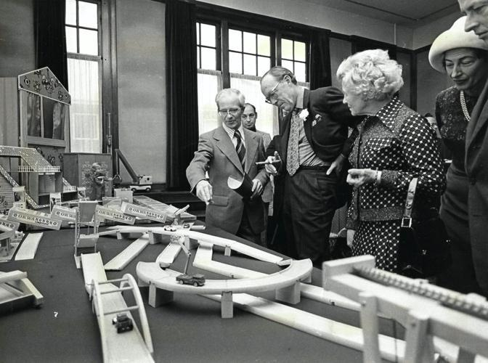

Working visit of Prince Bernard (source: Martin Droog, GC/AD)

During Prince Bernard's working visit to the factory in December 1974, the management proudly displayed the award-winning beechwood toys. This was remarkable, as demand for wooden toys was declining and the major Dutch toy manufacturers (ADO, Nooitgedagt, Jumbo) were ceasing production one after another. The designation of Purveyor to the Royal Household was not within reach: the company was leading, of impeccable character, etc., but the Bremmer years did not count.

1972
Back to Sliedrecht BV. No market research, no testing; Jaap de Jong and Gijsbert Sliedrecht sought a middle ground and developed the E10 Road System (1971) and the Europoort Port System (1972) based on their own ideas ^{5.} Apparently, they overlooked the fact that major brands such as Lego, Märklin, and Meccano included step-by-step instructions for building models in every box. However, Sliedrecht's boxes contained one and the same flyer, not a manual. What you could build, what you needed, and how to build it was left ambiguous.

Box 9: Market Development
When sales of beach chairs and beach beds rose sharply in the early 1970s without any promotional effort, the management of Sliedrecht conducted no investigation into the cause. Recent research shows that in 1971, the large Belgian furniture and toy manufacturer Torck in Deinze, with some 1,000 employees, producer of beach chairs and beach beds and their supplier of fabric for the covering of beach chairs ^{PS} had gone bankrupt ^{3.} Competitor Reijne en Zonen from Krommenie had meanwhile closed its wood department. These windfalls were not recognized by the management at the time, which seized upon the sales opportunities in Belgium for its own expansion. The small furniture manufacturer Louwen in Nauerna (Krommenie) was already producing some of Reijne's beach chairs and, due to this oversight, was given the opportunity to grow explosively.

Another development was the pooling of resources in the sales chain. Hausemann & Hötte held a substantial market share with its own Jumbo products such as Ganzebord, Halma, Mens erger je niet!, Pim Pam Pet, and Stabilo. Add to that the import and sale of Märklin, Meccano, DINKYtoys, Lego, and Schuco, and you have a true market leader.

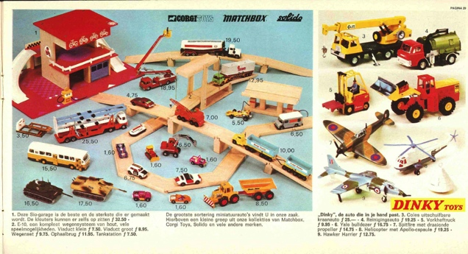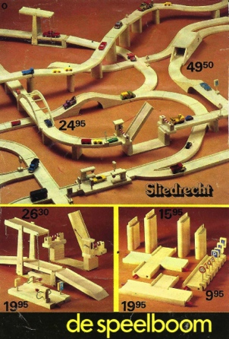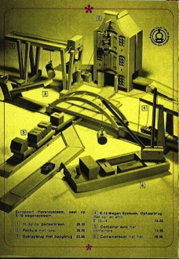

toy booklets: My Toys (1972), The Play Tree and Vedes (1974)

Large retailers, but smaller shops as well, did not sit idly by. They joined forces and copied the sales formula. An alphabetical list? Bart Smit, HoboFaam (later Intertoys), de Speelboom and Wigwam (later together Top 1 Toys), Toys 'R Us, Vedes, and even BOL.com. In any case, Hausemann & Hötte lost ground and continued as the games manufacturer Jumbo, known for the little red elephant. All manufacturers had to take a step back and supply whatever, according to the selling parties, had a chance of selling. A situation that is now considered normal with the rise of remote purchasing without seeing it first.

1973
The press and 'colleagues in the field' were enthusiastic: the E10 system and the Europoort Harbour System jointly received the Jaarbeurs Press Prize in 1973. The starting price was ƒ 17.90.
(€ 39.00 ) which indicated that the high-end segment was chosen.

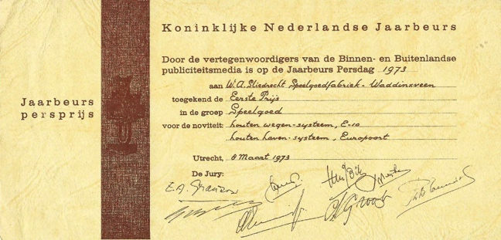

In 1974, the Goed Speelgoed Foundation awarded the Europoort Havensystem the title “Toy of the Year 1974, for preschoolers” ^{8.} It was noted that a remark was also made regarding the steep prices ^{PD} .

Gijsbert Sliedrecht built an installation based on his own design to store wood residues (dust, sawdust, and shavings) in a 14-meter-high silo and feed them in a controlled manner to an industrial heater. In this way, every wood fiber was utilized, and the company provided its own heat. On Sunday, September 16, 1973, a fire broke out in the silo of this well-thought-out system. Although the silo was located outside the building, in the event of a fire, or worse, an explosion, the damage to the company and the immediate surroundings could be extensive . The fire departments of Waddinxveen and Gouda deployed their equipment and expertise to reduce spontaneous combustion by sealing all holes and smothering the fire from above with sawdust. However, the temperature continued to rise. After three hours of unsuccessful cooling, the silo burst open on the west side. Extinguishing with water and preventing the fire from spreading was the only solution . The installation had to be abandoned. The company switched to 'modern' natural gas, a substantial increase in costs ^{XX} . Wood dust, sawdust, and shavings were henceforth stored and disposed of in smaller metal silos.

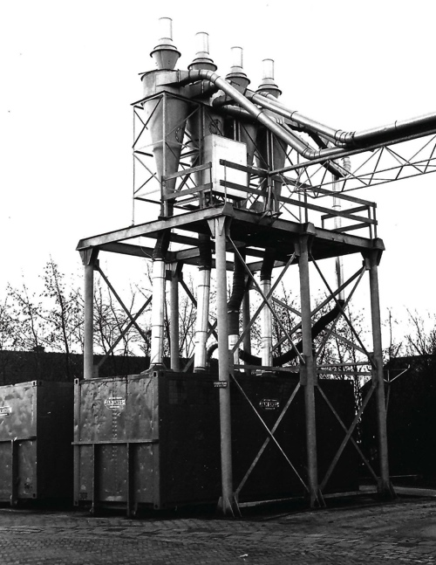

Pieter Sliedrecht sensed the changes in the market coming. Plastic toys, electronics, the influx of toys from the Eastern Bloc and Asia, and the increasing influence of toy chains on the selection in stores worried him. More than once, he voiced his apprehension about these developments within his family circle, concluding with, “Well, it will last my time.” ^{Not} a visionary, but certainly a well-considered cry for help.

1974
In 1974, it became apparent that the Europoort Harbour System had its fair share of limitations and flaws. The press's enthusiastic tone was not reflected in the sales figures. Against this backdrop, it is remarkable that Sliedrecht BV launched another system in 1974, namely Bouwbedrijf Delta. It is a series of six large wooden—one might even call them—designer models, in which the hands of Jaap de Jong and Gijsbert Sliedrecht can be found. Beautiful light beechwood toys for the sandbox. Where practical, metal parts were provided with the characteristic orange epoxy coating. These models must be considered elite toys.

Until that moment, the company was a General Partnership , a business form in which mutual agreements are made regarding the division of assets, rights/obligations, and profit distribution. Therefore, it did not have legal personality, nor required any notarial deeds. In complete silence, the General Partnership is ^{being} Sliedrecht Speelgoed BV split into three interconnected, smaller BVs, namely: Sliedrecht Beheer BV, Sliedrecht Vastgoed BV, and Sliedrecht Speelgoed BV. It becomes a structure of ownership and mutual leasing, a structure that changes little regarding operational activities and the financial situation.

1975
The Europoort Port System did indeed receive a high rating from peers in 1973.
'Toy of the Year', but sales figures were disappointing. Consequently, the management decided to phase out the harbor system and offer the best-selling models separately or incorporate them into the E10 Road System. This decision is understandable. Bouwbedrijf Delta, introduced one year later—a series of six beautiful wooden models—existed for barely a year and immediately went into a clearance sale.

BOX 10: Model Building
The two failed launches of attractive-looking wooden toys (the Havensysteem and Delta Bouwbedrijf) were certainly not reassuring for the company's continuity. The Sliedrecht firm set its sights on model building, the top segment of wooden toys, so to speak. The skills already acquired and adjustments to the machinery made it possible to work on a small scale. This led to the Sliedrecht firm supplying semi-finished products to Authentic Shipmodels (Amsterdam). The price list of Authentic Shipmodels, the leading Dutch manufacturer of ship models, shows that a kit for a large ship runs up to over two thousand guilders ^{PD} . That is a high price for a select group of wealthy elderly people; so, not a toy. Is that an alternative for continuity?

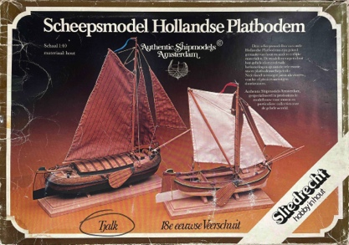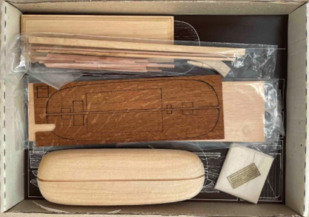

lid and box of the co-produced tjalk ^{PD}

Sliedrecht BV kept it simple and, in collaborative cooperation, brought a quartet of carriages to the market: a cart wagon, a play wagon, a glass carriage, and a farmer's chaise as model kits. Scale 1:10, everything accurately measured, including the Royal House's glass carriage. ^{The PS was measured} and detailed by the management. They themselves added six small ship models, a snuff mill, and a printing press to the assortment. New is the slogan: “ Sliedrecht , hobby in wood”. In 1981, these model kits also received the title 'Toy of the Year'.

1975
In the mid-seventies, Teunis and his sons Wim and Peter went to a German trade fair for mechanical woodworking. There, they purchased a four-sided planer with a matching crosscut saw. With this, they could produce virtually all sizes of wood (swing boards, thresholds, and even road strips) at high speed and with precision in a single operation, immediately followed by crosscutting. Finishing operations such as drilling followed afterwards. This represented a major step forward in automating the production process. Such a machine increases efficiency but also makes models and products somewhat more angular.
Creating curved lanes for the bends and junctions of the E10 system remained manual work. To this end, Gijsbert had devised a rotatable clamping device on the milling machine, a brilliant invention.

1976 (I)
Fellow townsman OKWA discontinued the production of its own toys in 1976 and continued for several years as a trading house. When Pieter Sliedrecht passed away unexpectedly in 1976, there was concern about the continuation of the company. To begin with, Pieter was a shareholder. This created an obligation to the heirs. Wim and Kees Sliedrecht, Pieter's sons, had in the meantime emigrated to Canada and Australia, respectively. How were the assets in the bank, or in real estate and machinery, to be handled to resolve this? But also : should the management be expanded to three directors, or would Teunis and Gijsbert continue together? A frantic search was undertaken for a successor or for adjustments to the organization.

1976 (II)
Following Pieter's funeral, Teunis and Willem ( Bill in Canada ) discussed with Pieter's son whether there were opportunities for future collaboration within or with the company. However, Willem (Bill) Sliedrecht had since started a family in Canada and saw no reason to return to the Netherlands and continue as a board member . Pieter Sliedrecht's daughters were not in the picture. Teunis and Gijsbert Sliedrecht were convinced of their potential to continue together. And, importantly, Teunis had three sons who might eventually be able to fill a management position in the family business . Things turned out a little differently. The eldest son, Aart, was pursuing university studies and did not participate in the company. The other two, Wim and Peter, on the other hand, did.
The investment in the four-sided planer and the crosscut saw was substantial. In addition, there was a financial and moral obligation to provide for the family. The company had a healthy cash flow but insufficient equity to finance everything itself. Conversely, the family considered the survival of the company more important than the money they might claim. A reallocation of personnel and resources was urgently necessary.

1976 (III)
To manage all of this effectively and prevent a recurrence of financial uncertainties and impossibilities, external expertise from the accountant and the bank was engaged. The entire company was thoroughly vetted. The valuation of the land, buildings, machinery, and tools is easily handled by an external party. However, the valuation of inventories, expected sales volume/revenue, cost price, and consequently the net present value of the company in the future, proved considerably more difficult. Consequently, that year saw a brief coming and going of appraisers, advisors, and accountants. This is not surprising, as the controllers and economists at AMRO Bank were monitoring developments in the society, looking at the toy world in particular, and thus at market opportunities. They observed that Lego had become a global brand in fifteen years. Wooden toys, on the other hand, were in decline according to them. In other words: according to AMRO Bank, profitable business in a niche such as children's toys and seasonal items was uncertain.
With this strong conclusion, their interest as house bank was at stake.
Eventually, years later , after a reallocation of assets, capital, and resources, a deal is reached with the bank. Land, buildings, and machinery were sold to the bank and ^{leased} back .

1977
Businessman Pieter Sliedrecht had a passion, namely: painting. His drive stemmed from reading books about art in general and painting in particular. No time for formal training, coaching remarks from fellow amateur painters aside. Pieter Sliedrecht sketched and painted landscapes, hundreds of them.

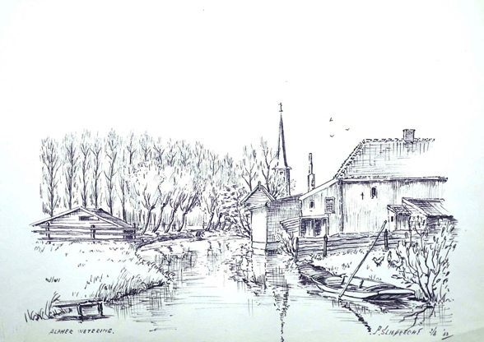
Alpherwetering, pen drawing by Pieter Sliedrecht ^{FA}

There were no sales; everything was given away to family members, enthusiasts, and business associates. He often captured the Alpherwetering behind the company. Posthumously, Pieter Sliedrecht received an exhibition of his work in 1977 ⁹ .

The original company continues under the name Sliedrecht Speelgoed BV. It soon became apparent that the high cost price, the mandatory repayment of debts , and the interest-
charges that it is indeed virtually impossible to continue the business in this manner. According to its own statements, the product range of Sliedrecht BV comprised 250 different items ⁸ . The accountants pointed out that by no means all products contributed to the profit.
It had not escaped the employees, and thereby many residents of Waddinxveen and the local press, that something was going on at Sliedrecht BV . There was uncertainty or unrest ^{FA} .

1978
The toy world received both a blow and a warning in 1978 when Meccano Ltd in England—the factory producing DINKYtoys, Hornby trains, Meccano sets, Triang cars, and much more global toys—went bankrupt. Sliedrecht BV continued undaunted but also with concern, focusing on the further development of its best-selling products, such as the E10 road system, on the one hand, and the discontinuation of low-sales products on the other. The product range shrank. By the late seventies, it was over and out for wooden toys—at least in the Netherlands—and success in the recreation sector declined, as did sales of gym equipment, wall bars, benches, etc., in the paramedical field. The accountant once again pointed out the uncertain financial results, the liabilities, and the complex financing, advising the involvement of third parties to restore the company's health. In an internal message to the ^{FA employees} , the management responded to reports from the outside world: there were no consequences attached to the changes within the company. After all, the three BVs had already existed in 1974.

1979
It seems that Teunis and Gijsbert Sliedrecht actually feel strengthened by the disappearance of fellow toy manufacturers. In the press and among colleagues, they hammer home the inferior products from Eastern European countries and Asia. They praise the educational value of Dutch wooden toys and believe they have a sufficient chance of survival. Even if they are the last wooden toy factory in the Netherlands, the thought remains: “just give us beechwood.”

BOX 11: Sliedrecht and the press
It must be said that, over the years, the management of Sliedrecht BV has found, maintained, and cherished its path to the press. Guests were received lavishly, and royal visits and award-winning toys were widely covered in the press and trade journals. Nevertheless, there were also critical voices regarding the play value of the wooden toys. Play value refers to the alignment of usability, price, and satisfaction. Factually speaking, nothing has changed regarding the quality of the wooden toys from Waddinxveen. However, the outside world has shifted into high gear. Moving toys from Japan, plastic toys from Denmark (Lego), and graphic toys from America (games) define the face of toys. Fathers and mothers, grandfathers and grandmothers achieve immediate success with children using these 'modern' toys.

In the *Weekblad voor Waddinxveen* of January 10, 1979, the management outlines the future in a cryptic manner: they expect sales growth through the expansion of the product range and new packaging. At the same time, the management points out that media attention for foreign products is leading to a reluctance regarding orders. This is followed, more or less, by a call to unite national forces for the sale of genuine toys made of honest wood .

In Food Magazine Special (1979), a magazine for small and medium-sized enterprises, the Sliedrecht directors state that they are proud to be the last Dutch manufacturer of wooden toys. They believe in the durability and strength of their products. Understandable from their perspective. But when, in that same interview, they suggest that buyers should be guided by the store regarding their purchase of responsible toys, it becomes clear that they have entered into a battle with reality. The versatile Lego had already set the standard for toys many years prior using plastic. That same magazine also contains an article about the declining demand for toys. A peculiar explanation is given for the waning interest: parents would rather spend money on a second holiday than on toys. In a subsequent issue of that magazine, advice is given to supermarkets and department stores regarding which toys they could offer: primarily small cars in blister packaging. Wooden toys are no longer mentioned. The Sliedrecht directors did not give up hope. Commercial director Wim A. Sliedrecht says of plastic toys: “ It has no life… it is dead toys, unlike wooden toys ” ^{5.} When sales stagnate in the early 1980s, attention is once again turned to the outside world. There is talk of a buyers' strike.

From the list of reports from 1979, it can be gathered that the management sensed and indicated that in a changing world, wooden toys in general, and the continued existence of Sliedrecht BV in particular, could indeed be put under pressure. The question of how to proceed arises once again. They were no longer alone in this.
Teunis and Gijsbert Sliedrecht held discussions with the AMRO bank regarding continuity. That went far, very far. A business plan drafted or approved by external parties was required to keep all the BVs afloat with cash .

1980
The major fire at the Homas games factory in Assen in 1978 plunged the company into significant financial difficulties. Homas, the number one manufacturer of shuffleboards, investigated during the reconstruction whether selling parts of its business would benefit its reconstruction capabilities. Consequently, takeover talks took place in 1980 with prospective buyer Sliedrecht BV. However, Sliedrecht BV also lacked the financial resources. A quick takeover was not possible (Homas was declared bankrupt in 1982) .
At Sliedrecht BV, there is a prevailing feeling at that time that toys and products for the domestic market need to become cheaper. When Sliedrecht steps into the Homas gap and manufactures shuffleboards from cheaper poplar wood, these remain unsold in the warehouse. However, sales of the more expensive mahogany shuffleboards do increase.
It must be said: Sliedrecht Speelgoed BV is looking for opportunities to increase turnover and raise the gross margin per product sold.

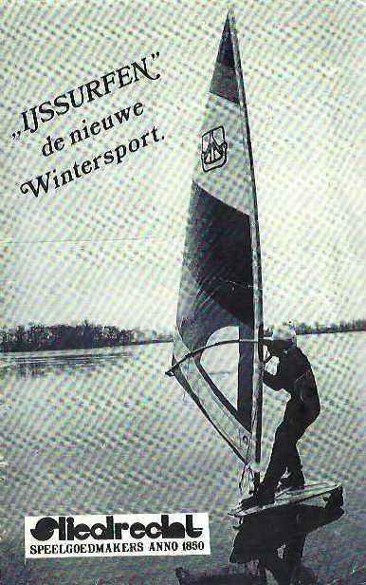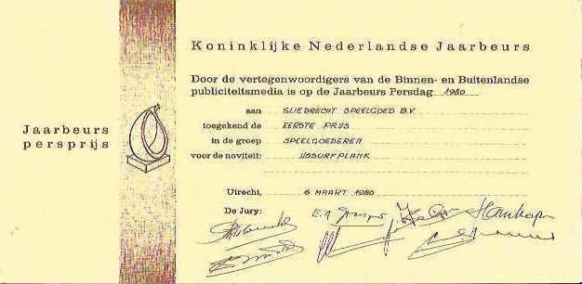

But look, Sliedrecht keeps wavering: a son-in-law points out a gap in the market: something for ice surfing . Gijsbert Sliedrecht gets to work and designs an ice surf board ¹¹ capable of reaching high speeds. Therefore, a brake has been installed as a precaution. They are gambling on sales through watersports schools that are quiet in the winter and on sales in countries where there are always icy winters. At the Spring Trade Fair of 1980 Sliedrecht received the 1980 Innovation Prize for this. After that, all trace is lost.

1981
The fire in the metal department on February 24, 1981, caused damage to the company once again. This time, wood was not the culprit. Due to overheating of the epoxy spraying system used for coating steel, the immediate vicinity of the system caught fire. During this fire, temperatures were so high that metals melted and machines were warped. Once again, many molds were lost ^{PS} .

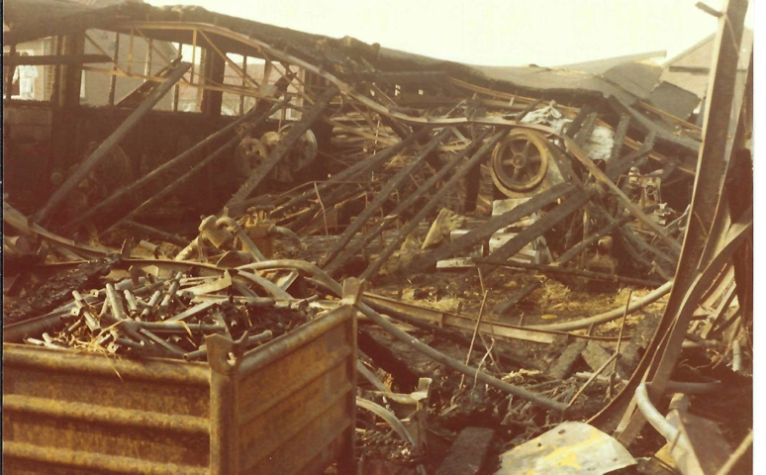
due to the high temperature, the steel profiles have their
lost strength and are folded over the machines ^{FA}

A quick rebuild and restart were therefore not an option. The employees made every effort to make the burned-out production hall accessible again, an effort that made no one happy. Production can continue by outsourcing the metalworking. However, this procurement contributes to a sharp rise in production costs. ^{PS} . What happens next?

On June 4, 1981, the management consultancy firm Van Dien + C0 (Utrecht) presented a report to Sliedrecht Speelgoed BV ¹⁰ , consisting of a sector analysis section and a recommendations section.
A few points from the industry survey:
- the market size tripled in the period 1970-1980, of which approximately half is due to better and higher-priced toys;
- the subdivision changes: fewer children and graphic toys (the designation of computer games) represent contraction and growth, respectively;
- The large department stores are seeing toy sales decline, the number of toy stores is also decreasing, and the retail chains from Bart Smit up to and including Wigwam together form the primary sales channel;
- well over three-quarters of purchases are made by older people for young people and, to put it more sharply: seventy percent of buyers are older than 24 years;
- the number of gift-giving occasions is increasing, the market size is growing, but sales of wooden toys remain the same or decrease;
- The market for wooden toys in general, and certainly that of Sliedrecht, is viewed as a niche with many one-off purchases (such as shuffleboards) without growth opportunities, and with limited possibilities to increase turnover.
- Price elasticity is high: people readily pay (especially in the months of November and December) for good quality toys;
- Supermarkets and mail-order companies (now known as webshops) are making efforts to sell toys for all seasons.

A few points from the recommendations:
- make toys for all ages and all seasons;
- make both expensive and cheap toys;
- streamline the offering and frequently come up with something new;
- search for new products for markets not yet entered (diversification);
- to expand the image of expensive/solid to something for everyone ;
- support sales with promotions and ease returns;
- Align the marketing and distribution with the supermarkets and toy chains.
Well, the above can be summarized as: take another good look at Lego.

This market exploration provided insufficient basis for improvements and changes. A project team was formed consisting of representatives from the bank, the government (RND, National Industrial Service), and Sliedrecht Speelgoed BV. All of this was done to qualify for a government guarantee. A period of intensive and inspiring discussions followed ^{(PS)} , with the observation that advising and facilitating a company is somewhat different from entrepreneurship oneself, taking risks, and hedging risks ^{(PD)} .
A Systematic Bottleneck Analysis (OW029) ^{FA will be conducted} . The analysis and recommendations are stricter and clearer on all points:
- revenue is declining, equity has disappeared;
- The selling price is based on the cost price increased by a certain percentage. In other words: the prices are not in line with market rates;
- Financially, Sliedrecht Speelgoed BV stands on the brink of collapse;
- the overhead (buildings, machinery, interest, liabilities) is too high;
- the ratio of indirect to direct personnel is skewed after layoffs;
- there are still opportunities in the short term, but swift action must be taken with a bridging loan (and guarantee);
- boost sales within two months, streamline product range, lower prices, critical inventory management, determine per department how the cost price can be reduced.
- To market the know-how regarding engineering metal and engineering wood (the non-toy products) and the availability of machinery for this purpose;
- And inevitably: a strategic plan and sales plan are needed.

The above is explained and elaborated upon in the appendix to the bottleneck analysis. It is striking that the option of 'stopping' is not mentioned in either report or recommendation, let alone elaborated upon.
The current management is disheartened after three fires and is looking for a way out, or rather: for a future. The intention to transfer company management to Wim and Peter Sliedrecht is being implemented at an accelerated pace. Wim attended the Higher Commercial School, was trained in the world of purchasing and sales by Uncle Pieter, and therefore already has several years of experience with the Sliedrecht company. Peter intended, after completing the MEAO ( Intermediate Economic and Administrative Education), to look for a job in healthcare. He soon abandoned that idea. After completing his studies, he also joined the company. He knew the ins and outs from the inside and wanted to support his brother Wim as well. ^{PS} . Strength in numbers is the motto. And so it happened. In ^{November} , the intended transfer of management was announced in many newspapers .

The years of Wim and Peter Sliedrecht (1982 -1984)

1982
With the bank's permission, Wim and Peter Sliedrecht became the new director/owners on January 1, 1982. The bank partially safeguards its interests by holding the young management personally liable up to an agreed amount in the event of improper management. The brothers face the almost impossible task of restoring the company to health. The newly appointed young management has Jaap de Jong as their mentor/coach—the man who joined the company at the age of sixteen, knew the entire business from the inside, and serves as operations manager.

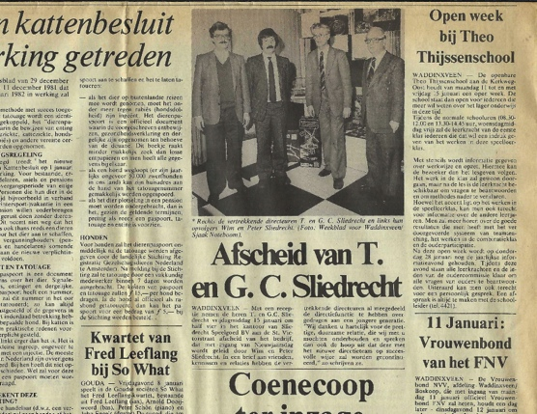

The Sliedrecht Quartet is in all the newspapers.

A press release in January ensured that the Sliedrecht quartet (Teunis, Gijsbert, Wim, and Peter) appeared in all regional papers and that attention was paid to the change in management ^{12.} The company was continued with ten employees. A driven team, willing to save the company. Unfortunately, one competence was still missing, namely that of market analyst.

Sales had to be boosted: an advertisement with substantial discounts appeared in the trade magazine Speelgoed+ Hobby ^{14.} Meanwhile, the young management, together with Jaap de Jong, made a strategic decision: cost reduction, innovation where possible, and improving the E10 Road System and promoting it as the spearhead of international growth. The horizon, or call it the deadline, for survival became the presentation of the revamped E10 Autobahn at the international and leading Nuremberg Toy Fair in 1983 ^{PS} .

Wim and Peter continue the established course of outsourcing and eliminating non-profitable products. The first result is promising: their own stand at the Toy Fair in Nuremberg (February 1982, Hall A4, Stand 2-06) ¹³ .
When comparing toy brochures, price lists, and order forms from different years, it is striking that over a period of 10 years, the product range is halved as prices rise. On the other hand, they aimed to break through internationally with, for example, the E10 Road System.

Financing is starting to become tight: due to repeated investments in short-term products ^{PS} Production costs remain high and the Gross Margin declines. Rent, repayments, and interest charges swallow up the profit. Profit threatens to turn into a loss. Further reducing the number of employees lowers costs but offers few prospects for continuation . That is why Peter and Wim Sliedrecht also made efforts to sell 'their' factory, or rather their concept, or to transfer it to Lundby of Sweden or Fisher Price, two toy manufacturers they knew as their customers for printed beechwood ^{PS} . There were discussions, there was interest, but to their disappointment, it remained as it was.

The management understands that, from an economic perspective, the toy market is indeed a growth market with strong purchasing power, but also a labor-intensive, displacement market. There is room for only one type of toy: plastic toys, to be precise, and you can only spend a guilder once. The same applies, of course, to a Euro.
This places their wooden toys in the same dead end as the German Anker building sets, the Dutch Mobaco, and the English Meccano. Thoughtful and responsible toys, but too slow and not challenging enough for children growing up with electronic or digitized toys.

The controllers at AMRO Bank had done their work thoroughly (exploring sectors and markets, the development of sales, revenue, profit, and rising production costs). There were doubts about the financial health of the company. The management frequently had to present invoices to the bank to demonstrate that the company was creditworthy.

1983
In the spring of 1983, Wim and Peter Sliedrecht drew up a survival plan ^{for FA themselves} . It outlined the disappointing results of 1982 and the lagging turnover of the first months of 1983. The operational company Sliedrecht BV was underwater, and the management wanted to keep the business going. Continuing production in an unfocused manner was irresponsible, so cost control was stepped up. The survival plan outlined interventions such as transferring machinery from one BV to another and applying for reduced working hours. How the downward trend in sales and turnover was to be reversed remains partially clear:
- continue producing wooden toys and wood engineering;
- continue with the sale of wooden toys, technical wood, and wooden model building.
The latter, wooden model building, is seen as the critical success factor in this survival plan. This niche in the toy market is a risk because although the price lists for wooden ship models show hefty prices , the number of enthusiasts is small. The collaboration with Authentic Shipmodels Holland BV is running smoothly and faltering due to a lack of resources.
In other words: there was no Plan B ^{PS} to change tack. What next? Let the debts mount until a creditor files for bankruptcy, or dissolve the company voluntarily? The granted reduction in working hours ^{(PS)} took some of the pressure off. The workforce is continuously being scaled down to ultimately nine employees, and that includes the two board members.
Discussions are entered into with the bank regarding the repayment of the business loan. The tax authorities are requested to defer payment of VAT, income tax, and social security contributions. Although the presentation of the revamped E10 Autobahn at the international toy fair in Nuremberg is achieved , this does not immediately lead to success and a jump in ^{PS} turnover . The December turnover for that year was disappointing. The results for 1983 remained below forecast.
1984
The annual figures for 1983 were negative in every respect. For the AMRO Bank, the limit of creditworthiness had thereby been crossed. And because, in their view, the profitable operation of Sliedrecht BV was now at stake, a letter followed stating that the credit was being withdrawn. The debt had to be repaid within a few days. ^{PS} . Strange. The AMRO Bank, the party running little risk in this restart due to the government guarantee, is withdrawing. Transferring the debts elsewhere or allowing them to accumulate was unthinkable. Bankruptcy was inevitable and inescapable.

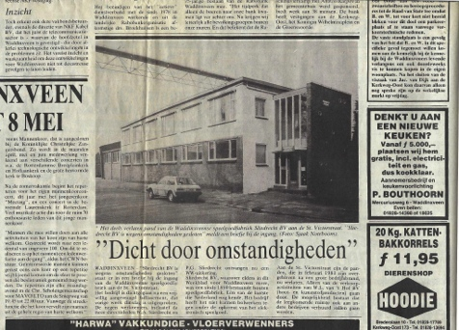
Weekly newspaper for Waddinxveen (March 14, 1984) ^{FA}

On March 3, 1984, Peter Sliedrecht—with mixed feelings—applied to the court to file for bankruptcy. ^{PS} . D. Hoedemaker from Waddinxveen was appointed as trustee.3 ^{This} was followed by a large clearance sale; small remaining items were distributed among family and staff. Auction house Troostwijk Auctions put the machines and tools up for sale. Whatever tools, materials, and assets remained were sold to a buyer at a price per kilo. House bank AMRO Bank still has a claim against Sliedrecht BV but refrains from holding both directors personally liable. Rightly so, because given their supervisory role over the years, there could be no question of improper management. After all, they were present during it.

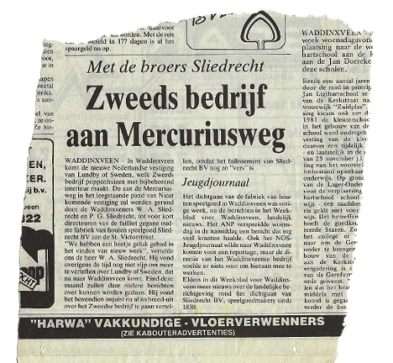

Shortly after the bankruptcy, there was a brief moment of confusion. The *Weekblad voor Waddinxveen* reported that Lundby of Sweden , internationally known as the maker of dollhouses, intended to establish a factory in Waddinxveen. Wim and Peter Sliedrecht were to become part of the management team. The report was premature , or rather, things turned out differently. Immediately following the bankruptcy, Wim and Peter Sliedrecht started the trading company Lundby of Sweden. This company merged into the toy retailer Veenborg BV in 1985, within a year of it . Wim Sliedrecht remained director of this company for several years. Peter Sliedrecht chose to pursue other work.

2026
It is spring 2026. The AMRO bank building has been demolished. The home of the first generation Sliedrecht (Zuidkade 229) has been replaced by new construction. The factory, the halls, and offices (Zuidkade 230) have been subdivided and converted for smaller businesses and residential homes.

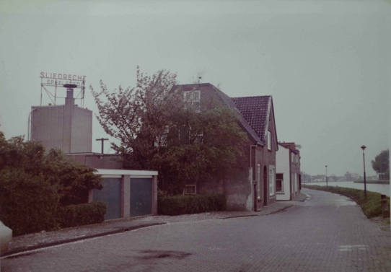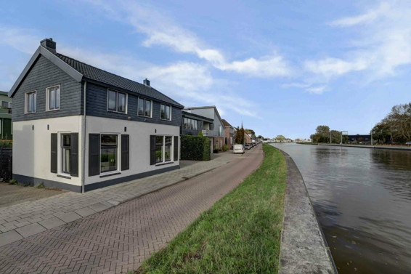

Zuidkade 230 (with silo) and house at 229 ^{FA} Reconstruction Zuidkade 229 ^{DM} ,

At that location, over forty years ago, Sliedrecht BV struggled with its survival. A company with ideals, with room for many and an eye for design, has gone under.

In January 2026, at the CES Electronics Show in Las Vegas, Lego announces that it has developed its own chip. A chip with light and sound , connectable to all kinds of Lego minifigures. Lego is becoming a game. This chip is housed in the familiar 2 x 4 stud building block. In this way, Lego has its own Smartbrick; with this, Lego stands with one foot outside the toy world. Uncomplicated wood has given way to a microcomputer hidden in a plastic building block. It is slowly becoming apparent that beechwood toys symbolize 'being just like the world'. Lego is the sequel for young and old.

Looking Back (2026)
Time for a look back. The question often arises whether things could have turned out differently. Then you have to weigh the strengths and weaknesses of the Sliedrecht company on the one hand, against the opportunities and threats in the world on the other. Well, the world? The world in which Sliedrecht Speelgoed has found itself. That is difficult, because weighing options and making decisions is human work, and making claims in hindsight without evidence can needlessly hurt anyone.
Here is an attempt anyway:
- No Dutch company played a significant role in the development or innovation of toys either after the First or the Second World War. The production and sale of toys were not taken seriously;
- After the Second World War, the economy grew in all dimensions. Leisure and mobility marked the beginning of the recreation market in the late 1950s. Given its competencies and network, Sliedrecht BV already had access to this market. However, the company limited itself to beach chairs and aluminium furniture. With tents, folding trailers, caravans, and motorhomes in succession, the Sliedrecht firm could have worked towards success and thus continuity. The management had its doubts ;
- For more than a hundred years, the management held the idea that there would always be a market for quality wooden toys. Innovative and competing products from all countries of the world were viewed with suspicion and treated unfairly for a long time . Charismatic leadership may have played a role in this.
- When, in the early seventies, the management realized that the company was falling behind due to declining results, it was in fact already too late for change. Too late because there was no longer time for product development and too late because equity had by then become insufficient to invest;
- The Sliedrecht firm has straightened its back three times after a severe fire. Kudos! Unprecedentedly emotionally and financially demanding. These moments of 'major change' were not seized upon to take a different path. Loyalty, conviction, or call it stewardship played a role in this;
- In the early 1970s, the management and employees made every effort on all fronts to make the best of it. However, the new products reflect more of what, in their own opinion, trying and persevering, rather than from a business perspective to undertake ;
- In the late 1970s, the major Dutch manufacturers of wooden toys called it quits and closed their doors. External advice to the management of Sliedrecht BV regarding its continued existence was insufficiently robust or incomplete: the option of ceasing operations was apparently not in the picture or was off the table;
- The fact that Sliedrecht BV continued for a few more years, driven by trust and hope, is telling. However, bankruptcy was inevitable. The bank forced it.
- For the sake of completeness, the following. The still successful BRIO has been split up, sold to/merged with the German Ravensburger, and is produced in China.

Sources:
(not yet complete)

⁶ Weekly newspaper for Waddinxveen, March 4, 1976
⁸ Weekly for Waddinxveen, November 30, 1977
² Weekly Newspaper for Waddinxveen, January 31, 1979

¹ Mixed Branch (PRODEHA TRADE MAGAZINE), second year, number 9, October 1950, pp. 146/147
² Algemeen Dagblad , Rijn en Gouwe supplement, May 10, 2003

⁷ = Dutch Government Gazette, October 26, 1942
⁸ = Professional Journal The Young Child , December 1974
⁹ = Weekly for Waddinxveen, May 11, 1977.
¹⁰ = Study of the market for toys, report Van Dien+C0 Organization (May 1981)
¹¹ = Waddinxveense Post January 29, 1980
¹² = Weekly newspaper for Waddinxveen, January 6, 1982
¹³ = Trade Magazine Toys + Hobby, December 1981
¹⁴ = Toys + hobbies, January 1982 number 1

Source, quote or paraphrase:
AS = Ali Sliedrecht (interview, wife of Teunis Sliedrecht)
BE = Exhibition Brochure (May 1965)
BS = Bill (Willem) Sliedrecht
BW = Bart Wiekart (the village of Waddinxveen, volume 25, no. 4, December 2017)
DR = Newspaper clipping via www.delpher.nl
KK = Newspaper clipping (source unknown)
LB = Lourens Bas et al. ( Toys from the Polder , Scriptum Books 2005)
PD = Peter Duijff archive
PS = Peter Sliedrecht
SS = Sarie Sliedrecht ( granddaughter of Hendrik Willem Sliedrecht )
SM = Regional Archives of Central Holland
WB = Wim Bol (correspondence in Bill Sliedrecht archive)
XX = Source 'under construction'

Photos with permission:
BS = Bill Sliedrecht
DM = Dupree Real Estate Agents
FA = Sliedrecht Family Archive
PD = Peter Duijff
PS = Peter Sliedrecht
XX = Source unknown or 'under construction', research initiated

Note: For photos where the source of the creator or rights holder remains unknown and continues to be unknown after investigation and unanswered letters or emails, XX is noted. See also the copyright clause .

© 2026 Copyright & Disclaimer article Toy Factory Sliedrecht

This article is made available free of charge to enthusiasts of vintage toys. The intellectual property rights to this article regarding the Sliedrecht toy factory belong to me, Peter Duijff. The derived copyright and image rights also belong to me. These rights entail that the enthusiast may use the content for personal use. However, nothing from this article may be reproduced, edited, stored, or made public without the prior permission of the rights holder, author, or photographer. This article is based on the Sliedrecht family archive and newspaper reports traced via www.delpher.nl , on interviews, and on email messages with family members. Sources have been cited where possible and meaningful. I have made every effort to determine whether there are rights holders other than myself and any mentioned author, photographer, draftsman, or illustrator. Nevertheless, it is possible that this research is incomplete. Anyone who believes that their interests have been violated as a result is requested to submit this to me with the aim of reaching a solution.

Peter Duijff
Schalkhaar, August 2026

