The E10 Road System

Introduction
This document discusses, in succession: the naming, the original E10 Road System, and the step-by-step expansion into the international E10 Motorway. The focus is on the structures, the contents, and the structural aspects. There is no certainty in any of this: due to in-house product improvement, outsourcing work to sheltered workshops in Waddinxveen and the surrounding area, and to the correctional facility in Scheveningen, many variations are possible. The road bridges, in particular, show significant differences. This document describes, step by step, the five editions of the E10 system and an intermediate period designated as 'experimental'.

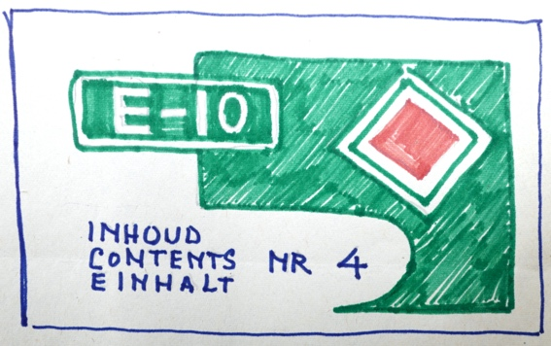

early sketch of the side of a ^{BS} box

It is noteworthy that Sliedrecht BV has consistently attempted to keep the dimensions of the boxes and the images on the front and sides as consistent as possible, assigning only a different number. Only the latest supplementary boxes had a distinctive appearance. The boxes (packaging) and parts that have appeared over the years are described in supplementary documents (PDF files). See the website for downloads.

The name E10
Until well into the last century, all European countries had their own system for numbering motorways. Topographically, Waddinxveen is closest to the A12—at the time the motorway from The Hague via Gouda, Utrecht, and Oldenzaal to Germany. Think of it as an east-west connection. The motorway from Groningen, via Amsterdam and Gouda to Paris—the north-south connection—was officially called the E10. Although situated a few kilometers away, Waddinxveen was therefore also located on the E10. And strangely enough, there was also an E10 high up in the north between Norway and Sweden. Amsterdam started construction of the only complete ring road in the Netherlands, the A10, in 1966. All of this caused confusion.

In 1985, the international routes were assigned their own white-on-green numbers. The white-on-red numbers in the Netherlands simply continued to exist. From that year on, the route from The Hague via Utrecht and Zevenaar to Germany became the E30. Amsterdam-Paris became the E19, Amsterdam retained its A10, and the old E10 was split into the A4, A13, and A16. And the motorway between Norway and Sweden retained its name E10.

Why did Sliedrechts BV choose E10 Wegensystemen at the time? After all, the A12 was also an option. The number 10 refers to top performance, and the E10 was located just a few kilometers away at the time—before 1985. The latest version of the E10 boxes featuring Autostrade, Autobahn , and Highway provides some insight into the intended sales markets, namely Italy, Germany, and England. In that context, E10 stands for international, neutral, and quality.

E10 road system

The first edition.
Assortment and contents. The first five boxes of the first edition of the E10 Roads system were launched in the early 1970s. Probably 1972, but an exact date is unknown. The lid simply stated E10 and a drawn landscape with lanes. The contents of the box were clearly indicated on the sides; a hyphen separated "Roads" and "systems." Heavy boxes, sometimes rattling, sometimes barely able to close. The boxes were all the same size and printing. Only a stamp or a check mark on the side indicated the contents.

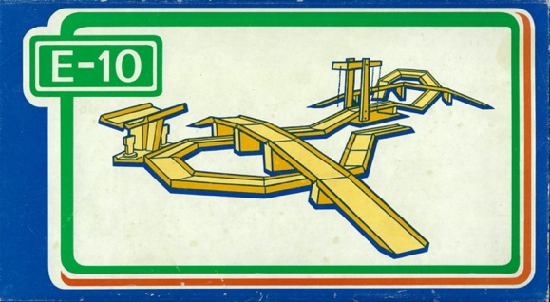

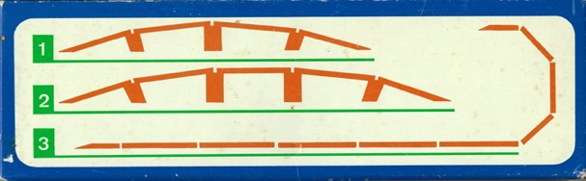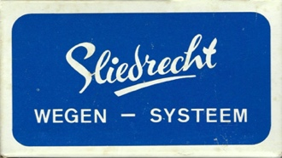

lid, front and side of the first E10 box (23.5 x 13 x 7 cm)

Three boxes contain a combination of straight or diagonally cut lanes. Incidentally, the Sliedrecht company itself refers to them as 'construction pieces'. These allow for the artful construction of a straight road or a curve. Pillars make it possible to raise the lanes to form a viaduct. Two boxes contain a model: box 4 a drawbridge and box 5 a pumping station (service station, petrol station).

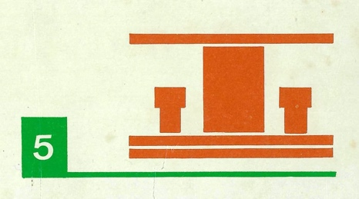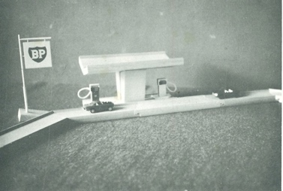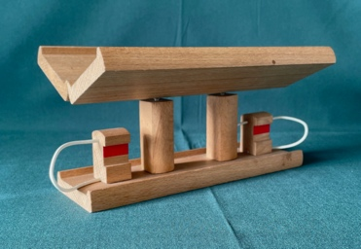

petrol station on the box (L), petrol station on the package leaflet (M) and service station as in the box (R)

Regarding the photos above, note that on both the first boxes and in the leaflet, the pumping station (gas station) features a robust wooden central block (console). However, this ' roof rack ' was not found in this configuration in any box . Apparently, this was a prototype that was replaced before production began by a roof with two pillars, each equipped with a metal Y-bracket. The roof itself consists of a single strip without holes. There are two versions: one with two 'curbs' and one with a planed 'curb'.

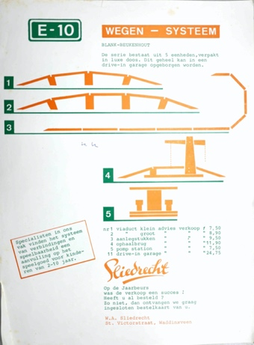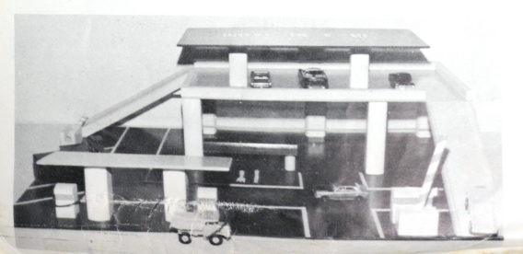

the first brochure and the first package leaflet with, among others, the garage with 6 pillars (1972)
There is also a brochure (flyer) included with this first edition. Here too, a petrol station with a center console is depicted. The contents of the five boxes are outlined, and out of nowhere, a pre-existing drive-in garage appears. This garage dates from the 1960s product range. The garage shown has six pillars supporting the parking deck; however, later models have seven. Therefore, it is unclear whether this garage was actually delivered in this configuration. At the bottom of this brochure, the sender is listed as WA Sliedrecht, but intended to refer to the Sliedrecht company.

Construction. The lanes are hooked together with a standing seam, a so-called crimped joint . This makes it possible to build a single street, a road network, or a street plan using the road sections. The dimensions of the road sections are on the generous side. As a result, the road surfaces slide away from each other with ease. A pity. The Swedish brio had this better organized with an eye (hole) and a flattened bollard in each case. The German brand Bino had a system in between: a bottom hook with a half-height bollard so that the lanes still lay flush against each other.

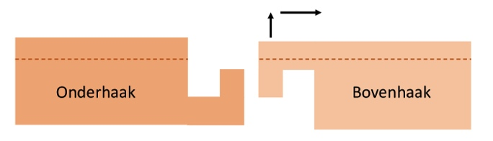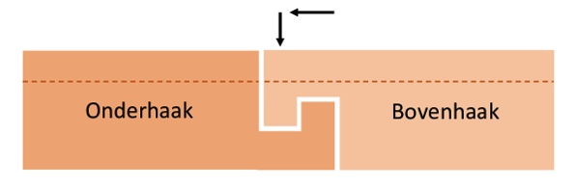
unhooked (crimped) joint hooked (crimped) joint

The turns . The turns look a bit strange. The lanes have been sawn off at a 45-degree angle, meaning the turns must be taken at an angle. As a result, normal toy cars like DINKYtoys barely make it through the bend. Strangely enough, or perhaps precisely for that reason, no cars are depicted on the 5 boxes. This is repeated in the enclosed leaflet, or it features small cars like Matchboxes that cannot pass each other, or can barely do so, and do not scale with, for example, the gas station.
Following the completion of the first five E10 boxes, an expansion was made with two boxes. Box 6 contains only straight lanes, and box 7 contains an intersection and a Y-junction. Both boxes are equipped with on- or off-ramps. These boxes are also considered part of the first edition.

Road width. In terms of dimensions, the new beechwood toys had to match standard 'mobile' toys (toy cars). Consideration was given to the cross-section (road width) of the road surface and the height of the models . That was not too difficult: Sliedrecht BV had three garages with wooden ramps in its assortment.

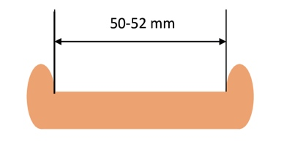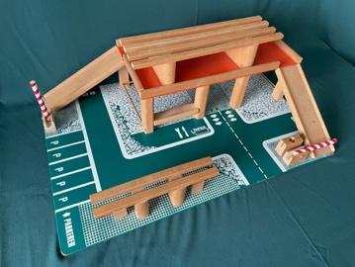

Cross-section of garage lane with entry and exit lanes

In his E10 design, Jaap de Jong thus opted for the existing road surface width of 50 to 52 mm. Sufficient space for one-way traffic with a DINKTtoys (width 35 to 40 mm), but just too tight for two-way traffic with two Matchboxes (together 48-56 mm wide). As a result, 'playability' is compromised.

The height . The heights of the gas station, the many bridges and cranes, and the clearance height of the viaducts intuitively correspond to the height of the DINKYtoys . The smaller cars, such as those from Matchbox , Kibri , and Busch, look meager against the sturdy beech wood.

In summary: the sizing seems to be aligned with the DINKYtoys , but smaller models are always shown on the boxes and brochures. Smaller models that can barely, if at all, drive past each other during play. As a result, playability is compromised.

The second edition.
Assortment and contents. It is 1973, the year the unrest of change begins. The assortment still numbers seven boxes, and according to the brochure, three E10 garages have been added. The orange-green leaflet in all boxes clarifies a few things, but not everything. Where did these garages come from, then? Were they ' connectable ' to the E10 road system? Are there two types of bends?

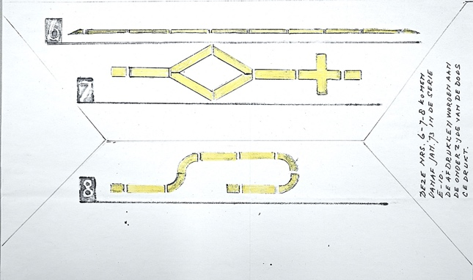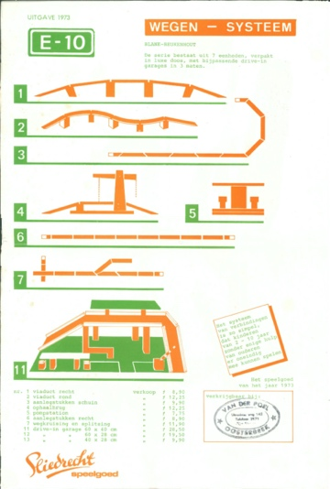

working drawing of the new boxes 7 and 8 ^{PS} folder with the E10 product overview

Indeed, there are two types of curves and garages cannot be connected to the road system. But there is more. The number of boxes is still seven, but that is actually quite different:
- the old box 1 (the short, broken viaduct, with 3 pillars) has been abandoned;
- the old box 2 (the long viaduct with four pillars) becomes the new box 1;
- the replacement box 2 contains 'round' bends;
- The new box 7 was supposed to contain a double Y-split, but it became a single one;
- There was talk of a box 8, but it never appeared.

Construction . So there is a new Box 2 with rounded curves on pillars. This is unusual, because it means the E10 road system has two types of curves: sawn-off strips and round-milled strips. Then there are the three new garages. These garages could not be connected to the lanes in any way . Existing Sliedrecht garages were likely fitted with E10 during a screen printing run to strengthen the supply. In summary: conceptually strong, a major step forward in the offering, but strange in execution. And unnoticed, the hyphen between Roads and systems has disappeared.

The experimental phase .
What follows the second edition can be described with the E for experimental. However, it is unclear whether this involves innovation, modification, or professional amateur work. In any case, the aim is to improve the connection of the lanes and to ensure a more secure support for the lanes on the pillars. But this must be done in such a way that the dimensions of the boxes remain the same and the old and new lanes can connect. There are two indications for this.

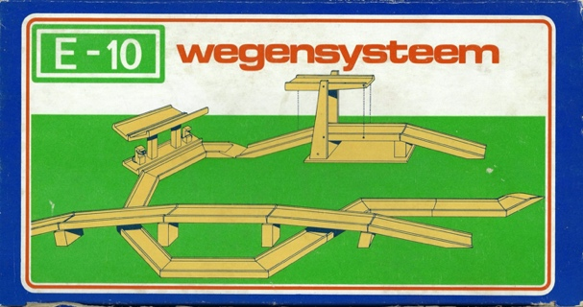

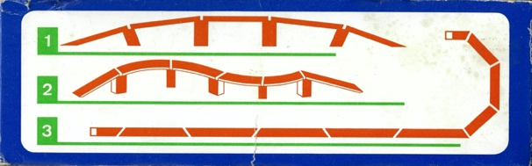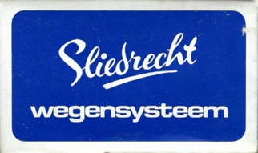

lid with horizon, straight and rounded curves (top) and sides

Instruction 1. The 5 lanes in the new box 1E are shorter (17 cm), thicker, have thinner edges, and feature a mortise and tenon joint with the pillars.

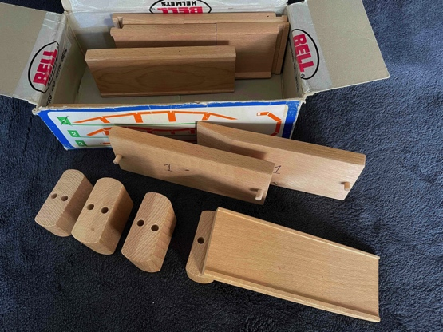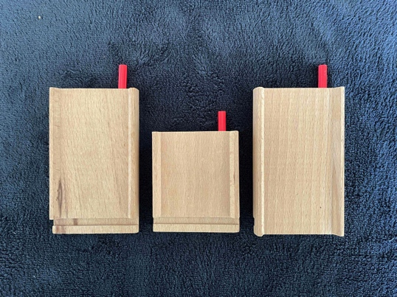

experimental viaduct with mortise and tenon joint transition pieces to the red plug lanes

With a diameter of 5 mm, the wooden pins are fragile . Consequently, this box has almost the same contents as the old box 2. Almost, because this box contains adapters for the updated E10 road system. That system is called E10 Autobaan and is recognizable by the red plugs.
Instruction 2. The familiar blue box color gives way to brown. The new 2E box contains five pillars, two on- or off-ramps, and, as a novelty, four rounded curves. The curves still feature the right-angle system of the first and second editions.

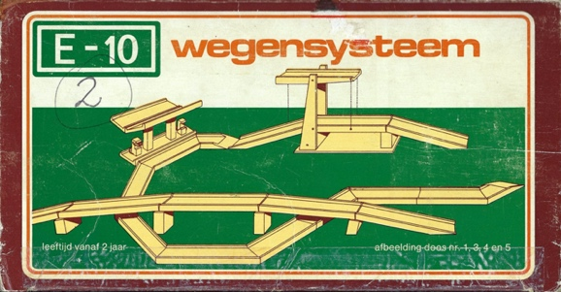

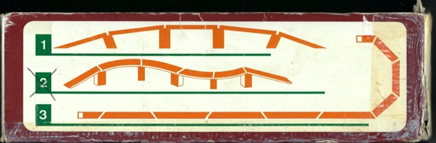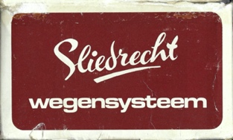

Blue becomes brown, with two extra adapters to the plug system.

These rounded bends are a real improvement: even somewhat longer cars can take the corner. Most remarkable is that two types of bends are depicted side by side on the instruction leaflet and on the side of the box: the rounded bends of the new 2E box and the sawed bends of the old 6 box. Well, confusing and strange. It is unmistakably the run-up to the third edition of the E10 system, the system with the red plugs.

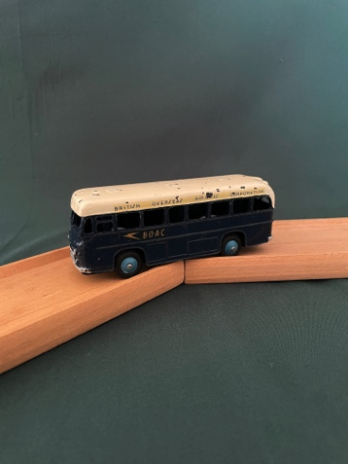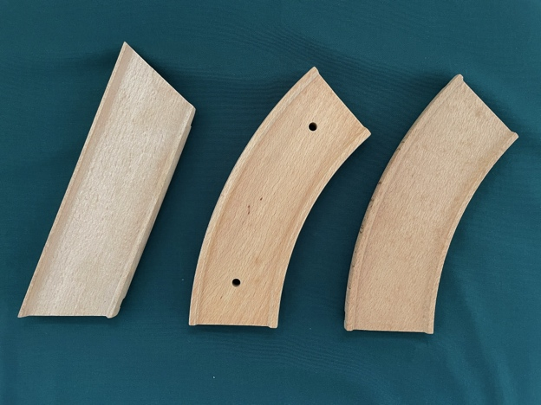

bus in the sawed-off bend sawn bend and the rounded bends with top hook

With a trained eye, it is visible that the road sections were clamped onto a jig and pulled through a milling cutter. To clamp the wood during milling, holes were initially drilled straight through the road surface. A solution was quickly found for this that kept the road surface intact. Measurements reveal that the radius of the rounded curves gradually increased slightly and eventually became one and a half centimeters larger.

Note: It cannot be ruled out that both the mortise and tenon joint and the new rounded curves were intended as prototypes and existed only briefly. By selling them without mentioning them anywhere, this nevertheless constitutes major changes to the connection system. In doing so, the Sliedrecht company contributes to the confusion surrounding the question of how lanes connect to each other. Moreover, the E-10 road system in its original version, that is to say with hooked road sections, existed for only a few years.

The third edition.
Assortment . In the mid-1970s, the E10 Road System was thoroughly revised. The new name became E10 Autobaan. A change of direction was necessary: the product range had to be visually stronger and clearer. The lack of success of the original road system may have played a role in this. The management and employees chose, with full confidence, to retain the concept and the strength of beech wood. However, they did adopt the idea from Lego or Meccano to work with an expansion model. Three green-brown base boxes (52 x 42 x 9 cm) were introduced, in full color and equipped with a hinged insert lid. In addition, a series of nine expansion sets was introduced. An “addition photo” on the inside of the lid shows how a base box can be expanded using expansion sets.

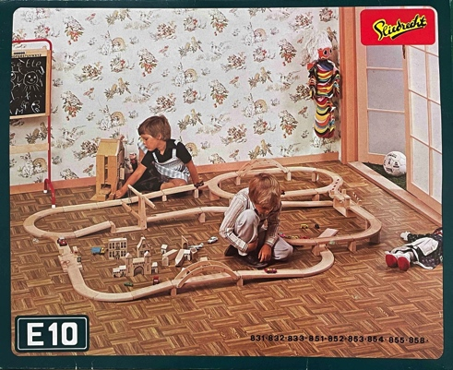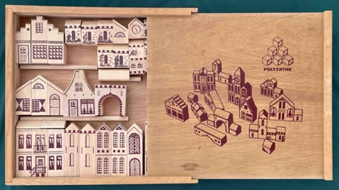

outside of insert lid Sliedrecht box with the block city

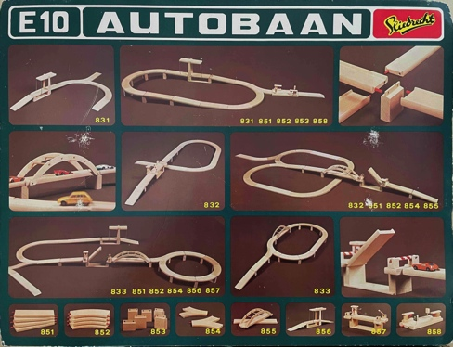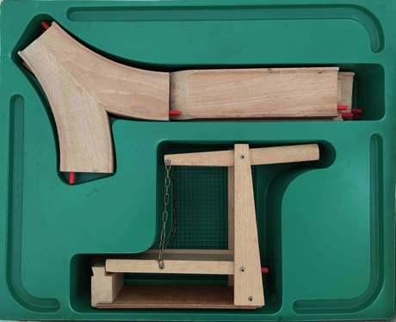

inside of insert cover tray with parts

The lid depicts children playing in a domestic Sliedrecht setting with a blackboard, a warehouse, and a block city. This might raise the question: do these attributes belong to the E10 Road System or not ? Not very practical, then.

The Sliedrecht logo is red with black 'brushed' letters in a yellow background.
Contents . The inside of the lid also served as a catalogue. The base boxes and add-on sets are shown, supplemented with three “addition photos” to illustrate what can be built, for example the base box with the drawbridge (831) supplemented with extra lanes, a viaduct and a petrol station (additional sets 851+852+853+858).
The garages are no longer shown on the boxes. They can still be found in the general product overview, but separate from the E10 Road System.
The beechwood parts lie in a green tray (pre-formed plastic compartments). Everything feels flimsy. Intact boxes quickly show signs of use. The add-on sets were also packed in flimsy cardboard boxes. However, the track sections and bridges varied in size and shape. This resulted in a few universal boxes (with padding material) and, for the add-on sets, many custom-made boxes. All of this increased production costs and shipping ^{costs} .

Construction. What stands out immediately are the red plugs and the raising of the road surfaces with rectangular pillars. Regarding that, the following:

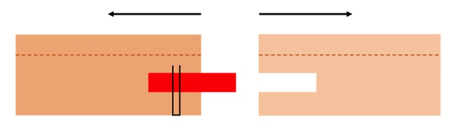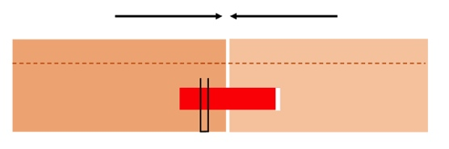
plug connection open plug connection closed

- The hooked connection between road sections has been replaced on the end by a red plug and a hole (diameter 6.10 mm). The red plug—from the construction industry—has been secured from below with a staple to prevent displacement. Glued dowels 40 mm long would have looked nicer; however, the wooden plugs could break due to prying and bending during assembly and disassembly, causing considerable disappointment. Plastic, on the other hand, bends with slight resistance.
- To connect the road sections with a hook connection from the old E10 system to the plug system, adapter pieces have been manufactured ( additional set 850);

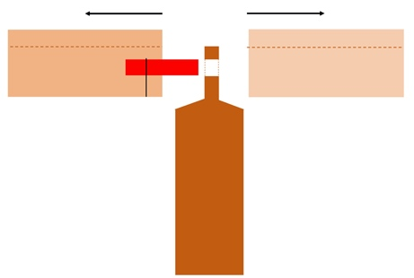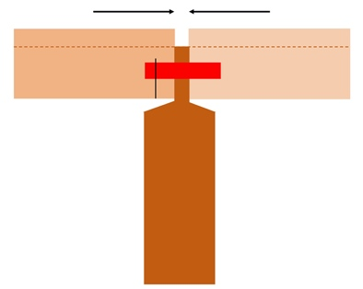
pillar with plug open pillar closed with plug

- It is possible to lay all road sections flat or to place them on pillars. This creates a 3D landscape with many roads on a small surface area. Beautiful to look at, that is for sure.

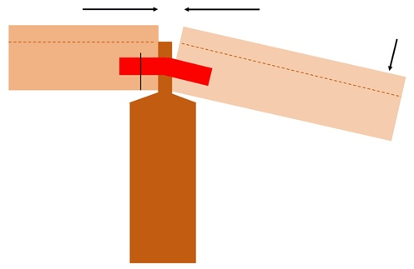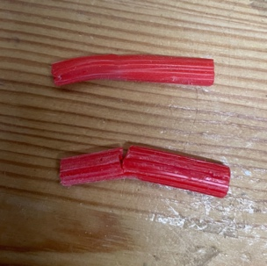

pillar with on or off ramp broken plugs

- The 3.5 and 6.0 cm pillars are fitted with two holes at the top through which the red plugs pass. Ramp ramps are required. The bend from horizontal to angled creates a gap in the road surface and puts the plug under pressure. With repeated insertion and retraction, and thus bending, drying out and crumbling occur under the influence of sunlight and age.

Note: the red plugs dry out, become less flexible, and develop brittleness, followed by breakage, under the influence of sunlight. The remnants of the plug are difficult to remove with an awl and small screwdriver. Hubo has mats with 25 red plugs in its assortment that are 5 mm too long. Cutting them off is not a problem. With some wood glue as a lubricant and a tap with a hammer, inserting the plug is not a problem. The diameter of this Hubo plug is, however, a problem: 6.10 to 6.20 mm. And some clearance is necessary for sliding the lanes in and out. Therefore, drilling out the 'empty hole' of the lanes to 6.50 mm is recommended for anyone who wants to build a track without problems. This drilling out also applies to original lanes, as the beech wood has shrunk slightly and many holes are drilled off-line.
The fourth edition.
Assortment and content . In early 1980, there was a change in management. Following a certain tradition, the logo was modified, now to sleek black letters on a yellow background.

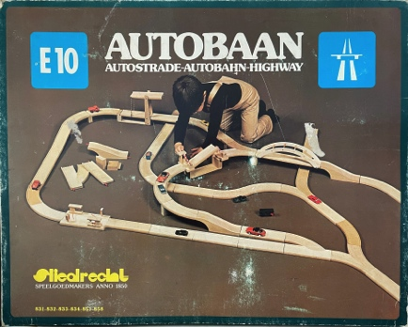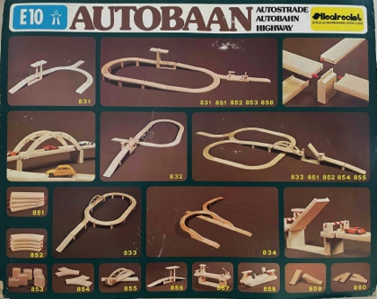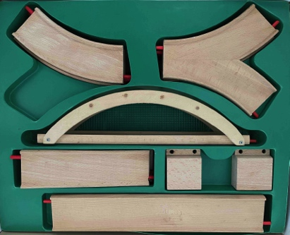

outside of lid inside lid tray with parts

The lid has been modified: the photo now shows only a playing child and the road system. The size of the base boxes and the add-on sets is the same as that of the third edition. The assortment has been expanded. New is base box 834 with a canal bridge and a right-hand exit lane. The overview on the inside of the lid shows that there are two new add-on sets, namely add-on set 859 with the two half canal bridges and add-on set 860 with two right-hand exit lanes.

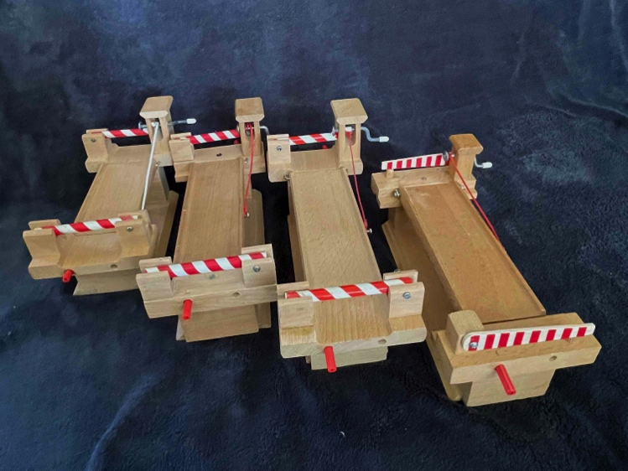

various lengths, various cross-sections and barriers

Variants . Just as with the Europoort Harbour System, it is striking that numerous variations appear in the finishing of the bridges in particular. Round and flat barriers, pins or screws, different lengths and widths of the lanes, glued joints or one or two screws, etc. No pattern can be discerned. That is correct. After all, the sawing and fiddling work, such as the assembly, was outsourced to the sheltered workshops in and around Waddinxveen. And if the model could be produced more economically or simply, it was carried out that way. The management of Sliedrecht BV had little to no involvement in this.

The fifth edition .
Introduction. It is 1982; the management needs growth and prosperity to improve its financial position. All attention is focused on the E10 Autobahn system. The basic boxes need to be expanded and have an international appeal. The goal is to present the new formula for the road system at the 1983 Nuremberg Toy Fair ^{PS} . That date is met.

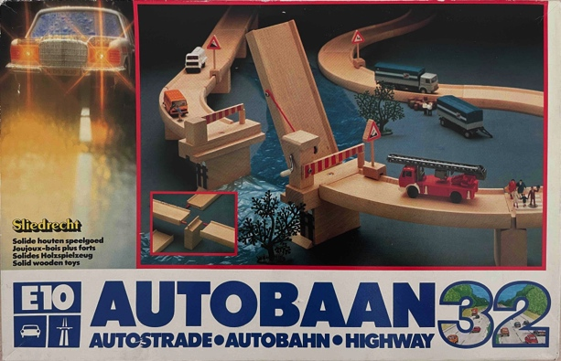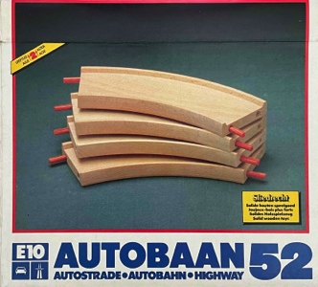

base box 32 (traffic bridge) add-on set 52

The base boxes are becoming smaller (42 x 29 x 9 cm) and the tray is being discontinued. The parts are placed loosely in the box. The lid gains more dynamism with the image of a Mercedes.
The expansion sets all come in decent, matching boxes. Here too, the front features a photo of the contents. Clear language: with large bold letters and sharp photography, Sliedrecht BV makes its ambition clear: contemporary, up-to-date, expandable toys of international appeal.

The assortment . The fifth edition of the E10 system, released in 1983, initially consisted of 4 base boxes and 15 blue and white add-on sets. New addition sets were add-on set 861 with a tunnel and add-on set 862 with an intersection and a T-junction. With this, the intersection, which had been included in the second edition, returned. The base box with the drawbridge (box 31) no longer appeared on the February 1984 price list. The four garages have completely disappeared. However, there is now the E10 airport named Schiphol. This airport has no lanes but can be connected to the E10 lanes using the red plugs. The airport also contains a blue airplane and a red/blue helicopter. Just as with the cars and traffic signs, the scaling detracts from the concept. It should also be noted that the management of Schiphol insisted in a legal letter that the lettering and logo be modified because the image rights belonged to them. Subsequently, Sliedrecht BV modified the screen printing ^{dies PS} . This means that two barely distinguishable versions of the airport exist.

Then a mystery. The leaflet for this edition shows supplement set 860 with one exit lane to the right and one to the left. The exit lane to the left was indeed in production, but is not shown on any box as a separate part or as part of the street plan. Nor is it known whether this exit lane had its own article number and price. Most likely, the original box 860 contained one exit lane to the left and one to the right. With the switch from boxes to shrink-wrap packaging (see Packaging), the choice would then have been made for two exit lanes to the right.

The contents. Each base box contains a small bag with: loose traffic signs, posts, and clips, all made of beech wood. With these, the motorway can be fitted with traffic signs. It should be noted that the width for through traffic is reduced by a few millimeters. The bag also contains small wooden cars with wooden wheels. These cars were purchased from the former East German toy manufacturer Lorenz ( Neukirchen ). For the photography, they sent a sample bag with five models: a yellow racing car, an orange truck, a blue passenger car, an orange bus, and a green ^{PS} tractor . The four non-agricultural models are shown on the side of the first international E10 boxes.

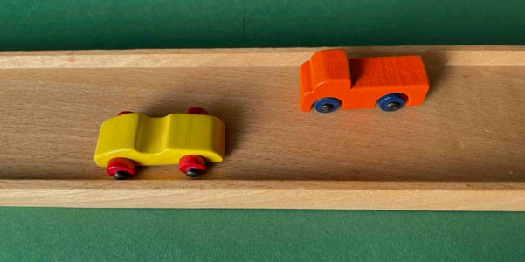

all wooden cars from toy manufacturer Lorenz ( Neukirchen , GDR) and the final models

That is misleading: only the race car and the truck were present in the bag. In duplicate, though, and that makes four after all. But look, in the subsequent and probably final production year (1983), this photo on the side of the box was replaced.
The miniature cars are gesiolite , a tumbling process also used by SIO and Simplex to give the wood a transparent, ecoline-like color. These fragile cars clash with the width of the road surface, and the traffic signs are oversized. The bag is completed with stickers to make the pillars and arches of the bridges more realistic. They are all fine sets, but the scaling of the lanes, the oversized traffic signs with fragile posts, and the miniature cars are at odds with each other. What raises another question is the height of the pillars. The increase in ride height of 3.8 and 5.8 cm was already known from the third and fourth editions, but now pillars of 9.0 and 12.5 cm respectively have been added. At 9 cm, the lanes are on the verge of tipping over. At 12.5 cm, one must really speak of instability. Nevertheless, it is a beautiful 3D landscape with roads towering high above one another. And F1 race enthusiasts know that at the Monaco circuit, roads also span one above the other.

Packaging . With the refill sets, Sliedrecht makes a remarkable choice: the stackable lanes are packaged in a much cheaper plastic shrink wrap through which the plugs sometimes protrude.

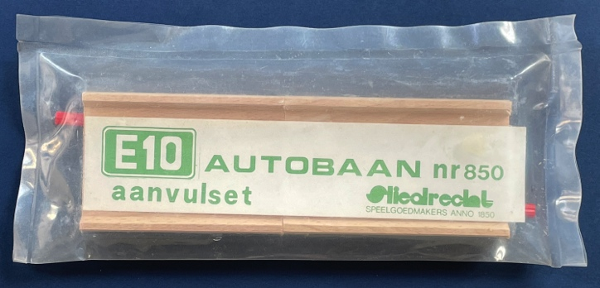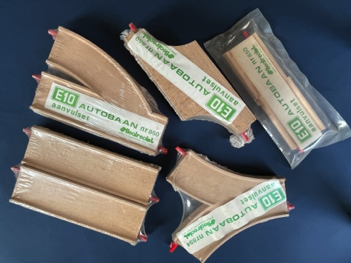

add-on set 850: two strips with a gradient from old to new various add-on sets

considered below par . A green printed strip of paper indicating the set number was enclosed. Extension set 850 contains two adapter strips: one from bottom hook to plug and one from top hook to plug. This allowed the new edition of strips (edition III) to be connected to the two preceding editions (I + II). The larger bridges and the petrol stations were packed in boxes.

Grey plugs . In late 1983, the grey nylon plug also made its appearance. These grey plugs have a diameter of 5.8 mm, making them undersized for the 6.0 mm holes. Consequently, the plug can slide in and out. Furthermore, due to the absence of a screw, the wings of the plug do not spread. To prevent the plug from moving, a metal staple has been fitted here as well.

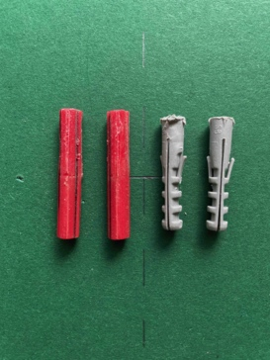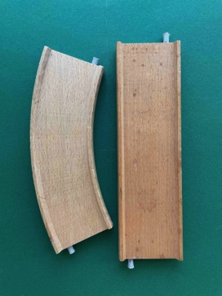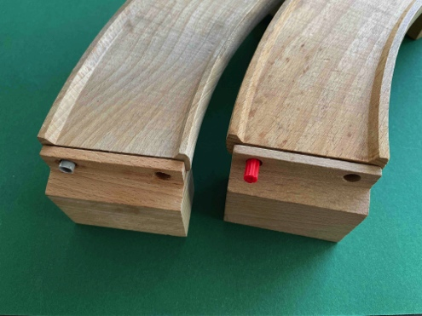

The grey nylon plug does not protrude enough at an overpass.

These Fischer S6 plugs have a length of 30 mm, making them 5 mm shorter than red plugs. This causes hardly any problems for flat lanes, but for lanes on pillars, it is definitely too short. So, not a solid and stable solution.

The legacy . Product and assortment on the one hand, and marketing and sales on the other, could not keep the company afloat. As the last Dutch post-war manufacturer of wooden toys, Sliedrecht BV closed its doors. In March 1984, the management filed for bankruptcy of Sliedrecht BV with the court. Staff were dismissed, and the machines stood idle. The bankruptcy trustee proceeded to sell the stocks of wood, machines, and tools. Everything that remained, including the molds used to make the road lanes, went to a buyer.

If now, more than forty years later, we look at the toy catalogs from Bart Smit, Blokker, BOL.com, Faam, Intertoys , de Speelboom, Goed Speelgoed, Hema, Marskramer, Top1Toys, Toys 'R If one looks at Us , Vedes , Vroom & Dreesmann, and Wigwam, there is only one conclusion: Sliedrecht BV, with its E10 concept, was the first provider of a road system. Lanes, single and double, made of cardboard, plastic, rubber, felt, and beech wood—everything is readily available for purchase in 2025. However, with the exception of a single bridge, there are no viaducts, pillars, garages, or airports.
That was Sliedrecht BV, that is in the past.

©2026 Copyright & Disclaimer of the article The E10 Road System

This article is made available free of charge to enthusiasts of vintage toys. The intellectual property rights to this article regarding the wooden track system of the Sliedrecht Toy Factory belong to me, Peter Duijff. The derived copyright and image rights also belong to me. These rights entail that the enthusiast may use the content for their own personal use. However, nothing from this article may be reproduced, edited, stored, or made public without the prior permission of the rights holder, author, or photographer. Where possible and meaningful, sources have been cited. I have made every effort to determine whether there are rights holders other than myself and any mentioned author, photographer, draftsman, or illustrator. Nevertheless, it is possible that this investigation is incomplete. Anyone who believes that their interests have been violated as a result is requested to submit this to me with the aim of reaching a solution.

Peter Duijff
Schalkhaar, May 2026

