Construction company Delta
Designer toys for the sandbox

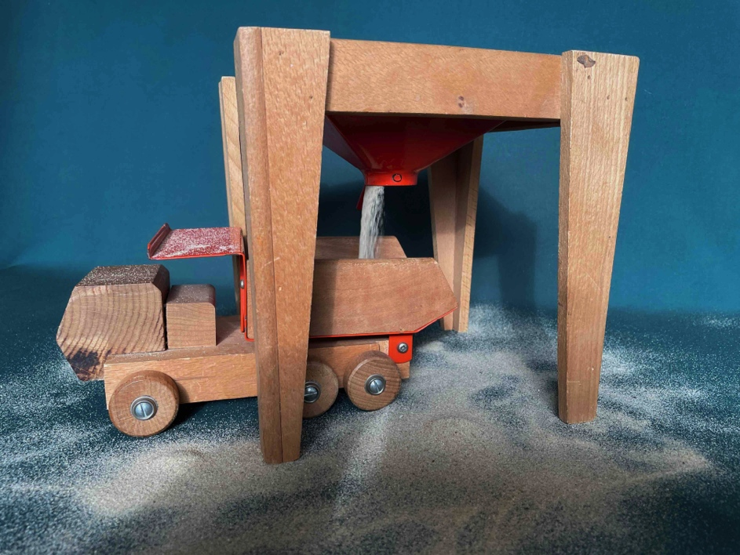

Sand hopper in operation with the dump truck underneath

Short history

In late 1972, early 1973, Sliedrecht BV (Waddinxveen) launched the E10 Road System, immediately followed by the Europoort Port System. The history of this beechwood toy can be found in the Newsletter of April 14, 2025*. A few lines in that article are devoted to a derivative product: Bouwbedrijf Delta , a series of six beechwood models for construction and infrastructure engineering (earthworks, road and water construction). An active researcher has tracked down all the models, leading to the following reconstruction.

In 1974, less than a year after the introduction of the Europoort Havensysteem, Sliedrecht BV released additional models, including a container truck with a semi-trailer and a trailer. A characteristic feature is the cab, which is pentagonal when viewed from the side. The Europoort Havensysteem itself thus consisted of seven models. Despite many positive reviews and awards, the Havensysteem was not a success. The lack of matching miniature cars may have played a role in this. To remedy this, four wooden commercial vehicles were hastily released: a crane truck, a tow truck, a container truck, and a stake truck; all models were equipped with this Bauhaus-style cab. It was to no avail; sales stagnated. Production was halted, and the beautiful arched bridge moved to the E10 Road System. Against this backdrop, it is strange that six beechwood models were nevertheless produced in 1975 for playing in the sandbox or in the backyard. The Name? Bouwbedrijf Delta . This article is about these six sleekly styled models.

source: Newsletter April 2025 ( publication by Ellen-Wien Augustijn)

Box, package leaflet and price
The four models with a boom were packed in a flimsy cardboard box featuring orange/dark green printing. One sentence on the box and the leaflet raises eyebrows: 'This series is a supplement to the plain beech toy Europoort harbour system' . Strange, because the scale of the Europoort Harbour System was approximately 1:87. With Delta Bouwbedrijf, it is approximately 1:35, making the models all feel oversized.

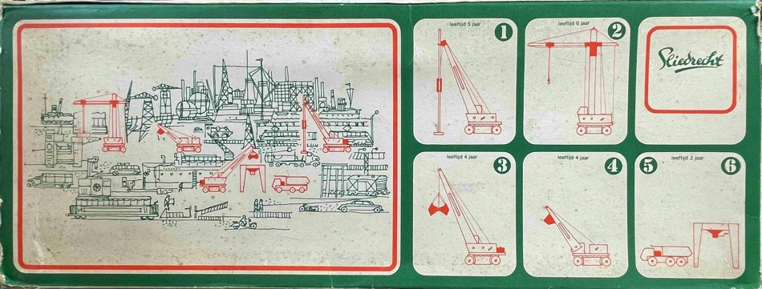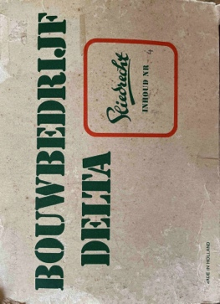

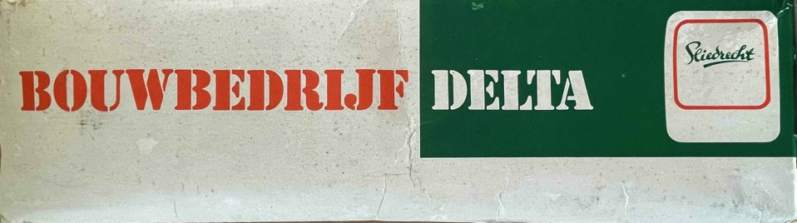

top of box with two sides

Due to their non-standard size, the dump truck and the sand hopper were placed on a piece of printed cardboard and slid into an elastic net, similar to the net used for mandarins or shallots. A cheap, not very solid method of packaging that Sliedrecht had previously used at the Europoort Port System.

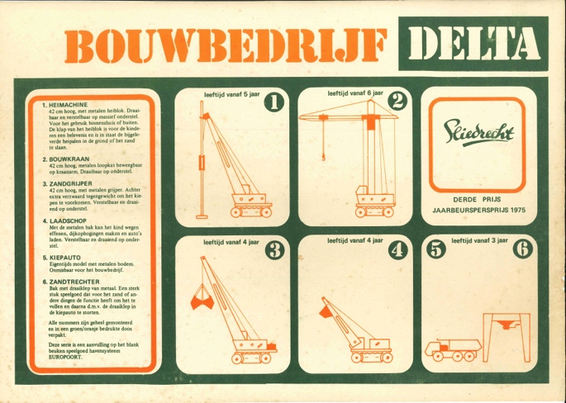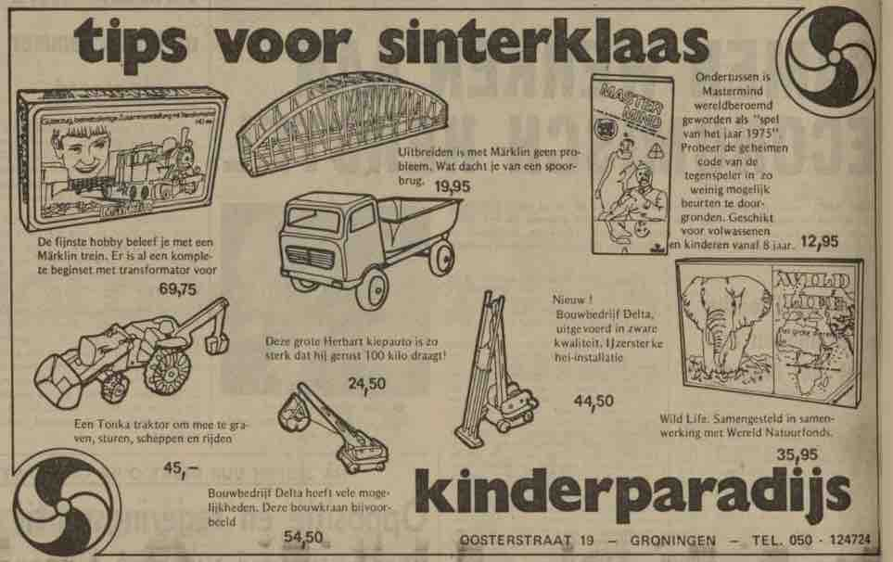

leaflet with reference to the Port System (L) advertisement from 1975

The orange/dark green instruction leaflet is the same for all six models. It is noteworthy that for each model, the minimum age for play is indicated. It must be said: the price was high. An advertisement from 1975* tracked down using Delpher lists prices of ƒ45 to 55 per model. For context: that was four times more expensive than the average ƒDINKYtoys at the time . Converted (and adjusted for inflation) in 2025, that would be € 85 to € 105. Toys for the elite, really.

Nieuwsblad van het Noorden, November 18, 1975

The six models

The design is fresh out of the box and side by side: a Bauhaus-style interplay of lines in beech wood combined with metal parts finished with a fresh orange epoxy coating. It calls for a display case! Each individual model looks large, sleek, and well thought out, and its operation seems beyond any doubt. The cabs of the working models make it clear that in-house designer Jaap de Jong* has carried through his design philosophy. Scale 1:35, approximately scale 0 in model railway building, is substantial.

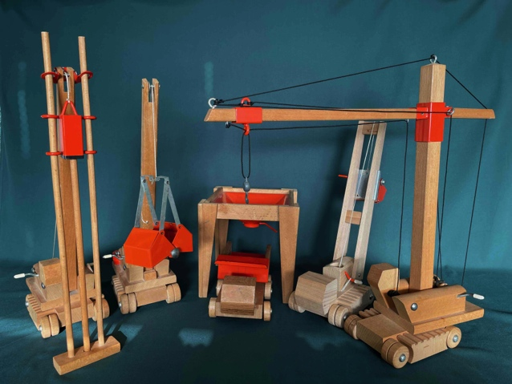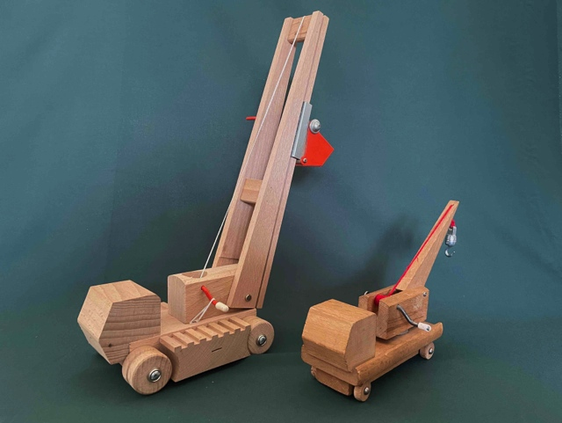

six models of Delta Bouwbedrijf models in a row Delta Bouwbedrijf (L) next to Europoort Port System (R)

It is unclear why Jaap de Jong chose these six models. The dump truck and the sand hopper, okay, they belong together. Nice for the sandbox. The other four models share a sort of common base that suggests caterpillar tracks. However, they simply stand on wheels that rotate around a propeller.

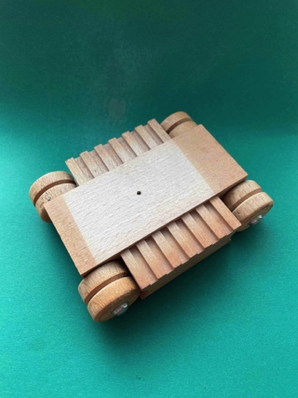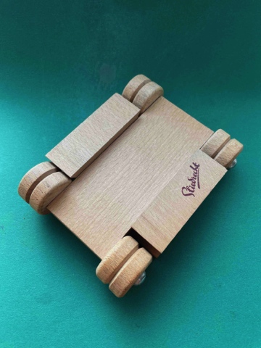

base model (top) base model (bottom)

Cleverly conceived, but prone to sinking and tipping over. However, the bulldozer, the vehicle that derives all its power and utility from those caterpillar tracks, is missing. The six models are discussed below.
With that, a preliminary remark:
- The rust-preventive orange epoxy layer has low friction when rubbing against rope or wood. Handy, and could have been implemented further.
- the light-tinted beech wood has no dust- or grease-repellent coating and becomes grubby after just one visit to the sandbox;
- The models with a hoisting hook have a hand-operated winch. This means a shaft with or without a drum and a crank to turn the shaft clockwise or counterclockwise by hand. On the one hand, the crank prevents the shaft from shooting inwards. On the other hand, a retaining ring ( Starlock type with decorative cap ) ensures that the shaft does not shoot inwards. A construction and method of operation adopted from the Europoort Harbour System.

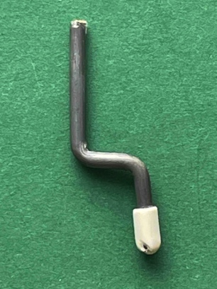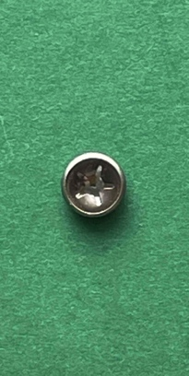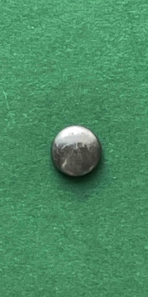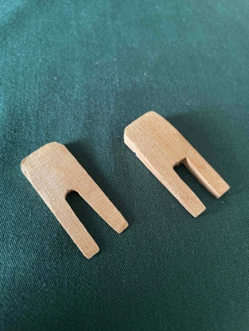

winch (crank, crank) Starlock retaining ring with decorative wedge/cone cap (example)

With these large models, it is important that the shaft can be locked at some point. That mechanism is missing. The result is that all hoisting movements caused by gravity end with a thud, resulting in frustration. This could have been prevented with a small wooden or plastic wedge. A simple construction with a worm gear would have been even better.

source: Newsletter April 2025 ( publication by Ellen-Wien Augustijn)

Pile driver

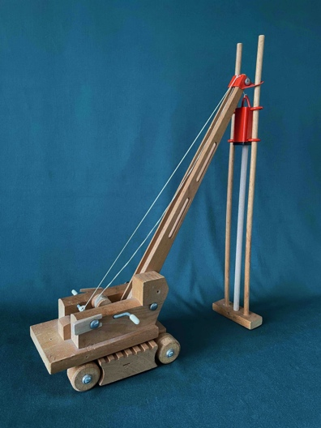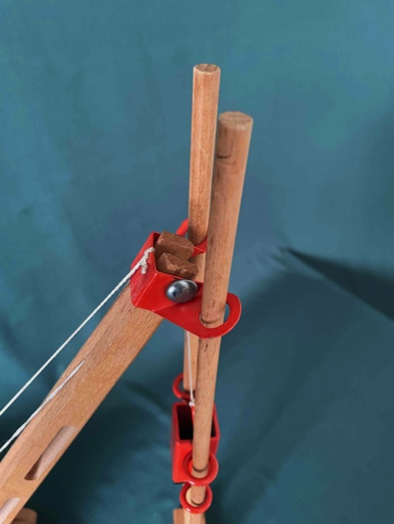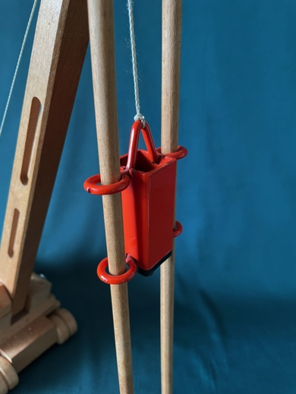

piling machine with pile piling rig piling hammer

The structure features a boom on which the winch, unfortunately, cannot be secured. As a result, the boom constantly falls forward. At the top of the boom is a butterfly-shaped piece of steel with two large eyes. The beechwood pile driver is inserted through this. The pile hammer consists of a square steel block with two sets of two eyes, through which the pile driver is also inserted. The pile hammer is closed at the bottom and thus rests on the pile. So? Does it work? The hollow pile hammer is too light to deliver a knocking blow. A solid steel pile hammer or one filled with lead would have been better. Moreover, the pile (9 mm round beechwood with a pointed end) must first be driven 10 cm into dry sand before any impact can be made with the pile hammer. The model looks so fine and, in principle, all functions are present, but alas, the pile driving? No, *that* doesn't work.

Facts:
- article number 1101
- base: 15.0 cm long, 11.5 cm wide
- boom pitch: 38.0 cm
- piling rig: high 47.5 cm, base width 9.0 cm, base depth 3.2 cm
- foundation piles: length 31.0 cm , diameter 0.9 cm
- Screen print Sliedrecht on the bottom
Construction crane

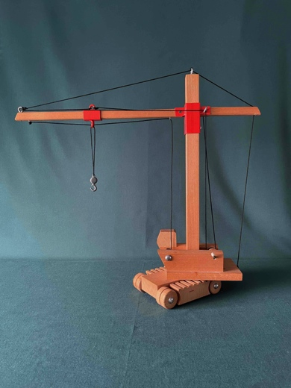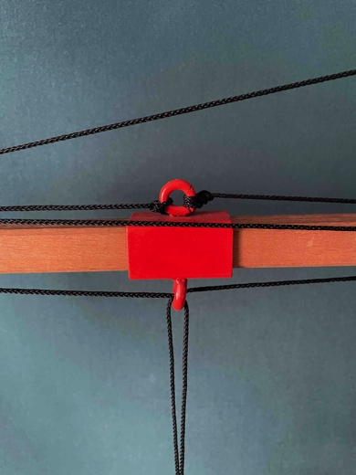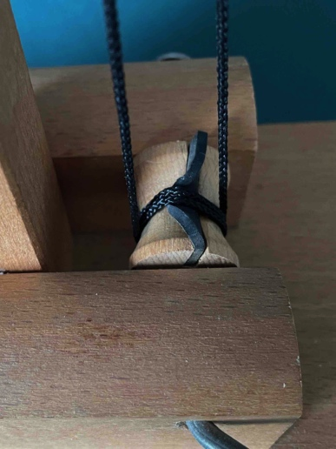

construction crane (tower crane) trolley with crossing cables rubber to tension the cables

The construction crane, or rather a tower crane with a short and a long boom, has one structural element that catches the eye: the orange trolley that can extend and retract horizontally beneath the long boom. To this end, a cable is attached to the front and rear of the trolley. A system of eyelets feeds the cable to the winch drum in the model's cab. This only works if the cable is kept under tension. If not, slippage occurs. Designers Jaap de Jong and Gijsbert Sliedrecht ^{PS} have ingeniously solved this by incorporating a tangentially placed piece of rubber into the wooden winch drum. Less noticeable is the solution for the so-called horizontal load path of the hoisting hook. During extension and retraction, the hoisting hook could move downwards or upwards. Here too, a unique solution has been devised using cables and guide eyelets. Both solutions for these crane movements have one drawback: the ropes rub against and past each other. Fortunately, as long as there is sufficient weight hanging from the hoisting hook, this is not a problem.

Facts:
- article number 1102
- base: 15.0 cm long, 11.5 cm wide
- mast height from floor: 46.5 cm
- short boom 12.2 cm, long boom 35.0 cm
- Cat length: 3.5 cm
- Screen print Sliedrecht on the bottom

The grab crane

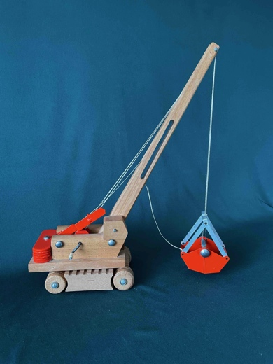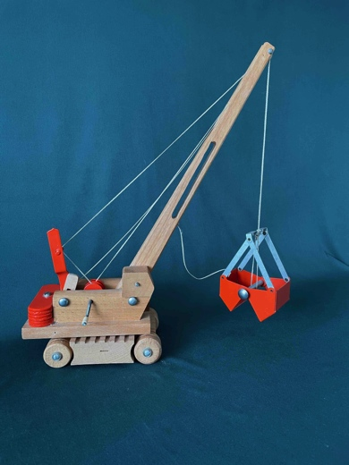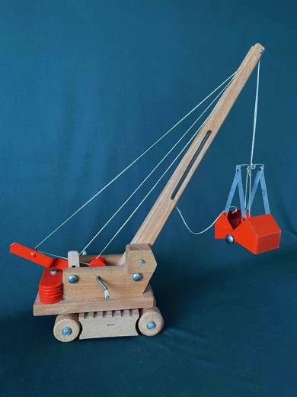

closed gripper (low) semi-open gripper (ascending) open gripper (high)

Undoubtedly an ingenious model, a model to be proud of. All grabbers in the world have one thing in common: the shells (the sides) move apart, the grabber opens, and upon closing, the shells move towards each other. To guarantee safety on the construction site, various laws, decrees, and guidelines have been established for single- and double-wire grabbers. Toys are, of course, exempt from this.

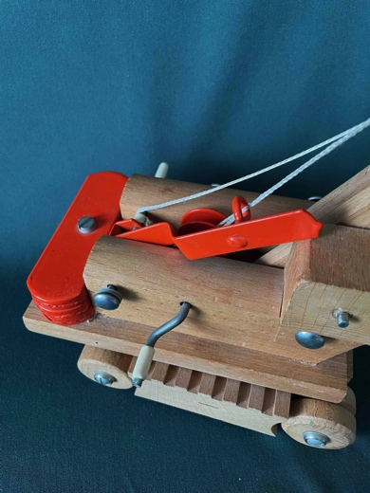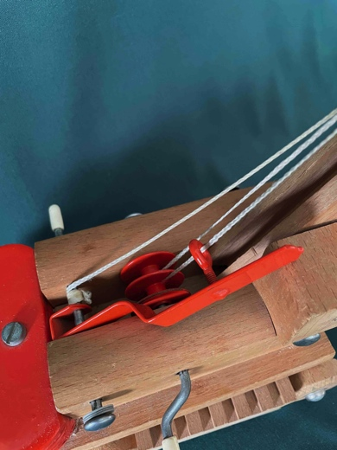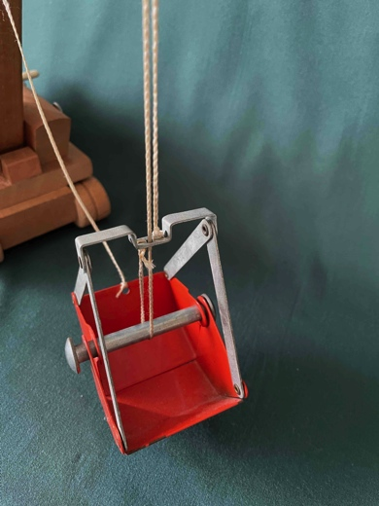

counterweight and lever winch shaft with two drums grabber with two wires

Gijsbert Sliedrecht and Jaap de Jong have devised their own construction ^{PS} whereby the gripper opens and moves upwards with a lever (see the three top photos). A combination of movements that is forbidden in the outside world. Likewise, the gripper closes and moves downwards when the lever returns to its original position. Cleverly conceived, to be sure; technically speaking, it is a one-and-a-half- wire gripper , and those do not exist. Apart from that, there is a practical drawback to this construction. The shafts of the gripper mechanism lack any form of locking mechanism. Want to let go of something? Gravity does the rest; everything goes down, making play virtually impossible. A simple clamp or worm gear would have been appropriate for this fine model.

Facts:
- article number 1103
- 15 cm long, 11.5 cm wide
- boom pitch: 38 cm
- gripper height: 10.5 cm, gripper width: 6.5 cm
- Gripper opening: 0 - 8.8 cm
- Screen print Sliedrecht on the bottom
The loader

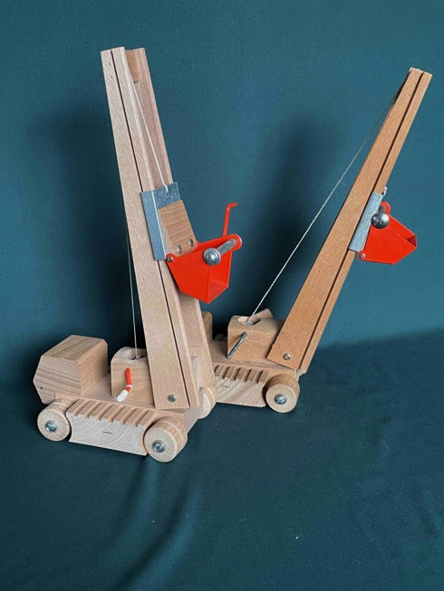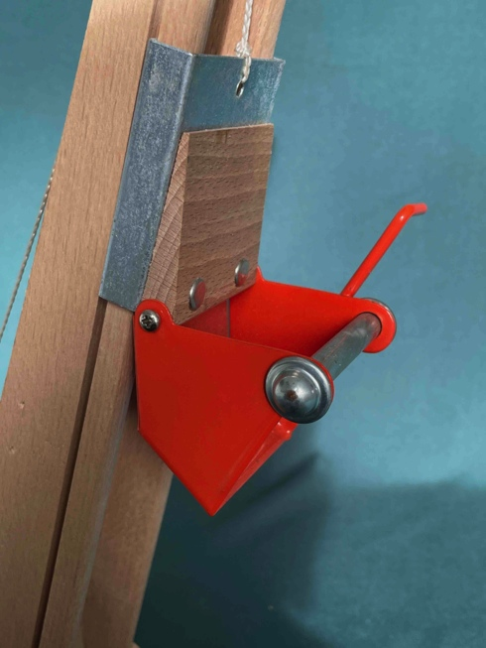

boom tilted backward and forward loader (open) on skid

The model immediately raises questions upon viewing. The boom can tilt 15 degrees forward and backward relative to the vertical axis (see photo). More or less is impossible because the angular shape of the boom blocks raising and lowering. Upon closer examination, the loader shovel is half of the grabber as described for the grab crane. The loader shovel can slide up and down along the boom using a winch (see detail photo). A lever is attached to the half grabber, allowing the loader shovel to tilt forward and unload. However, it is completely unclear how this loader grabs, loads, or fills itself. The best it can do is scrape along a vertical wall. In short: an incomprehensible and unplayable model.

Facts:
- article number 1104
- 15 cm long, 11.5 cm wide
- boom pitch: 32.0 cm
- Boom swing angle: 30 degrees
- 1/2 gripper, not working
- Screen print Sliedrecht on the bottom

The dump truck

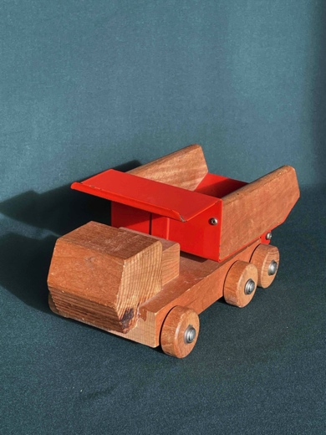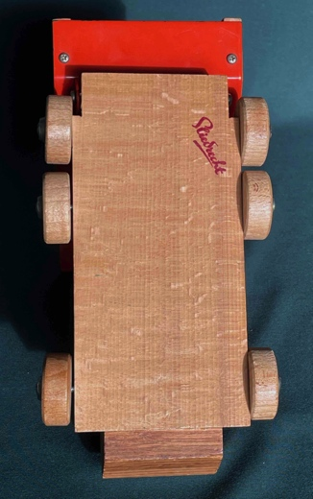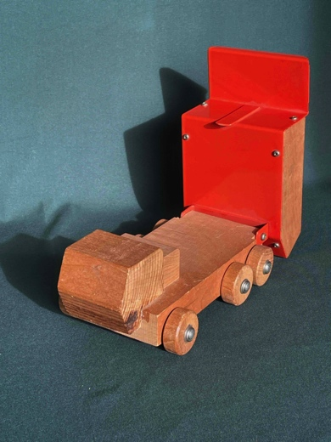

dump truck with the body horizontal and vertical

A wonderfully indestructible model with only one function: tipping and returning to the starting position. No flap at the end of the bucket and a simple hinge construction. This is how toys should be. The epoxy coating guarantees trouble-free pouring. This model was rightly available for a number of years. Together with the sand hopper, it is a delightful toy.

Facts:
- article number 1105
- 23.0 cm long, 11.5 cm wide
- Tray height horizontal 10.0 cm
- Vertical bin height 17.9 cm
- Screen print Sliedrecht on the bottom

The sand funnel (article number 1106)

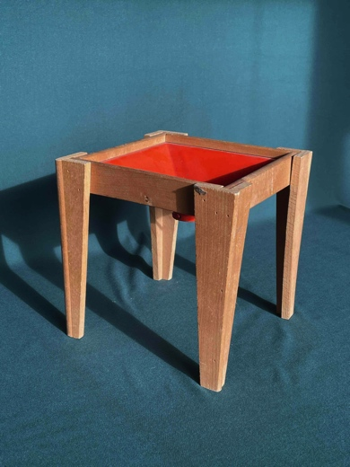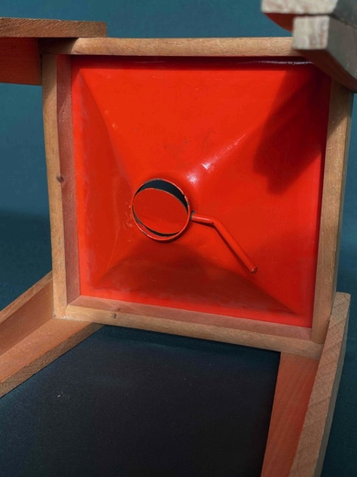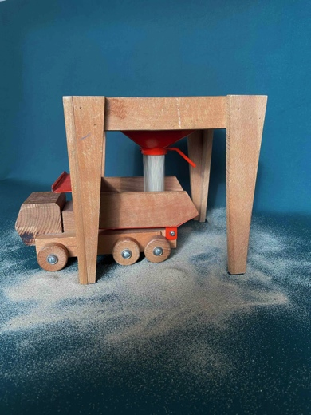

empty sand funnel closed butterfly valve (bottom) butterfly valve fully open

A sand hopper (transfer hopper) is used in the transport sector to temporarily store sand, gravel, and crushed stone from a ship and discharge it in a controlled manner into a dump truck. For dosing, a so-called butterfly valve with a lever is used in this model. In engineering, a butterfly valve is only used for gas or liquid. Well, it just about works finely with dry, fine-grained sand. But if the hopper is (over)full, the valve is difficult to open because the overlying sand must first be pushed aside. A problem can also occur when closing the valve. A larger grain or pebbles can prevent the valve from closing completely. But anyway, with dry play sand, this is a delightful model.

Facts:
- article number 1106
- length 19.2 cm
- width 19.2 cm
- height 20.0 cm

End

Six sleek, beautiful, and pricey models, each one distinct, often four times more expensive than the DINKYtoys of that time. A number of models feature a well-thought-out solution for the many crane movements. Acknowledgment for that. Unfortunately, not a single toy chain included the models in its December catalogs. A few toy stores tried by including one or two models in their assortment and advertising them themselves. A brief summary of the objections:
- the models fall outside the private budget;
- Sand and earth quickly stain the unvarnished beech wood dingy;
- the four models with a boom tend to tilt or sink;
- The hoisting mechanisms of the cranes show shortcomings.
This list points to two problems, namely insufficient understanding of the buyer's perspective and insufficient testing/improvement of the product during the development phase. The fact that children can play with it does not alter this. Sales were disappointing, a blow to the management. Production was quickly halted. Only the dump truck and the sand hopper remained in production and will be available for a few more years. It looked and still looks so beautiful and promising. Too bad, end of story.

Thanks to Ida Gerrits for her research and Peter Sliedrecht (PS) for the many interviews about the toy factory Sliedrecht BV.

©2026 Copyright & Disclaimer of the article Construction company Delta

This article is made available free of charge to the enthusiast of vintage toys. The intellectual property of this article concerning six beechwood design models from the Sliedrecht toy factory rests with me, Peter Duijff. The derived copyright and image rights also rest with me. These rights entail that the enthusiast may use the content for personal use. However, nothing from this article may be reproduced, edited, stored, or made public without the prior permission of the rights holder, author, or photographer. Where possible and meaningful, sources have been cited. I have made every effort to determine whether there are rights holders other than myself and any mentioned author, photographer, draftsman, or illustrator. Nevertheless, it is possible that this investigation is incomplete. Anyone who believes that their interests have been violated as a result is requested to submit this to me with the aim of reaching a solution.

Peter Duijff
Schalkhaar, May 2026

