Boxes and package leaflets

E10 road system, boxes and contents

Note: all boxes were printed on 0.75 mm thick cardboard with waterproof ink. The boxes were not self-supporting and broke easily. This explains why there are many track layouts for sale on www.marktplaats.nl, but the intact boxes are missing. The overview of the boxes from 1971 follows below. It concerns both basic boxes and expansion sets.

Edition 1: The first edition of the Road System

Lids
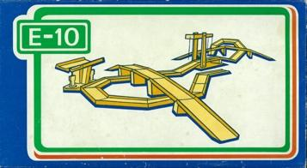

Sides
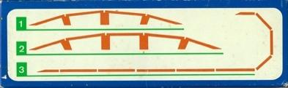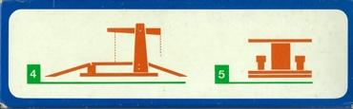

Bottoms
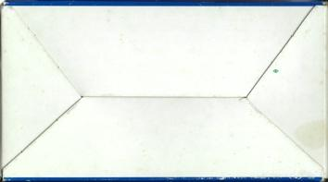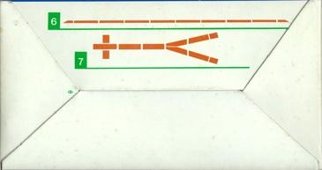

Numbering
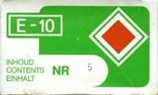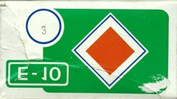

Logo
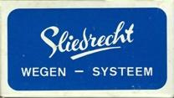

Contents:
- Box 1: straight viaduct (4 road decks, 3 pillars)
- Box 2: straight viaduct (5 road decks, 4 pillars)
- box 3: angled connectors
- box 4: drawbridge
- box 5: pumping station
--------------------------------------------------------------------------------
- box 6: straight connectors
- box 7: road crossing and junction
Edition 2 : The second (supplementary) edition of the Road System

Lids
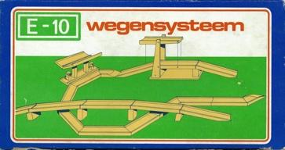

Sides
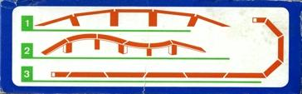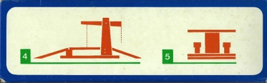

Bottoms
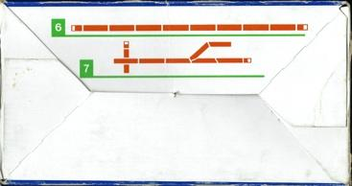

Numbering

Logo
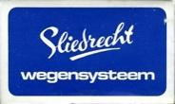

Content:

- Box 1: straight viaduct (5 road decks, 4 piers and 4 transition pieces)
- Box 2: angled viaduct (4 road decks, 5 pillars)
- Box 3: 8 diagonally sawn lanes, 2 short on- or off-ramps
- box 4: drawbridge
- box 5: pumping station
- box 6: straight connectors
- box 7: road intersection and junction
----------------------------------------------------------------------------------
- box 11: drive-in garage 60 x 40 cm
- box 12: drive-in garage 60 x 28 cm
- box 13: drive-in garage 40 x 28 cm

Experimental: Edition E

Lids
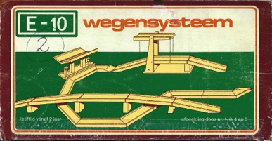

Sides
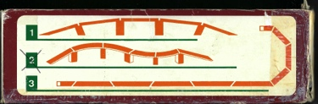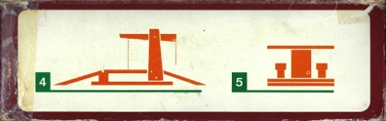

Bottom
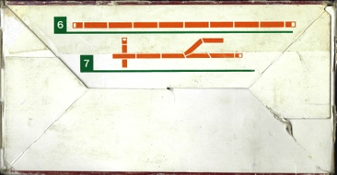

Numbering
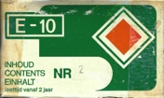

Logo


Contents:

- Box 1E: viaduct with straight lanes fitted with a mortise and tenon joint;
- Box 2E: viaduct with 4 rounded curved sections, 5 pillars, 2 on- or off-ramps;

Edition 3: The E10 Motorway (red logo)

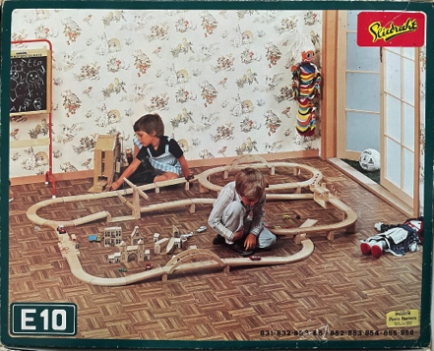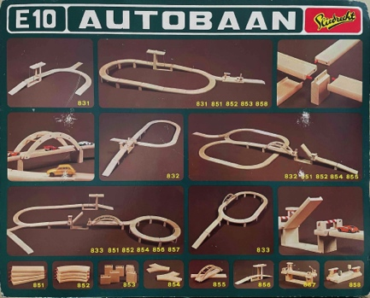

Universal base box lid (L) and inside of lid (R)

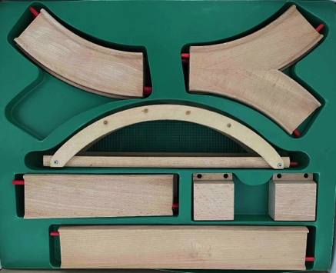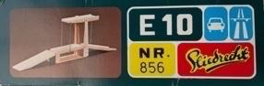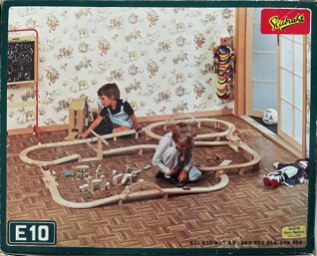

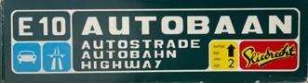

Tray with contents box 833 Universal add-on set (half unfolded )
[to be acquired: photos of the sides of the base box]

Contents:
- Article number 831: Base box with drawbridge (bascule bridge)
- Article number 832: Base box with traffic bridge
- Article number 833: Base box with arched bridge

- Article number 850: Extension set with 2 transition lanes
- Article number 851: Extension set with 4 straight road sections
- Article number 852: Extension set with 4 curved road sections
- Article number 853: Extension set with 5 pillars
- Article number 854: Extension set with 2 Y-splits
- Article number 855: Extension set for arch bridge and parallel road surface
- Article number 856: Extension set with drawbridge and 2 ramps
- Article number 857: Extension set with folding bridge (round barrier)
- Article number 858: Add-on set with gas station (double- sided, 22 cm)

Edition 4: The E10 Motorway (yellow logo)

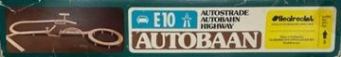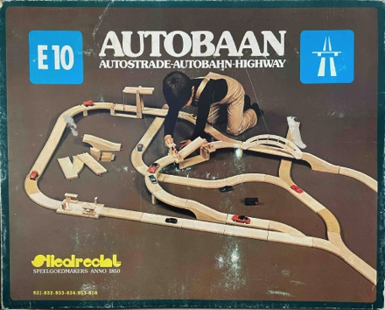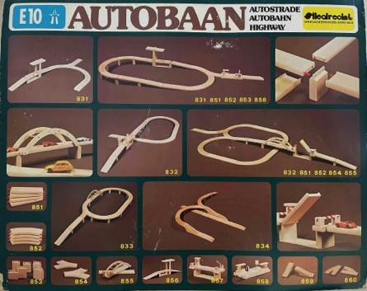

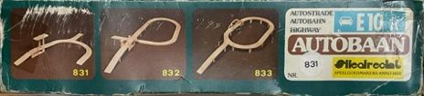

Universal Base Box half unfolded (L) and inside of lid (R)

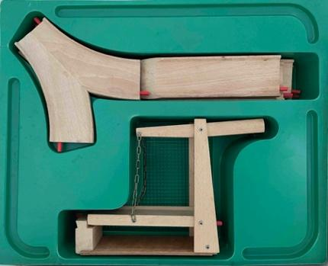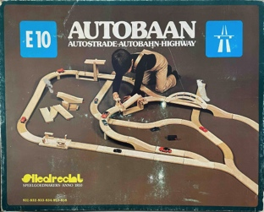

Tray with contents box 833 universal add-on set
(top of lid)

[yet to be acquired: side photos of add-on sets]

Contents:

- Article number 831: Base box with drawbridge (bascule bridge)
- Article number 832: Base box with traffic bridge
- Article number 833: Base box with arched bridge
- Article number 834: Base box with canal bridge and exit lane

- Article number 850: Extension set with 2 transition lanes
- Article number 851: Extension set with 4 straight road sections
- Article number 852: Extension set with 4 curved road sections
- Article number 853: Extension set with 5 pillars
- Article number 854: Extension set with 2 Y-splits
- Article number 855: Extension set for arch bridge and parallel road surface
- Article number 856: Extension set with drawbridge (bascule bridge) with 2 ramps
- Article number 857: Extension set with folding bridge (round barrier)
- Article number 858: Add-on set with gas station (double-sided, 22 cm)
- item number 859: Extension set with canal bridge (2 halves, 22 cm each)
- Article number 860: Extension set with entry or exit strip (22 cm)

In the brown brochure/leaflet (see chapter 4), four matching garages are shown:
- article number 811: drive-in garage 60 x 40 cm*
- item number 812: drive-in garage 60 x 28 cm (with E-10 print)
- item number 813: drive-in garage 40 x 28 cm (with E-10 print)
- item number 822: drive-in garage, 60 x 40 cm, with lift

An identical model with a flat roof made of hardboard and the imprint E-10 has been spotted on www.marktplaats.nl . This model has also been spotted in orange/yellow and pink/purple. O ok The petrol pumps may vary. For more information, please refer to the [Catalog] button.

Edition 5: The International E10 Motorway

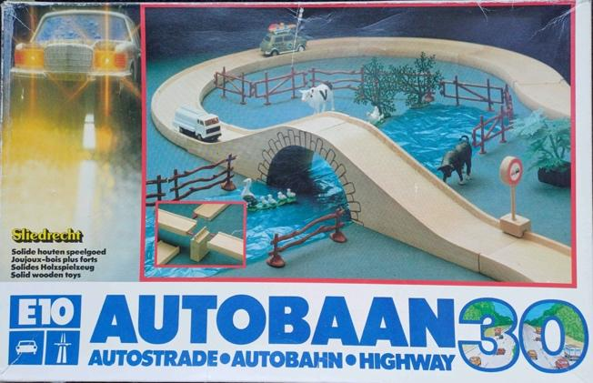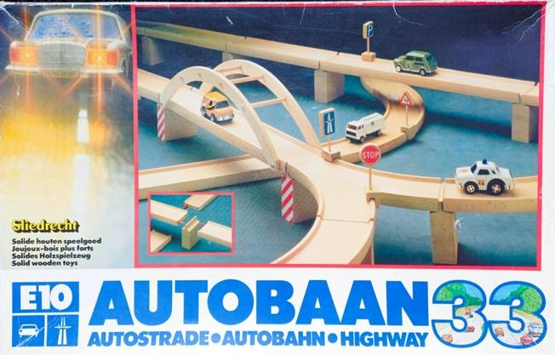

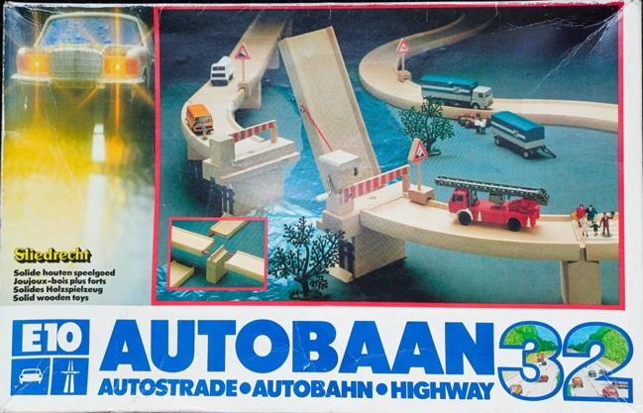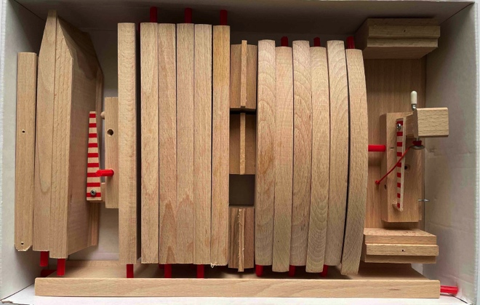

Above: base boxes 30, 32 and 33 and the contents of box 33 (photo C. Stevens)

Below: boxes of the various add-on sets

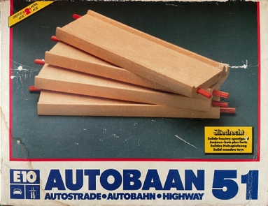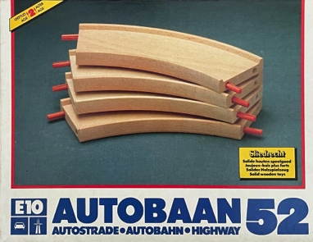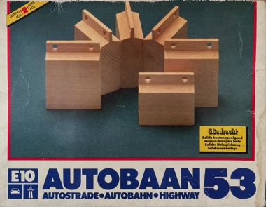

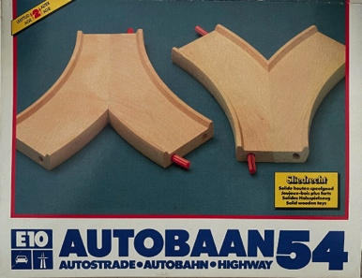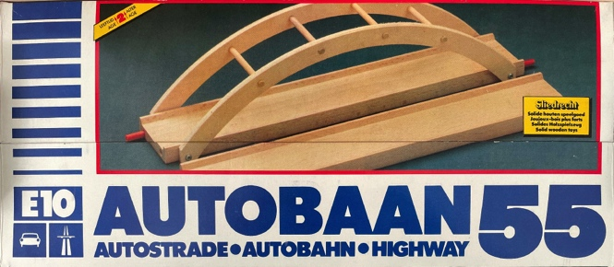

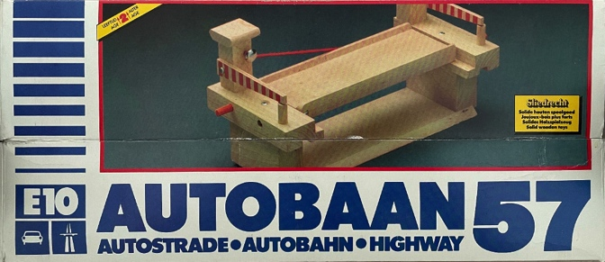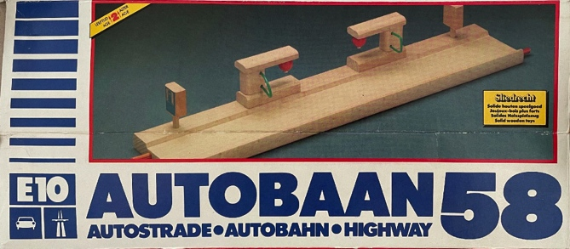

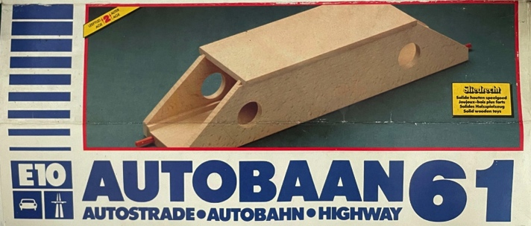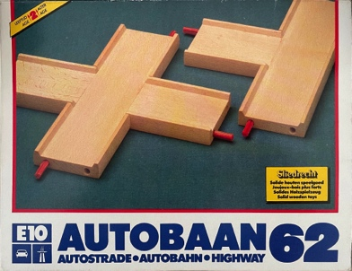

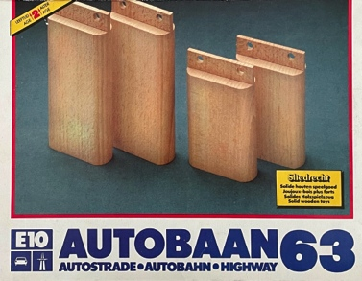

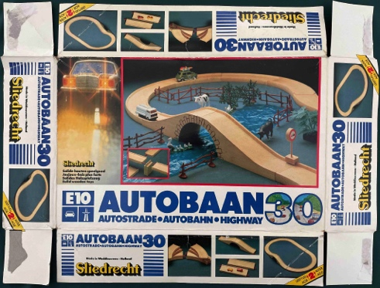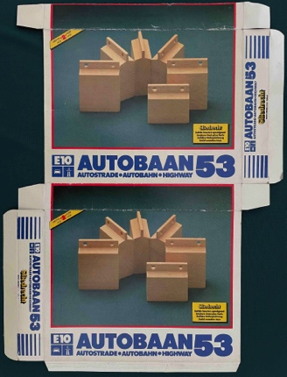

Unfolded lid of base box Unfolded add-on set

Overview and content:

- Basic Box (8)30: Oval with canal bridge
- Basic Box (8)32: 3/4 roller coaster with traffic bridge
- Basic box (8)33: Oval with arched bridge and ramp

- Extension set (8)50: 2 x 2 connecting strips (hook to plug and plug to hook)
- Add-on set (8)51: 4 straight lanes
- Add-on set (8)52: 4 curved lanes
- Add-on set (8)53: 5 high and 1 low pillar (rectangular)
- Add-on set (8)54: 2 Y-junctions
- Add-on set (8)55: Arch bridge with parallel lane (37 cm)
- Add-on set (8)56: Drawbridge and 2 ramps or access ramps
- Add-on set (8)57: Traffic bridge (flat barrier)
- Add-on set (8)58: Petrol station (without roof with two P signs, 37 cm)
- Add-on set (8)59: Canal bridge (two-part)
- Add-on set (8)60: Exit lane to the right*
- Add-on set (8)61: Tunnel (37 cm)
- Add-on set (8)62: Crossing and T-junction
- Add-on set (8)63: High pillars (rounded corners)
- Refill set (8)64: Traffic signs (set of 10)**
- Add-on set (8)70: Airport with plane and helicopter (41 x 44 cm)***

[yet to be acquired: photos of the top of refill sets 50, 56, 57, 59, 60, and bag with refill set 64]

From early late 1982, early 1983, various refill sets were shrink-wrapped ^{PS} .

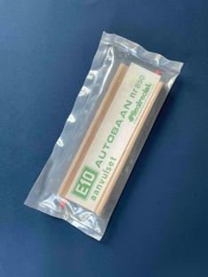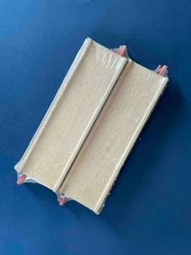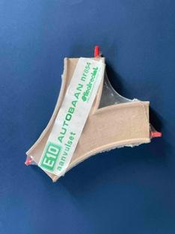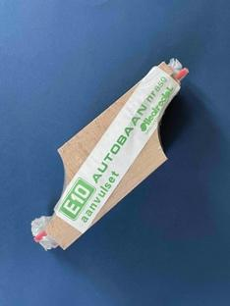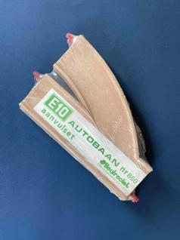

Shrink wrap refill sets (from left to right: 850, 851, 854, 859 and 860)

Note: it is striking that, contrary to what the name E10 Autobaan suggests, no expansion set with cars was ever available.

The left exit was indeed in production and is shown in the blue/black and white fold-out brochure of the fifth edition (Appendix IV). However, a left exit lane was not found in any box or add-on set. Nor is a left exit lane to be found in the enhanced photos of the lids of the base boxes.

** The traffic sign refill set was packaged in a plastic bag with a sealing strip.

^{PS} toy stores in an unprinted cardboard box after ordering .

Boxes and package leaflets (and promotional material)

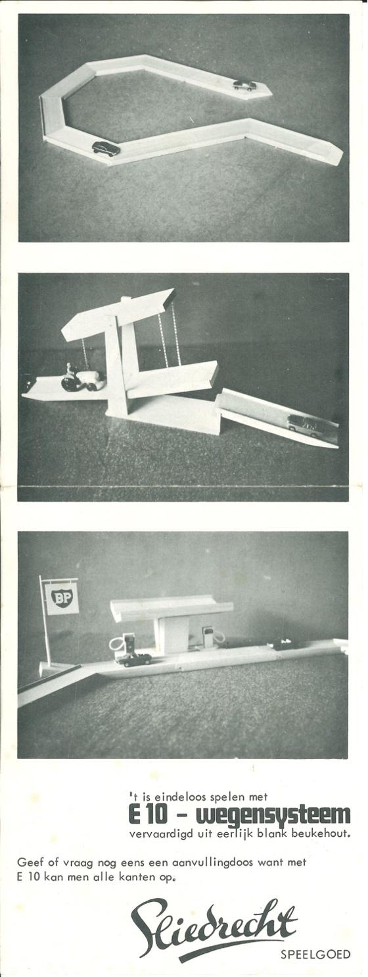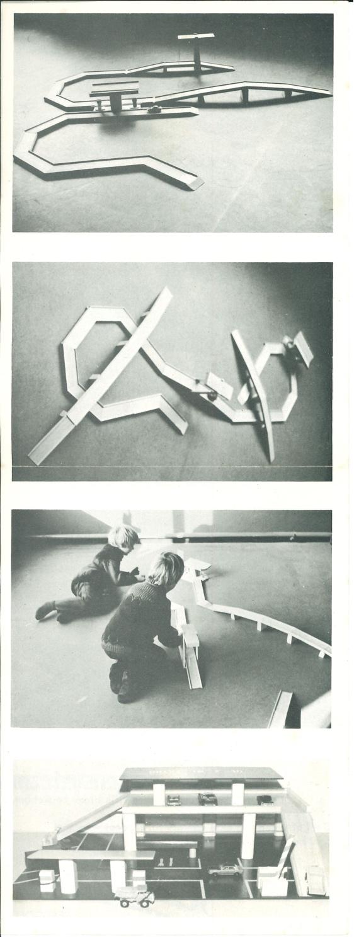

Package leaflet (fold-out leaflet, leporello) for Editions 1 and 2 of the E10 Road System
Year: from 1972, presumably the 1st version
Size: 32.0 x 12.0 cm (portrait)
Color: black
Printing technique: offset
Note: the gas station would have a massive pillar/centerboard and a BP flag.

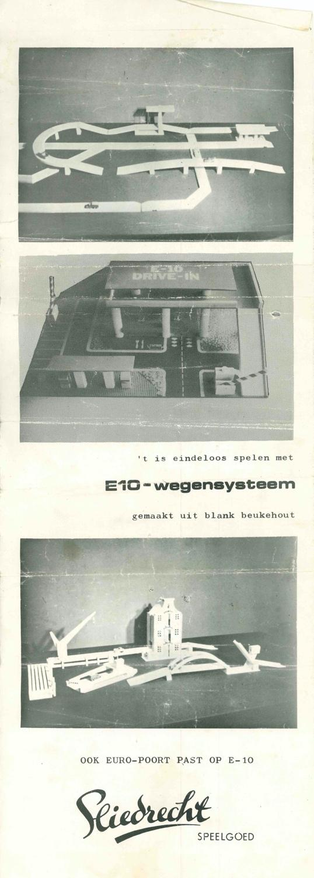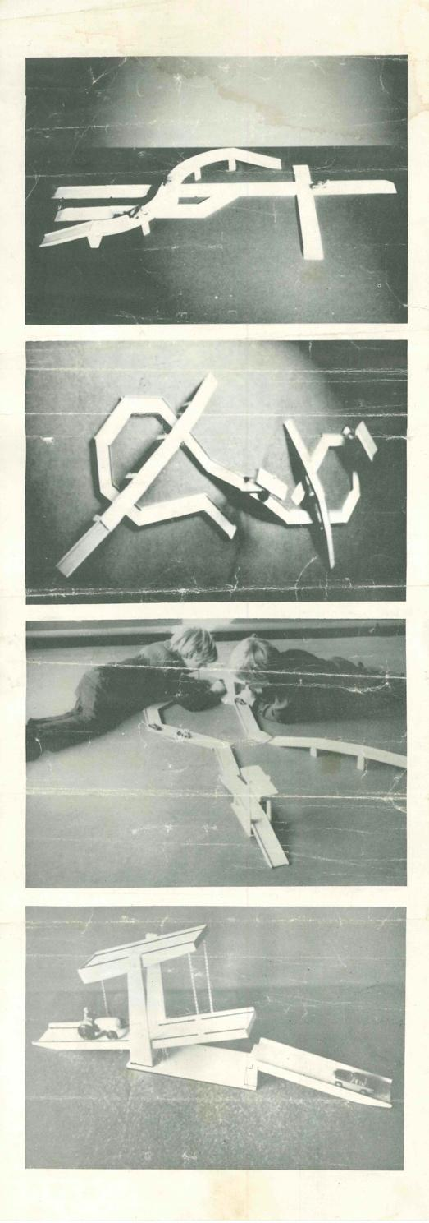

Package leaflet (fold-out leaflet, leporello) for Editions 1 and 2 of the E10 Road System
Year: from 1972, presumably the ^{2nd} version
Size: 32.0 x 12.0 cm (portrait)
Color: black
Printing technique: offset
Note: the gas station now has two pillars and two roof racks
Reference is made to EURO-POORT (without Port System)

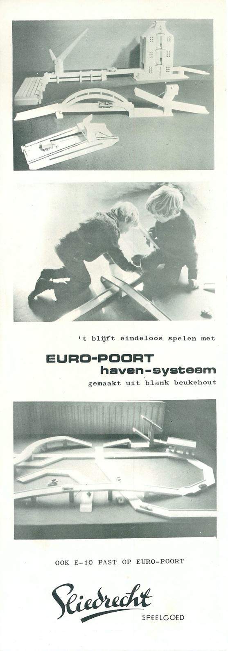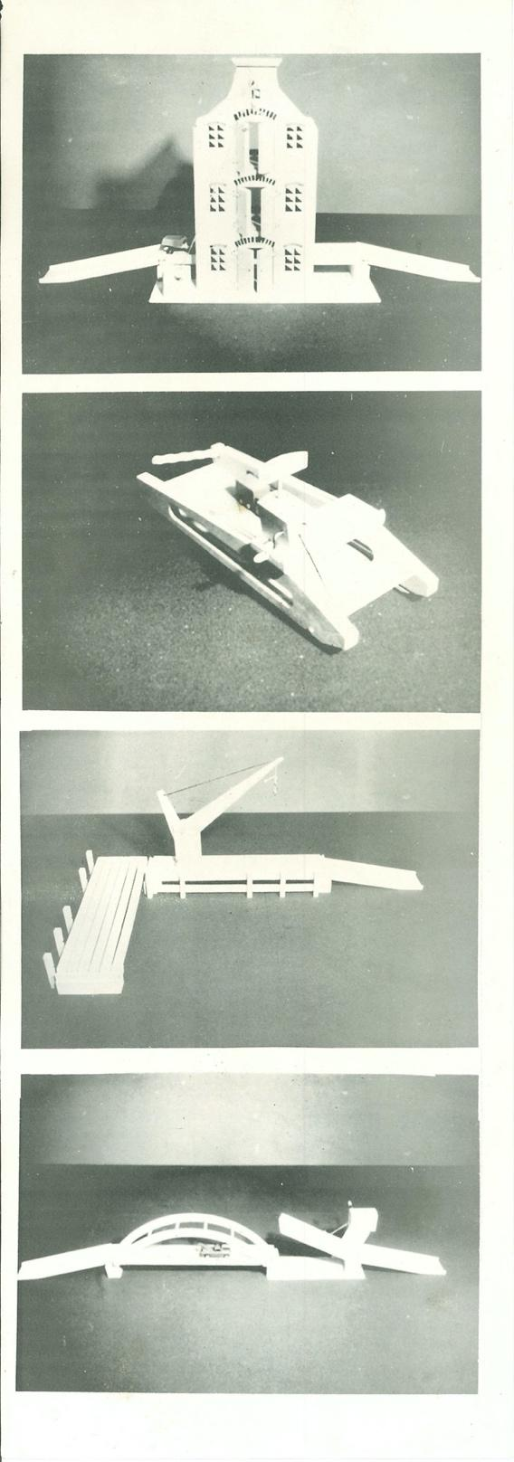

Package leaflet (fold-out leaflet, leporello) for: Edition 2 of the E10 Road System
Edition 1 of the Europoort Port System
Year: from 1973, presumably the ^{3rd} version
Size: 35.0 x 12.3 cm (portrait)
Color: black
Printing technique: offset
Remark: -
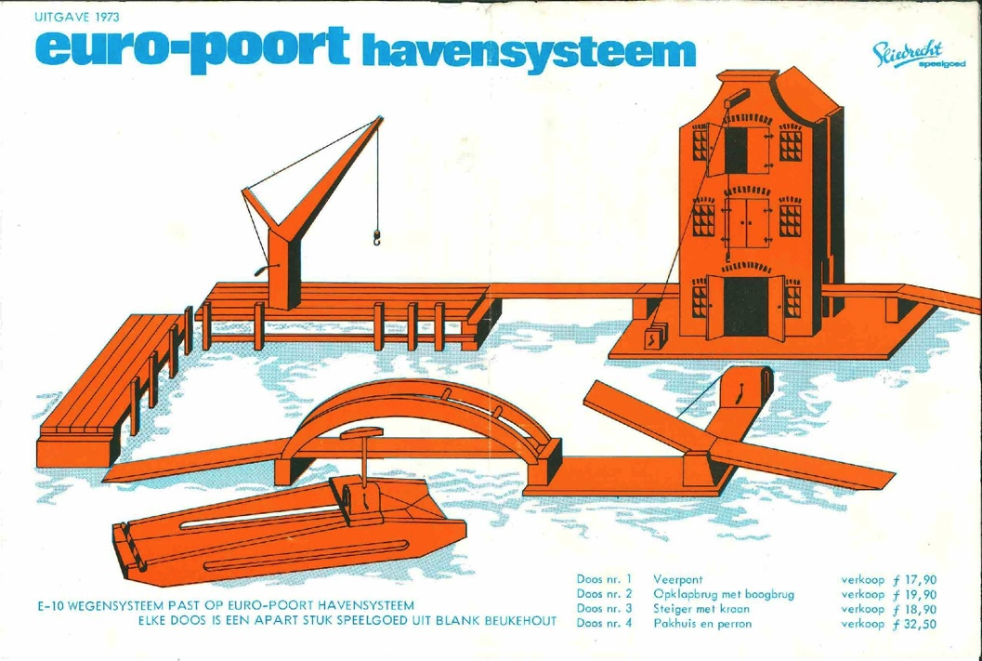

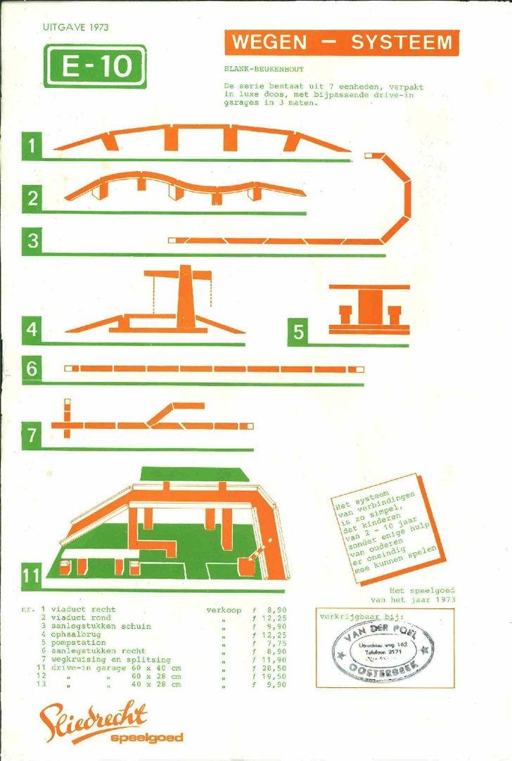

Leaflet to Edition 1 of the Europoort Port System and the E10 Road System
Year: from 1973
Size: 32.2 x 21.5 cm, printed on front and back
Color: orange/blue/black respectively orange/light green
Printing technique: screen printing
Note: this concerns the second edition of the E10 Road System
The roof of the gas station is supported by a single central pillar/console.

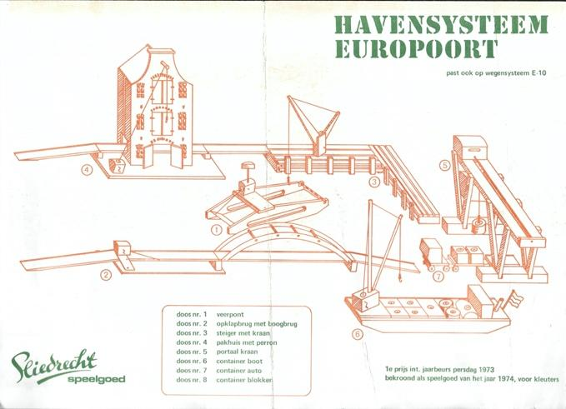

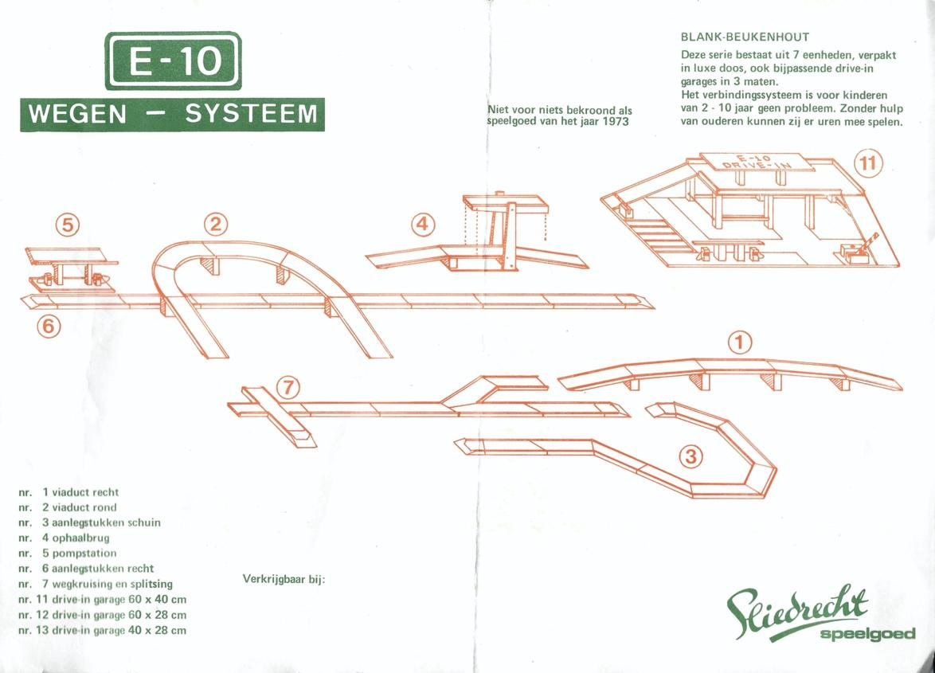

Leaflet to Edition 2 of the Europoort Port System and the E10 Road System
Year: from 1973
Size: 30.2 x 21.3 cm (landscape) and uncropped 32.8 x 23.0 cm (landscape)
Color: orange/dark green
Printing technique: screen printing
Note: this concerns the second edition of the E10 Road System
The roof of the gas station (number 5) is supported by two roof racks.

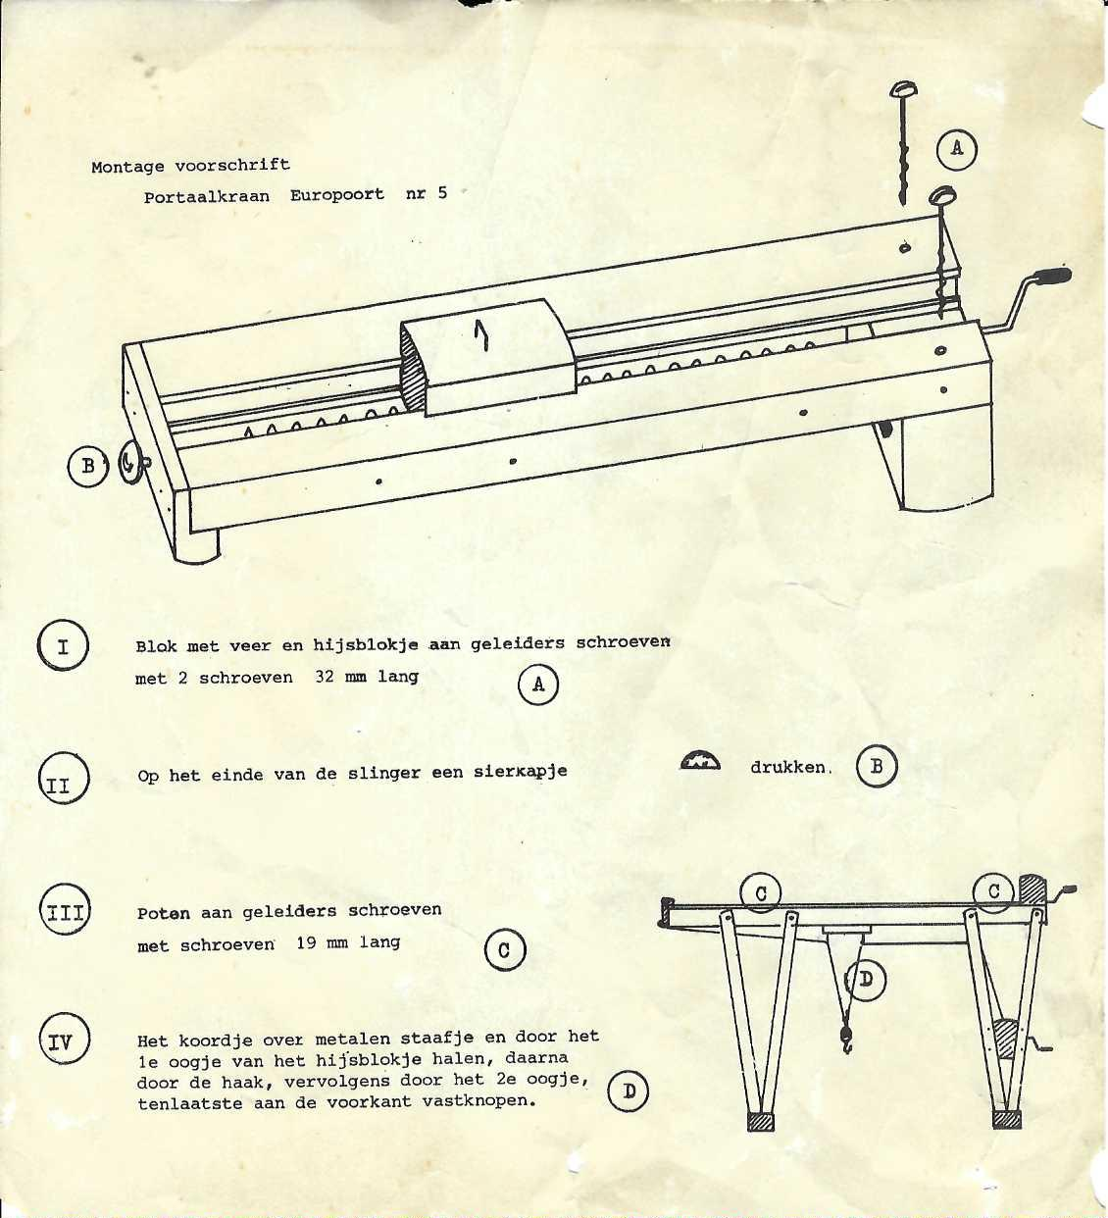

Assembly instructions for the gantry crane
Year: from 1973
Size: 4.3 x 15.9 cm (portrait)
Color: black on 90-gram paper white paper
Printing technique: screen printing, possibly offset (but stencil work is not excluded)
Note: the explanation can only be understood by educated enthusiasts.

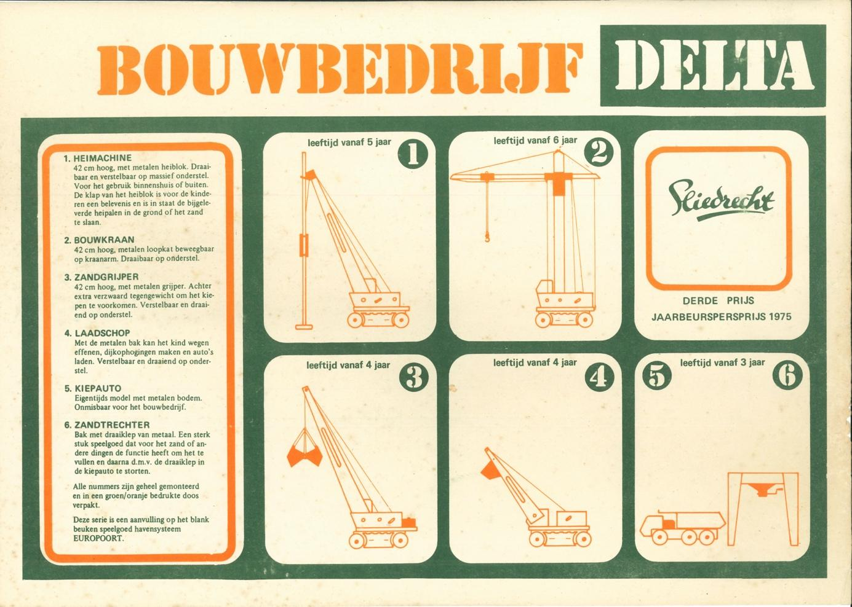

Leaflet with the boxes from Construction Company Delta
Year: 1974
Size: 31.7 x 22.5 cm (landscape)
Color: orange/dark green
Printing technique: screen printing
Note: According to the text, Bouwbedrijf Delta is an addition to the
Europoort Port System

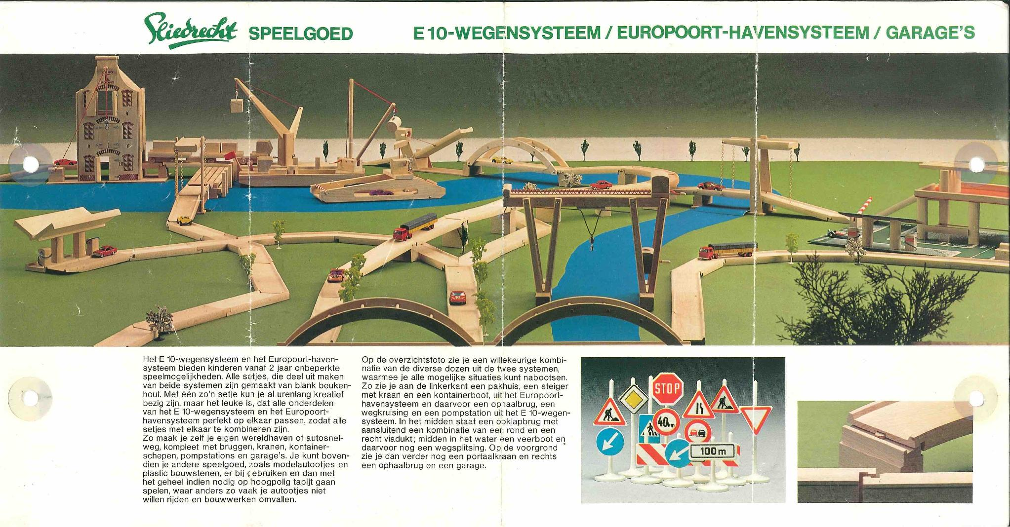

front (with 'borrowed' traffic signs and greenery)

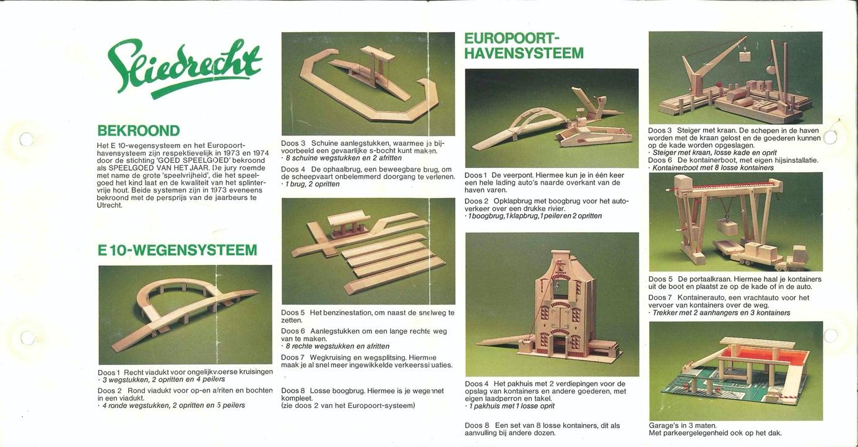

rear side

Speelboom brochure (leporello with three folds) with models by Sliedrecht BV
Year: 1974
Size: 34.4 x 18.0 cm (landscape)
Color: full color
Printing technique: offset
Note: traffic signs and 'green' are not from Sliedrecht BV

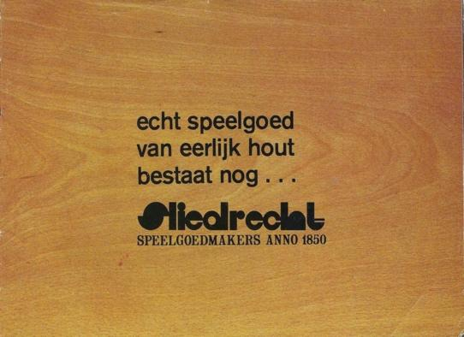

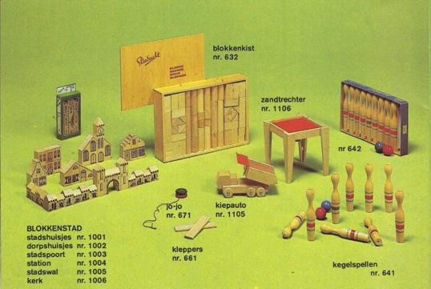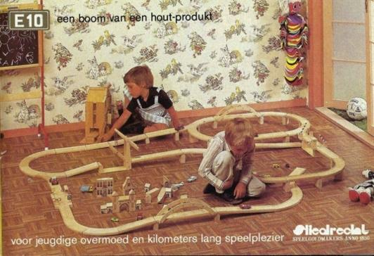

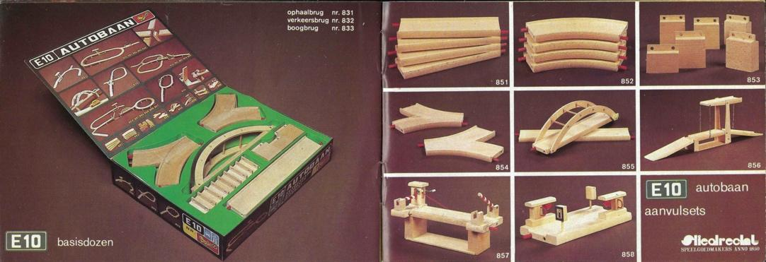

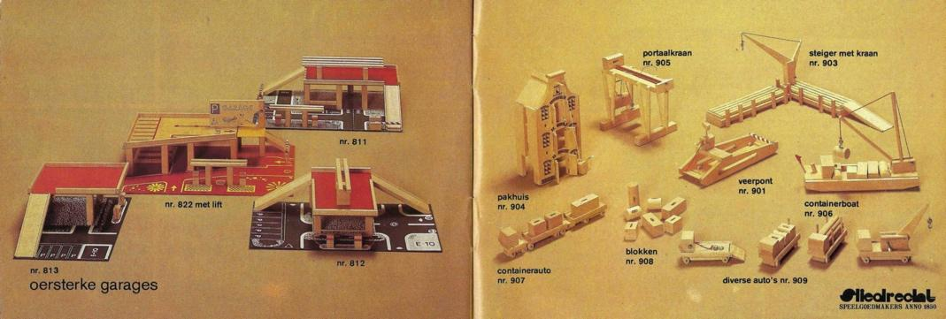

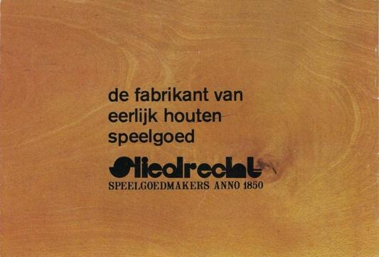 left and right pages in order

General product overview, stapled, with left and right pages
Year: around 1976
Size: 14.8 x 10.0 cm (landscape)
Color: full color
Printing technique: offset

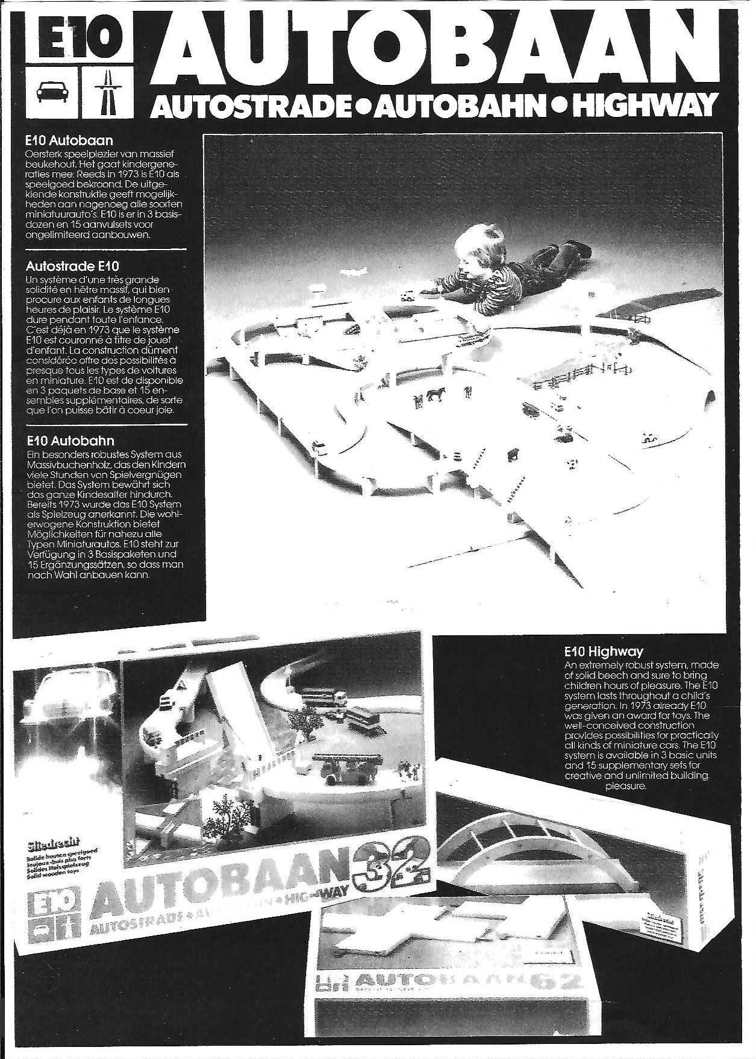

Page about the E10 road system

General product overview, right-hand pages
Year: 1983
Format: A4, folded leporello with two seams
Color: black/white
Printing technique: offset
Note: four-lingual

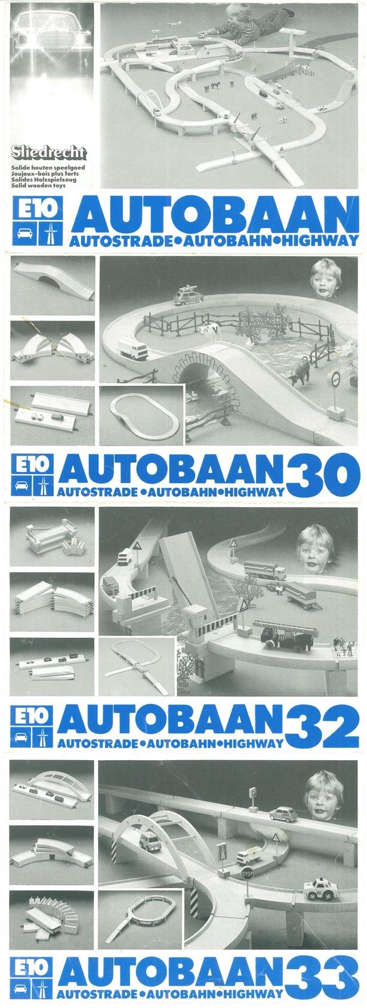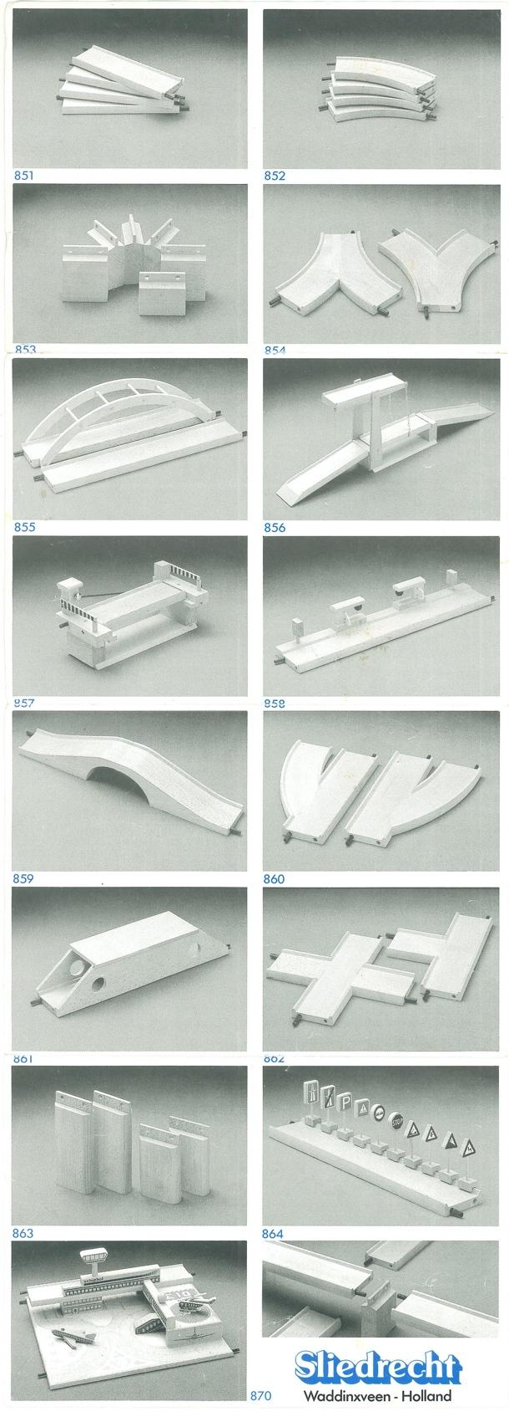

front rear

Package leaflet (fold-out leaflet, leporello) for Edition 5 of the E10 Motorway System
Year: from 1982
Size: 41.5 x 15.0 cm (portrait)
Color: blue/black
Printing technique: offset
Note 1: add-on set 860 is depicted with one turn to the right and one to the left.
However, the turn to the left rarely occurs;
Note 2: Refill set 860 in shrink wrap packaging 860 contains two turns to the right.

© 2026 Copyright & Disclaimer Overview of boxes and package leaflets

This overview is made available free of charge to enthusiasts of vintage toys. The intellectual property rights to this overview of the boxes, leaflets, and promotional material of the Sliedrecht Toy Factory belong to me, Peter Duijff. The derived copyright and image rights also belong to me. These rights entail that the enthusiast may use the content for personal use. However, nothing from this article may be reproduced, edited, stored, or made public without the prior permission of the rights holder, author, or photographer. Where possible and meaningful, sources have been cited. I have made every effort to determine whether there are rights holders other than myself and any mentioned author, photographer, draftsman, or illustrator. Nevertheless, it is possible that this research is incomplete. Anyone who believes that their interests have been violated as a result is requested to contact me.

Peter Duijff
Schalkhaar, August 2026

