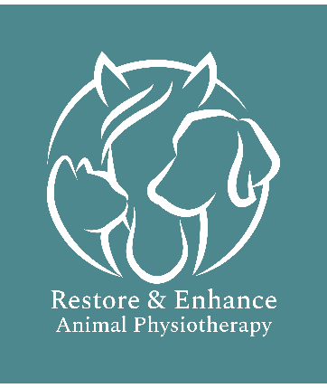
Animal Physiotherapist
Josie Richards RVN Cert ECC PG Dip Animal Physio
Tel: 07834713182
Email: Restore.Enhance.AnimalPhysio@outlook.com
Requesting Veterinary Permission
Date:
Veterinary Practice:
Email:
Tel:
Email:
Tel:
ate:
Veterinary Surgery:
Email:
Tel:
Date:
Veterinary Surgery:
Email:
Tel:

I have been contacted by one of your clients requesting physiotherapy treatment for their animal. In accordance with the Veterinary Surgery (Exemptions) order 1962, I am seeking your permission to treat this animal.
I would be very grateful if a Veterinary Surgeon could complete this form and email it back to me at Restore.Enhance.AnimalPhysio@outlook.com
If you wish to discuss this referral, please contact me at Tel: 07834713182 If required treatment reports are available on request.
Client
Name: Phone:
Address: Email:

Animal
Name: Species:
Gender: Age:
Reason for treatment:

Treatment Start Date:

I hereby give veterinary consent for Josie Richards RVN, Cert ECC, PG Dip Animal Physio to treat this animal.
Name: Position:
Signature: Phone:
Date:
Comments:

