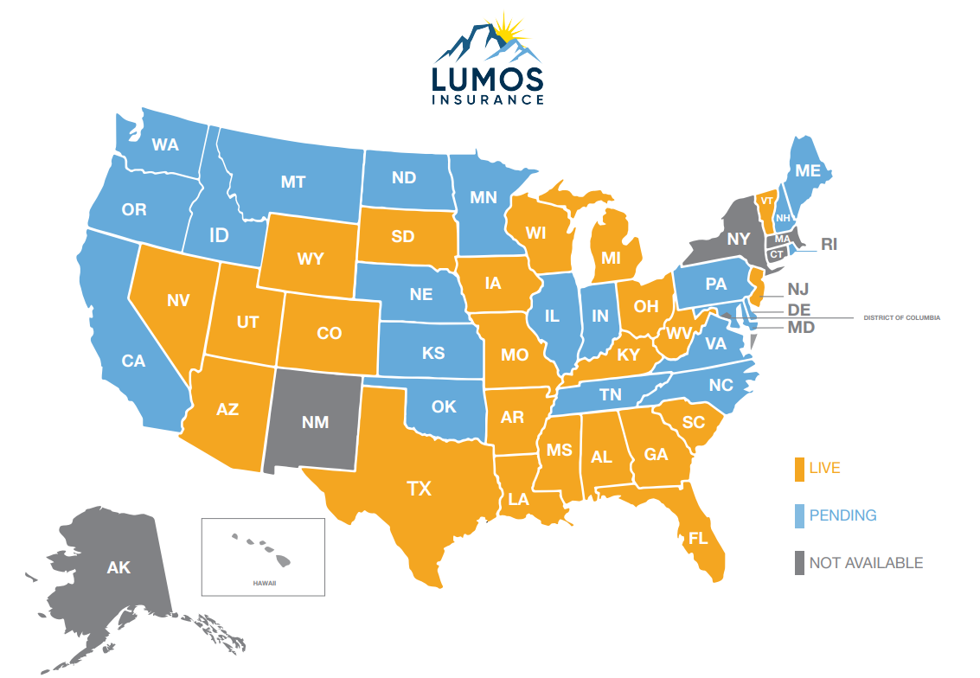Carrier Highlights
- Founded 1981 - Plateau is now Lumos Insurance
- Headquarters in Crossville, TN
- Licensing 44 states (21 approved)
- Launching in select states: AL, AR, AZ, CO, FL, GA, IA, KY, LA, MI, MO, MS, NJ, NV, OH, SC, SD, TX, UT, VT, WI, WV, and WY!
- Level for life commissions in birthday rule states
- All state appointments paid by the carrier
- AM Best A- (Excellent)
- Licensed Statutory Insurer
- Proven underwriting discipline refined across 45 years and 1,200+ programs
- Long-term stability that reduces counterparty risk and friction for distribution partners
Product Highlights
- Administered by Integrity Partner – IAS
- Plans A, F, G, High-Deductible G & N
- E-app: Q-Sig with Mother’s Maiden Name
- HHD - TBD
Underwriting Highlights
- Heart: 2-year lookback
- Cancer: 2-year lookback
- Stroke: 2-year lookback
- Diabetes: Up to 50 units of insulin daily

Talking points:
- A new product built for the current and evolving Med Supp market
- Rates will not be the cheapest by design to promote long term stability
- High rating, fair look backs and competitive comp

