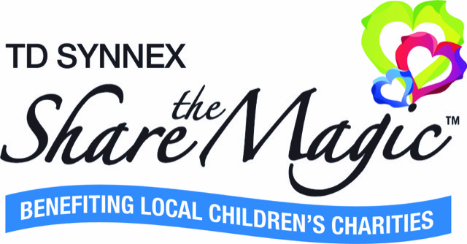

2026 Silent & Live Auction Donation

The TD SYNNEX Share the Magic event on Saturday, October 10, 2026 will feature a silent and live auction. The silent auction will include various items, art, getaways, trip packages, electronics, dining certificates, and more. Silent auction donations should have a value of $200 or more and may be combined with other packages to increase the value.

Select high-value donations chosen by the event committee will be featured in a live auction. We are looking for distinct items, trips or experiences that our attendees cannot often find elsewhere. Items with minimum bid requirements or contingencies will not be accepted.
auction donation form

Item | Item Description  (Please be as detailed as possible as this is used to describe the item on the auction bidding website.) | Restrictions  (Please state any limitations or restrictions pertaining to your donation.) | Retail Value

Name or Company Donating Item:
 |  |  |  |  | (List name as it should read on event materials for donor acknowledgement.)
TDSSTM Charity Affiliation: (Optional)
Contact Name:
Address:
City, State, Zip:
Phone: |  |  |  | Email:
Signature: |  |  |  |  |  |  | Date:

Remit form and items by August 3, 2026 to: Eleanor Kneeland
EleanorK@hughes-agency.com
110 E. Court Street, Suite 100
Greenville, SC 29601

