Braunvieh: Moderate, Maternal, Carcass, Adaptable

Braunvieh have been available commercially in the United States for over 40 years. During that time, they have been evaluated and used in a variety of situations and systems around the country. This has afforded ample opportunity to assess how they might fit into a commercial program, and what a producer could reasonably expect to see by introducing them.
Versus a black baldie cow, based on summer of 2025 prices, Braunvieh cross cows can increase your bottom line by over $73 at weaning per cow exposed (21 lbs higher weaning weight x $350 CWT). They can increase profit $4 per 100 lb hot carcass weight by improving yield grade by 1. By giving you one extra year of fertility producing 6 calves instead of 5, assuming $3000 for a bred heifer and $1500 salvage price, Braunvieh provide a $50 profit. All this and some of the lowest input costs of any cross studied at the Meat Animal Research Center (MARC).

Braunvieh Profit Summary:

Profit at weaning per cow exposed | $73
Profit per 1000 lb hot carcass weight | $40
Extra year of fertility | $50
Total profit | $163

In this article we will explain how Braunvieh can accomplish these numbers. We will discuss some of the positive traits and characteristics Braunvieh can bring to your herd such as maternal excellence, carcass merits, and adaptability. We will also outline a few suggestions for introducing Braunvieh genetics and discuss some of the shortcomings to consider.
Whether you’re trying to improve cow herd traits through crossbreeding, market more valuable calves, produce replacement females, or improve feedlot performance and grid marketing, Braunvieh is a proven breed that can help you achieve these goals.

Maternal:

Braunvieh were developed over centuries in the harsh extremes of the Swiss Alps. Unlike breeds developed for one specific area or climate, Braunvieh had to survive and thrive in quickly changing and treacherous areas with diverse forages. Natural selection dictated that cattle had to be adaptable to climate extremes, a variety of

forages, and a wide variety of terrains. Cows had to survive and produce calves in these harsh environments. Cattle that didn’t adapt didn’t survive. Over the centuries the cattle that were productive and did survive became the basis for Braunvieh cattle today.
Braunvieh are a very maternal breed. They are a moderate sized breed weighing between 1100 and 1400 pounds with ample milk, and high rates of fertility, all while passing on preferred carcass traits. As a moderate breed, Braunvieh and Braunvieh cross cattle can be harvested sooner at an acceptable quality grade before the carcass gets too big, avoiding those expensive later days on feed.
Fertility is an important trait for any beef herd’s profitability. Braunvieh and Braunvieh cross cattle have been shown to have high rates of conception and fertility. At the MARC in Clay Center, NE, 93% of Braunvieh cross females were found to be pregnant at 550 days (table 1).
Braunvieh sired females also produce more marketable weight at weaning. At the MARC these females produced 5% more marketable weight, or 21 lbs, than a traditional Angus / Hereford (black baldie) cross at the time of weaning (Table 2). Based on summer 2025 prices, assuming $3.50/lb, each Braunvieh sired cow delivered $73 (21 x
$3.50) more per year at weaning than a black baldie. They do all this with a lower BCS and the lowest cow maintenance energy requirements of any cross studied at the MARC. This research suggests Braunvieh cross females produce more marketable weight at weaning with the lowest input costs of any cross studied, including black baldie.
Longevity is also an important quality for any commercial cow, avoiding expensive replacement costs. At JHL Ranch in Ashby, NE they run a 1500 cow commercial herd. Over a 7 year period, 47% of Braunvieh sired females were still in the herd compared to 28% of the Angus sired females. When you consider the longer a cow is in production the more profitable she is, this time is money.

Carcass:

Braunvieh rank very high among continental breeds for marbling. Data published from the MARC in Clay Center, NE on calves born in 2023 showed Braunvieh sired animals had the second highest marbling score of any continental breed, second only to Simmental. Among the 15 breeds tested, Braunvieh scored fourth overall behind Simmental, Red Angus, and Black Angus.
Importantly, despite their high level of marbling, Braunvieh sired calves had the third lowest back fat thickness; behind Maine and Charolais. The three breeds with the thickest back fat were Black Angus, Red Angus and Hereford. Although Black and Red Angus led the group in marbling, they also led the group in back fat, negatively impacting yield grade.

Braunvieh sired calves not only had high levels of marbling but kept back fat in check, improving yield grade. Despite being a moderate framed breed, Braunvieh also had an average ribeye area. Based on this information from MARC, English cow herds could theoretically improve their overall yield grade by one simply by switching to a Braunvieh bull without negatively impacting their quality grade. Based on summer 2025 prices, improving yield grade by one anywhere from 1 to 5 results in an average increase of $4 per CWT for cattle sold on the grid. On a 1000 lb carcass, that’s in increased profit of $40 per cow with the same, or lower, inputs.

Adaptable:

Braunvieh are incredibly adaptable. A testament to Braunvieh adaptability is the fact that they are used around the world from hot, semi-arid climates to cold climates, from 12,500 feet to sea level. They adapt well to high altitudes, tropics and grasslands. They tend to tolerate whatever Mother Nature throws at them while remaining productive and functional.
Braunvieh evolved in the mountains where sure-footedness was necessary for survival and have retained that trait today. They are still popular in the Swiss Alps for this reason. In central Mexico they are used in the foothills and on rocky terrain where other breeds struggle. In eastern Kentucky producers have appreciated their ability to graze mountainous and rocky valleys that other breeds avoid. Their hard hooves and leg conformation allow them to navigate these difficult areas to find forage with fewer problems than most beef cattle.
Despite being developed in the mountains, Braunvieh are very heat tolerant. This is evidenced by their popularity in warmer climates such as central Mexico, India and South Africa. The brown color does not absorb heat, decreasing heat stress vs black cattle. Braunvieh have hair that is sleek and fine in warm weather allowing them to adapt to warmer climates better than many breeds. They can also grow a heavy coat in response to extended cold weather, making Braunvieh adaptable to these environments as well. During the recent droughts in Texas, Braunvieh have weathered the lack of forage as well or better than other breeds.
Tommy Stoddard raises cattle in southern Louisiana on some of the most inhospitable land you can raise cattle. Areas that “An Angus won’t survive” according to him. He uses Braunvieh for their ability to not only survive but thrive in this harsh environment. He describes Braunvieh as docile and functional with better feet and fewer problems than other non Bos Indicus breeds. He states they have fewer problems with Pink Eye and Foot Rot than any other British or Continental breed in his area, and are only surpassed by the Bos Indicus cattle in his operation. He also crosses Braunvieh with Brahman to graze swampy areas that are often submerged. According to Tommy, this F1 cross can survive anywhere. He feels the Braunvieh make the Brahman more

docile and better mothers while contributing to the hardiness of the Brahman themselves. Additionally Braunvieh improve the carcass merits of the F1 cross.
From Mountains to rangeland, hot conditions to cold, drought to swamp, Braunvieh have proven their ability to adapt and produce in the harshest of conditions.

Minimal Problems:

Braunvieh are relatively problem free. Like other breeds with black skin around the eyes, Braunvieh have low rates of ocular cancer. They also have lower rates of pink eye. Centuries of breeding and natural selection in the Swiss Alps have provided the breed with good legs and feet. This allows them to survive and thrive even in the most challenging of conditions. This feature has persisted in modern Braunvieh and contributes to their longevity, adaptability, and overall health.
Braunvieh have hard black hooves. This helps prevent foot problems such as foot rot and cracked hooves. In the harsh environment of southern Louisiana, Braunvieh have fewer foot problems than other Continental or British breeds.
A few thoughts about pink eye. Over the years some have claimed that Braunvieh are immune from pink eye. This is not the case, but Braunvieh do seem to be less susceptible than other breeds. In Southern Louisiana, Braunvieh are much less susceptible to pink eye than Hereford or Angus but not as resistant as Brahman. A rancher running a mixed herd in Wyoming explained that when they would have a pink eye out break; if 50% to 75% of the Angus and black cows contracted it, only 5% to 10% of the Braunvieh would. Another example is in Wisconsin where three Braunvieh calves were born into a commercial Hereford recip herd containing 30 cow / calf pairs.
The remainder of the calves were registered Hereford embryo calves or black baldies from the clean up bull. The herd experienced two outbreaks of pink eye in 3 months, during which 26 of 27 Hereford and black baldie calves contracted pink eye twice while the three Braunvieh calves were unaffected, never contracting pink eye. This is an extreme example but one that Braunvieh breeders hear frequently.
The next question is how often do crossbred and F1 Braunvieh cattle contract pink eye? The MARC does not keep accurate data on this disease in the different breeds studied. Anecdotally the rate of pink eye seems to be decreased compared to the rate in other Bos Taurus breeds alone. To this author's knowledge, there is no scientific research on the subject. To complicate the matter, many Braunvieh cross cattle are stocked with high percentage, purebred, or Fullblood Braunvieh that seem to have a lower incidence of pink eye. Therefore, whether the decreased rates of pink eye observed in F1 cattle are from genetic factors or an overall low burden within the herd, is unknown.

Challenges moving forward

Just like all breeds, Braunvieh are not perfect and are certainly not perfect for everyone in every situation. In this article we will focus on three challenges Braunvieh have within the commercial beef industry; birth weight, horns, and color.
Braunvieh are a continental breed that evolved over the centuries at high altitudes with limited oxygen and resources. Additionally, living so close to their family in a herd of one or two cows allowed any calving issues to be dealt with. However, when Braunvieh were brought down to lower altitudes with more oxygen and plentiful resources, they produced larger calves, occasionally much larger calves.
The first challenge is birth weight and calving ease. Many continental breeds struggled with large calves when introduced into the United States and had to work through the problem. Braunvieh was no exception. However, Braunvieh were introduced later and to less acceptance and fanfare, which led to fewer long term breeders to work on the problem. As a breed known for their bone and structure, improving birth weight in Braunvieh cattle often changes their aesthetic, discouraging many breeders from addressing the problem. That, combined with the “dairy look” of their coloring, kept the breed small, providing little incentive to improve birth weights overall. This left many Hobby breeders with no long term goal or incentive to improve calving ease and birth weight.
To compound matters, many early adopters of Braunvieh were more focused on frame and growth with little attention paid to birth weight. Some of the first bulls introduced to the United States had terrible calving ease and very high birth weights.
This created a founder’s effect with some of the first animals introduced into the United States passing on high birth weights and not much calving ease. This founder's effect also decreased the genetic pool of calving ease for breeders to draw from. These early factors hampered long term improvement.
The breed has made significant strides over the last two decades in bringing down overall birth weights and improving calving ease. The average EPD’s for calving ease direct (CED) and calving ease maternal (CEM) have steadily increased, indicating fewer unassisted calvings, while the average birth weight (BW) EPD has steadily decreased during that time. Importantly, the average weaning weight (WW) and yearling weight (YW) have increased during that time. At the MARC in Clay Center, NE the average birth weight of Braunvieh sired calves in 2023 was 87.6 lbs. This put them in the middle ⅓ of breeds sampled with the same birth weight as Simmental.
The Braunvieh breed has struggled with birth weight and calving ease and, in some cases, continues to struggle. Many producers trying to introduce Braunvieh for their positive traits have been turned off by this. Birth weight and calving ease are less of a problem in warmer climates and resource limited areas but overall it is an ongoing concern. The breed is working on these traits with more emphasis being placed on birth weight and calving ease in breeding stock every year, but the issue is not completely

resolved. If you are looking into using Braunvieh genetics, bear this in mind. The authors recommend paying close attention to EPD’s when selecting a Braunvieh bull. They are helpful and there for a reason. Many purebred Braunvieh bulls can now be used in the same scenario as a producer might use Simmental or Gelbvieh bulls, with similar expected outcomes. These traits have gotten better overall but need to be kept in mind for all matings.
The second challenge for the Braunvieh breed is horns. Traditional, 100% Braunvieh are horned. In Switzerland this is not seen as a negative trait, with most cattle retaining their horns throughout life. Higher percentage animals in the United States are more likely to carry at least one horned gene with the percentage of homozygous polled animals increasing with decreasing percentage. There are currently a large number of high quality heterozygous polled cows within the breed with more high quality homozygous polled animals available every year. Consequently there are more homozygous polled bulls available every year as well. If this is an important trait to you, insist on having an animal tested before purchasing. The test is relatively inexpensive and can prevent headaches later on.
With horns can also come scurs. These are not technically horns and animals that are homozygous or heterozygous polled can still possess scurs. Cattle do not seem to use scurs in the same capacity as horns but they can be a nuisance. Scurs are present in most traditionally horned breeds to some extent. Currently there is no DNA test for scurs but adhering to homozygous polled breeding will minimize their occurrence.
The third major challenge facing Braunvieh today is color. Traditional colored Braunvieh have the same coloring as a Brown Swiss dairy cow. Because of this coloring, many immediately assume Braunvieh are a dairy animal, but today’s Braunvieh is primarily a beef cow. They can, however, be milked, which we explore in another article. Living in Wisconsin, I’ve personally had more comments about coloring than anything else. Examples include: “How do you like those Brown Swiss?” or “That’s the beefiest dairy animal I’ve ever seen.” My feed guy once commented “I thought they were just Brown Swiss, but when I got close I realized there’s a lot of meat on those things.”
The other challenge related to color is when Braunvieh are used in crossbreeding or commercial programs. A full discussion of coloring in cattle is beyond the scope of this article but, in short, it’s complex. Traditional coloring in Braunvieh is considered a wild type, just look at a picture of a deer next to a picture of a Braunvieh. This coloring helps with heat tolerance and adaptability but can make crossbreeding a challenge.
Braunvieh coloring is also generally recessive. Therefore, when crossed with other breeds, Braunvieh can unmask underlying color schemes that have long been overshadowed by more dominant traits. One such example is when Braunvieh are crossed with red breeds, particularly red British breeds. When this mating is undertaken

brindle coloring can be unmasked, but it is variable. A personal observation is crossing Braunvieh with Hereford cattle. When crossed with Line 1 Herefords, there is minimal to no brindle pattern in the offspring but other lines can produce an animal with prominent and striking stripes. Commercial producers need to bear this in mind if they have any red in their breeding history as brindle coloring may be unmasked by using Braunvieh.
Aside from brindle, Braunvieh cross cattle can produce other challenging color schemes. These challenges can occur when Braunvieh are crossed with another
non-dominant color. Braunvieh crossed with Fleckvieh (brown x red) have produced a black calf, other times a tan calf will result.
Braunvieh can be colored black while testing negative for a “black” gene which is then not passed on to their offspring. Some Braunvieh have a dark brown or “dunn” color which can produce a variety of colors in their offspring. This dunn color is present in both fullblood and purebred animals. To be clear, it is not known if this is the same “dunn” pattern found in Highland cattle. Braunvieh can be varying shades of brown depending on blood line. Some blood lines are known to be darker or lighter and can produce an almost white or black calf.
In the past, an albino gene was present within the Braunvieh breed. This can be tested for and has all but been eradicated. If this is important to you, there is a test for the albino gene which can be obtained for a modest price.
Braunvieh are not known to possess a unique diluter gene. They have been crossed with breeds that do carry diluter genes over the years so the presence of one is possible and not currently tested for within the breed.

Incorporating Braunvieh Into Your Herd:

How best to incorporate Braunvieh into your operation depends on your goal. Each strategy has its benefits and drawbacks. It is important to first think about what you are trying to accomplish before deciding on a plan. Consider your situation and do your homework! Talk to people who raise Brainvieh. There is a BAA membership directory available on the Braunvieh Association of America website (www.braunvieh.org). Braunvieh folks like to talk about their cows. At all times it is important to keep in mind the challenges mentioned above to avoid disappointment and surprises.
If you are looking to get started in cattle and feel Braunvieh might be right for you, I’d suggest visiting someone who raises them. Depending on where you live this might be easier said than done. Talk to others in your situation, select a few females either through private treaty sale or a multibreeder sale and an appropriate bull. Do your homework on all of the animals you’re interested in as well as the breeders to make sure you're getting what you want.

If you are a small or large commercial operation looking to branch out or sample some of the traits Brainvieh are known for, the easiest way is to purchase a few Braunvieh cows or heifers and integrate them into your herd. I would suggest keeping the above challenges in mind and purchasing from a reputable breeder. If you live in Fescue country, consider cattle raised around Fescue or buying them young. Producers using a Black Angus bull or a homozygous black bull from another breed should see black or dark brown calves with similar calving results to the rest of your herd.
The other easy way for small to large commercial herds to sample Braunvieh is to purchase a bull. The MARC data cited above is almost exclusively from this scenario. Depending on your type of herd, there is a Braunvieh bull out there to fit your needs.
Consider calving ease, color preference and carcass goals. Producers selling fat cattle on the grid based on yield grade and quality grade will likely see an improvement in one or both by using a Braunvieh bull.
Quite possibly the best use for Braunvieh in the large commercial operation might be in making commercial F1 females, a “black baldie” alternative. Black Angus females crossed with Braunvieh bulls will produce polled and black calves. These F1 females will possess all of the positive traits mentioned above along with the expected hybrid vigor. These cattle have been proven to be fertile, adaptable, efficient and have good longevity (see above). The steers from this F1 mating will be black and polled and quite possibly improve your performance on the grid in one generation. If those F1 Braunvieh x Black Angus females are then crossed back to a terminal, homozygous black bull, the offspring will be black and do very well on the grid. In this way a large commercial producer can take full advantage of the positive Braunvieh traits without taking a penalty on sale day.
One way to approach this is by using BraunX bulls at any point in the process. These bulls will be homozygous polled and homozygous black minimizing the risk of horns or color changes in the future.

Conclusion:

Braunvieh are a maternal breed that brings carcass merits and adaptability.
Centuries of selection in the Swiss Alps, and 40 years of commercial use and study in the US, have confirmed these benefits. The breed still has some challenges to work through and Braunvieh may not be the perfect cow in every situation, but they deserve to be considered.

Table 1

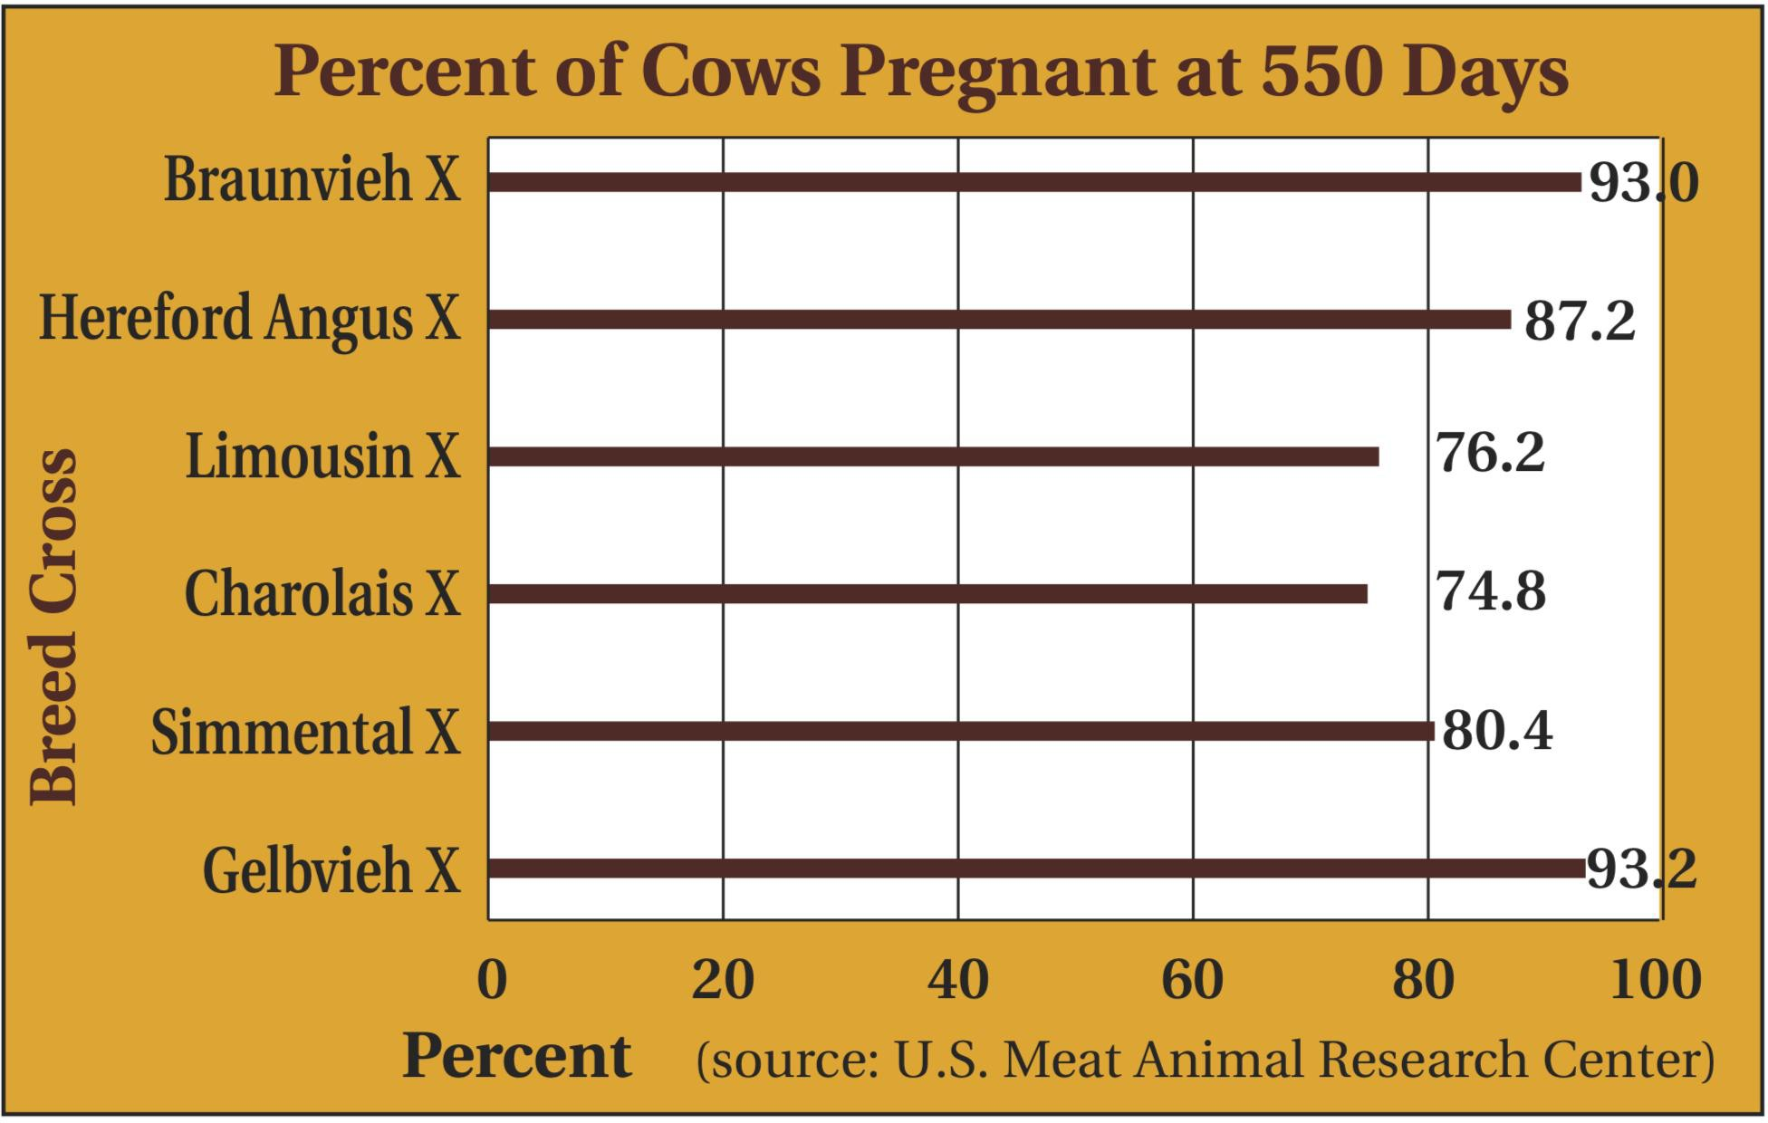

Table 2
