Dear Potential Partner,
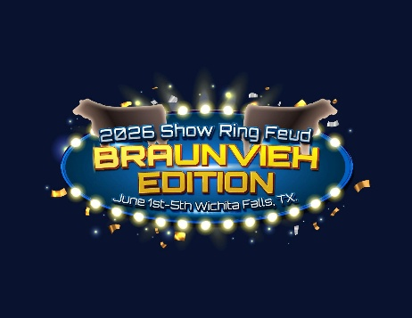
In June 2026, the JBAA will host the 26th National Junior Braunvieh Show (NJBS) in Wichita Falls, Texas. The junior board and advisors are working hard to make this a memorable event that inspires young Braunvieh enthusiasts to stay committed to the breed.
The NJBS gives juniors the chance to showcase the cattle they have raised, while also building friendships, connecting with fellow exhibitors and adult breeders, and developing leadership and life skills. Throughout the week, educational contests and activities challenge participants, helping them grow as knowledgeable, confident, and future leaders in the cattle industry.
From our President:
My name is Coy Pittman, and I am proud to have been involved with the Junior Braunvieh Association of America for the last 11 years, and I am currently serving as your Jr President. I am from Canadian, Texas, and I am currently pursuing a degree in Agricultural Business and Animal Science at Oklahoma Panhandle State University. My passion for agriculture and the Braunvieh breed has been shaped by many experiences, the National Junior Braunvieh Show (NJBS) has allowed me to exhibit and practice those skills that have made me successful and given me a week each year to make memories with my Braunvieh Family that will last a lifetime.
Naturally, hosting such an event requires a substantial amount of financial support from loyal donors. In previous years, we have found that offering sponsorships is a positive way to raise funds. These sponsorships will carry the name of the donor for events such as meals, contests, class sponsors, as well as prizes for participants. We offer various levels of sponsorship to choose from, including platinum, gold, silver and bronze. Below is an itemized list of options to contribute to. There is no donation too small. We would not be able to have this event for these kids without the support or our donors. Please consider partnering with the JBAA to make our 2026 Junior Nationals a success. Thank you so much if you have sponsored with us in the past, we truly appreciate your support.
