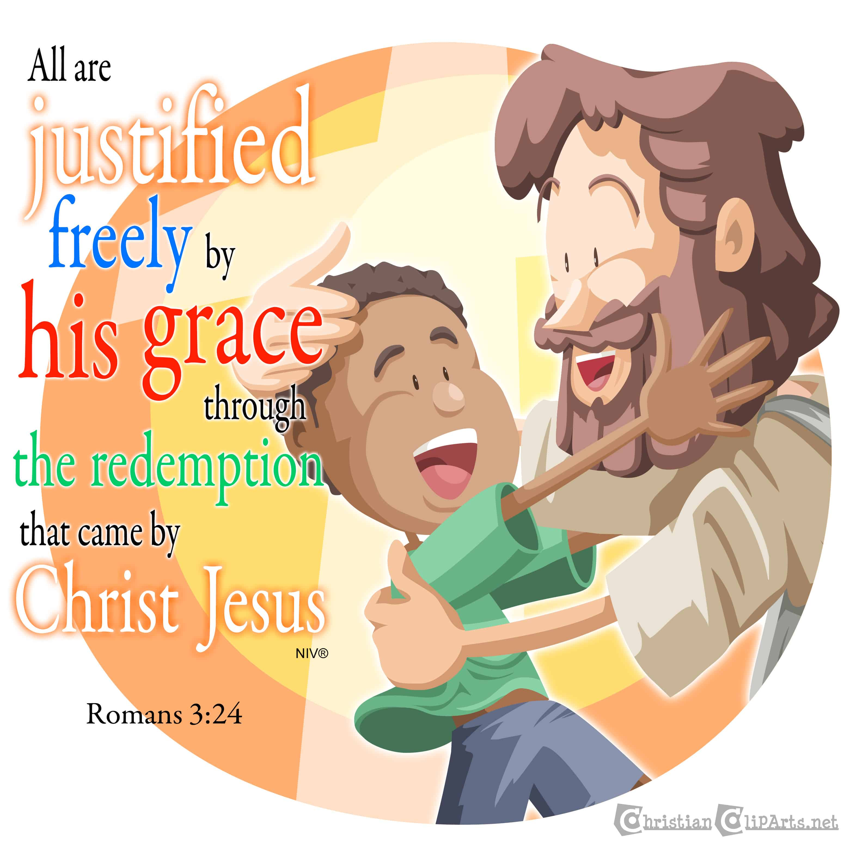  SPECIAL EVENTS  All Saints Festival  Epiphany Party  He Is Risen Egg Hunt  Valentines To Shut Ins  May Crowning
  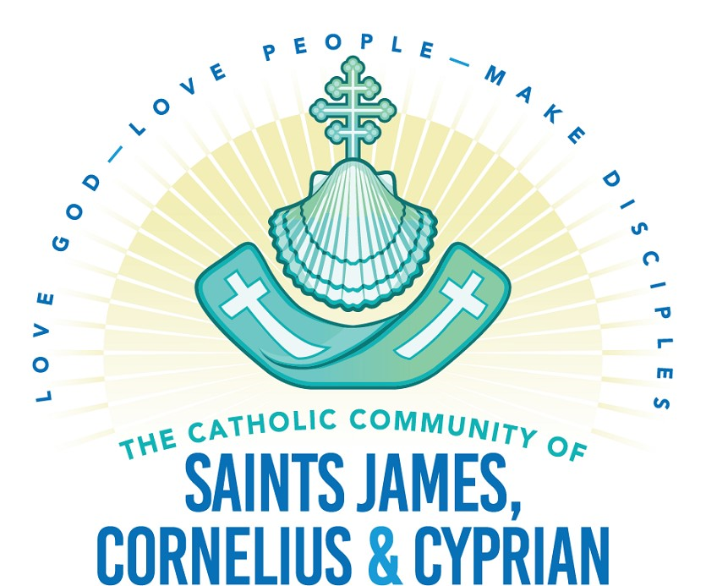
  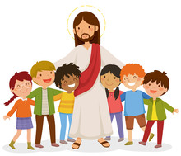
  GIFT
    - Growing In Faith Together
  Faith Formation Program
  For Grades K - 5
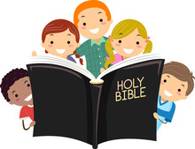  CHILDREN’S LITURGY OF THE WORD  This program provides an opportunity for young children to experience the Sunday Gospel reading with age-appropriate resources in order that they might gain a better understanding of the Word of God.  Children are dismissed from Mass before the readings commence for approximately twenty minutes and then they are dismissed back to the congregation for the remainder of the Mass. This program meets September to April in Keating Hall. | 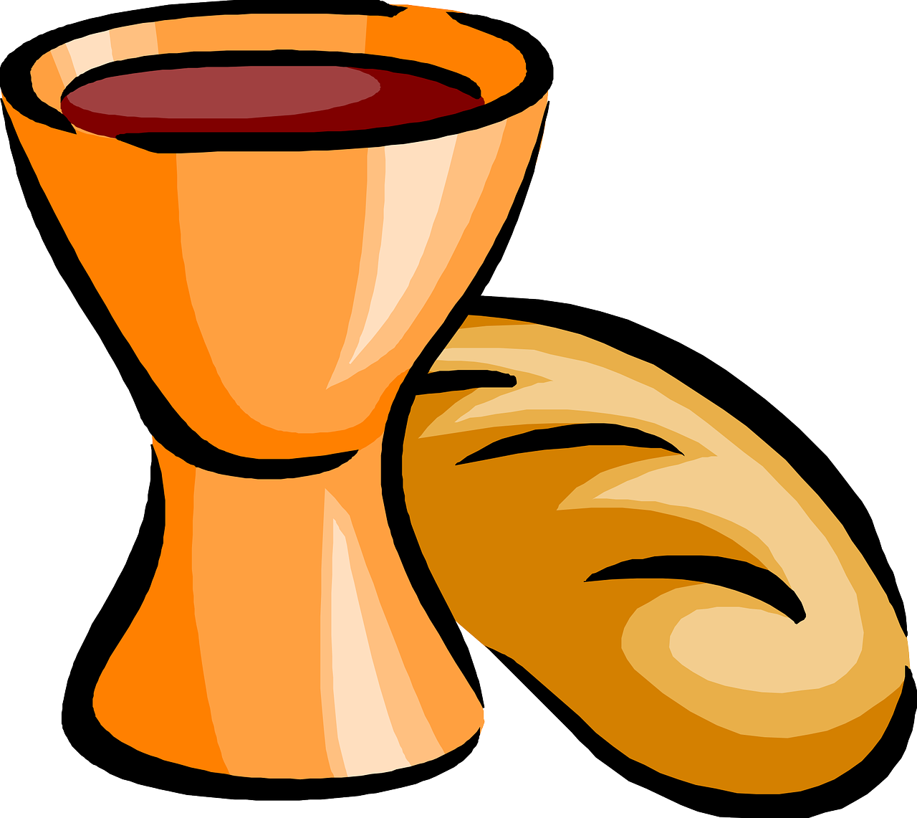  SACRAMENTAL PREPARATION  GIFT Students preparing for First Communion or First Reconciliation will be enrolled in the appropriate class. Students will receive instruction in the First Reconciliation Class for one year before enrolling in the First Communion Class.  Students will also receive take home material that they will complete with their parents. They will also attend a Sacramental Retreat with their parents.  Preparation for each sacrament takes one program year. | 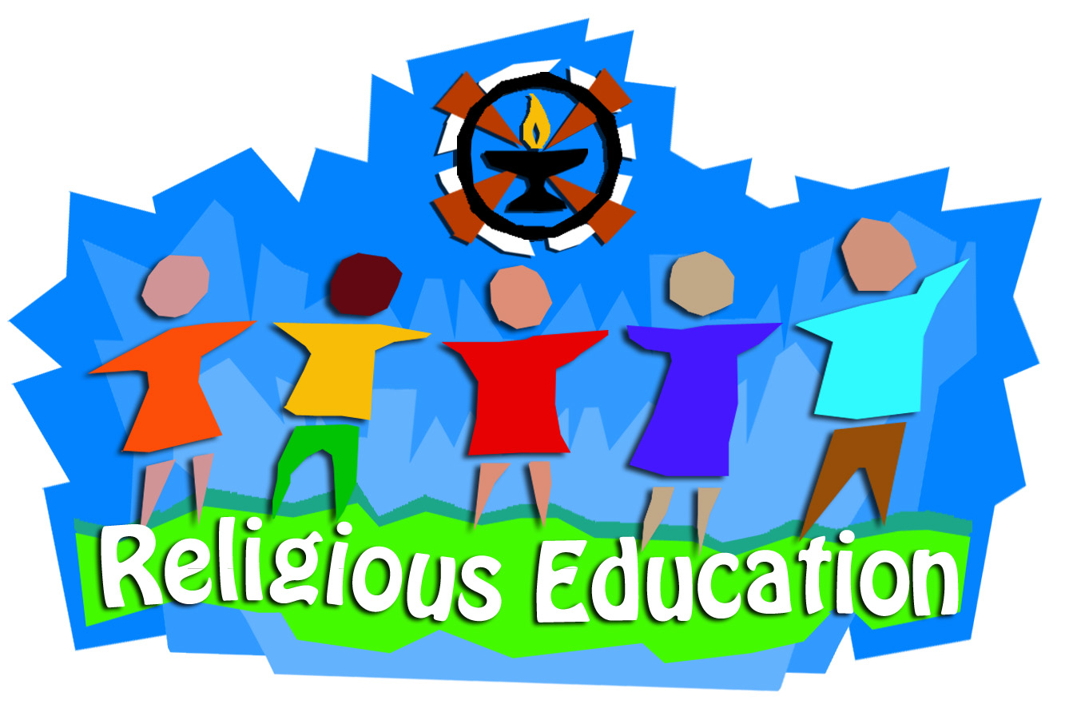  The GIFT Program is designed for grades Kindergarten through Fifth Grade. It provides basic instruction of the Catholic faith appropriate for each age level.  The program meets on Sunday, 9:00 AM to 10:15 AM in the Faith Formation Center on the St. James Campus from September to April.  The registration fee for the GIFT program is as follows……………  One Student…………….$75  Two Students…………….$135  Three or More Students………$165  Checks payable to Sts. James C&C Parish  Phone: 517-6766-9111  Email: teresa@saintsjcc.org  Web: www.saintsjcc.org

