GIBSON FAMILY HEALTH CARE

Strategic Plan
2026 - 2030

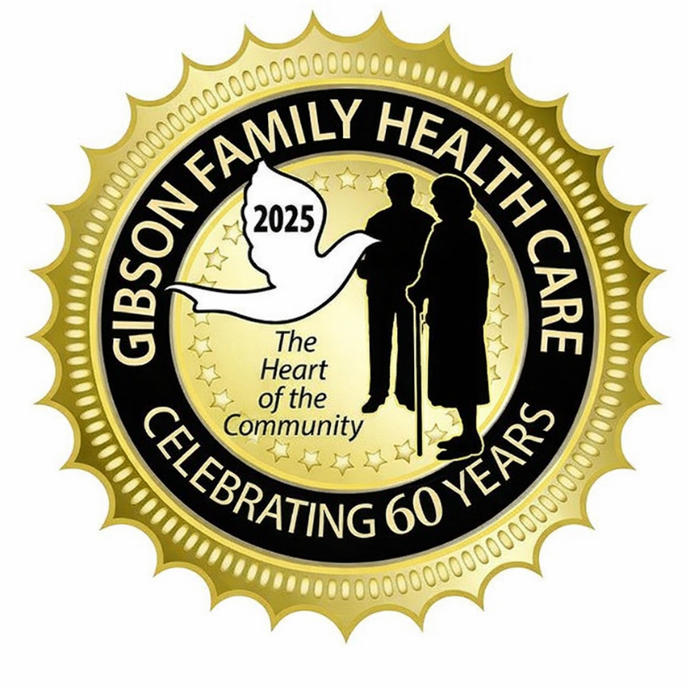

Table of Contents
BACKGROUND 2
INTRODUCTION 4
Strategic Direction 4
Key Challenges 5
Mission statement 7
vision 7
statement of philosophy 7
ORGANIZATIONAL CHART 8
Gibson Family cARE Operational Plan 9
STRATEGIC GOALS AND KEY DELIVERABLES 9
Delivery of Exceptional Person-Centered/Trauma Informed Care 9
Strengthen Our Healthcare Team 10
Foster a Culture of Diversity and Inclusion 11
Efficient Operations 12
Maintaining a Workplace Safety Culture 12
SUMMARY 14
Annual Strategic PLan Review Signature Sheet 15
Appendix A: 17
ENVIRONMENTAL SCAN – INTERNAL STRENGHTS/WEAKNESSES 17
ENVIRONMENTAL SCAN – External Opportunities/Threats 17
Appendix B: 19
INTERNAL & EXTERNAL COMMUNICATIONS 19
Appendix C: 22
OPERATIONAL PLAN 22
Appendix D: 24
QUALITY AND PATIENT SAFETY PLAN/FRAMEWORK 24
Appendix e: 26
HOME SPECIFIC ORGANIZATIONAL CHARTS 26
Appendix F: 28
REDEVELOPMENT PROJECT 28

Background

The Gibson Family have owned and operated a nursing home since 1965, with a number of employees who have worked for the Gibson Family for 40 or more years. The experience, knowledge and passion these employees have for the residents is invaluable in continuing to improve the quality of life for our residents. Gibson Family Care Centre is continually improving the quality of service provided to our residents. Our Homes are recognized in their communities as the nursing homes of choice for those families and residents who require our services.
The Gibson Family currently operates two residences, Carveth Care Centre (“Carveth”), located in Gananoque, Ontario, and Helen Henderson Care Centre (“Helen Henderson”), located in Amherstview, Ontario. Through the two residences, the Gibson’s currently operates a total of 208 LTC beds and 103 retirement beds.

Gibson Family Health Care homes, located in Loyalist and Leeds & the 100 Islands Townships, are situated on the ancestral lands of the Haudenosaunee, Michi Saagiig, and Omamiwinini peoples. We can support the Indigenous beliefs, traditions and health choices by providing appropriate safe places to practice ceremonies and health customs. We have access to resources at the Wellbeing Centre in the Tyendinaga Mohawk Territory. Our shared goal is to move forward, creating new welcoming partnerships that are built on truth, honor, and respect for members of the indigenous community within the home.
Admissions to the homes are done through Ontario Health atHome, at which a coordinator will assess the individual’s health as needed to determine their needs. In the 60 plus years the Gibson Family have owned and operated nursing homes, there has been a substantial change to care and the services provided to their residents.
At Gibson Family Care Centre, we research and evaluate processes, programs and services that will improve the quality of services we provide for our residents. Traditionally, the regulatory bodies have focused on the quality of clinical care provided to the residents. The social and spiritual needs of the residents were left up to the facility and the supporting families. The definition, implementation and support of ‘quality improvement’ programs have changed dramatically over the last 30 years.
Our mission is to provide excellent care and support for all residents and their family members by using a team approach to enhance their quality of life. With the amount of data that is collected, evaluated and stored on our residents and our Home, it has been necessary to computerize / automate some of the processes within the nursing home. Our learning curve is steep, and we are prioritizing the processes to be automated according to our philosophy for our residents. Our quality improvement process will benefit from computerization and input from outside organizations to complement our existing processes.
Accreditation Canada (now known as OnBoardQI), a major national accrediting body for organizations across all health sectors in Canada, Ministry of Health & Long-Term Care (MOLTC) and Ontario College of Nurses provides Gibson Family Care Centre with the necessary standards to ensure the quality of life our residents expect. Their mission is to help us improve the services we provide to our residents and the community.
Accreditation is a process that organizations use to evaluate their services to better the quality of their services. Accreditation also provides recognition that an organization’s services are meeting national standards of quality. Gibson Family Care Centre is a member of Accreditation Canada and utilizes their evaluation standards to ensure necessary processes are in place to provide continuous quality improvement and safety to our residents.
Family Council, Residents Council and the MOLTC Compliance Reviews provide direction and suggestions for quality improvement throughout the Home.
This Strategic Plan is used as a focal point for the Leadership Team to refer to on a regular basis. We have identified areas we need to focus on to ensure we continue to provide effective and efficient services for our residents.

In creating this plan, we reviewed our current operations and gathered information and feedback from staff, Resident and Family Councils, families, volunteers and stakeholders to ensure we are staying in line with our Mission, vision and values in ensuring we are providing the best care possible.

The primary focus of Gibson Family Care Centre is to provide Trauma-Informed and person-centered care with the comforts of home.

Introduction
Gibson Family Health Care Strategic Plan 2026 – 2030

Over the next 4 years we will be faced with ongoing changes which will affect our day-to-day operations.
Our strategic plan provides a framework for advancing Gibson Family Healthcare (both Carveth and Helen Henderson Care Centers) to their residents, staff, and community partners over the next 4 years. Our strategic directions build upon our Vision, Mission and Philosophy and provide a road map for meeting both our goals.

Guided by our Vision “Our Family Caring for Your Family” our plan is developed around our primary focus; our residents, their quality of life, their optimum care, and their safety. Our plan is developed and guided by five strategic directions:

- Enhance Resident Based Care (Trauma-Informed/Person-Centered Care):
To continuously strive to enhance the quality of life of our residents through our value-based behaviors, continuous quality improvement and diverse activities. Provide a home-like environment which respects the individual and ensures safety, security, and encourages involvement.

- Engage & Develop our People:
To deliver excellent care and service, we must foster a culture of excellence among staff, partners, and volunteers where they are encouraged to be and do their best. We support a workplace that is safe, inclusive, inspires teamwork and strives for organizational excellence through collaboration, sharing of knowledge and education.

- Foster a Culture of Innovation & Continuous Improvement:
Continuously strive to enhance our resident centered services ensuring safety, security, efficiency, and quality of life by reviewing and improving our processes, performance, and outcomes.
Leverage technology to create efficiencies and support both administrative and clinical applications.

- Promote Partnerships:
Strengthen existing partnerships and develop new partnerships to expand our range of services and optimize our performance. Collaboration and strategic partnering are essential in a multi-disciplinary environment. We will be proactive in cultivating relationships with our partner organizations, key stakeholders, and government bodies to improve our delivery of care.

- Proactive Facility and Infrastructure Planning
Exercise an ounce of prevention to increase resident and staff safety, minimize facility and equipment disruption and reduce costly breakdowns.
Our plan considers the changing landscape of long-term care and the following key challenges:

- Change in resident complexity/more severe cognitive behaviors
- Older and frailer residents with increased health needs/comorbidities requiring more complex care
- More complex care and the costs associated with multiple illnesses
- Complexity of integrating programs for a diverse population of residents
- Shorter hospital stays where residents are returned in a more fragile condition
- Increase in chronic care residents complex medical/physical/emotional and social needs

- Change in demand for services; Meeting the demands and expectations of families and caregivers
  - Increased government directives
  - Increased competition
  - Increased demand for complex and specialized services
  - Increased demand for information and the technological requirements to facilitate this
  - As the aging population grows, the expectations for Long-Term Care services are also increasing
  - Keeping up with our competitors
  - Staying in tune with technology
  - Families and caregivers continue to have high expectations related to LTC homes’ delivery of care to residents

- Change in Human Resources/recruiting and retaining the right staff
- Critical shortages in the global healthcare sector and employee pandemic fatigue
- Increased continued education for staff to deal with the complexity of resident care.
- Increased government directives to ensure a safe work environment and the resources to achieve this.
- Increased pressure from the union for higher wages and benefits.
- Improved work life satisfaction.
- Improve on being a culturally responsive environment that recognizes people served; staff members and volunteers come from a myriad of cultural backgrounds and that these cultures are integral to how we view and experience the world

- Re-Development Plans for all Long-Term Care Homes in Ontario
  - Ontario plans to invest an additional $3.7 billion, beginning in 2024-25, on top of the historic $2.68 billion already invested, to support this new series of allocations for the development of 10,000 net new and more than 12,000 upgraded beds across the province. These historic investments would bring the total to $6.4 billion since spring 2019
  - Carveth Care Centre has begin the extensive project; projected to take approximately 2-3 years until completion (details to be found in Appendix D)
  - Helen Henderson Care Centre to start preparation for re-development in 2030

This plan will serve as a tool to provide guidance to all department heads and team leaders in directing their staff to achieve the homes’ goals and vision for the future. This plan encompasses a comprehensive review of our Homes operations including input from staff, Residents Council, Family Council, families, caregivers, service providers and volunteers.

Our Quality Improvement Team meets quarterly and these meetings include reviewing the Strategic Plan to ensure we are meeting our goals. This team is made up of the Administrator/Owner, Director of Care, Assistant Director of Care, Dietary Manager, Activities Manager and Environmental Services Manager. In addition to ensure we are meeting are goals and staying in line with our Mission and Vision, the team reviews where improvements are needed. This includes a thorough review of all satisfaction surveys. Information will be shared with employees, Residents Council and Family Council to ensure our strategic direction is being met.

With an ever-growing aging population and an increasing number of illnesses and complex behaviors, staff and management in the health care sector are constantly faced with challenges. Gibson Family Healthcare is committed to finding ways to better the services it delivers to its residents, community, and staff. This strategic plan is focused solely on continuously making Gibson Family Healthcare and specifically Gibson Family Care Centre a safe and healthy environment for our staff and residents now and in the future.



Mission Statement:

Gibson Family Care Centre aims to provide excellent care and support for all residents and their family members by using a team approach to enhance their quality of life. While promoting resident safety, we strive to reinforce independence through values such as kindness, helpfulness, personal responsibility, and respect for others - qualities we believe are essential to leading humane and productive lives in our home.
Vision Statement:

“Our Family Caring for your Family.”

Statement of Philosophy:

Gibson Family Care Centre believes that their residents are entitled to the best quality of nursing care possible in a manner that will maintain the well-being, dignity and self-respect of each resident.

We believe that each Resident has the right to be cared for in a caring, friendly, and safe environment that is sensitive to their physical, emotional and spiritual needs.

We believe in a multi-disciplinary team approach in providing optimal nursing care which also includes the Residents family member or care provider/designate in his or her care planning.

We believe that in order to ensure the highest quality of care we must have established outcomes which can be clearly measured, monitored and evaluated at the department, program and committee level.

We believe that ultimately the success of our services will rely upon the total involvement of our staff, Residents and the community.



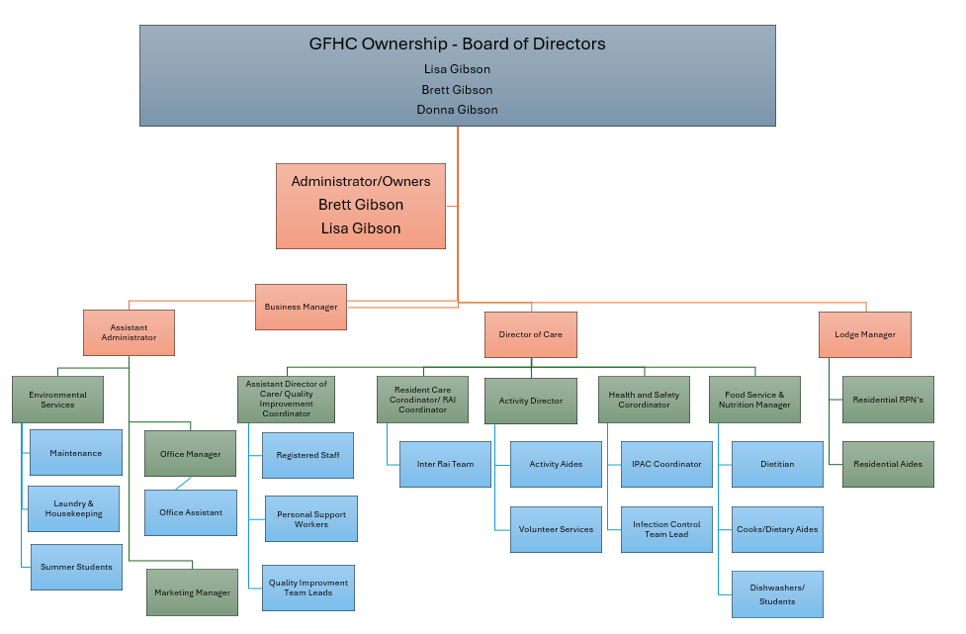
Organization Chart

GIBSON FAMILY HEALTH CARE STRATEGIC GOALS AND KEY DELIVERABLES
*SEE OPERATIONAL PLAN IN APPENDIX C

To develop this strategic plan, the homes Administration and Management undertook a comprehensive review of its operations and gathered input from its employees, Residents Council, Family Council, family members and caregivers, stakeholders and volunteers.
Residents Council and Family Council are active groups in the home and assist to provide feedback about the quality of care in the home. The views and concerns of residents and families about the quality of care being provided in the home need to inform all decisions. Families and residents receive ongoing communications from the home on all updates and changes that occur. Any concerns they may have are encouraged to be brought forward to the Management team, however they do have access to the MOLTC phone number and website if needed.
Gibson Family Care Center strives to ensure all goals are developed from a multidisciplinary approach, while ensuring they are departmental specific. Goals are defined as broad qualitative statements that describe what Gibson Family hopes to achieve within the planning horizon; objectives will be practical, specific, and measurable components that will achieve the goals identified.
The strategic plan has identified areas of focus to support the effective and efficient delivery of services to residents and enhance the operations of the home.

Strategic Goals and Key Deliverables

During 2026-2030, the home’s administration will focus on operational areas, building on our current foundation as these strategic goals are advanced. Staff, residents, family members and community partners will be informed of the direction in this strategic plan and its progress, seeking input along the way.

- Delivery of exceptional Trauma-Informed and Person-Centered Care.
Gibson Family Care Centre strives to provide exceptional Trauma-Informed and Person Centered Care with palliative care philosophy to ensure comfort and quality for residents. Person-centred care is a way of thinking and working that places residents, families, and staff at the centre of all decisions. Residents and families are recognized as experts in their own lives and are active partners in planning, delivering, and evaluating care.

Key Deliverables:

Gibson Family Healthcare is committed to providing safe, compassionate, and high-quality care that recognizes each resident as a whole person. Our care approach integrates Trauma-Informed Care (TIC) principles with a Person-Centred Care (PCC) Model, ensuring residents feel safe, respected, empowered, and heard.

Many individuals living in long-term care have experienced trauma throughout their lives. A trauma-informed, person-centred approach helps prevent re-traumatization, promotes trust, and supports dignity, choice, and meaningful relationships.

Key Principles of Trauma-Informed Care
Our care practices are guided by six foundational Trauma-Informed Care principles:
- Safety
We create physically and emotionally safe environments for residents, families, staff, and visitors. Policies and practices aim to prevent harassment, violence, neglect, and re-traumatization.
- Trustworthiness and Transparency
Decisions and operations are carried out consistently, fairly, and transparently to build and maintain trust between residents, families, staff, and leadership.
- Peer Support
We value the importance of shared experiences and encourage supportive relationships that foster connection, understanding, and recovery.
- Collaboration and Mutuality
Care is built on partnership rather than hierarchy. Residents, families, staff, and community partners work together, recognizing that everyone has a role in achieving positive outcomes.
- Empowerment, Voice, and Choice
We focus on individual strengths and promote self-advocacy by offering meaningful choices and respecting resident preferences.
- Cultural, Historical, and Gender Awareness
We acknowledge the impact of culture, history, identity, and lived experience. Care is delivered in an inclusive, respectful, and bias-aware manner.

- Continue to Strengthen our Healthcare Team through Growth
Gibson Family Care Centre will continue to focus on recruitment and retention to ensure that the residents have the staff in place to meet the exceptional person-centered and trauma-informed care needs.

Key Deliverables:

The ability to entice, engage, and retain the brightest talent is key to the long-term care sector, and in our rapidly evolving professional world is critical to Gibson Family Healthcare’s mandate and success. In addition, it is making sure staff understand the demands of the industry and can adapt to ongoing changes along with generational expectations.

It’s accomplished by finding and keeping people who fit with and contribute to our organization’s mission statement, culture, goals and values; people whose values are aligned with Gibson Family Healthcare and are motivated to deliver exemplary performance in the delivery of care to our residents and their families.

Focus areas may include ways to nurture:
  - mutual dignity, respect, recognition, and appreciation
  - ways to learn and grow professionally
  - peer and leadership mentorship opportunities
  - fair and equitable opportunities treatment within the organization and the industry
  - leadership training, coaching, feedback, performance management and opportunities to utilize a leadership role
  - work-life balance and fun
  - ongoing performance management
  - onboarding and orientation – set new staff up for success
  - support staff wellbeing and offer on-site services
  - Teamwork and team building
  - Employee recognition program
  - Build strong relationships through ongoing communication and engagement

- Foster a Culture of Diversity, Equity and Inclusion with healthy vibrant staff
Gibson Family Healthcare is committed to fostering an inclusive, welcoming, and affirming environments for all residents, families and staff through support and education. We believe in dignity, independence, and a sense of belonging. We embrace diversity in all its forms—including race, ethnicity, religion, language, ability, gender identity, gender expression, and sexual orientation—and we are committed to providing care that is free from discrimination and harassment.

Key Deliverables:

Gibson Family Healthcare homes and lodges propose adopting a strategy for enhancing greater staff diversity and inclusion.

Practices may include:
- recruiting, developing, and retaining a high performing workforce drawn from all segments of the Canadian landscape
- striving to foster an inclusive workplace by establishing diversity and inclusion committees and company-wide strategies and policies that encourage equity and fairness, elevating diverse talent and investing in training programs to build inclusive leadership
- promoting diversity and inclusion by organizing mentorship programs and employee resource groups aimed to support professional development black, indigenous, and people of color employees; various ages; differing backgrounds and experience; an initiative with the key objective to support the professional development of cultural diversity and the retention of their skills within the industry.
- host a guest speaker event on unconscious bias and building inclusion.
- inclusion and diversity strategy and the execution of a multi-year action plan. The plan includes training at all levels, the integration of inclusion and diversity in the company’s talent, and strategic support for community efforts to create a more inclusive world.
- Support the development of a Diversity and Inclusion Committee.
- Support their well-being through on-site service

- Efficient Operations
Proactively maintain up-to-date technologies, equipment and supports for staff to provide the best possible care to residents in a desirable space.

Key Deliverables:

- Upgrade equipment as needed; implement new technologies to streamline processes and improve outcomes
- Ensure staff are properly trained as new technologies and equipment arise
- Capital redevelopment at Carveth Care Centre (Gananoque location) - The original long-term care licensing expired in 2025. As part of the redevelopment process, the Ministry of Long-Term Care (“MLTC”) granted a 5-year license, to 2030, to cover operations during the construction period. The facility has received approval for redevelopment under the 2025 Long- Term Care Home Capital Funding Policy which includes a renewal of each of the 104 bed licenses upon completion of the new facility.
To accommodate the compliance of redevelopment, a new 28 bed wing will be constructed on the existing site, connecting to the existing home. All existing resident rooms will be renovated to meet current redevelopment regulations.
The construction of the new building will not interfere with the operation of the existing home or services to the residents. It is expected that the new building will take 20 months to complete once construction begins in January 2026. Once the new building is substantially complete and approved for occupancy, residents will be transferred from the existing home to the new 28 bed wing (additional information available upon request).
- Making sure necessary resources are available to all and communicating the means of getting such resources

- Maintaining a Workplace Safety Culture
A workplace safety culture is the collective set of shared beliefs, values and behaviors that prioritize safety throughout an organization. A strong safety culture leads to fewer accidents, improved performance and a safer, more confident workplace. Promote self-reporting of safety and near-miss events to provide timely feedback and informed change in the workplace.
Key Deliverables:
- Shared values and beliefs: the entire organization, from management to frontline employees, must view safety as a top priority that is integrated into every aspect of operations.
- Proactive Approach: a strong culture involves identifying potential hazards and addressing them before they cause harm.
- Open communication: employees must feel comfortable communicating/reporting safety concerns and asking questions without fear of retaliation.
- Employee empowerment: workers are given the training and tools to recognize and report unsafe practices and feel empowered to stop work if they believe it is unsafe.
- Leadership commitment: management demonstrates its commitment by actively participating in safety initiatives, allocating necessary resources, and making safety a key factor in decision-making. As well as providing the necessary education and communication to staff, residents, families and caregivers.

By following these key components, a strong safety culture results in:
- Reduced accidents
- Improved performance
- Compliance with all
- Employee well-being
- Resident and family satisfaction

SUMMARY
Gibson Family Care Centre has and continues to build their programs utilizing the experience of the management team, staff, volunteers and residents. The Gibson family has been owners/operators for more than 60 years; with many employees who have worked at Gibson Family Care Centre for more than 30-40 years; and over twenty-five percent of residents from the local community that have been living at Gibson Family Care Centre for more than 10 years.
In order to fulfill our vision and achieve the mission we have defined for our homes, we need to establish a formal approach to ensure we not only maintain our present quality of life for our residents but also continue to improve their quality of life.
On quality improvement; direction from the Ministry of Long-Term Care; the documented approach by the Canadian Council on Health Services Accreditation (CCHSA), Residents First, OHQA, and our present program; we have designed a structured approach to our Quality Improvement program that will continue to enhance the quality of life for our residents. In order to provide a consistent, efficient and effective approach to quality improvement we will use the National standards, definition of quality and indicators, identified by CCHSA. The integration of CCHSA’s approach to quality improvement with our present approach will eliminate the duplication of effort for Accreditation.
In order to achieve the highest quality of life for our residents, we must be able to meet the goals identified for Gibson Family Care Centre.
Gibson Family Care Centre’s continuous quality improvement philosophy, to meet residents’ needs and exceed their expectations by using a structured process that identifies areas to improve our services, including the outcomes of services to our residents, will be attained by meeting or exceeding our goals and objectives. As a cohesive team; staff, management, residents, and volunteers of Gibson Family Care Centre, and continue to always look for ways to improve.
The Gibson Family strongly believe in promoting within. Many Managers came from working on the floor in various positions. This goes in line with ‘Our Family Caring for Your Family’ as we truly believe our family extends much farther than the household. This has also allowed to have extremely strong relationships with staff, residents and families.

ANNUAL STRATEGIC PLAN REVIEW

SIGNATURE SHEET

Reviewed and approved by:

Year 1
________________________________________________ ____________________
Lisa Gibson, Owner/Administrator Date:
________________________________________________ ____________________
Sue Reynolds, Director of Care Date:
________________________________________________ ____________________
Resident’s Council Date:
________________________________________________ ____________________
Family Council Date:

Year 2
________________________________________________ ____________________
Lisa Gibson, Owner/Administrator Date:
________________________________________________ ____________________
Sue Reynolds, Director of Care Date:
________________________________________________ ____________________
Resident’s Council Date:
________________________________________________ ____________________
Family Council Date:

Year 3
________________________________________________ ____________________
Lisa Gibson, Owner/Administrator Date:
________________________________________________ ____________________
Sue Reynolds, Director of Care Date:
________________________________________________ ____________________
Resident’s Council Date:
________________________________________________ ____________________
Family Council Date:

Year 4
________________________________________________ ____________________
Lisa Gibson, Owner/Administrator Date:
________________________________________________ ____________________
Sue Reynolds, Director of Care Date:
________________________________________________ ____________________
Resident’s Council Date:
________________________________________________ ____________________
Family Council Date:

APPENDIX A:
ENVIRONMENTAL SCAN:

Strengths: |  | Weaknesses/Challenges:
- take great pride in our Homelike environment, beautiful décor and continuous upgrades made to the home.  - High resident and family satisfaction results  - Engaged Residents’ Council  - Newly established Family Council  - supportive families and essential caregivers and volunteers  - Caring, compassionate and well-trained employees  - Comprehensive training program (SURGE)  - Outstanding volunteer program, including family volunteers  - ongoing Staff appreciation efforts  - Increasing focus on palliative, comfort and end-of-life care  - Safety is a priority for all  - Longevity and experience of leadership team/promoting within  - Utilizing technology for both staff and residents in multiple aspects in the home including connecting with families through email and various media platforms  - Support for student learning including collaboration with multiple colleges  - Focused on maintaining and improving resident independence  - Robust Infection Control Practices and Health and Safety Committee with employee engagement including high vaccination results within the home | - Continuous shortage of RPN’s/recruitment of staff  - Human resources realities including aging workforce, injuries, and absenteeism  - Ongoing challenges managing responsive behaviours, workplace violence and physiological safety in the workplace  - keeping up with structural challenges (painting, floors, baseboards, etc.)  - burnout with staff and maintaining work-life balance
Opportunities:  - Excellent reputation/family owned and operated for 60+ years  - Strong support from the Community  - Accredited by Accreditation Canada (OnBoard) since 2008  - Multiple committed contracted service providers including physicians, physiotherapy, other health and building related  - Large pool of volunteers  - A plethora of options for technology improvements for care, communication, safety, etc.  - Supportive community partners  - Collaboration with local hospital and public health unit | Roadblocks/Threats:  - Increasing Regulatory demands and extraordinary documentation requirements/changes are continuous  - Majority of admission are crisis, waitlists and demand is growing.  - Limited pool of potential (qualified) employees in the local area  - Limited funding and a vast amount of home needs  - Periods of harsh weather (heat waves, storms including snow)

APPENDIX B:
COMMUNICATIONS PLAN:

- INTERNAL COMMUNICATIONS:

  - Open Door Communication Policy

Gibson Family Care Centre encourages employees to discuss any issues they may have with a co-worker directly with that person. If a resolution is not reached, employees should arrange a meeting with their direct supervisor. If the concern, problem, or issue is not properly addressed, employees should contact Administration. Any information discussed in an Open Communication meeting is considered confidential, to the extent possible while still allowing management to respond to the problem. Retaliation against any employee for appropriate usage of Open Communication channels is unacceptable.

  - Staff Meetings

Quarterly
In order to keep the communication channels open, Gibson Family Care Centre implements a quarterly department specific staff meeting.

Bi-annual
Company-wide staff meeting.

  - Manager’s Morning Reports

Every morning at 10:00 a.m. all managers/supervisors as well as Nurse Practitioner when available, meet to discuss the previous 24 hour events (or 48 hour for weekends).

Round table of what is happening that day.

    - Morning Announcements to outline the day/weekly events.

  - Labour Management Meetings

  - Residents Council

  - Family Council

  - Care Conferences with Families: Initial 6 week care conference, and yearly afterwards

  - Newsletters: on website and Mailed Out/Highlights sent out with billing monthly to inform families of events and news, etc.

  - Electronic Bulletin Boards

Gibson Family Care Centre runs a company-wide electronic bulletin board service where employees can find organizational announcements, news/events, and discussions about specific topics. The employee is responsible for reading necessary information posted on the bulletin boards.

  - Quarterly Joint Manager’s meeting with sister home to maximize resources

  - Suggestions Box

Gibson Family Care Centre encourages all employees to bring forward their suggestions and good ideas about making Gibson Family a better place to work and enhancing service to their customers. Any employee who sees an opportunity for improvement is encouraged to talk it over with management. Management can help bring ideas to the attention of the people in the organization who will be responsible for possibly implementing them. All suggestions are valued. The box is strategically located in the staff room so that it is easily accessible for staff use.

  - Events Calendar/Staff Education Calendar

  - Lunchtime information sessions for new initiatives ie RAI-MDS

  - Departmental Communication Log

  - Bulletin Boards throughout the home

  - Enhanced Internal Communications system with portable phone access to both Nursing Home and Lodge

  - Email

EXTERNAL COMMUNICATIONS

  - Electronic information boards in CCAC office in Kingston, Brockville and Gananoque as well as CPHC offices and KGH

  - Pamphlets/brochures

  - Monthly meeting with Investment Advisor/Accountant and Administrator

  - Radio MYFM and Fly FM to promote home events and broadcast info for the home

  - Host Community workshops- ie Horticultural society and the residents attend events

  - Constant communication with Veterans-monthly visits host the veterans annual

  - Skyping and e-mail with families

  - Fundraising/support of Toy Drive, Salvation Army, Food Bank, Terry Fox Run, Special Olympics/Lung Association

  - Newspaper EMC/Kingston This Week/VISTA

  - Submit articles to APO/OLTCA

  - Updates and bulletins sent to Management team daily from OLTCA

  - Church Bulletins

  - EMARS - Communication amongst Pharmacy, Management, Reception to Reception, Nursing, etc. with updates and news

  - Administrator and DOC attend quarterly zoom CCAC and KFL&A Meetings

  - Website-broadcast upcoming events, notifications of alerts/outbreaks

  - Professional advisory Committee Meetings held quarterly (includes Management Team, Owner, Medical Director, Dietician, Public Health, Pharmacist, Physiotherapist)

  - Ontario Health atHome

  - ODSP

  - Lennox & Addington Mental Health

  - Ongoing collaborations with clinics through the hospitals

  - Strong relations with local Police and Fire Departments

  - Strong relations with local MPP’s

APPENDIX C:

GIBSON FAMILY HEALTHCARE
OPERATIONAL PLAN

APPENDIX D:

QUALITY AND PATIENT SAFETY PLAN/FRAMEWORK

APPENDIX E:
HOME SPECIFIC ORGANIZATION CHARTS

Carveth Care Centre
Organizational Chart

Helen Henderson Care Centre
Organizational Chart
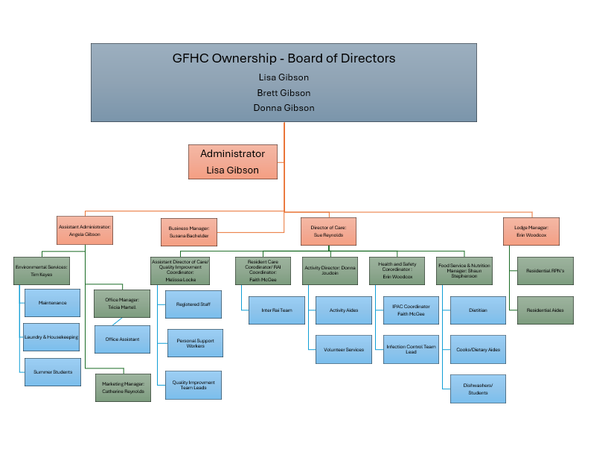

APPENDIX F:
REDEVLOPMENT ANNOUNCEMENT/PROJECT

DRAFT
FOR IMMEDIATE RELEASE
FRIDAY FEBRUARY 11, 2022

Ontario Redeveloping Long-Term Care Beds
at Carveth Care Centre in Gananoque
Ongoing investments in new projects will protect our progress
by bringing much-needed beds to the province

GANANOQUE — The Ontario government is redeveloping 104 beds at Carveth Care Centre in Gananoque. This is part of the government’s $6.4 billion commitment to build more than 30,000 net new beds by 2028 and 28,000 upgraded long-term care beds across the province.

“Our government has a plan to fix long-term care and a key part of that plan is building modern, safe, and comfortable homes for our seniors,” said Paul Calandra, Minister of Long-Term Care. “When the construction at this home is complete, it will be a place for local seniors to call home, near their family and friends.”

Construction is expected to start by March 2024.

“After years of neglect, our government is exceeding our commitment to get shovels in the ground and long-term care beds built and redeveloped,” said Steve Clark, MPP for Leeds-Grenville-Thousand Islands and Rideau Lakes. “Local residents deserve high quality healthcare, like that offered here at Carveth, in their own communities, close to home and to family.”

There are now 294 new and 230 upgraded long-term care beds in development, under construction or completed in Leeds and Grenville, including the following projects:
- 104 upgraded beds allocated to Carveth Care Centre, announced today
- 94 new and 66 upgraded beds at Bayfield Manor in Kemptville
- 68 new and 60 upgraded beds at Wellington House in Prescott
- 132 new beds at Maple View Lodge in Athens.

“The Carveth Care Centre has been a part of the fabric of our Town of Gananoque for over 50 years,” said Ted Lojko, Mayor of the Town of Gananoque. “This significant redevelopment recognizes the excellent care the Centre provides and the province’s commitment to creating long-term care in rural communities.”

The government has a plan to fix long-term care and to ensure Ontario’s seniors get the quality of care and quality of life they need and deserve both now and in the future. The plan is built on three pillars: staffing and care; accountability, enforcement, and transparency; and building modern, safe, comfortable homes for seniors.

QUICK FACTS
- As of today, Ontario now has 22,343 new and XX upgraded beds in the development pipeline - which means more than 74% percent of the 30,000 net new beds being delivered are in the planning, construction and opening stages of the development process.

- Ontario plans to invest an additional $3.7 billion, beginning in 2024-25, on top of the historic $2.68 billion already invested, to support this new series of allocations for the development of 10,000 net new and more than 12,000 upgraded beds across the province. These historic investments would bring the total to $6.4 billion since spring 2019.

- Ontario is providing $868 million in 2021-2022 to cover the extraordinary costs of COVID-19 prevention and containment in long-term care homes - $328 million primarily to address the enhanced measures enacted in response to the Omicron variant. This additional funding will help ensure long-term care homes have the resources they need to protect the health and safety of residents, staff and caregivers and to help homes maintain sufficient staffing levels to support residents.

ADDITIONAL RESOURCES

Visit Ontario's website to learn more about how the Province continues to protect Ontarians from COVID-19.
2021 Ontario Economic Outlook and Fiscal Review: Build Ontario

FOR MORE INFORMATION, CONTACT:
Doug Brewer:
MPP Steve Clark’s Office
Office: (613) 342-9522
Cell: (613) 246-4278

Province announces major development at Carveth Care Centre in Gananoque
Investment is good news for community

(FEB.11, 2022) — A long-term care home in Gananoque has been selected by the Ontario government for a major upgrade.

The province is redeveloping 104 beds at Carveth Care Centre which is part of the government’s $6.4 billion commitment to build more than 30,000 net new beds by 2028 and 28,000 upgraded long-term care beds across the province.

It is welcome news for Brett Gibson, Administrator of Carveth Care Centre.

“With so much uncertainty in the world due to the Covid-19 pandemic, today brings excitement and clarity for the residents, staff, families of Carveth and the community of Gananoque” he said. “Our residents will have an upgraded and improved place to call home. Our staff will have a permanent place of employment that will be enhanced, with a focus on safety for all. Our families will have confidence and trust that they are placing their loved ones in a progressive/modernized home. Our community is going to have a long-term care home to be proud of.”

“Our government has a plan to fix long-term care and a key part of that plan is building modern, safe, and comfortable homes for our seniors,” said Paul Calandra, Minister of Long-Term Care. “When the construction at this home is complete, it will be a place for local seniors to call home, near their family and friends.”

Construction is expected to start by March 2024.

“After years of neglect, our government is exceeding our commitment to get shovels in the ground and long-term care beds built and redeveloped,” said Steve Clark, MPP for Leeds-Grenville-Thousand Islands and Rideau Lakes. “Local residents deserve high quality health care, like that offered here at Carveth, in their own communities, close to home and to family.”

“Carveth Care Centre has been a part of the fabric of our Town of Gananoque for more than 50 years,” said Ted Lojko, Mayor of the Town of Gananoque. “This significant redevelopment recognizes the excellent care the centre provides and the province’s commitment to creating long-term care in rural communities.”

The government has a plan to fix long-term care and to ensure Ontario’s seniors get the quality of care and quality of life they need and deserve both now and in the future. The plan is built on three pillars: staffing and care; accountability, enforcement, and transparency; and building modern, safe, comfortable homes for seniors.

“Knowing our family will continue for another 25 years of providing quality long-term care to our community is a proud accomplishment for my sister and I as we continue the legacy our grandparents and parents started more than 50 years ago,” said Gibson proudly. “I know they are smiling down on us. This is a great day for our residents, staff, families, and our community.”

About Gibson Family Health Care

Carveth Care Centre is a combined retirement logde and long-term care home located at 375 James Street, Gananoque, Ontario. It is owned and operated by Gibson Family Health Care. The sister home of Carveth Care Centre is Helen Henderson Care Centre in Amherstview.

To reach Brett Gibson, please call 613-382-4752 ext. 102 or email brettgibson@gibsonfamilyhealthcare.com

To learn more about Gibson Family Health Care, please visit: www.gibsonfamilyhealthcare.com

