Chemical Spill Kit Contents
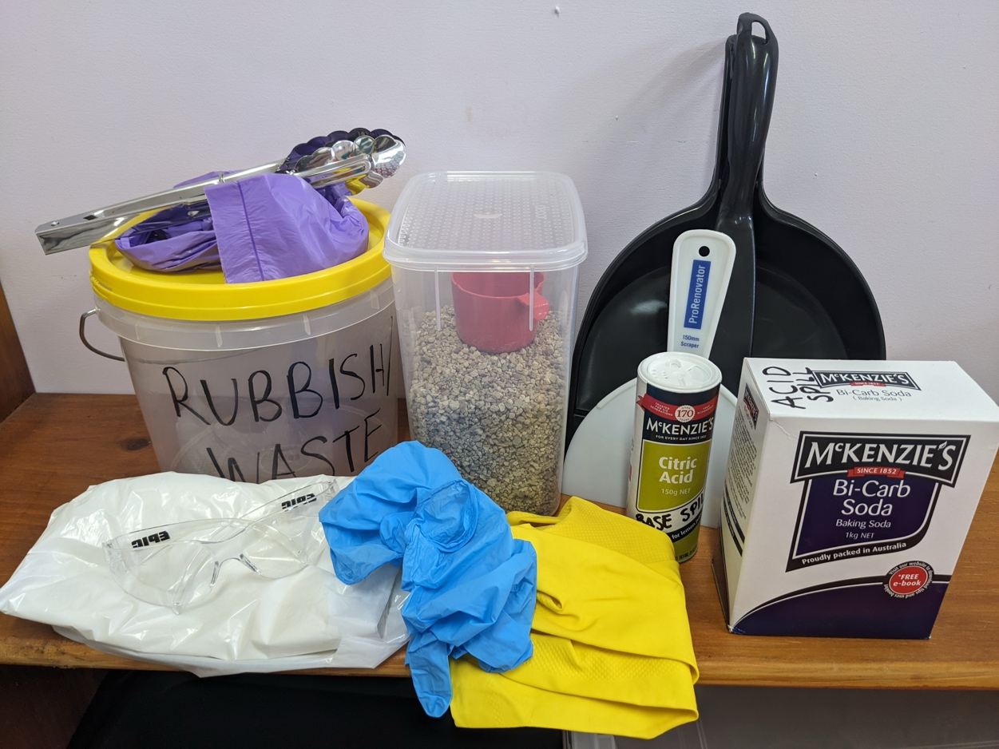

Personal Protective Equipment (PPE):
- Safety Glasses
- Nitrile Gloves
- Washing Up Gloves
- Dust Mask
- Disposable Plastic Apron
Spill Equipment:
- Kitty Litter (to dam the spill)
- Bi-Carb Soda (to neutralise acid spills)
- Citric Acid (to neutralise base spills)
- Dustpan and Brush
- Plastic Scraper
- Tongs
- Rubbish Bag and Bucket
- Paper Towel

