

Discharge Instructions – TTA

Thank you for bringing {Patient Name} to Sydney Animal Hospitals for their treatment of cranial cruciate ligament disease.
As your pet has had orthopaedic surgery, strict adherence to the following post-operative instructions will ensure the best possible chance of an uncomplicated recovery.

Please review the image below for an understanding of the surgery:

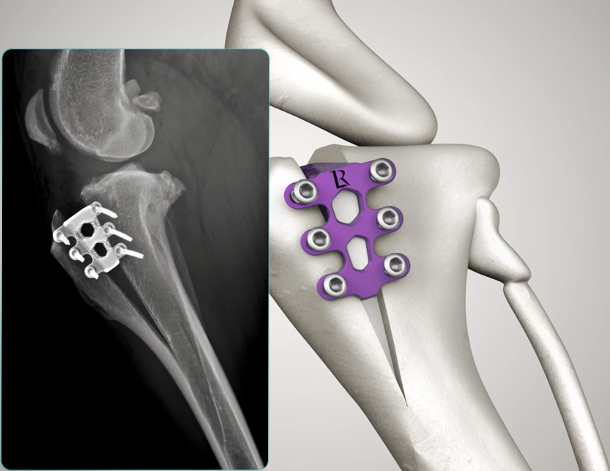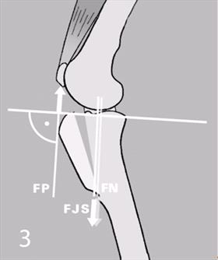

The Tibial Tuberosity Advancement (TTA) procedure is aimed at changing the biomechanics of the stifle (knee). The procedure is suitable for dogs in the small weight and size range, however, can be recommended up to any size depending on breed and presentation. The Tibial tuberosity is advanced forward to correct the instability caused by cruciate ligament rupture.
At SAH we use the TTA Rapid implant system (as per above). This system is robust and secure, and consistently gives excellent results for the TTA procedure.

Wound Care:
A dressing may be covering the wound at the time of discharge from the hospital. This can be removed two days post-surgery or earlier if soiled. There should be zero - very minimal discharge coming from the wound. Some swelling and bruising is normal in the first few days post operatively especially around the ankle area. Please reach out to us if you are concerned that the wound is showing signs of infection or swelling excessively.
We normally discharge patients with an “E collar/ Cone”. This is to prevent your dog from licking the wound. Please leave the collar on for 2 weeks. If an infection were to get in through the wound, this could result in further surgery.

Medications:
Please continue the following medication as labelled. Occasionally dogs will develop vomiting or diarrhoea whilst taking medication. Please stop the medication and contact us if this happens.
- Amoxycillin / Clavulanic acid– this is a broad-spectrum antibiotic. Please give twice daily with food until finished.
- Meloxicam– this is a nonsteroidal anti-inflammatory. Please give as directed once daily with or after food. Use this medication daily for up to 4 to 6 weeks post operatively, then as needed if you feel your dog is painful.
- Paracetamol – For additional pain relief. This is human paracetamol, however some formulations have different strengths, other medications or sweeteners in them that can be toxic for dogs so please stick with the formulation dispensed. We will advise the dose of paracetamol if indicated.
- Trazadone – dogs are often prescribed trazadone as an additional anti-anxiety medication to help adjust to cage rest and confinement.
- Antinol – An omega 3 supplement. Antinol can be used continuously for arthritis and inflammation management. Lifelong dietary supplementation with Omega 3 or fish oils can be valuable in controlling arthritic pain. Please note that some patients can demonstrate sensitivity to this supplement.
- Synovan (Pentosan polysulphate) – This stimulates cartilage synthesis, production of joint fluid and improves blood flow to the joint. This aids in repair and protection of the joint and reduction of osteoarthritic changes in dogs. This is a series of 4 injections, given once per week. We repeat the course every 6 months.

Diet:
As normal. However, please ensure you maintain an ideal bodyweight throughout your pet’s life. During this rest period, this may mean reducing portions.

Rehabilitation:
Initially at home you should apply an ice pack wrapped in a towel to the knee regularly for the first week and then as needed. Please perform some gentle flexion and extension exercises. Regular, gentle massage (sweeping motions from ankle to hip) may help dissipate any oedema fluid. Massage techniques will be advised at discharge. Your vet will talk you through this if this is something your dog requires.

Exercise:
10-12 weeks following surgery, you must restrict your dog's activity. For the first 6 weeks strict rest and confinement is essential. After this period the dog's activities will be gradually increased.
Crate confinement is an excellent insurance against post-operative injury. We can arrange crate hire through our reception.
Your pet can be inside, on non-slip surfaces, under direct supervision.
Avoid all slippery surfaces, stairs and any form of jumping.
When not under your direct supervision, your dog should be kept confined (ideally to a large cage or alternatively a small room with non-slip flooring).
For the first 6 weeks post op: Please restrict your dog to four 5min leashed walks with a pelvic sling daily, to toilet.
At 6 weeks post op: we will see your dog back for a recheck and radiographs to evaluate healing of the surgery site. If healing is progressing normally, you can start adding 5 – 10 mins to the walk time each week.
10-12 weeks after surgery, A final examination will be needed to evaluate final healing. Instructions will then be given for returning your pet to normal activity.
Swimming is very effective in accelerating your pet’s recovery from surgery. Aim to swim your pet for 3-5 minutes alternate daily if possible.

Follow up appointments:
Your pet will need regular rechecks at the following times.
Week 1 - Wound check and second Synovan injection
Week 2 - Suture removal and third Synovan
Week 3 - Final wound check and fourth Synovan.
Week 6 - Repeat radiographs. Patients will require fasting overnight as anesthesia is required.
Weeks 10-12 - Final examination. We recommend this recheck is performed with your surgeon, or one of the vet team.

The cost of these rechecks including post op radiographs is included in the initial TTA fee.

Please contact the hospital to arrange these appointments.

If any time during healing, your dog appears to have increased pain or other set-backs, please contact us direct.

Sydney Animal Hospitals

