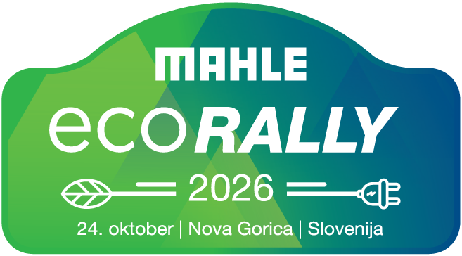

ENTRY FORM / PRIJAVNICA

MAHLE ECO RALLY 2026i

24. oktober 2026, Šempeter pri Gorici, Slovenija

Avto moto društvo Gorica
Cesta IX. Korpusa 48, 5250 Solkan, Slovenija

Pošljite prijavnico na: prijave@rally-novagorica.si
Send the Entry form to: prijave@rally-novagorica.si

APPLICATION TO REGISTER / VLOGA ZA REGISTRACIJO
Date and time received / Datum in ura prejetja:
Rally no. / Štartna št. :
COMPETITOR / TEKMOVALEC
Name/Ime:
Licence no./Št. Licence:
COMPETITOR / TEKMOVALEC
Name/Ime
Licence no./Št. Licence
First surname/Priimek
Address/Naslov
Num./Hišna št.
Town or city / Kraj
ID number/Št. Os. dokumenta
Nationality/Nacionalnost
Postal code/Poštna številka
Phone/Telefonska št.
Mobile phone/Mobilna št.
E-mail/Elektronski naslov
CO-DRIVER / SOVOZNIK
Name/Ime
Licence no./Št. Licence
First surname/Priimek
Address/Naslov
Num./Hišna št.
Town or city / Kraj
ID number/Št. Os. dokumenta
Nationality/Nacionalnost
Postal code/Poštna številka
Phone/Telefonska št.
Mobile phone/Mobilna št.
E-mail/Elektronski naslov
VEHICLE/VOZILO
Manufacturer/Proizvajalec
Model
Year/month built/Leto&mesec proizvodnje
Predominant colour/Prevladujoča barva
Registration number/Registracijska oznaka
Chassis no./Št. Šasije
Country of registration/Država registracije
Weight/Teža
Battery energy (kWh)/Moč baterije (kWh)
Consumption (Wh/km)/Poraba (Wh/km)
Tyres data/Podatki o pnevmatikah

Vehicle/Vozilo
1 photo of the vehicle/1x slika vozila
Vehicle documentation/Prometno dovoljenje
Certificate of Conformity (CoC)/Potrdilo o skladnosti vozila (CoC)
Technical Specification Card/Homologacija vozila
REGISTRATION FEES/PRISTOJBINA ZA PRIJAVO | Amount EUR | Total  Euro
WITH Organiser’s publicity/Z reklamo organizatorja |  | 300€
WITHOUT Organizer’s publicity/Brez reklam organizatorja |  | 600€

Details of bank account into which the total amount has to be paid:
Podatki o bančnem računu na katerega se vplača skupni znesek:
Avto moto društvo Gorica, Cesta IX. Korpusa 48, 5250 Solkan, Slovenija
NOVA KBM d.d. : SI56 0400 1004 6912 972, BIC code: KBMASI2X

The undersigned accepts responsibility for the details that figure in this document, and declares and he or she To accept and agree in full to the terms and conditions of the Supplementary Regulations.
Spodaj podpisani sprejemam odgovornost za pravilnost podatkov in izjavljam sprejemamo pogoje iz dodatnega pravilnika.
----------------------------------------------------------------------------------------
DATE / DATUM

Signature of Competitor  Podpis Tekmovalca |  | Signature of Driver  Podpis Voznika |  | Signature of Co-Driver  Podpis Sovoznika

