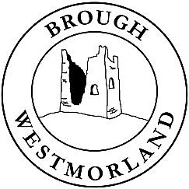
BROUGH PARISH
COUNCIL
PARISH PLAN 2026-27

“Taking Pride in Improving Brough”

The Parish Council’s priorities for 2026-27 are:

- Support the continued improvement of Brough Parish, helping it to be an even better place to live, work and visit, and fostering a sense of Civic Pride

- Improve the environment and appearance of Brough, with particular emphasis on:
tree management
maintenance and improvement of community orchards, gardens and greens
maintenance and rationalisation of benches, fences and other street furniture
encouraging litter-picking and
taking action against dog fouling

- Continue to “Make Brough Bloom”

- Support children’s and young people’s activities in the Parish

- Support the maintenance and improvement of local facilities, including Brough public conveniences

- Support local events and an increase in local sports & leisure activities

- Continue efforts to secure improved broadband services for Market Brough, following the successful implementation of improvements in Church Brough

- Support and encourage public transport services into and out of Brough, the development of the A66

- Continue to liaise with the Multi-Agency Strategic Co-ordinating Group (MASCG) regarding Appleby Horse Fair to ensure a successful event

- Provide observations and comments Westmorland & Furness Council regarding planning applications

- Review, and strengthen where necessary, arrangements for community emergency planning and resilience

- Develop further the Brough Parish Council website to:

improve the accountability of the Council and provide better access to Council business
provide up-to-date information to Brough residents, those in neighbouring parishes and visitors
promote Brough as both a “stop-off” and “stay-at” destination

- Seek to engage more people in volunteer activity for the benefit of the Parish.

Councillors
Gillie Allison
Clare Birkbeck
Alan Brocklehurst
Pauline Capstick
Sarah Ellwood
Steve Heap
Dawn Henderson

