UPDATING DEDUCTIBLE AND OUT OF POCKET AT BLUE SHIELD OF CA

Background: Effective July 1, 2025, HMC’s transitioned its medical plan from Anthem/HNAS to Blue Shield of California for all enrolled members. With this change, member (& enrolled dependents) information such as their annual deductible and out of pocket maximums had to be transferred from Anthem to Blue Shield of CA.
This transition was completed using a snapshot of each employee’s deductible and out-of-pocket totals as recorded by HNAS in late May/early June. As this snapshot reflects a specific point in time, any, claims processed after that date were not included.
Blue Shield of California allows a one-time opportunity to update member deductible and out-of-pocket balances. Therefore, if any late claims are processed by HNAS (the prior administrator), employees will need to contact Blue Shield directly and provide appropriate documentation to request any necessary adjustments.
The following set of directions details the method to use to check if Anthem/HNAS information aligns with the current Blue Shield information.
Summary Overview:
- Obtain your most up to date deductible/out-of-pocket information at HNAS/Anthem by logging into https://myhnas.com and download latest EOB statement.
- Check your Blue Shield account to see if deductible & out-of-pocket information reflects similar information.
  - Android Google play: Blue Shield of California - Apps on Google Play
  - Iphone Store: Blue Shield of California on the App Store
  - Website: blueshieldca.com/godigital

- If there is a discrepancy in numbers, reach out to Blue Shield of CA Connect team at 888-499-5532. Team will provide you an email address if required.

Process Details

- Obtain your latest (EOB) Explanation of Benefit Form on your account at https://myhnas.com. If you have not accessed your account at all, you will need to contact HNAS to obtain the latest copy.
  - Phone: 800-220-2600, email claims.hnas@hnas.com

Example of HNAS EOB:
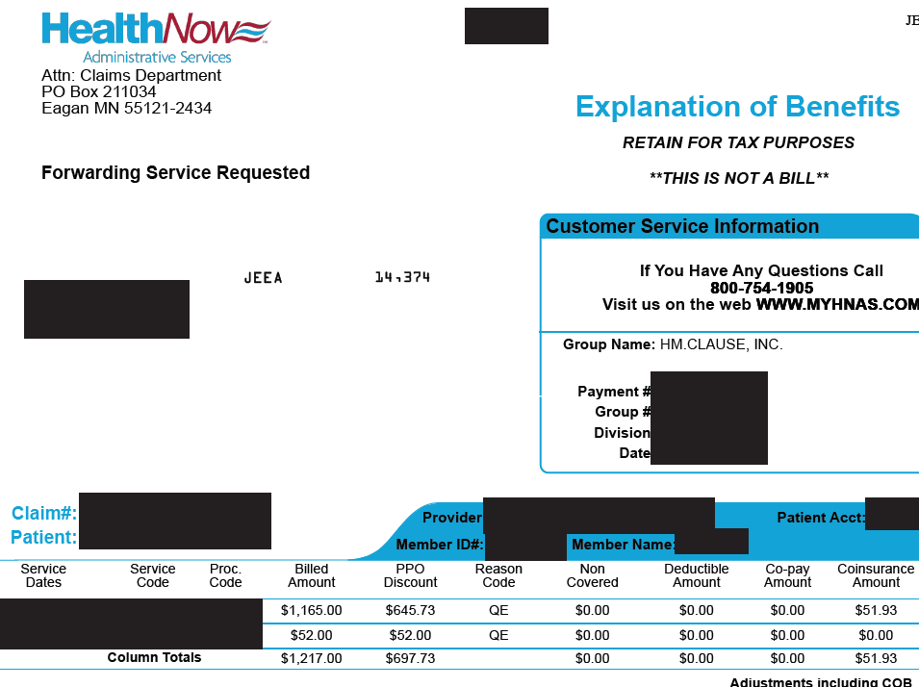

  - Specifically look for the Accumulator Status. This section provides information on the deductible and out-of-pocket met. If you have family members under your plan, obtain copies that will have your family member listed under Member. *** This is the statement Blue Shield of CA needs to update your deductible and out-of-pocket.***

If such information is not available, search for a claim under your dependent’s account to locate the accumulator status for them.
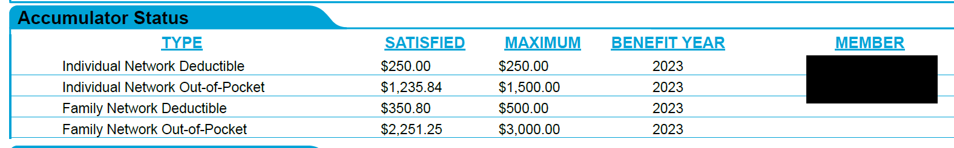

- Check on your Blue Shield of CA account to view your current deductible.
  - Access information:
    - Android Google play: Blue Shield of California - Apps on Google Play
    - Iphone Store: Blue Shield of California on the App Store
    - Website: blueshieldca.com/godigital
  - To view Blue Shield’s current record of your deductible and out-of-pocket.
    - Phone App
- Select the Benefits icon located on the bottom of the screen.
- In the usage area, the medical deductible will appear. Swipe left to view out-of-network (non-participating provider) deductible and out-of-pocket maximum met.
    - Desktop
- Under Dashboard tab > Select View Claims
- View deductible and out of pocket met.
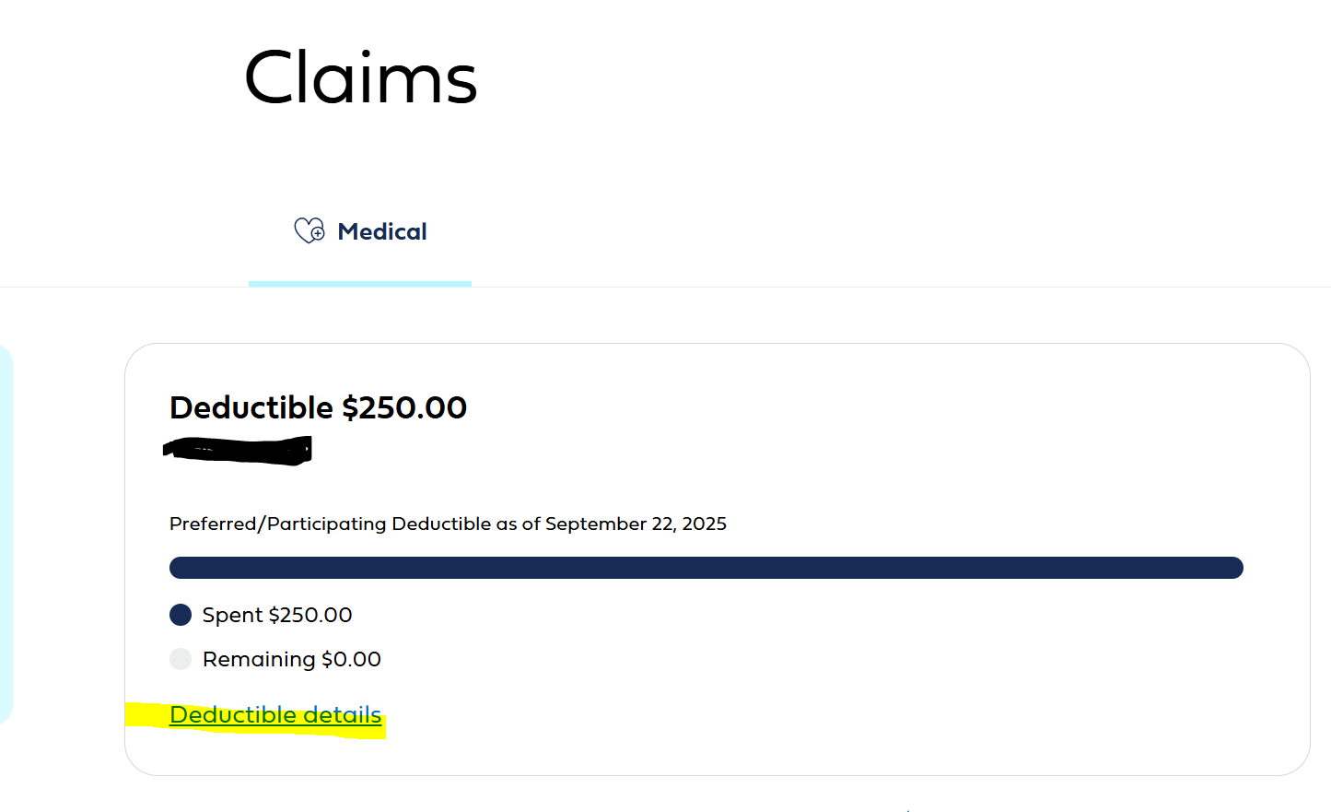

- Deductible or Out of Pocket met on Blue Shield’s records show less than HNAS/Anthem amount.
  - Gather your and dependent(s) latest EOB from HNAS. All copies of family members are required to show Blue Shield how the individual and family deductible / out-of-pocket were met.
  - Call Blue Shield Connect at 888-499-5532
  - Describe the nature of the call. The representative should provide you an email address for you to send the HNAS/Anthem EOB documents to Blue Shield for review.
    - If representative will not assist in the update of your deductible & out of pocket
      - Request to speak to a manager. If manager declares the same information.
        - Get name of representative & manager
        - Note date and time of call
        - Email hr.ampa@hmclause.com of the situation.

