Submitting FSA Reimbursement on HealthEquity’s Phone App

- Log into HealthEquity’s app:

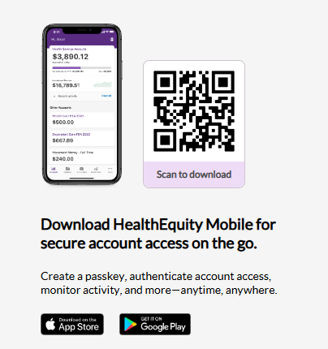

- Type in Username and Password when prompted. If logging in for the first time, select Register your account.
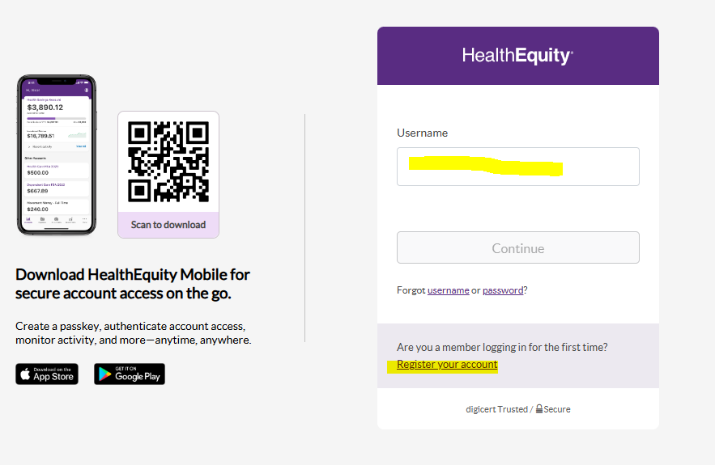

- Setup passkey if prompted.
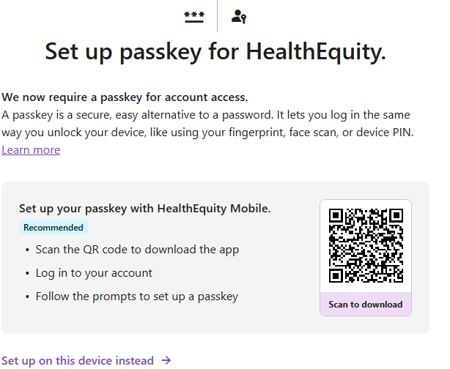

- Once logged in, click on the desired prompt. Details listed below.
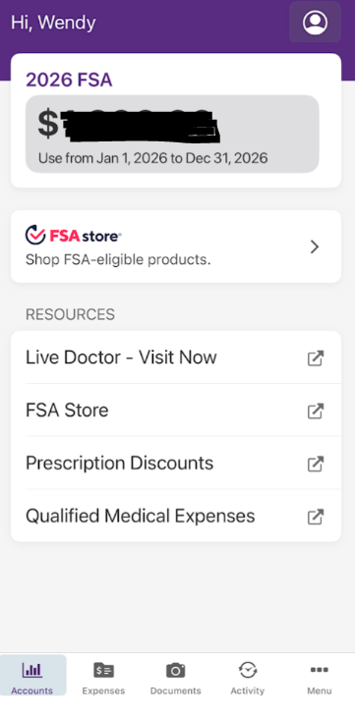
  - Expenses – Submit a claim for reimbursement.
  - Documents – Upload or take photo of your receipt.
  - Activity – View current actions pending (e.g. claims in process)
  - Menu with 3 dots
  - Account Activity - View current actions pending (e.g. claims in process)
    - Contributions – View contribution history from payroll
    - Profile
      - Dependents & Authorized Users
      - Beneficiaries – Add beneficiary information
      - External Accounts – Set up banking information for direct deposit
      - Manage Cards – Copy of FSA card (if enrolled in Medical FSA). Dependent care FSA do not have debit cards.
    - Manage Cards – Copy of FSA card (if enrolled in Medical FSA). Dependent care FSA do not have debit cards.
    - Support – contact with HealthEquity representatives
    - Scan Barcode – Available for employees enrolled in the Health Savings account (enrollment in the Blue Shield of CA High Deductible plan is required).

Set up banking information to have direct deposit for claims
  - Follow prompts – Verify your phone number via text
  - Connect phone number to Plaid
    - Banking accounts will appear for you to select the account you want.
    - You will need to log into your banking institution
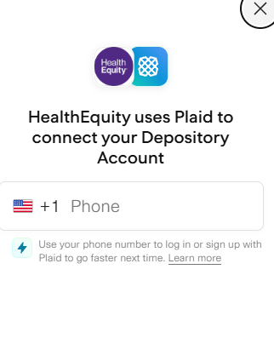

Submitting Expenses

- Click on the Expenses icon | 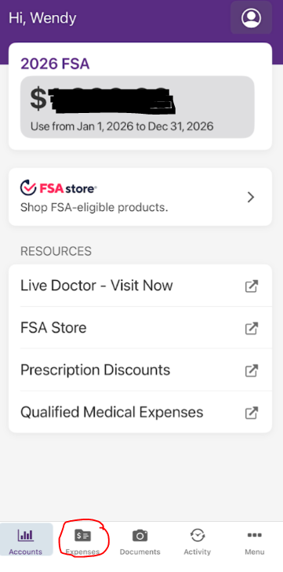

- Key in required fields. Complete the Add New Provider option to complete the reimbursement request. | 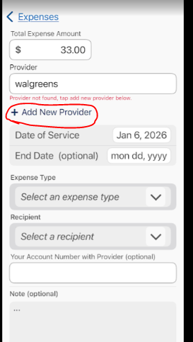

- Attach your supporting documentation. Once completed, click on Save and Reimburse Me. | 