Submitting FSA Reimbursement on HealthEquity’s Account via Desktop

- Log into HealthEquity’s website: https://www.healthequity.com/login
  - Select HealthEquity > Members | For Individuals

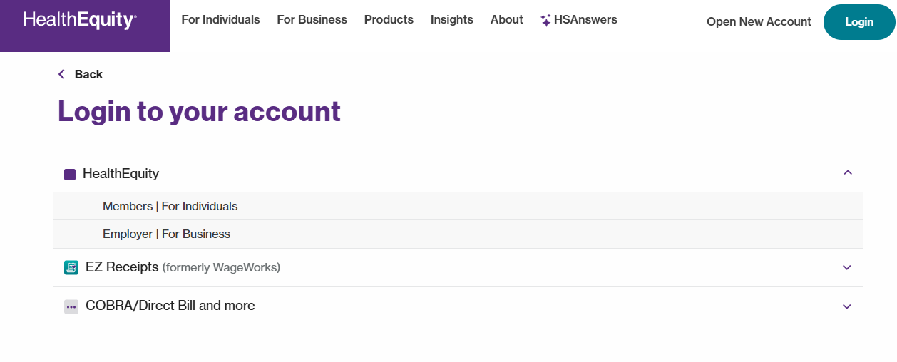

- Type in Username and Password when prompted. If logging in for the first time, select Register your account.
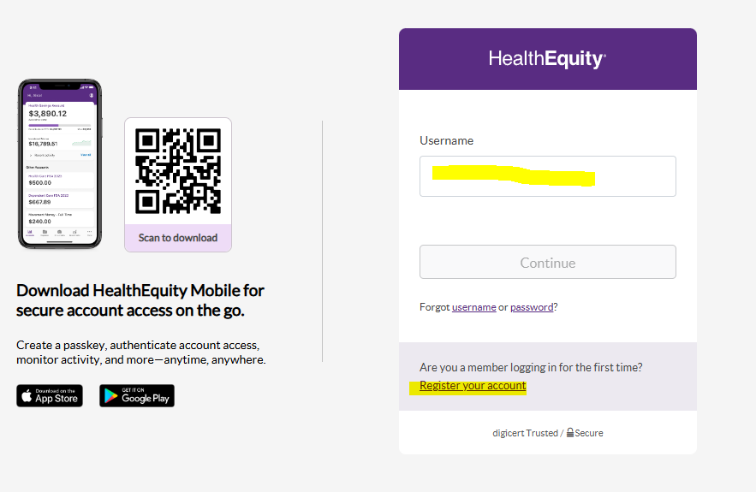

- Setup passkey if prompted. You will need to upload the HealthEquity app onto your phone to complete the passkey process.
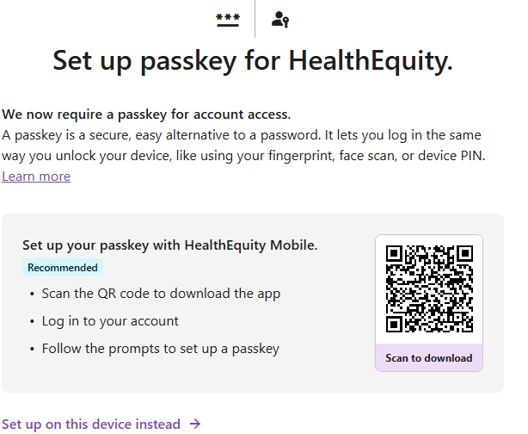

- Once logged in, access “Reimburse Me” in the home page.
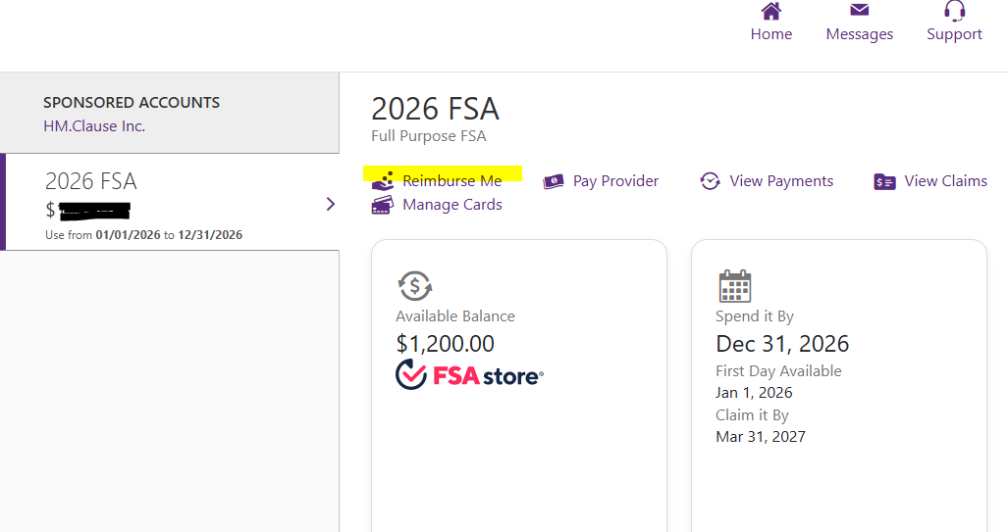

- Set up banking information to be direct deposited for claims
  - Follow prompts – Verify your phone number via text
  - Connect phone number to Plaid
    - Banking accounts will appear for you to select the account you want.
    - You will need to log into your banking institution
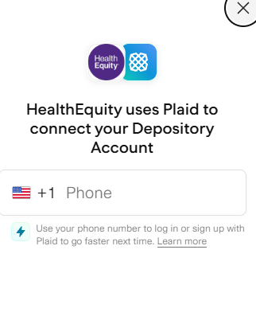

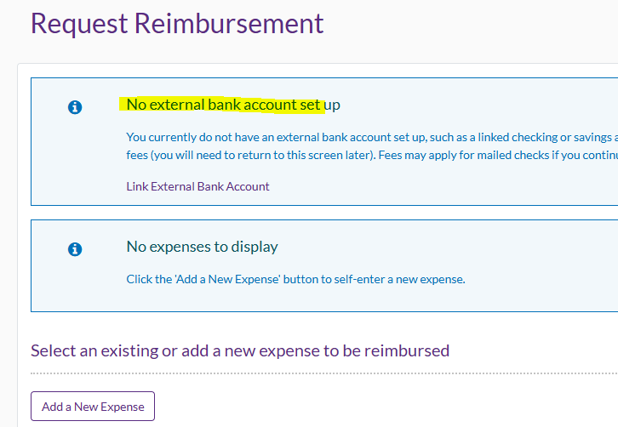

- Select Add a New Expense
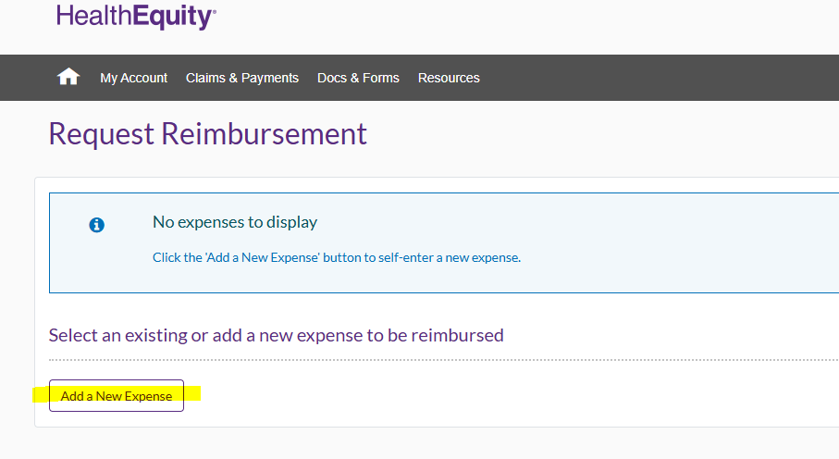

- Key in the information as prompted
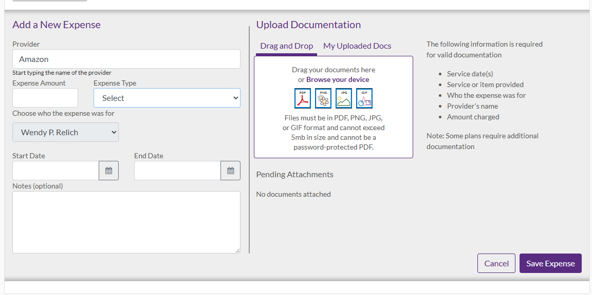
  - Start Date & End Date: Date when item was purchased or when service provider was seen. If invoice captures multiple dates, key in the first and last date on the invoice.
  - Save Expense

- To finalize – select the Claims & Payments tab > View Claims
  - Select the claim you uploaded by clicking on Details
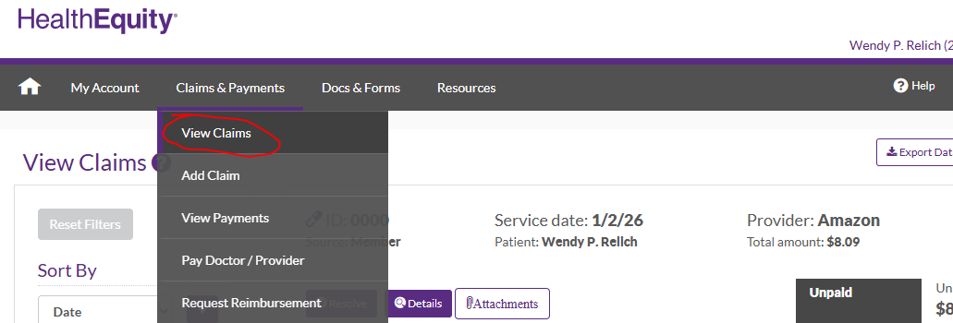

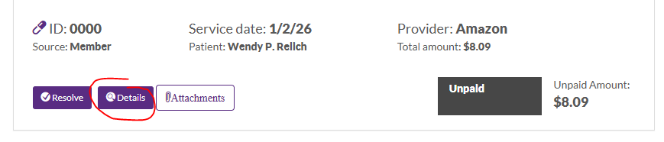

  - Select Reimburse Me
