Background:
As our wellness vendor, HC360+ tracks employee’s fitness activities either automatically by syncing the individual’s fitness tracker to their phone or by manually entering fitness activity. Activity is a required component if the employee is participating the in the annual gym reimbursement program offered to HMC employees only. Sister companies, such as Vilmorin, do not have the gym reimbursement program available.

Contents
Available Methods of Tracking 1
Links to phone apps 1
Methodology 1
Syncing Fitness Tracker to phone 1
Manual tracking on HC360+ phone app 2
Manual tracking on HC360+ desktop 4

Available Methods of Tracking
- Sync fitness tracker to phone
- Manual tracking on HC360+ phone app
- Manual tracking on HC360+ desktop

Links to phone apps
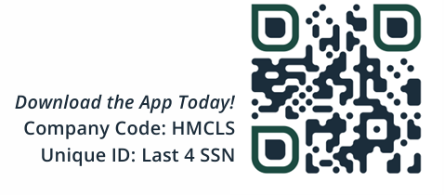

Click here to register for a HC360+ account. If HC360+ cannot locate your information, please reach out to hr.ampa@hmclause.com

Methodology

Syncing Fitness Tracker to phone
- Download HC360+ app
- Connect to one of the following
  - Apple Health
  - Fitbit
  - Garmin Connect
- Click here for instructions on syncing app to your fitness tracker.

Once synced, your activity will be transferred to your HC360+ app. Ensure that your preferred connection device, Apple Health, Fitbit, or Garmin Connect, is connected to both your fitness tracker and HC360+

You can check if the HC360+ app is receiving fitness activity by viewing the Activity tile on the app.

Phone App Desktop
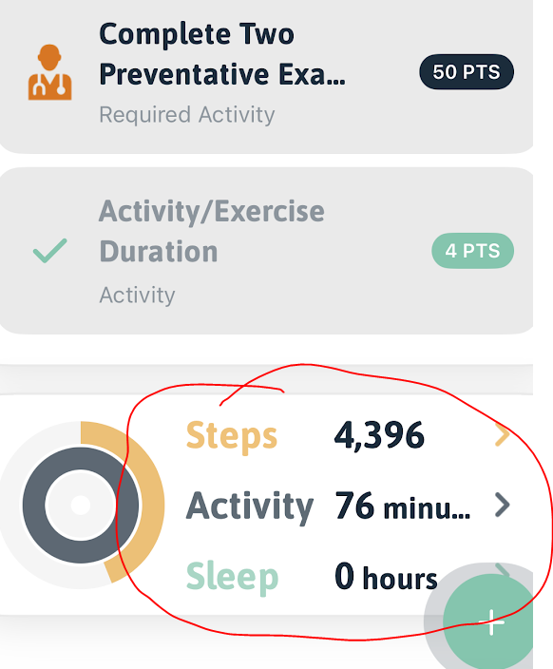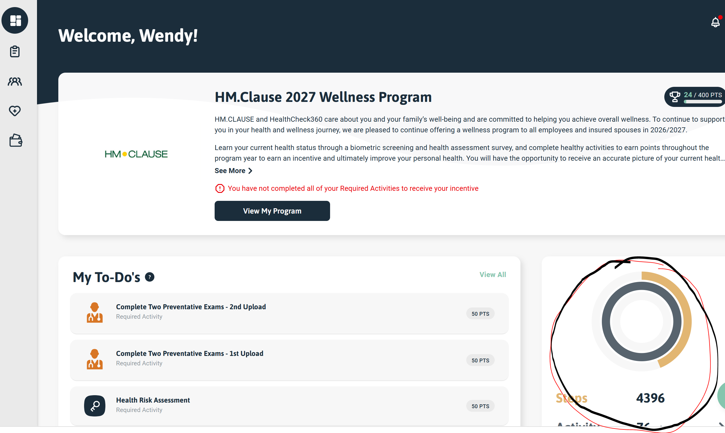

Manual tracking on HC360+ phone app

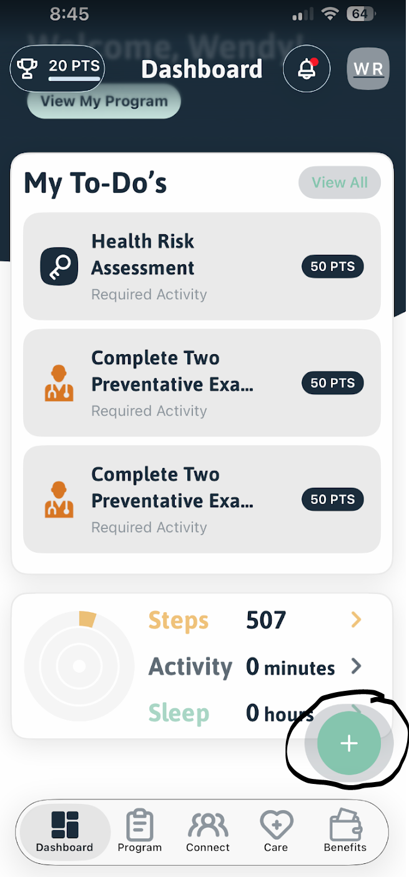 | Log into the phone app  Click on the plus sign circle icon
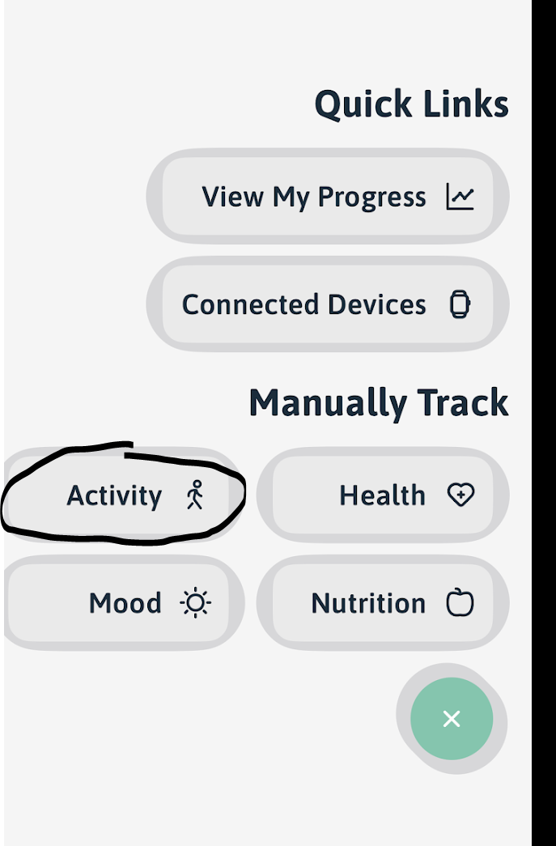 | Select Activity
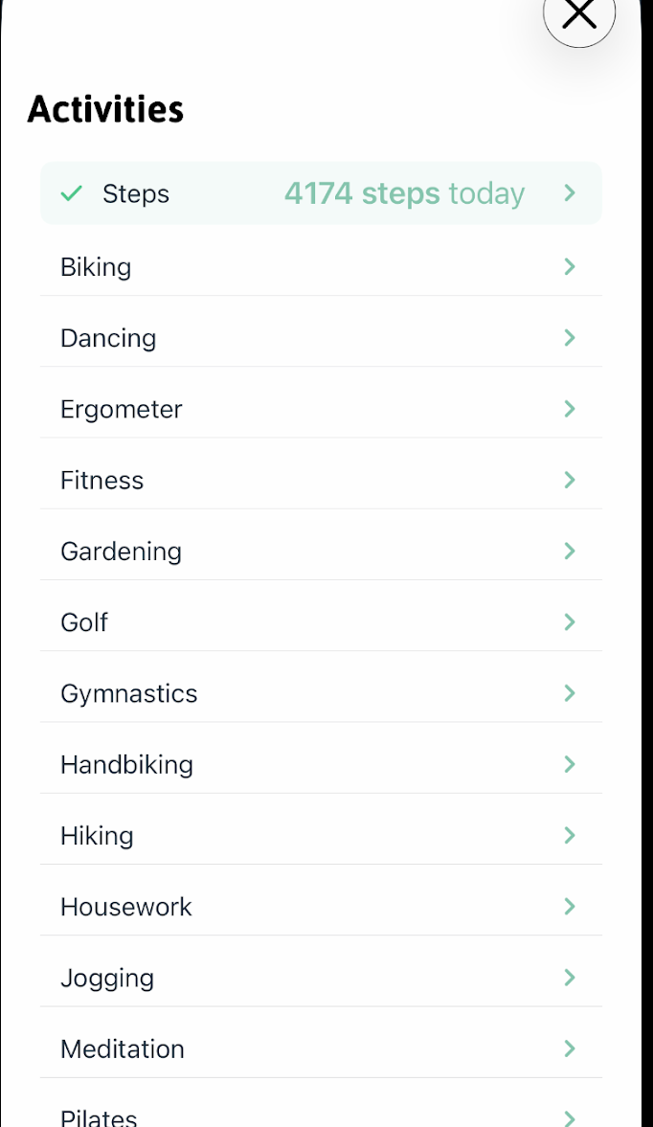 | Choose the option that best fits your activity.
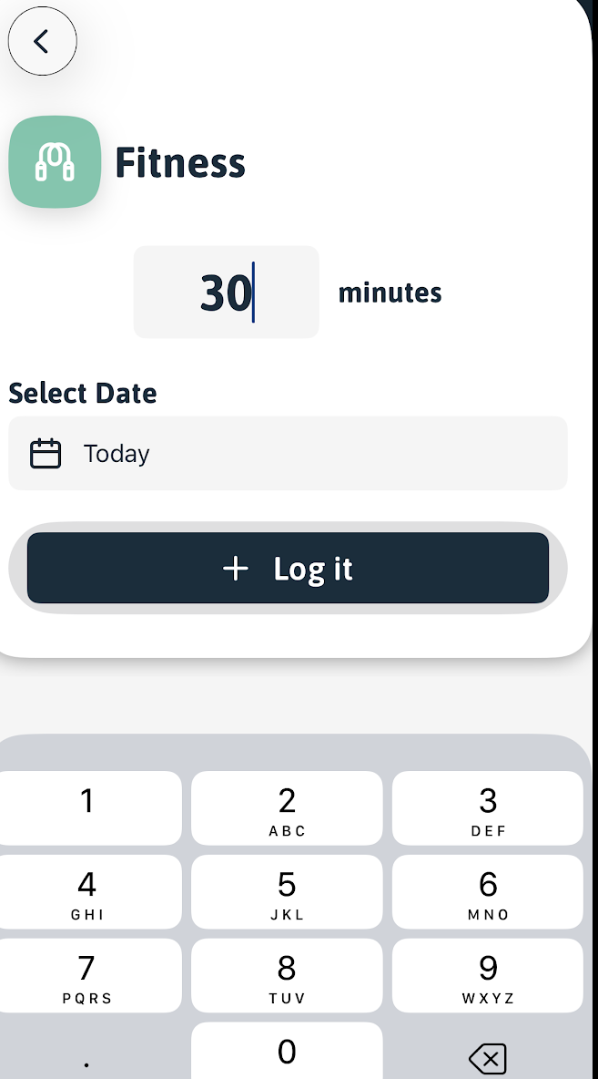 | Key in the amount of time you completed for the specific session. For the fitness reimbursement, a minimum of 60 minutes of activity is required each week.
 | Check the Activity tile to confirm that your activity was submitted.

Manual tracking on HC360+ desktop

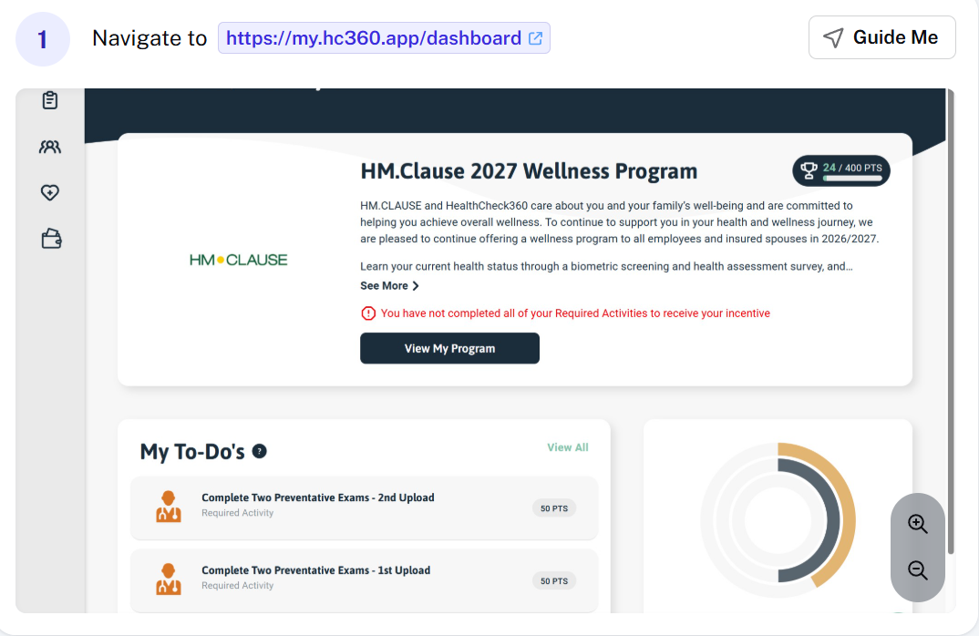 | Log onto your desktop account by visiting:  https://my.hc360.app  Click on the plus sign circle icon
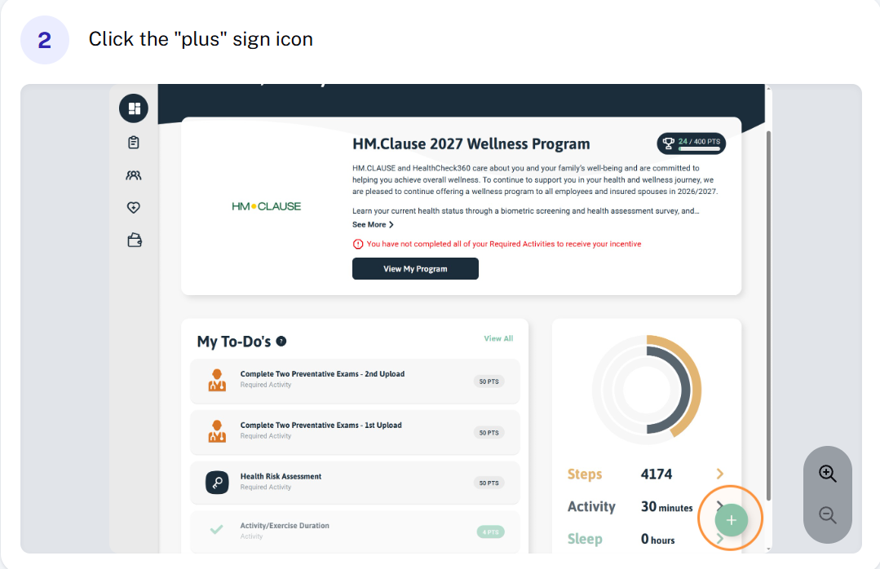 | Click on the “plus” sign icon on the bottom right portion of the screen.
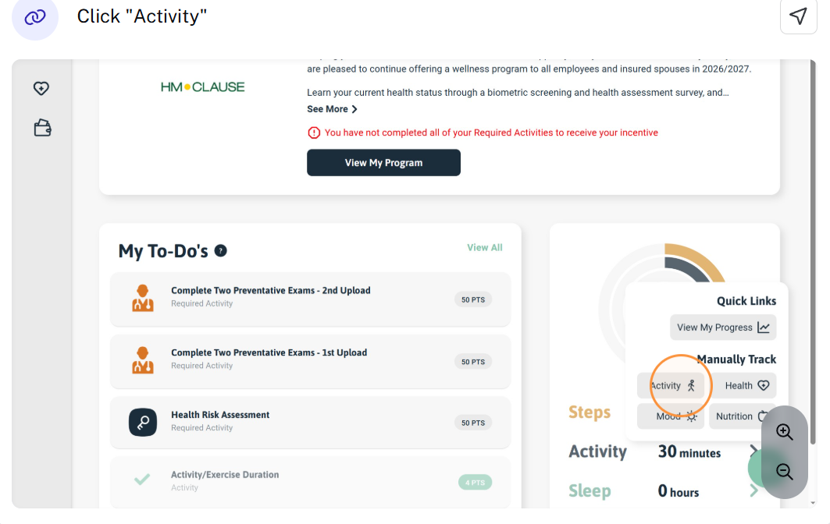 | Select “Activity” button
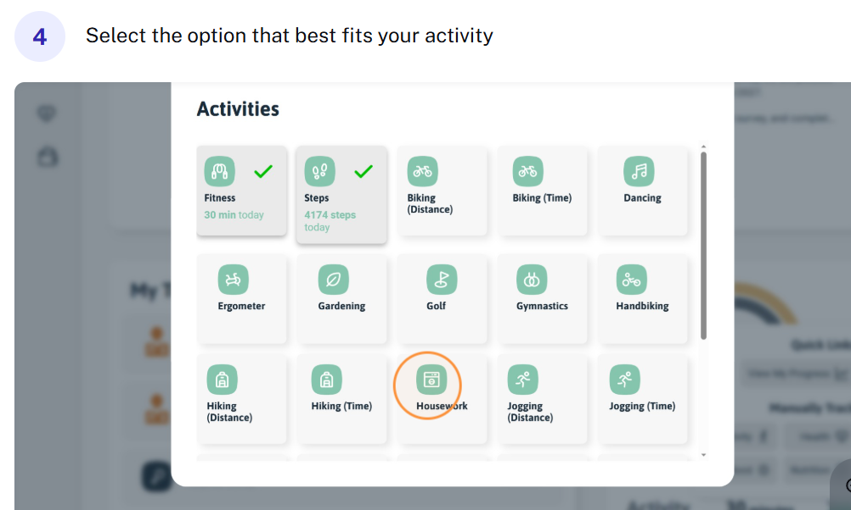 | Select the best option that fits your activity
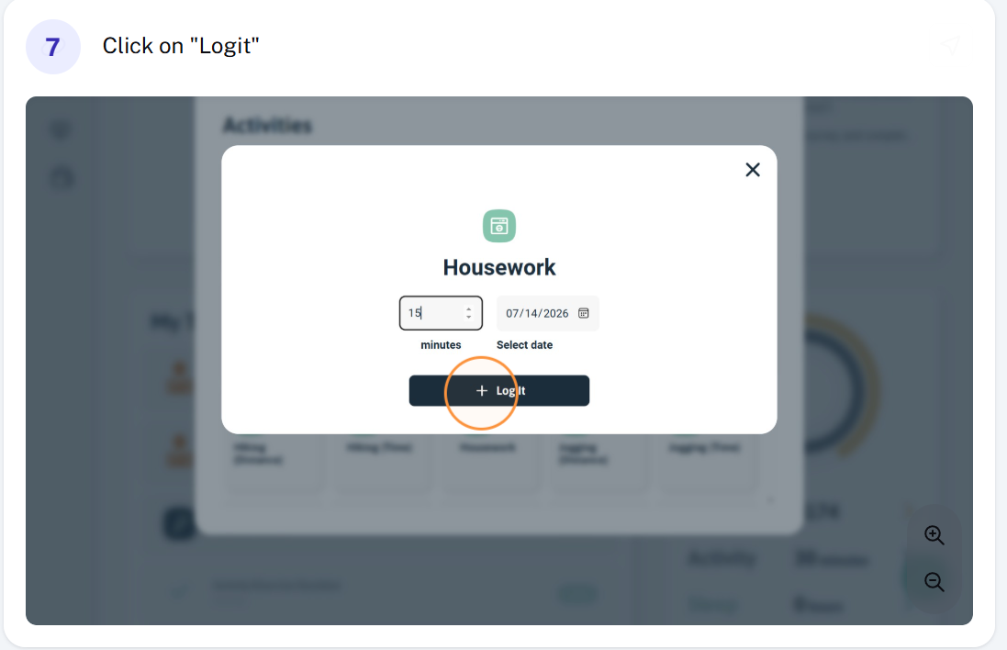 | Key in the number of minutes completed for your activity and select “Logit” to complete the process.
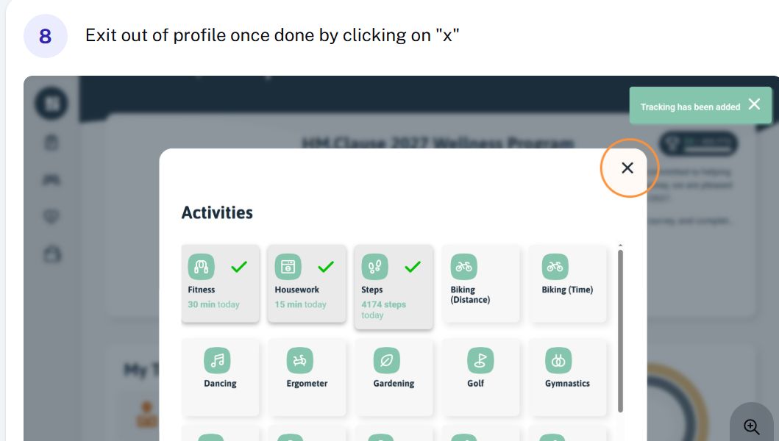 | Click on “x” on the top right corner to exit out of the activities window.

