Good Plants 2026
Hi everyone, this is a request from the Flora Committee. The new ‘Flora of Wiltshire’ is gradually being pieced together but analysing some of the records we find there is either a bias in some of the data i.e. differences in recorder effort or distance from home travelled or, just some records that have been missed altogether e.g. recorder not visiting at a particular time of year. In an effort to get as complete a picture as possible recorders will, for this year only, attempt to seek out rare or apparently little recorded species.
So as to include our members we have produced another in the series of Good Plants

Snowdrop Galanthus nivalis
Surely, this plant needs no introduction.
As you will see from the Snowdrop recorded map below there are many ‘white gaps’ indicating no records of any snowdrop in the county. The grey dots represent pre- 2000 records and the blue ones, post 2000. We would like to improve on this. Can you turn a grey dot blue?
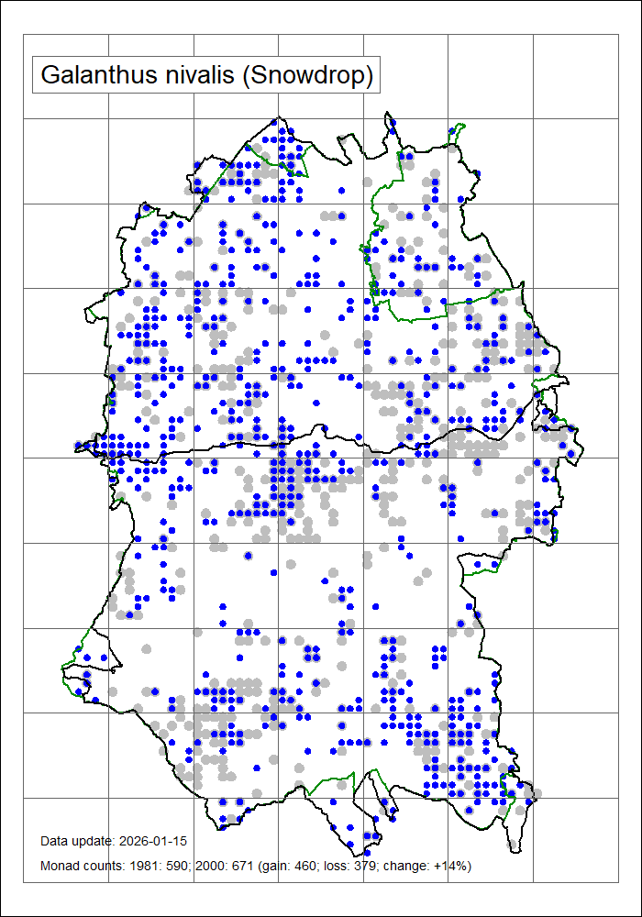
There are several species of Snowdrop with G.nivalis probably the most common. These species readily hybridise with each other either naturally or in cultivation and there are many hundreds of named cultivars. We do not expect you to attempt to identify to species or name a cultivar! Under the Snowdrop heading in the upcoming new Flora will be a caveat indicating that G.nivalis will likely include other species and hybrids.
© BSBI
In the usual way, we would like you to give us at least a six-figure grid reference, the site and where it is growing together with how well established they are e.g. A361 Beckhampton Road, SU082687. Many patches on roadside verge, probably dumped but now established and spreading into ditch. Or maybe, originally planted but now well-established and spreading across verge.
Please, no records from churchyards, public parks or private gardens.

Grey Field-speedwell Veronica polita and Green Field-speedwell Veronica agrestis
These two species have been added as they tend to be early flowering; for instance, both species were recorded on this year’s New Year Plant Hunt. References will comment that the flowering period is around March to November however hot summers can mean frazzled plants and the species get missed. Both of these can be found in the corners or margins of arable fields, in gardens and allotments and often in cracks in paving.
There are too many grey dots on these plans. Can you make them blue?
Instead of descriptions, we point you to page 4 of the excellent article on Speedwells on the BSBI website.
https://webprototype.bsbi.org/media/pages/file-archive/a7f00b75b0-1756475407/bsbi-news-158-pp21-24-beginners-corner-speedwells-part1.pdf

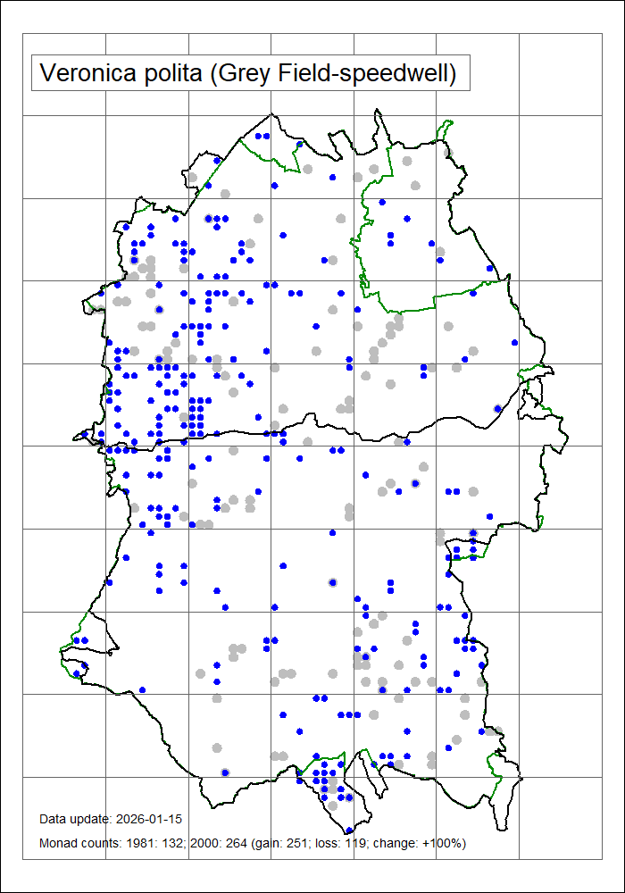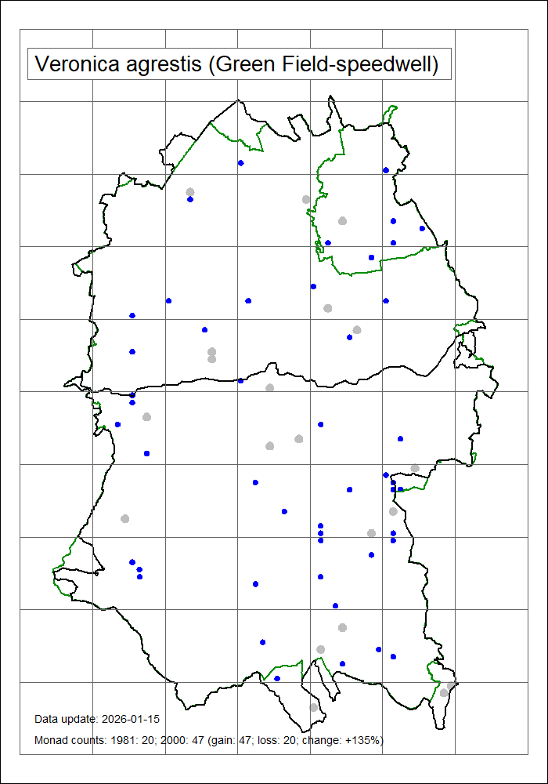

Every record counts, even just one, thank you
WBS Flora Committee

