Preparing Wildlife Records for MapMate:

A Data Entry Form for Excel – version 2.33
Purposes:
- To allow Excel users to prepare wildlife records which are validated for import into the MapMate recording software. This may be particularly useful where wildlife recorders need to submit large numbers of records to hard-pressed County Recorders.
- To allow MapMate users to validate data before import into MapMate.
The form can be used in two ways:
- to identify and correct errors on records that have already been typed into Excel;
- to check and correct records as they are typed into an Excel spreadsheet.

Starting the form
Save the Excel file onto your computer. It is available either from an Excel 2007 macro-enabled spreadsheet (MapMate Entry Form v2.33.xlsm) or an Excel 1997-2003 compatible spreadsheet (MapMate Entry Form v2.33.xls). Either way you will have to “allow macros” (allowing the background code to run) with this spreadsheet in order to use the form. Details of how to do this vary with different versions of Excel and Windows, but you will usually be prompted when necessary.
You should store your original file as a backup and work with a copy saved with a different name. The first worksheet on the file is called “Lists”; this is needed for the form to work and must not be deleted. The file will open on a blank sheet that you can rename if you wish. You can also add any extra sheets that you need. The order of the sheets is not important.
Select either a blank worksheet or a sheet containing your records. Press the control key + “R” together to launch the form. If nothing happens, you need to enable macros. If the sheet is blank, a pop-up asks you if you want to enter records. If you click “Yes”, the form adds column headings to the sheet. The form sits over the worksheet, but can be dragged around if it is covering cells that you want to see. It has a text box for each field down the left hand side and various control buttons down the right.

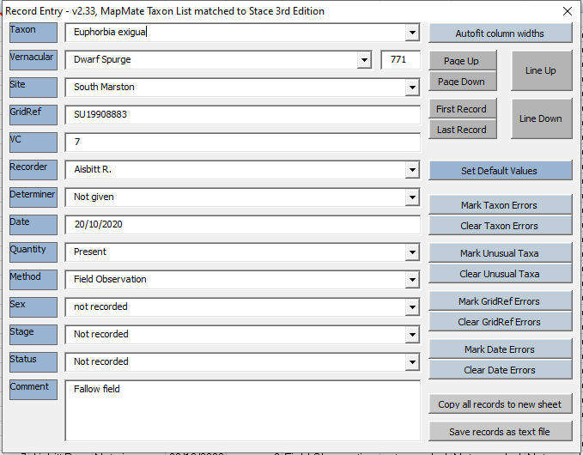
When the form is open, you can only navigate and enter data by using the form. However, you can close the form at any time and alter data directly or use the spreadsheet’s fill and copy facilities.

Entering Data
Type into each field in turn. Pressing <Enter> or <Tab> stores the entry on the worksheet and moves to the next field. When you have entered the last field (Comment), the worksheet automatically moves to the next record. You can move backwards through the fields with <Shift> + <Tab>. Doing this from “Taxon” takes you back to the previous record.
A “Tooltip” appears if you place the mouse pointer over a text box.
You can use the “Autofit column widths” button at any time.

Data checking
A message will pop up if there is a problem with your data entry. If the form can suggest a correction, you can respond by clicking “Yes”, “No” or “Cancel”.
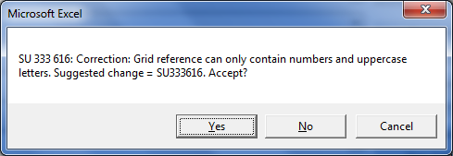
The “Yes” button will accept the suggested correction; if you want to change the entry yourself, click “No”; clicking “Cancel” will move to the next field without correcting your entry. If there is no suggestion, the options are “OK” and “Cancel”.
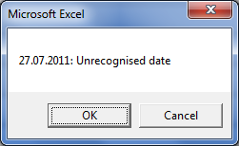
“OK” will let you make corrections and “Cancel” will move to the next field leaving the entry as it is. You can leave fields temporarily blank even if they are mandatory for import into MapMate.

Navigation
Select a field Click on it with the mouse or use Tab or Enter keys
Move up or down one record Click the “Line Up” or “Line Down” buttons in the top right corner of the form
Move up or down one screen-full Click the “Page Up” or “Page Down” buttons
Move to first or last record Click “First Record” or “Last Record” buttons

Keyboard cursor keys:
- Left and right arrows will move the cursor within the text being edited.
- Up and down arrows move the cursor up and down through the form, BUT will change the entry if the cursor is in a text box with a drop-down list. It is best not to use these keys.

Field details
Taxon  (mandatory) | Type the first few letters of the scientific name. A taxon name will appear that fits this. Use the drop-down arrow on the right of the field to show other possibilities. You can scroll up and down the list, clicking on your final choice. You can also move through the list using the up/down arrow keys or page-up/page-down keys.  The common name (if there is one) will appear in the right-hand column of the drop-down list and is entered in the field below.  You can also type in the number code from the BSBI recording form. The taxon name appears when you press enter. Check that this is what you wanted and adjust it if necessary. The number appears in a small box beside the common name and you can correct this if you need to. You will get an error message if the code is not recognised.  Entering a taxon that has been recorded in Wiltshire 20 times or fewer will bring up an alert so that you can accept or reconsider your choice. See ‘Advanced Tasks’ below to change the rarity limit.  The form currently uses the taxon names from Edition 3 of Stace’s New Flora.
Vernacular | This is for information only and is not stored in the records. If you do not know the binomial, choosing the vernacular will automatically select this for you.  The drop-down list shows the binomial in its right-hand column. Press <Enter> to update the Taxon field. Where taxa (especially hybrids and sub-species) share the same vernacular name, check the binomial carefully to make sure the correct one has been chosen.
Site  (mandatory) | This is the name of the place, often the nearest name on the OS map. Put the most important part of the name first to aid data searches, e.g. put “Swindon, north” rather than “North Swindon”. However, correct village names like “East Kennett” should be left as they are. The drop-down list is empty on first use, but is populated by new site names as you add them.
GridRef  (mandatory) | Letters must be in capitals (data entry using the form will force uppercase letters). Various checks will trap invalid grid references, but will not check that they are right for your site name
VC: Vice County  (mandatory) | A number if you know it, otherwise “0” (zero), in which case, MapMate almost always works out the VC from the grid reference
Recorder  (mandatory) | Surname first, followed by initials. You can have several recorders; separate these with commas (do not put a comma between the surname and initials). MapMate limits this field to 64 characters. The drop-down list is empty on first use, but becomes populated by new recorder names as you add them.
Determiner  (optional) | MapMate puts in the Recorder’s name if this is left blank. Put in your own entry if appropriate. Determiner uses the same drop-down list as Recorder and will also add new names to the list.
Date  (mandatory) | MapMate is very strict on format (“dd/mm/yyyy” for exact dates), but the form will re-format any valid date that Excel understands. A range between two dates must be typed in the form “dd/mm/yyyy-dd/mm/yyyy”. Date ranges for months and years have their own special formats. The form will offer suggestions if possible.
Quantity  (mandatory) | Must be a number, but “0” (zero) means “Present”. A drop-down list gives DAFOR and DOMIN scales. You can type an initial letter for Present or for DAFOR scores. It is best also to include abundance measures in the notes if you use these.
Method  (mandatory) | How was the record made? “Field Observation” is suggested. MapMate has a list and the most appropriate ones have been included in the drop-down list. MapMate will accept other entries, but do this with caution. Any new entries are added to the form’s list for Method.
Sex  (optional) | Rarely appropriate for botanical records, but you can use the entries on the drop-down list. You could set “Not Recorded” as a default entry.
Stage  (optional) | The available entries are often inappropriate for botanical records, so “Not Recorded” is suitable as a default (MapMate accepts “0” (zero)). Other entries from the drop-down list.
Status  (optional) | Again, “Not Recorded” is suitable as a default (MapMate accepts “0” (zero)). For other entries use the drop-down list. “Planted” could be used for obvious plantings.
Comment  (optional) | Include any extra information here: numbers, habitat, associates, position, history, size, extent etc, as needed. No limit on length.

Default settings
Any combination of fields can be given default values which will be inserted in empty fields when they get the focus. Default values do not overwrite existing entries.
To set the defaults:
- Click the “Set Default Values” button. This makes any entries showing on the form into default settings.
- Click a field label (pale blue background, on the left) to set the default for an individual field. This turns the default setting on or off.
  - If the default is already set, it is turned off.
  - If the default is off, the current entry becomes the default, even if it is blank.
Clicking “Vernacular” has the same effect as clicking “Taxon”.
Suggested uses:
- To enter a site list, set defaults for all fields except Taxon. Each time you enter a taxon name, the other fields will be completed and the form will move to the next record.
- To enter many locations for a single taxon, set defaults on all fields except GridRef.
- Set VC to zero (then MapMate works out the VC from GridRef), and Sex, Stage and Status to “Not recorded” if these are not important to your records.

Checking an existing spreadsheet
You can copy worksheets into the file that hosts the data entry form. If the worksheet does not match the MapMate layout, open the MapMate form on a blank sheet first to get the headings, close the form, copy in the data and move to match the headings.
If you open the form over an existing worksheet of records, you can check whole columns of data for errors. You can do this by clicking “Mark ... Errors” for Taxa, GridRefs or Dates. Any errors are marked with yellow background. If there are no errors, a pop-up box will inform you. If there are errors, the box will tell you how many there are and will give details of the first error. You will be taken to the first error when you click “OK”.

You can also click “Mark Unusual Taxa” to highlight any taxon that has been recorded in Wiltshire 20 times or less (see Advanced Actions below to change this limit). This could alert you to:
- Specially interesting records, or
- Errors in identification or data entry.
You may occasionally need to update the counts on the ‘Lists’ sheet. See ‘Advanced tasks’ below.
You can now either:
- Correct the errors. Taxon errors: these are often caused by spelling mistakes. Use backspace to remove letters from the right-hand end until a valid entry appears. You can then use the drop-down list to select the correct taxon. If a vernacular name exists, it will appear when a valid entry has been made.
- Close the form and edit the worksheet directly. This could be useful if (a) grid references contain spaces or other unwanted characters. You could remove these by highlighting the column and using the spreadsheet’s “Replace” function. Or (b) you can use “Copy” or “Fill” to enter the same data into a whole column.
If you close the form without clicking “Clear Taxon Errors”, Taxon errors on the worksheet will remain yellow and will have a drop-down list that you can use to select a valid taxon. GridRef and Date errors have a comment attached which will guide you towards a correct entry.
Repeating “Mark ... Errors” (re-load the form if you closed it) will remove the marks from any entries that have been corrected. “Clear ... Errors” removes error markings and comments.

Combining Worksheets
If you have records on several worksheets, you may want to combine them before saving them as a text file for import into MapMate. The button “Copy all records to a new sheet” does this. First, it creates a new sheet called “Combined” [it will create “Combined(2), Combined(3), etc if copies already exist] and then copies any records to it from the other worksheets.

Creating a text file
The “Save records as text file” creates a txt file of the data on the current sheet. The “Save As” box comes up with the name of the current worksheet as the filename. You can accept or alter this. You also need to check and maybe alter the destination folder. The file is in the correct format for import into MapMate. The spreadsheet will remember the last-saved location.

Advanced tasks:
- Do not open the data entry form for these operations
- Some users may want to ask the author to help with these.

Changing the rarity limit
Select “RarityLimit” from the drop-down box above column A. This takes you to a single cell containing a number on the “Lists” sheet; you can edit this number.
Changing the rarity limit to zero inactivates the rarity alerts. You should do this if count data are not available for your records.

Remove unwanted Sites, Recorders or Methods from the lists
Edit the relevant table in “Lists”, being careful not to alter the other lists. Do not leave a gap where you remove an entry. Find the named ranges “Sites”, “Recorders” and “Methods” by selecting them from the box just above column A on any worksheet.
An easy and safe way to remove entries: delete any that you wish to remove, leaving blank cells; select the named range (Sites, Recorders or Methods); apply an alphabetical sort – this moves any blank cells to the bottom of the list.

Using the form for other taxon groups
You can do this by replacing the tables in the “Lists” worksheet. The form uses named ranges, which are re-created each time the form is opened as long as data is not re-positioned. The data for named ranges starts on row 2 (row 1 is for headings) and ends at any blank row.
- Set your recording preferences in MapMate and display the taxon list (Analysis/Browse Tables/Browse Taxa). Select and copy the “Taxon” and “Vernacular” columns and paste into column A and B respectively on the Lists worksheet. Sort on Taxon. (Range TaxVer)
- Paste the same data to columns L and M, but with “Vernacular” in column M and “Taxon” in column L. Sort on “Vernacular” and remove any blank or meaningless common names and associated taxa from the top of the table (do not “delete lines”, which would delete other data on the sheet). (Range VerTax)
- To enable the selection of taxa from their number codes, you will also need to copy taxon names into column AT, Vernaculars into column AU and the number codes (left-hand column of ‘Browse Taxa’) into columns AS and AV. (Ranges TaxonCode and CodeTaxon)
- Other tables on the “Lists” sheet may also need adjusting or replacing.
- The taxon counts used to identify unusual taxa are stored in the named range “RecordCount”. You can regenerate this data by running the stock query Analysis/Species Lists/Species List in MapMate. Copy the columns from “Taxon” to “Records” and paste into columns D to J. Sort on “Taxon”.
- The tables on the “Lists” sheets should not be moved. Their home columns are as follows:
Range Name | Columns
CodeTaxon | AT to AV
LastSavePath | Cell AY2
Methods | AL to AM
QuantityCode | Y to Z
QuantityName | Z to AA (duplicate copies of number codes in Y and AA)
RarityLimit | Cell AX2
RecordCount | D to J
Recorders | AG only
SexCode | U to W
Sites | AI only
StageCode | P to Q
StatusCode | AC to AD
TaxonCode | AS to AU
TaxonList | A (first column of TaxVer)
TaxVer | A to B
VerTax | L to M

Updating the data
Procedures 1, 2 and 3 above may be needed if the taxon list or other tables in MapMate are updated.

Conditions for use
This software may be freely used and shared, but acknowledgement would be appreciated.
It is a work-in-progress and may not be crash-proof or error free. Please give me details of any problems that occur.
Richard Aisbitt, revised December 2020

