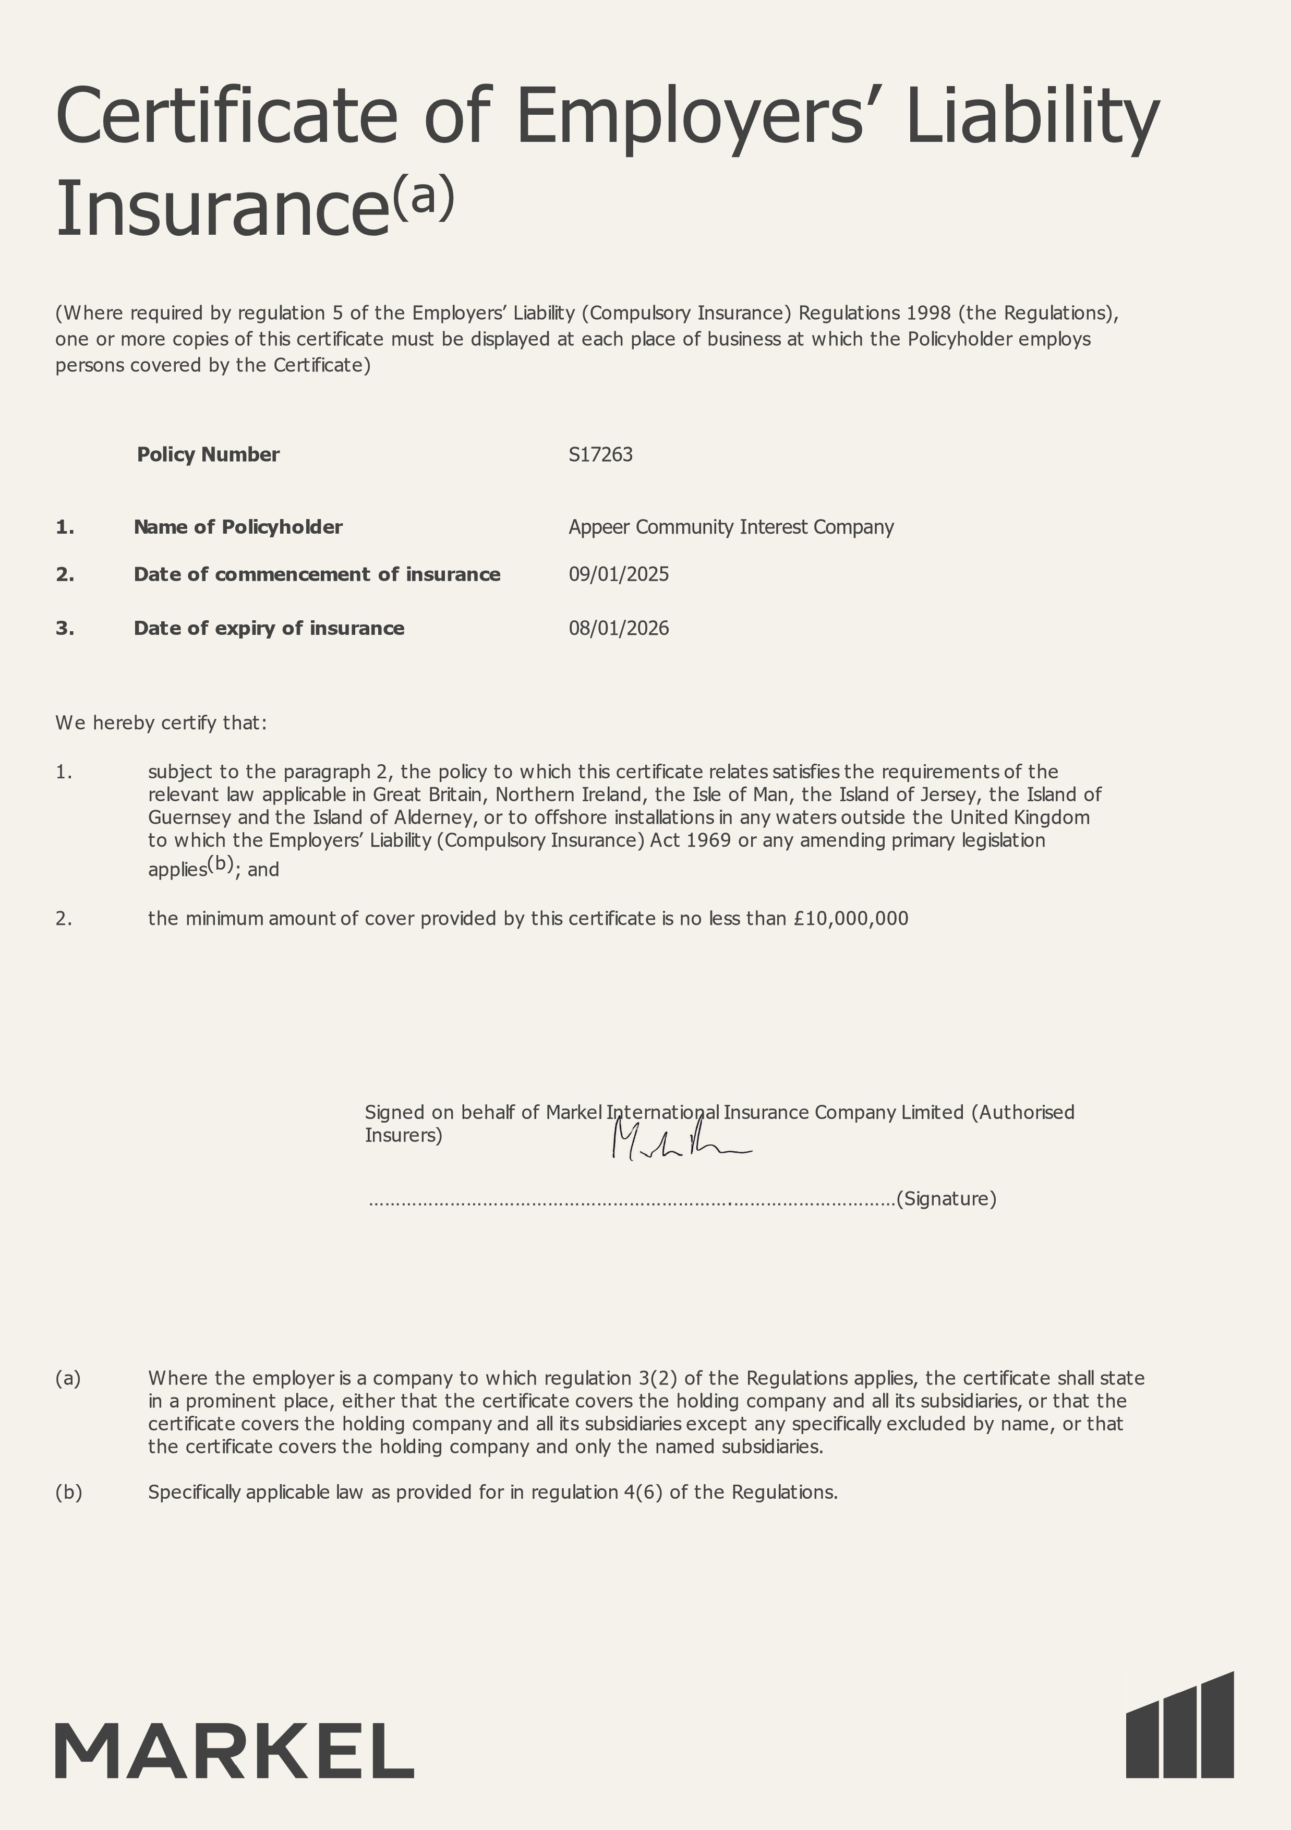

**Health and safety for small/medium sized businesses**

**How myinsurer helpsme manage myhealth and safetyrisk**

Good health and safety standards help you to run your business successfully. Meeting the requirements of relevant regulation is a central factor in achieving this. Insurers recognise the wider benefits to society of encouraging businesses in following sensible, proportionate measures aimed at helping them to carry out their activities.

W e are providing this information to help you take sensible steps to manage health and safety effectively.

Insurers will continue to settle legitimate claims. Insurers will also co-operate with businesses such as yours if you need to deal with the consequences of vexatious claims made against you.

Your insurer will always be willing to offer you guidance on what constitutes good practice in managing health and safety. This guidance should be aimed at improving the resilience of your business in dealing with civil law claims made against you, and will be proportionate to the level of risk involved.

**Employers’ liabilityvs public liability- what’s the difference?**

Insurers provide cover for businesses’ legal liabilities by issuing:

* Employers’ liability policies - this covers employers for injury or disease to people they employ; and
* Public liability policies - this covers businesses for injury, disease or damage to people they do not employ, for example visitors.

**The law - the Health and Safetyat Work etc. Act 1974**

* This is the main law on health and safety and says that every employer is to ensure, so far as is reasonably practicable, the health and safety of employees and also persons not in their employment who may be affected by work activities.
* Your insurer expects you to take reasonable steps to comply with this requirement and other related regulations, using the guidance and tools provided by the Health and Safety Executive (or other competent organisations) to help with this aim. You can find more information at www.hse.gov.uk/index.htm.
* Your insurer will not refuse to pay a claim purely because of a breach of health and safety regulations.
* Your insurer will not withdraw cover mid-term purely because of a breach of health and safety regulations.

**Who is an employee?**

There are various forms of employment. Often a working individual may not be engaged under a contract of employment. For this reason, insurers include, under an employers’ liability policy, a definition of who is to be treated as an ‘employee’. A typical definition would be:

* Any person employed under a contract of service or apprenticeship;
* people on work experience schemes, for example, students;
* any person hired or borrowed from another employer including drivers or operators of hired in plant;
* labour only subcontractors; and
* home workers.

All these people are covered while working for and under your control in your business.

**Some common concerns**

**More help**

Insurers approve the principles set out in the Association of British Insurers’ Key Principles document: Health and Safety for Businesses and the Voluntary Sector. This is available at http://www.abi.org.uk.

You can also find more guidance on the HSE website available at www.hse.gov.uk.