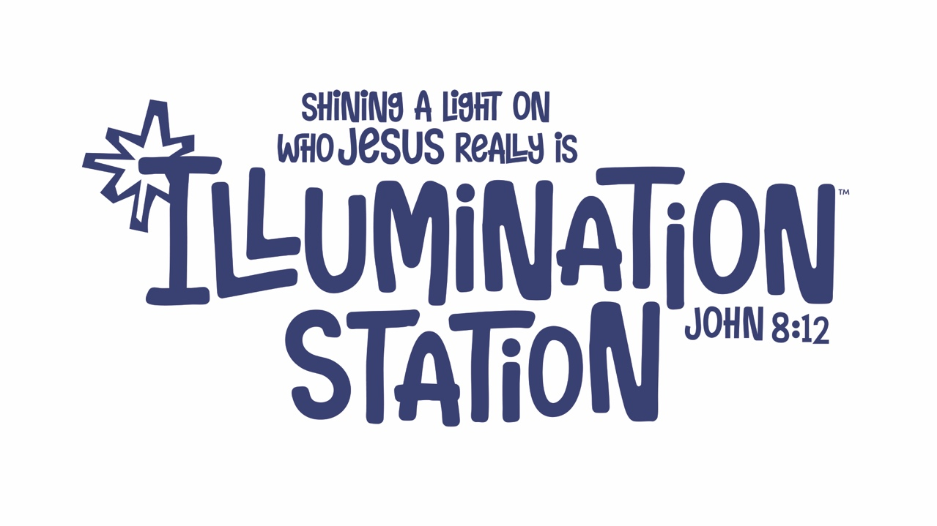

Crafts 2026

SUNDAY: FAMILY KICK OFF
- CANVAS BAGS
MONDAY: ROTATION
- LIGHT SWITCH COVER
WEDNESDAY: ROTATION
- RESSURECTION LIFEWAY CRAFT PACK

1-6TH GRADE SNACKS 2026

MONDAY
- LAYS POTATO CHIPS AND WATERMELON
TUESDAY
- SNACK MIX AND BANANA
*SNACK MIX CONTAINS POTATO STICKS, VEGGIE STRAWS, AND POPCORN
WEDNESDAY
- FRUIT SNACKS AND APPLES
THURSDAY
- LUIGI’S ITALIAN ICE

PRESCHOL SNACKS 2026

MONDAY
- LAYS POTATO CHIPS AND WATERMELON
TUESDAY
- VEGGIE STRAWS AND CUTIES

WEDNESDAY
- GOLDFISH CRACKETS AND BANANAS
THURSDAY
- LUIGI’S ITALIAN ICE

