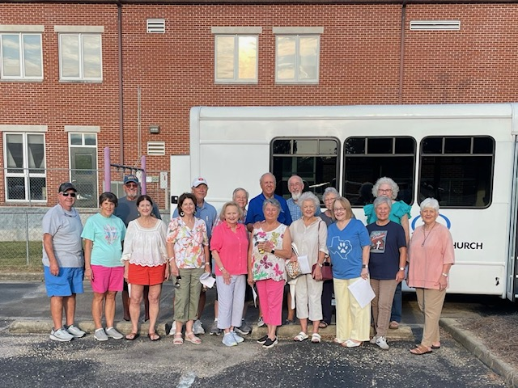
2026 Senior Adult Mission Trip
September 21-25, 2026
New Orleans, LA

MissionLab at New Orleans Baptist Theological Seminary

Who May Participate:
Senior Adults (group is limited to 20 total)

What kind of work will we do?
We will partner with MissionLab at NOBTS. Our work assignments will include: Outreach Activities and Service Projects with local ministries. (Last year we fed breakfast at a homeless shelter/ partnered with a Women’s and Children’s shelter/ a teen ministry and a community garden).

Special skills / abilities needed:
*Desire to share your faith / *Good physical condition / *Have a Servant heart / * Be a “Team Player”
Travel plans:
We will drive the Church Mini-Bus and one personal vehicle.

Housing: Hotel-style Guest Housing at New Orleans Baptist Theological Seminary

Cost: $350 per person covers your lodging, travel insurance, ministry supplies & all meals in New Orleans. You will pay for any attractions and travel meals.
Team Leaders: Larry Jenkins / Donna Wilson

To Register: Complete an online mission trip application at this link: www.fbcprattville.org/missions and turn in a $200 deposit by March 15, 2026.

(Balance of $150 due by July 15, 2026.) *SPACE IS LIMITED*
