D.R.E.A.M. Schedule 2025-2026 (201-845-8543 )
_____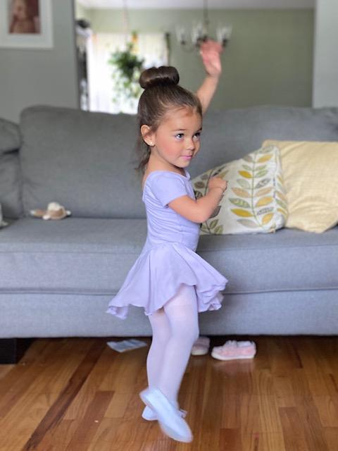___
Dr. 2/3 (2 – young 3 yr )
Monday 4:30- 5:00 PM ( Ms Candace)
Saturday 8:45-9:15 AM (TBA)
Dr. 3- (3-3.75 yrs)
Wednesday 5:00-5:45 PM (Ms. Kiersten)

Dr. 3.5/4.5 (3.5 - 4.75 yrs ..*no newly turned 3s)
Saturday 9:15-10:00 AM ( TBA)
Dr. 4- (4-4.75 yrs)
Thursday 5:00-5:45 PM (Ms. Bella)
____________________________________________________________
Dr. 5 (5 -6 yrs -KINDERGARTEN) Ballet/Tap Combo
Monday 6:00- 6:50 (Ms Candace)
Saturday 10:15-11:10 AM (TBA)
Any Kindergartner (5 yrs old by first class in Sept- no exceptions) wanting acro class will be able to sign up for our Beg. Acro I/II . Thursdays 4:00 (MS Gianna)

** Student must be “AGE” of class NO later than Oct. 31st, except for Dream 2, when child must ALREADY be 2 by time of first class in September. Proof of age may be requested. Classes may be subject to cancellation depending upon enrollment. We also may add more options depending on interest as above! Sign up early…classes fill Quickly…www.maywooddancecenter.com

