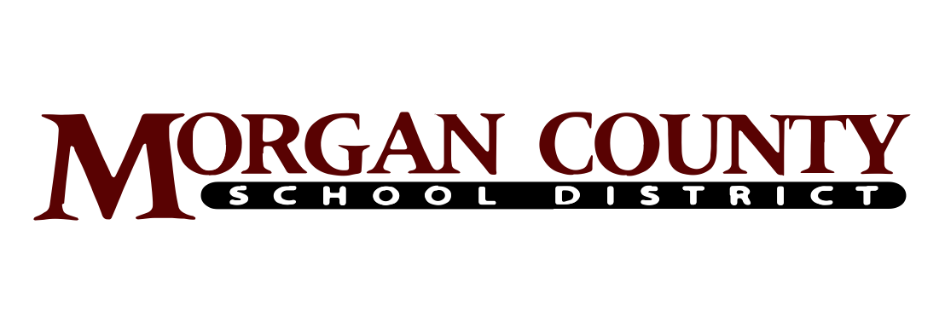
Morgan Technology Center Childcare Preschool Program

Parent/Guardian Acknowledgment and Liability Waiver

Program Overview
The Morgan County School District operates a childcare preschool program housed in the Morgan Technical Center. The program is instructional in nature and is designed to provide high school students with practical learning experiences in Early Childhood Education. Preschool-aged children from the community participate as part of this instructional setting.

Health & Medical Responsibility
I understand that my child is not an enrolled student of Morgan County School District and therefore does not receive the full range of student health services provided by the school nurse.
I understand that:
- The district’s school nurse serves in a consultative and emergency-response capacity only for the preschool program.
- The nurse does not provide ongoing medical care, develop health plans, administer medications, or conduct health screenings for preschool participants.
- Day-to-day health supervision, including medication storage/administration (if applicable), is the responsibility of program staff and myself as the parent/guardian.
- I agree that I will inform the program staff in writing of any known allergies, medical conditions, or special health needs for my child.

Emergency Medical Response
Program staff are trained in first aid and CPR.
In the event of a medical emergency:
- Staff will take immediate action to ensure my child’s safety, including contacting emergency services (911) if necessary.
- The school nurse, if available on site, may provide emergency aid as a licensed nurse.
- I will be contacted immediately.
I authorize program staff to seek emergency medical treatment for my child if I cannot be reached.

Parent/Guardian Responsibility
- I understand that I remain the primary provider and decision-maker for my child’s healthcare.
- I agree to keep my child home if they are sick or showing symptoms of illness, and to promptly pick up my child if contacted during the program day.

Acknowledgment & Signature
By signing below, I acknowledge that I have read and understood this agreement regarding the scope of health and medical responsibility for my child while enrolled in the Morgan County School District Childcare Preschool Program.
Child’s Name: ________________________________________________________________________
Parent/Guardian Name: ______________________________________________________________
Parent/Guardian Signature: __________________________________________________________
Date: ______________________________________
Emergency Contact (other than parent/guardian):
Name: _________________________________________________________ Phone: _________________________________________________

