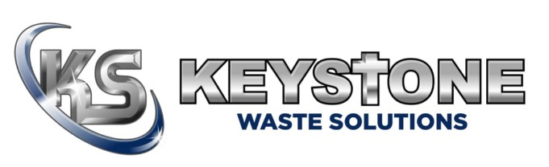
Keystone Waste — Your Trusted Partner
Proudly Serving the Redbox+ Franchise Network
June 2026

Keystone Waste Solutions is proud to serve as the approved equipment supplier for the Redbox+ franchise network. We are committed to your success — delivering quality products, responsive service, and the kind of partnership that helps your business grow.
Our team is made up of industry veterans who have built routes, run equipment, and grown waste businesses. We don’t just build the box — we understand what it takes to make money with it.

About Keystone Waste Solutions
Keystone Waste Solutions is a US-based manufacturer of commercial dumpsters, roll-off containers, front load containers, hook lift containers, and related waste equipment. We manufacture everything in-house at our facilities in Texas and Ohio — giving you quality control, consistency, and supply reliability that import-dependent competitors simply can’t match.
Our core values—Faith, Family, and Finances—guide everything we do. We believe in treating customers, vendors, and employees with integrity while delivering quality products and dependable service.

Two US Manufacturing Facilities
Our dual manufacturing footprint means faster delivery, lower freight costs, and no supply chain single points of failure — no matter where your territory is located.

Rhome, Texas — Primary Facility
Dallas-Fort Worth metroplex — central to the South and Midwest. High-volume production for standard and heavy-duty containers with competitive freight rates nationwide.

Millersburg, Ohio — Secondary Facility
Serves Northeast and Midwest franchise territories. Reduces lead times and freight costs for Eastern US franchisees with full production redundancy.

What We Build
As a Redbox+ franchisee, you have access to our full product line at approved franchise pricing:
Standard Tub Style Containers — our core roll-off container built to the Redbox+ spec, durable field-ready construction designed for the demands of daily hauling operations.
Elite Series Containers — a container design developed exclusively for the Redbox+ franchise network; built to the specific standards and requirements of your brand, ensuring every franchisee delivers a consistent, professional product to their customers.
Custom Fabrication — beyond our standard product line, we offer custom fabrication to meet Redbox+ special requirement needs; items such as the Redbox+ ag tank, flatbeds, oil tanks, storage containers, and more — if you need it built, we can build it.
Truck Upfitting — we outfit trucks with cable roll-offs and hooklift systems (7,500–75,000 lb. capacity), delivering turnkey packages so your franchise is road-ready from day one.

Innovation, Service & Consultative Solutions
As your approved supplier, Keystone brings three pillars to the Redbox+ partnership — Innovation, Service, and Consultative Solutions — ensuring every franchisee has the support they need to grow and compete.
Innovation — we continuously invest in product design, fabrication technology, and process improvement; recent design changes and improvements to the Elite Series are just one example of our dedication to innovation driven by franchise feedback.
Service — from order to delivery and beyond, we back every unit with a dedicated support team and a commitment to fast, no-hassle resolution; we manage reorders, coordinate freight, and make sure your fleet stays running.
Consultative Solutions — our team brings real-world waste industry experience to every conversation; we help franchisees select the right equipment mix, plan fleet growth, navigate custom fabrication needs, and make smarter operational decisions — we are a resource, not just a vendor.

Why Keystone as Your Franchise Supplier
We’re not just a vendor — we’re a franchise supplier built for the unique demands of a growing network:
Franchise-level pricing — consistent, competitive pricing standardized across your entire network.
Network scalability — whether one franchisee needs 5 units or 20 need 500, we accommodate without disruption.
Dedicated franchise support — one point of contact for corporate and field-level needs.
Streamlined onboarding — new franchisees get up and running fast with pre-approved specs and simplified ordering.
Long-term partnership — we invest in the success of the Redbox+ brand alongside you.

Your Direct Contact at Keystone
We’re here to make your franchise successful. Reach out anytime — whether you’re placing your first order or your fiftieth.
Brent Ottmers | Keystone Waste Solutions
Office: 817-636-3350 | Cell: 214-236-6244
bottmers@keystonesynergy.com
www.keystonewaste.com Watch: Keystone Facility Overview

