How to Enroll Customers in the NiceJob Get Reviews Campaign

Option 1: Quickbooks Online
If your Quickbooks Online account is connected to Docket and customer/invoice/payment activity is regularly synced from Docket to Quickbooks, you can integrate NiceJob directly with Quickbook.

Log in to NiceJob via app.nicejob.com
- Go to https://app.nicejob.com/settings/product/apps
- Click the Connect button beside QuickBooks
- You will be prompted to login to QuickBooks and go through some simple authorization instructions.
- You will then be directed back to NiceJob where you will see the connection is now active: you will see your customers loading in the People tab here: https://app.nicejob.com/people
Invoice and payment information will automatically appear in the customers profile.
Your contacts will automatically be sent invites after the invoice is created or a payment is made in QuickBooks.*
* You may need to adjust your campaign rules first in order to automate this.
To edit campaign rules, go to Campaigns > Get Reviews > Edit Campaign
Select More
Select Switch Template
Select Default Reviews Campaign
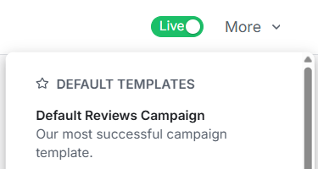

Make sure only the Entry and Exit Rules option is checked (leave Messages unchecked)
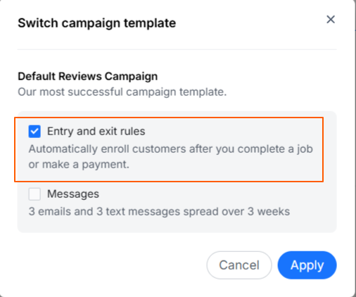
- Hit Apply
- Set Campaign toggle to Live
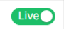
- Save Campaign

Option 2: Exporting Customer Lists from Docket / Importing to NiceJob
Begin by exporting your customer list from Docket, ensuring the export contains the customer’s full name, email address, and phone number.
Log in to NiceJob via app.nicejob.com

- Go to the People tab here: https://app.nicejob.com/people
- Select Import Contacts
- Check off all required boxes, then select your CSV file to import.
- Be sure your CSV file is formatted correctly with the following column headers: Name, Email, Phone.
*If the CSV is not properly formatted, it will not import. A template is available for download as well.
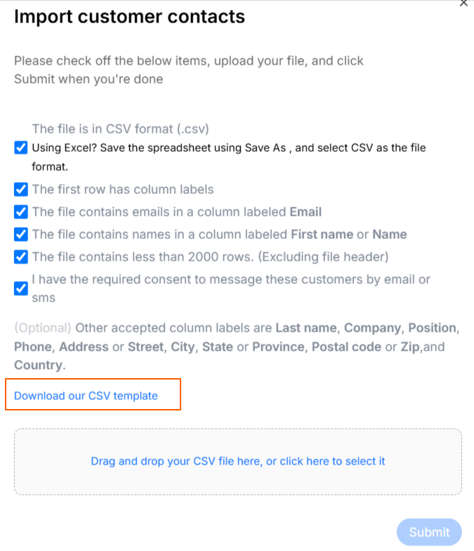

Once the import is complete, you will see all your customers listed in the People tab.
To enroll a customer in the Get Reviews campaign, simply click the blue Invite button next to their name.
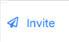

You can regularly repeat this process as often as needed - no need to filter your export for only new customers as they will not be duplicated in NiceJob.

Support / Questions

If you have any questions or want to make sure your campaigns are set up correctly, schedule a call with your NiceJob Account Manager, Megan: NiceJob - Schedule A Meeting with Megan

