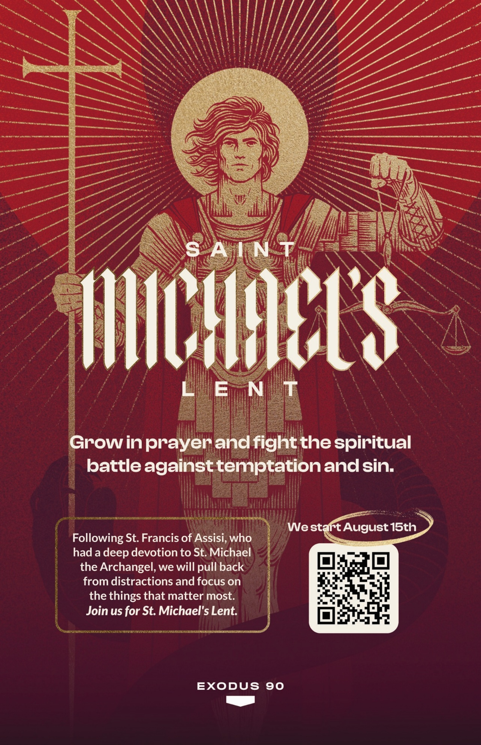

Gentlemen, greetings in Christ Our Strength.

I invite you to join me this Summer in reviving the ancient practice of the Church of observing **St. Michael’s Lent**, a period of forty days of prayer, meditation, and discipline that helps strengthen us in faith, fatherhood, family, and fraternity. We begin on August 15, the Solemnity of the Assumption and conclude on St. Michael’s Feast Day September 29. This observance will help us become more gentle men and, with God’s grace, holier men for the benefit of our families and Holy Mother Church.

**Through the Exodus 90 app**, we will be joining Fr. Innocent and Fr. Angelus, two Franciscan Friars of the Renewal (CFR, founded by Fr. Benedict Groeschel, Fr. Andrew Apostoli, and others), who will lead us in prayerful meditation **after the example of St. Francis of Assisi** in order to “seek what is above” (Colossians 3:1), to store treasure in Heaven, and to be “rich in what matters to God” (Luke 12:21).

The full observance of this is best done in small groups of men in fraternity, about 6 to 8 in each group and the observance of the disciplines below.

**Please note**: fulfilling all of these disciplines is the ideal. **You are invited, after prudent discernment**, to do what you are able to do, remembering, particularly if you are married, that your observance of some of these disciplines might cause some challenges in your household. **Discern with your wife if this is something that you are able to do**.

And if you do decide to participate, it is perfectly understandable to make accommodations as needed for the benefit of your spouse and family.

If you are interested in St. Michael’s Lent but these disciplines seem too demanding, then select the first two plus three of your own choosing below. Meeting in our fraternity groups will help us all persevere, grow, and be held accountable.

1. Read the daily Reading & Reflection
2. 30 Minutes of Silent Prayer each day
3. Pray the Creed daily [fittingly in honor of the 1700th anniversary of the Creed]
4. Hold Vigil for 1 Hour at 2am Friday Morning
5. Get a Full Night’s Sleep (8 hours)
6. Wake Up at the Same Time each day, including weekends
7. No Snoozing the Alarm Clock in the morning
8. No Social Media / News for the whole of St. Michael’s Lent
9. Fast on Wednesday & Friday [i.e., as the Church observes on Ash Wednesday and Good Friday: two small meals and one regular meal].
10. No Meat on Wednesday & Friday
11. Take a Cold Shower on Wednesday & Friday
12. Check in with your Anchor each day
13. Weekly Fraternity Meeting
14. Celebrate the Lord’s Day on Sundays

**The Exodus 90 app is required** to receive the daily readings and reflections. **The app is free as are the first two weeks of the content**. Afterwards, if you choose, you are welcome to subscribe.

**This is entirely voluntary**.

If you are unable to participate in St. Michael’s Lent given the above, then I welcome you to participate by selecting one or two of the disciplines above and observe it independently. **Any amount of participation will help you grow stronger for spiritual combat; healthier in body, mind, and soul; and holier for the greater glory of God**.

As your Pastor, I aspire to be a better and holy Priest for you, your spouses, your families, and our parish family to lead you all closer and closer to Christ Jesus Our Savior and Lord. That is why I will be observing St. Michael’s Lent this Summer.

Please **check out the website for more information** and feel free to ask me any questions: <https://exodus90.com/st-michaels-lent/>

If you do choose to sign up, please let the office know so that we can form groups of men to meet in fraternity and grow as stronger disciples of Christ, as better men of family, and as holier men of faith.

God love you! I do.

Fr. Lewis

PS: And don’t worry, cold showers can be refreshing with the summer’s heat.

