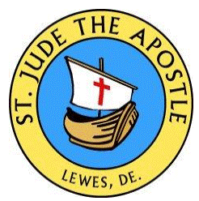
Witnessed Statement of Eligibility
for a Sponsor for Baptism or Confirmation

As a registered and participating member of _______________________________

parish in __________________________________________________, I affirm that

- I have received Baptism, Confirmation, and Eucharist.

- I participate faithfully at Mass on Sundays and Holy Days of Obligation

- If married, I have been validly married according to the laws of the Church, before a priest or deacon in a Catholic church or before a minister or rabbi with the permission of a Catholic bishop.

- I assume a great responsibility before God and His Church in becoming a sponsor. By my daily prayers and sacramental life and my moral example, I will give faithful witness and support to

________________________________________, who is to be baptized/confirmed.

By my signature, I attest to the truth of the above statements:

sponsor’s signature ________________________________________

please print name ________________________________________

For the Deacon or Priest

I attest that the above-signed person is a registered member of this parish (for which I affix the parish seal) and that he/she understands the requirements of being a godparent/sponsor.

signature ______________________________________ date __________________
(seal)

