Youth Activities for All St Pius X Youth
2025-2026


August 23 NCYC Pilgrims meeting 6 pm
September 7 Canonization of Carlo Acutis & Pier Frasati
September 10 & 14 Youth Ministry/Family Faith Info Sessions
September 13 & 14 NCYC Take Stock Collection at all Masses
September 16 NCYC Pilgrims meeting 6 pm
September 17 Optional: REBOOT A LIFE-CHANGING EVENT Speaker Chris Stefanick at Saint Marianne Cope Parish
September 21 Catechist Sunday - theme “Always be ready to explain…for a reason for
your hope”. 1 Pet 3:15


September 21 Sunday Youth starts 11-12:30, enter Main School Doors (every Sunday except holidays & where noted, merged with Family Faith)
September 23 CYO Soccer Games begin
September 30 NCYC Pilgrims meeting 6 pm
October 4 St Pius X Youth Retreat Day 9:30 am – 8 pm @ the Youth Room in School
October 5 Family Faith/Youth Ministry Combo Day
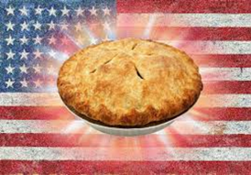
October 10th CYO Basketball practices can begin
October 13 Optional Family activity Apple Picking for Coldwater
Women and Children Residential Home
October 18 CYO Soccer Pink Game & End of Season
October 18 Optional Family Gathering VerHulist Haunted Hayride
October 21 NCYC Pilgrims meeting 6 pm
October 25 DOR NCYC Gathering 11: 00 am St John’s Fairport
October 28 NCYC Pilgrims meeting 6 pm
November 2 Sunday Youth meets at St Pius X Cemetery 11:00 am to 12:30 pm
November 9 Family Faith Sunday Youth Combo
November 11 No School, Veterans Day, Apple Pie Making at Parish Center
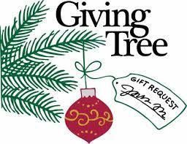
November 19-23 National Catholic Youth Conference in Indianapolis IN, please pray for Julia, Mia, Sean, Karen, & Peg
November 29 & 30 CYO Basketball Games begin
November 30 1st Sunday of Advent No Sunday Youth - Thanksgiving Weekend
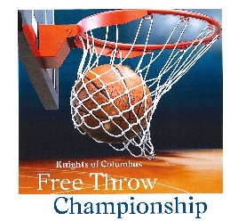
December Advent Babysitting Service – nights to be announced
December 1 SWEM & Giving Tree begins, drop donations at Gates Presbyterian on Wegman Road
December 7 2nd Sunday of Advent FF/YM Combo

December 8 Feast of the Immaculate Conception of Mary, Masses 7:30 am, 9:30 am and 6 pm
December 14 3rd Sunday of Advent Sunday Youth Christmas Party
December 21 4th Sunday of Advent

December 21 - January 5 - Christmas Recess no school
December 25 Nativity of Our Lord Jesus Christ
January 1 Feast of Mary, Mother of God
January 4 Feast of the Epiphany - Family Faith/Sunday Youth Combo
January 11 Sunday Youth resumes with an additional 30 min of Adoration in
Church 11:00-12:30 pick up at Church

January 18 Martin Luther King Day Wknd No Sunday Youth
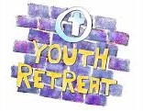
January 19 Martin Luther King Jr Service Event (tentative)
January 20 Knights of Columbus Free-throw Contest ages 9-14
January 24 St Pius X Youth Retreat
January 26-30 Catholic Schools Week
February 1 Family Faith/Sunday Youth Combo
February 9 CYO Basketball ends
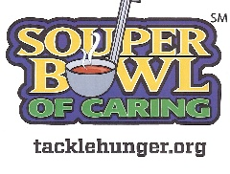
February 7-8 Souper Bowl of Caring Superbowl Sunday (all Masses)
February 13-23 WINTER BREAK
February 14-15 CYO Basketball Games end
February 18 Ash Wednesday
February 22 1st Sunday of LENT
March 1 2nd Sunday of LENT Family Faith/Sunday Youth Combo

March 8 3rd Sunday of Lent

March 15 4th Sunday of Lent

March 22 5th Sunday of Lent

March 22 Speed Faithing

March 29 PALM SUNDAY – No Sunday Youth

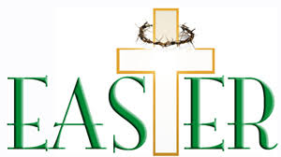
March 30-April 3 Spring Break

April 2 Holy Thursday

April 3 Good Friday

April 4 Easter Vigil

April 5 EASTER SUNDAY

April 12 Family Faith/Youth Ministry Combo
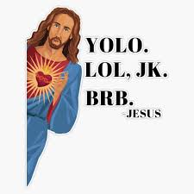
May 14 Ascension Thursday

May 17 Last Sunday Youth

May 24 Pentecost Sunday

