One Year Membership Contract Paid in Full Memberships
$43.50 per month $13.00 per additional person PIF memberships do not include
First Month and one time $50 processing fee Kids club pass, however they may be
due at time of signing. $99 cancellation fee purchased in addition to membership.
will be assessed if membership is canceled 1 Month $75 Individual $15 addon
within the first year. Membership is auto 3 Month $145 Individual $50 addon
renewed after 12 months. One free Kids 6 Month $285 Individual $90 addon
Club Pass is included. Additional passes may 1 Year $520 Individual $160 addon be purchased at normal rate. 1 Month teen (14-18) $42.90

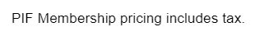
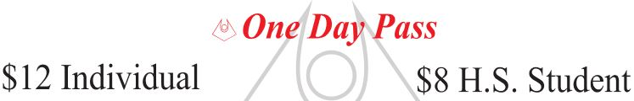
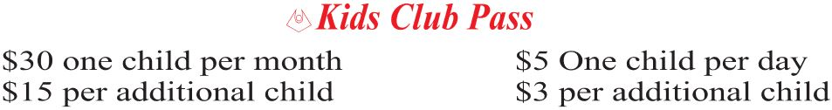

All classes are included in membership. Visit Southtowngym.com for more information and reservations. Drop In for a class-fee is $8.00. Classes are subject to change and if registered you will be notified of any changes.
