

Pythouse Club Safeguarding Policy

May 2024

Reporting a Safeguarding Concern within the Tennis Environment
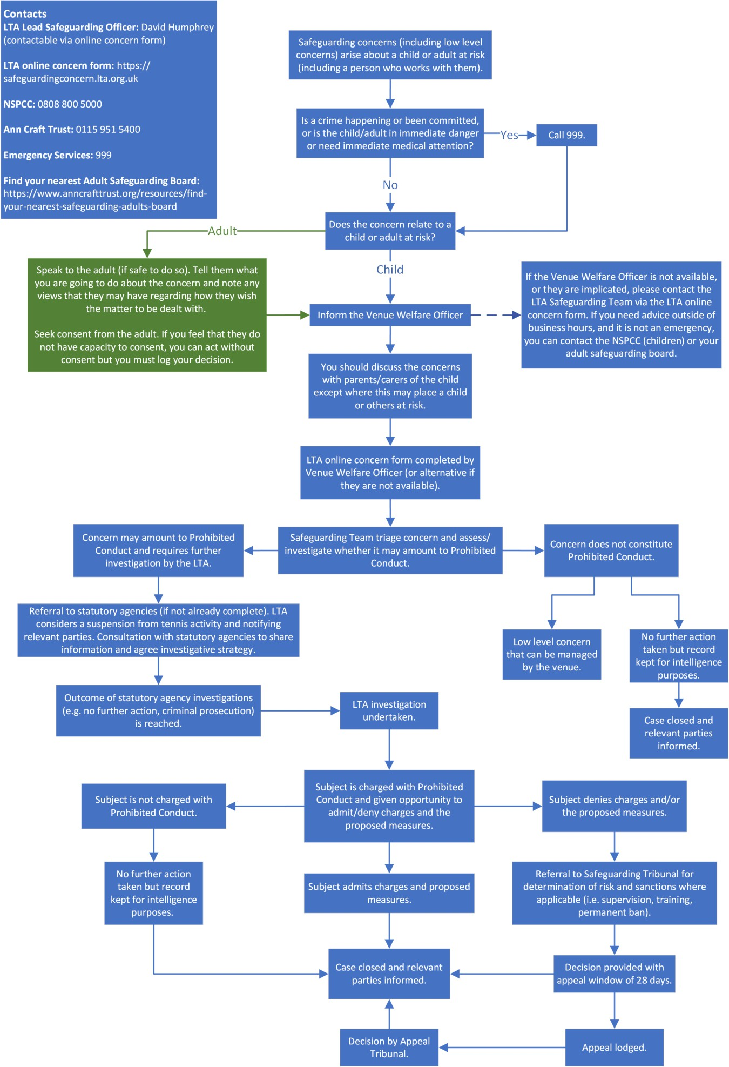

Safeguarding Policy

Policy statement

Pythouse Club is committed to prioritising the well-being of all children and adults at risk, promoting safeguarding in our club at all times, including all programmes and events we run. This Policy strives to minimise risk, deliver a positive tennis experience for everyone and respond appropriately to all safeguarding concerns/disclosures.

Use of terminology

Child: a person under the age of eighteen years.

Note that some legislation in Scotland defines a child as a person under sixteen years old. However, where there is any safeguarding concern, anyone under the age of 18 is regarded as a child unless advised otherwise by the LTA Safeguarding Team.

Adult at risk of abuse or neglect: a person aged eighteen years or over who is, or may be, in need of community care services by reason of disability, age or illness; and is, or may be, unable to take care of, or unable to protect him or herself against abuse or neglect.

Safeguarding children: protecting children from abuse and neglect, preventing the impairment of children’s health or development, ensuring that they grow up in circumstances consistent with the provision of safe and effective care, and taking action to enable all children to have the best life chances.

Safeguarding adults at risk: protecting adults from abuse and/or neglect. Enabling adults to maintain control over their lives and make informed choices without coercion. Empowering adults at risk, consulting them before taking action, unless someone lacks the capacity to make a decision, or their mental health poses a risk to their own or someone else’s safety, in which case, always acting in his or her best interests.

(See appendix A for full glossary of terms).

Scope

This Policy is applicable to all staff, volunteers, committee members, coaches and club members at Pythouse. It is in line with national legislation and applicable across the UK.

Advice, guidance and support is available from the LTA Safeguarding Team.

Responsibility for the implementation of the Safeguarding Policy, Code of Conduct and Reporting Procedure

SAFEGUARDING IS EVERYONE’S RESPONSIBILITY: NOT RESPONDING TO A SAFEGUARDING CONCERN IS NOT AN OPTION.

  - Our club’s committee has overall accountability for this Policy and its implementation
  - Our club Welfare Officer (Emma White) is responsible for updating this Policy in line with legislative and club developments
  - All individuals involved in/present at the club are required to adhere to the Policy and Code of Conduct
  - The LTA Safeguarding Team and Tennis Scotland, Tennis Wales and Tennis Foundation Safeguarding Leads can offer support to help clubs proactively safeguard.

Where there is a safeguarding concern/disclosure:
  - The individual who is told about, hears, or is made aware of the concern/disclosure is responsible for following the Reporting a Safeguarding Concern Procedure. Unless someone is in immediate danger, they should inform their club Welfare Officer, LTA Safeguarding Team or National Safeguarding Lead.
  - The club Welfare Officer and Safeguarding Leads are responsible for reporting safeguarding concerns to the LTA Safe Safeguarding Team.
  - The LTA Safeguarding Team is responsible for assessing all safeguarding concern/disclosures that are reported to them and working with the club Welfare Officer and national Safeguarding Leads to follow up as appropriate on a case-by-case basis, prioritising the well-being of the child/ adult at risk at all times. Dependent on the concern/disclosure, a referral may be made to:

The police in an emergency (999)

The Local Authority:
Wiltshire Council
Integrated Front Door (IFD):
0300 456 0108 (8.45-5 pm Mon-Thursday; to 4 pm Friday); Out of hours 0300 456 0100
LADO Referral: dofaservice@wiltshire.gov.uk
For less urgent enquiries email mash@wiltshire.gov.uk

Venue Welfare Office: for concerns/disclosures about a member of staff, consultant, coach, official or
volunteer [Emma White - safeguarding@pythouseclub.co.uk or 07881294784]

Disclosure and Barring Service (or Disclosure Scotland; Adult Social Work Team or Health and Social
Service Department (Channel Islands) for concerns/disclosures about a member of staff, consultant,
coach, official or volunteer [03000 200 190]

Breaches of the Safeguarding Policy, Code of Conduct and Reporting Procedure

Breaches of this Policy and/or failure to comply with the outlined responsibilities may result in the following:
  - Disciplinary action leading to possible exclusion from the club, dismissal and legal action
  - Termination of current and future roles within the club and roles in other clubs, the LTA, Tennis Wales, Tennis Scotland and the Tennis Foundation.

Actions taken by players, parents or carers, staff, consultants, volunteers, officials, coaches inside or outside of the club that are seen to contradict this Policy may be considered a violation of this Policy.

Where an appeal is lodged in response to a safeguarding decision made by the club, the individual should adhere to the club’s appeal procedure.

Codes of Conduct

All members of staff and volunteers agree to:
  - Prioritise the well-being of all children and adults at risk at all times
  - Treat all children and adults at risk fairly and with respect
  - Be a positive role model. Act with integrity, even when no one is looking
  - Help to create a safe and inclusive environment both on and off court
  - Not allow any rough or dangerous behaviour, bullying or the use of bad or inappropriate language
  - Report all allegations of abuse or poor practice to the club Welfare Officer
  - Not use any sanctions that humiliate or harm a child or adult at risk
  - Value and celebrate diversity and make all reasonable efforts to meet individual needs
  - Keep clear boundaries between professional and personal life in relation to children and adults at risk, including on social media
  - Have the relevant consent from parents/carers, children and adults before taking or using photos and videos
  - Refrain from making physical contact with children or adults unless it is necessary as part of an emergency or congratulatory (e.g. handshake / high five)
  - Refrain from smoking and consuming alcohol during coaching sessions
  - Ensure roles and responsibilities are clearly outlined and everyone has the required information and training
  - Avoid being alone with a child or adult at risk not known to them unless there are exceptional circumstances
  - Refrain from transporting children or adults at risk, unless this is required as part of a club activity (e.g. away match) and there is another adult in the vehicle
  - Not abuse, neglect, harm or discriminate against anyone; or act in a way that may be interpreted as such
  - Not have a relationship with anyone under 18 for whom they are coaching or responsible for

All children agree to:
  - Be friendly, supportive and welcoming to other children and adults
  - Play fairly and honestly
  - Respect club coaches, volunteers and Officials and accept their decisions
  - Behave, respect and listen to your coach
  - Take care of your equipment and club property
  - Respect the rights, dignity and worth of all participants regardless of age, gender, ability, race, culture, religion or sexual identity
  - Not use bad, inappropriate or racist language, including on social media
  - Not bully, intimidate or harass anyone, including on social media
  - Not smoke, drink alcohol or drugs of any kind on club premises or whilst representing the club at competitions or events
  - Talk to the club Welfare Officer about any concerns or worries they have about themselves or others

All adults agree to:
  - Positively reinforce your child and show an interest in their tennis
  - Use appropriate language at all times
  - Be realistic and supportive
  - Never ridicule or admonish a child for making a mistake or losing a match
  - Treat all children, adults, volunteers, coaches, officials and members of staff with respect
  - Behave responsibly at the venue; do not embarrass your child
  - Accept the official’s decisions and do not go on court or interfere with matches
  - Encourage your child to play by the rules, and teach them that they can only do their best
  - Deliver and collect your child punctually from the venue
  - Ensure your child has appropriate clothing for the weather conditions
  - Ensure that your child understands their code of conduct
  - Adhere to the Club’s changing room policy (see Appendix D)
  - Adhere to your venue’s safeguarding policy, diversity and inclusion policy, rules and regulations
  - Provide emergency contact details and any relevant information about your child including medical history

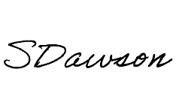

This Policy is reviewed every two years (or earlier if there is a change in national legislation). This Policy is recommended for approval by:

Club Committee Chair [Stephen Dawson]: Club Welfare Officer [Emma White]:

Appendix A: Glossary of Terms
Safeguarding: protecting children from abuse and neglect, preventing the impairment of children’s health or development, ensuring that children are growing up in circumstances consistent with the provision of safe and effective care, and taking action to enable all children to have the best life chances. Enabling adults at risk to achieve the outcomes that matter to them in their life; protecting their right to live in safety, free from abuse and neglect. Empowering and supporting them to make choices, stay safe and raise any concerns. Beginning with the assumption that an individual is best-placed to make decisions about their own wellbeing, taking proportional action on their behalf only if someone lacks the capacity to make a decision, they are exposed to a life- threatening risk, someone else may be at risk of harm, or a criminal offence has been committed or is likely to be committed.

Child: anyone under the age of 18.

Parent: birth parents and other adults who are in a parenting role.

Adult at risk:

England (Care Act 2014) | Scotland (Adult Support and Protection Act 2007) | Wales (Social Services and Well Being Act 2014)
An individual aged 18 years and over who:  - has needs for care and support (whether or not the local authority is meeting any of those needs) and;  - is experiencing, or at risk of, abuse or neglect, and;  - as a result of those care and support needs is unable to protect themselves from either the risk of, or the experience of  abuse or neglect. | An individual aged 16 years and over who:  - is unable to safeguard their own well-being, property, rights or other interests,  - is at risk of harm, and because they are affected by disability, mental disorder, illness or physical or mental infirmity, is more vulnerable to being harmed than adults who are not so affected. | An individual aged 18 years and over who:  - is experiencing or is at risk of abuse or neglect, and;  - has needs for care and support (whether or not the authority is meeting any of those needs) and;  - as a result of those needs is unable to protect himself or herself against the abuse or neglect or the risk of it.

Abuse and neglect

Physical abuse: A form of abuse which may involve hitting, shaking, throwing, poisoning, burning or scalding, drowning, suffocating or otherwise causing physical harm to a child or adult at risk. Physical harm may also be caused when a parent or carer fabricates the symptoms of, or deliberately induces illness

Sexual abuse: Involves forcing or enticing a child or young person to take part in abuse sexual activities, not necessarily involving a high level of violence, whether or not the child is aware of what is happening. The activities may involve physical contact, including assault by penetration (for example, rape or oral sex) or non-penetrative acts such as masturbation, kissing, rubbing and touching outside of clothing. They may also include non-contact activities, such as involving children in looking at, or in the production of, sexual images, watching sexual activities, encouraging children to behave in sexually inappropriate ways, or grooming a child in preparation for abuse (including via the internet). Sexual abuse is not solely perpetrated by adult males. Women can also commit acts of sexual abuse, as can other children

Emotional abuse: The persistent emotional maltreatment of a child or adult at risk such as to cause severe and persistent adverse effects on their emotional development. It may involve conveying to a child/ adult at risk that they are worthless or unloved, inadequate, or valued only insofar as they meet the needs of another person; not giving them opportunities to express their views; deliberately silencing them or ‘making fun’ of what they say or how they communicate. It may feature age or developmentally inappropriate expectations being imposed, including interactions that are beyond a child or adult at risk’s developmental capability, as well as overprotection and limitation of exploration and learning, or preventing them participating in normal social interaction. It may involve seeing or hearing the ill-treatment of another. It may involve serious bullying (including cyber bullying), causing a child or adult at risk to feel frightened or in danger, or the exploitation or corruption of children. Some level of emotional abuse is involved in all types of maltreatment of a child, though it may occur alone.

Neglect: The persistent failure to meet a child/ adult at risk’s basic physical and/or psychological needs, likely to result in the serious impairment of their health or development. It may involve a parent or carer failing to:
    - provide adequate food, clothing and shelter (including exclusion from home or abandonment);
    - protect a child/ adult at risk from physical and emotional harm or danger;
    - ensure adequate supervision (including the use of inadequate care-givers); or
    - ensure access to appropriate medical care or treatment.
It may also include neglect of, or unresponsiveness to, a child’s or adult at risk’s basic emotional needs. Neglect may occur during pregnancy as a result of maternal substance abuse.

Additional examples of abuse and neglect of adults at risk

Financial abuse: having money or property stolen; being defrauded; being put under pressure in relation to money or other property; and having money or other property misused.

Discriminatory abuse: treating someone in a less favourable way and causing them harm, because of their age, gender, sexuality, gender identity, disability, socio-economic status, ethnic origin, religion and any other visible or non-visible difference.

Domestic abuse: includes physical, sexual, psychological or financial abuse by someone who is, or has been a partner or family member. Includes forced marriage, female genital mutilation and honour-based violence (an act of violence based on the belief that the person has brought shame on their family or culture). Domestic abuse does not necessarily involve physical contact or violence.

Psychological abuse: including emotional abuse, threats of harm or abandonment, deprivation of contact, humiliation, blaming, controlling, intimidation, coercion, harassment, verbal abuse, isolation or withdrawal from services or supportive networks.

Organisational abuse: where the needs of an individual are not met by an organisation due to a culture of poor practice or abusive behaviour within the organisation.

Self-neglect: behaviour which threatens an adult’s personal health or safety (but not that of others). Includes an adult’s decision to not provide themselves with adequate food, clothing, shelter, personal hygiene, or medication (when indicated), or take appropriate safety precautions

Modern slavery: encompasses slavery, human trafficking, criminal and sexual exploitation, forced labour and domestic servitude. Traffickers and slave masters use whatever means they have at their disposal to coerce, deceive and force individuals into a life of abuse, servitude and inhumane treatment.

  - A person who is being abused may experience more than one type of abuse
  - Harassment, and bullying are also abusive and can be harmful
  - Female Genital Mutilation (FGM) is now recognised as a form of physical, sexual and emotional abuse that is practised across the UK
  - Child Sexual Exploitation is recognised as a form of sexual abuse in which children are sexually exploited for money, power or status
  - Child trafficking is recognised as child abuse where children are often subject to multiple forms of exploitation. Children are recruited, moved or transported to, or within the UK, then exploited, forced to work or sold
  - People from all cultures are subject to abuse. It cannot be condoned for religious or cultural reasons
  - Abuse can have immediate and long-term impacts on someone’s well-being, including anxiety, depression, substance misuse, eating disorders and self-destructive Conducts, offending and anti-social Conduct
  - Those committing abuse are most often adults, both male and female. However, child-to-child abuse also takes place.

Appendix B: What to do if a disclosure from a child or adult at risk is made to you:
- Reassure the child/adult that s/he is right to report the behaviour
- Listen carefully and calmly to him/her
- Keep questions to a minimum – and never ask leading questions
- Do not promise secrecy. Inform him/her that you must report your conversation to the LTA Safe and Inclusive Tennis Team (and the police in an emergency) because it is in his/her best interest
- REPORT IT! If someone is in immediate danger call the police (999), otherwise talk to the LTA Safeguarding Team as soon as possible. Once reported, the Safe and Inclusive Tennis Team will work with you to ensure the safety and well-being of the child/ adult at risk
- Do not permit personal doubt prevent you from reporting the concern/disclosure
- Make an immediate objective written record of the conversation using the Reporting a Concern Form. Make certain you distinguish between what the person has actually said and the inferences you may have made. Your report should be sent to the LTA Safeguarding Team within 48 hours of the incident, who will store it safely.

Appendix C: Reporting a Safeguarding Concern outside the Tennis Environment

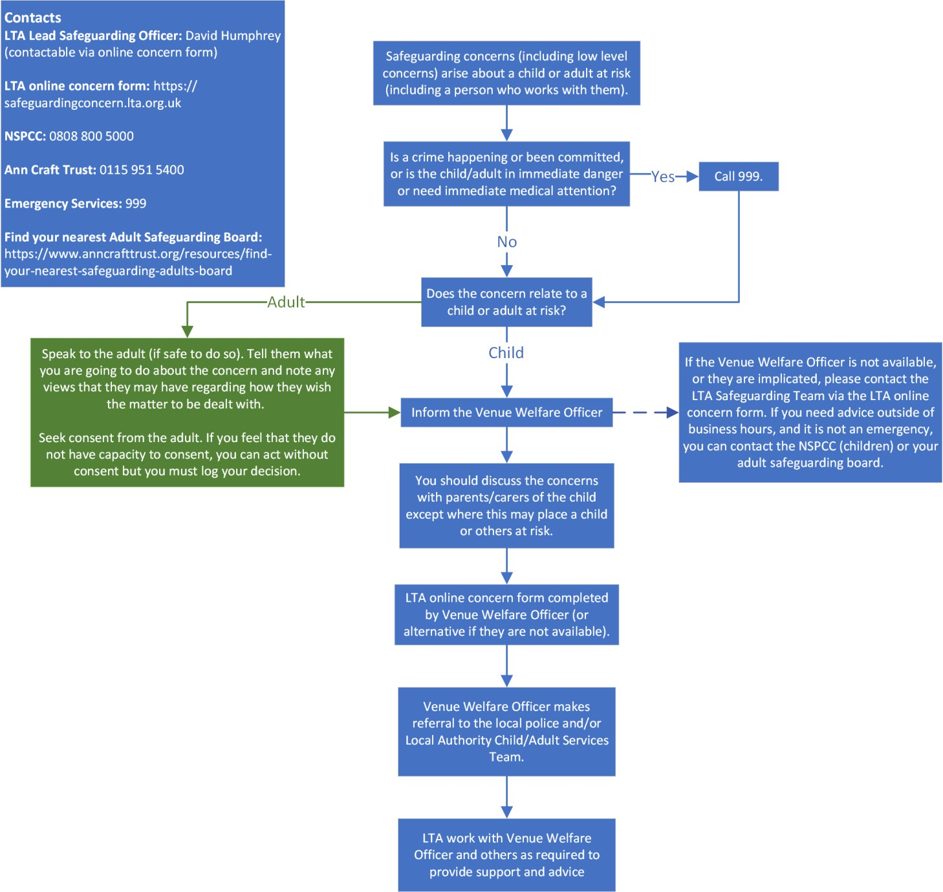
What to do if you are worried that a child is being abused outside the tennis environment (e.g. at home, school or in the community) but the concern is identified through the child’s involvement in tennis

Appendix D: Changing Rooms Policy

Pythouse Club strives to ensure that all children are safeguarded and have an enjoyable tennis experience.

This document sets out the club’s policy for the acceptable use of our changing rooms. If any child or adult feels that the policies contained herein are not adhered to, they should report this to the club Welfare Officer.

- Groups of children will have sole use of changing rooms at necessary times (during club tennis camps). This reduces any risks and potential vulnerability associated with mixing adults and children when changing and showering.

- Under no circumstances will adult staff, coaches or volunteers change or shower at the same time as children using the changing rooms.

- Mixed gender groups of children will have access to separate changing rooms.

- Mobile phones and other electronic devices must not be used in changing rooms by anyone.

- For younger groups of children (those under 7), a DBS checked member of staff or volunteer will wait outside the changing rooms to allow children to call for assistance if required.

