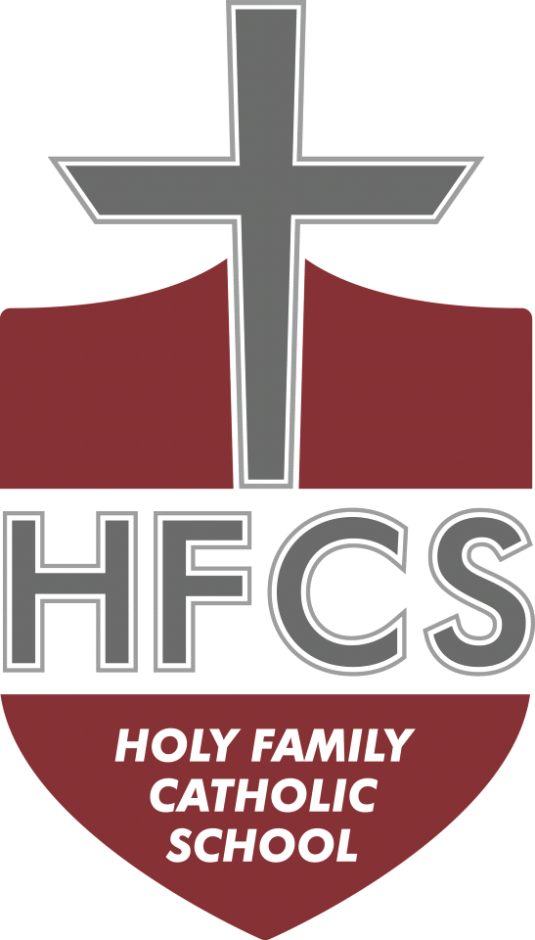
Holy Family Catholic School

2026 - 2027

PreK 3 Supplies

2 reams bright colored cardstock
4 packages baby wipes
4 packages wipes for tables (Lysol/Clorox)
1 box small size zip-lock plastic bags
1 roll Viva or Bounty paper towels
2 packages small paper plates
2 boxes washable thick Crayola markers
2 packages Play-Doh, 4-count
1 box of Crayola crayons
1 child safe scissors
6 Elmer’s glue sticks

Please label the following with your child’s name
- Normal size backpack (no minis or toddler size) to carry books, folders, blanket, and lunchbox
- One complete change of clothing including outfit, undergarments, and socks in a zip-lock bag, please label bag and clothing with your child’s name
- Full day students only, for naptime - one small blanket (no pillows, sleeping bags, or “lovies”)
- Full day students only: “Kinder Mat” for rest time (can be found at Wal-Mart) and 1 mat size blanket
- Plastic pencil box (no zippers)
Holy Family Catholic School

2026 - 2027

PreK 4 Supplies

1 package baby wipes
2 large packages Lysol wipes
1 bottle hand sanitizer with pump
1 package napkins, 200 count
1 box gallon size Ziplock bags
1 roll double-sided tape, Scotch brand
1 box Kleenex
12 Elmer’s glue sticks
1 bottle Elmer’s glue
2 boxes 24 Crayola crayons
1 box markers
1 pair safety scissors
1 pencil box, 5x8 inches
1 package Astrobrights paper
$5 for class journal (paid to teacher)

Please label the following with your child’s name
- Book bag large enough to hold 8-1/2 x 11 papers
- One complete change of clothing including undergarments, long pants, and socks in a zip-lock bag
- Full day students only: “Kinder Mat” for rest time (can be found at Wal-Mart) and 1 mat size blanket

Holy Family Catholic School

2026 - 2027

Kindergarten Supplies

*Please write your child’s name on each item…thank you!

3 containers antibacterial wipes
2 boxes Kleenex
2 boxes gallon-size Ziploc bags
1 large bottle hand sanitizer with pump
2 plastic pencil boxes
2 boxes No.2 pencils, Ticonderoga brand (sharpened)
2 packs primary writing tablet
4 pink erasers
2 pairs child-size scissors (blunt tip, no sharp tip)
2 boxes Crayola Classic Color Washable markers
2 boxes 24 Crayola crayons – regular size
1 watercolor paint set
10 Elmer’s glue sticks
3 sturdy folders
1 1-inch binder
Inexpensive headphones
One book bag large enough to carry 2 folders
One complete change of clothing in a large zip-lock bag with your child’s name on it, include underwear and socks…thank you!

Optional
Colored pencils
Extra crayons

Classroom donations (not required)
Seasonal stickers
Baby wipes (hands/faces)
Astrobrights cardstock
Post-it notes
Seasonal books
Crayons
Holy Family Catholic School

2026 - 2027

First Grade Supplies

Please write your child’s name on each item…thank you!

1 bottle hand sanitizer with pump
2 soft pink erasers
1 scissors that your child can use successfully
1 bottle Elmer’s Glue
8 glue sticks
1 box Crayola Markers (10 or 12)
2 highlighters (any color)
4 boxes 24 count Crayola crayons
1 large zippered pencil pouch
25 No.2 pencils, sharpened (Ticonderoga brand preferred)
2 Crayola colored pencils, 12 count
1 3-ring binder, 1-inch, D-ring (solid color, please, new students only)
3 plastic folders with pockets, without prongs (any color)
1 red plastic folder without prongs
1 spiral notebook, wide-rule
4 Dry Erase markers (any color)
1 Play-Doh, regular size container
1 container disinfectant wipes, Clorox or Lysol
1 box gallon size slider bags (last name A-M)
1 box quart size slider bags (last name N-Z)
Inexpensive headphones (no earbuds, please)
Book bag

Optional Classroom Donations
Stickers
Sticky notes
Extra box of pencils
Holy Family Catholic School

2026 - 2027

Second Grade Supplies

Please write your child’s name on each item…thank you!

1 soft pink eraser
1 pair pointed scissors
4 Elmer’s large glue sticks
1 box 24 Crayola crayons
1 box markers
Dry erase markers
1 highlighter (any color)
1 box colored pencils (no sharpeners needed…thank you!)
4 folders with pockets
12 No.2 pencils, Ticonderoga brand
12 mechanical pencils
1 plastic pencil box (to hold crayons and markers for Art class)
1 pencil pouch for classroom use
4 pads small Post-It notes (1x1)
1 spiral notebook
1 box Kleenex 200 count
4 large containers sanitizing wipes
1 set headphones, no earbuds
1 small tub Play-Doh
Book bag

Classroom Donations (not required)
Paper plates
Paper napkins
Astrobrights paper
Baby wipes for hands and face

Holy Family Catholic School

2026 - 2027

Third Grade Supplies

Please write your child’s name on each item…thank you!

2 soft pink erasers
1 scissors
8 Elmer’s glue sticks
2 spiral notebooks
1 composition notebook
1 box 24 Crayola crayons
1 box Crayola markers
4 folders with pockets
10 No.2 pencils
10 mechanical pencils
1 box Crayola colored pencils
4 highlighters
2 EXPO markers
1 zippered pencil bag (no pencil boxes)
2 boxes Kleenex 200 count
1 small flashlight
Inexpensive headphones
Book bag

** zippered pencil bags only
Holy Family Catholic School

2026 - 2027

Fourth Grade Supplies

1 soft pink eraser
1 pair pointed scissors
2 glue sticks
1 box 24 Crayola crayons
2 red ballpoint pens
2 Dry Erase markers any color
1 pencil pouch
Pencils, mechanical or regular
Colored pencils
1 box 8 markers
2 highlighters, different colors
3 pocket folders
1 accordion folder, at least 8 pockets
1 ruler with metric and inch markings
Inexpensive headphones
2 containers Clorox or Lysol wipes
4 boxes Kleenex 200 count
1 bottle of hand sanitizer with pump
1 package antibacterial hand wipes
1 box Ziploc sandwich bags
1 box Ziploc gallon-size bags
Book bag

Holy Family Catholic School

2026 - 2027

Fifth Grade Supplies

1 box pencils
1 box colored pencils
1 set markers
2 highlighters, any color
2 black Sharpies
2 red pens
2 pink erasers
1 ruler with metric and inch markings
1 basic calculator (nothing fancy or expensive!)
1 scissors
2 glue sticks
1 pencil pouch
1 book cover
1 spiral notebook for Spanish
1 writing journal
1 package 3x5 index cards
2 pocket folders
1 accordion folder, at least 8 pockets
3 boxes Kleenex
2 containers wet wipes
4 dry erase markers
Inexpensive headphones
Chromebook case
Planner - inexpensive
Book bag

Holy Family Catholic School

2026 - 2027

Junior High Supplies

Headphones or earbuds
13” to 15” padded bag with straps for Chromebook
Student planner
1 pair pointed scissors
2 highlighters
20 #2 pencils
1 black Sharpie
2 red pens
1 pencil pouch
1 accordion folder
4 containers Clorox wipes
1 bottle hand sanitizer
4 boxes Kleenex
Locker shelf
Backpack

Science Classroom
3 packs notecards
1 metric ruler
1 box colored pencils
1 box markers
2 glue sticks
1 one-subject notebook
1 box pencils

Math
Calculator – TI-30X IIS preferred
1 five-subject notebook
Graph paper

Literature/English/Spanish/Religion
1 composition notebook for 7th and 8th Literature
1 three-subject notebook for 7th and 8th English
1 one-subject notebook for 6th Literature
1 one-subject notebook for 6th, 7th, and 8th Spanish
1 one-subject notebook for 6th, 7th, and 8th `Religion

