STEP BY STEP INSTRUCTIONS ON HOW TO USE MEDICARE.GOV TO RESEARCH PRESCRIPTION DRUG PLANS.

1. Go to [www.medicare.gov](http://www.medicare.gov)
2. Click on “Log In” in the top right corner of the screen.

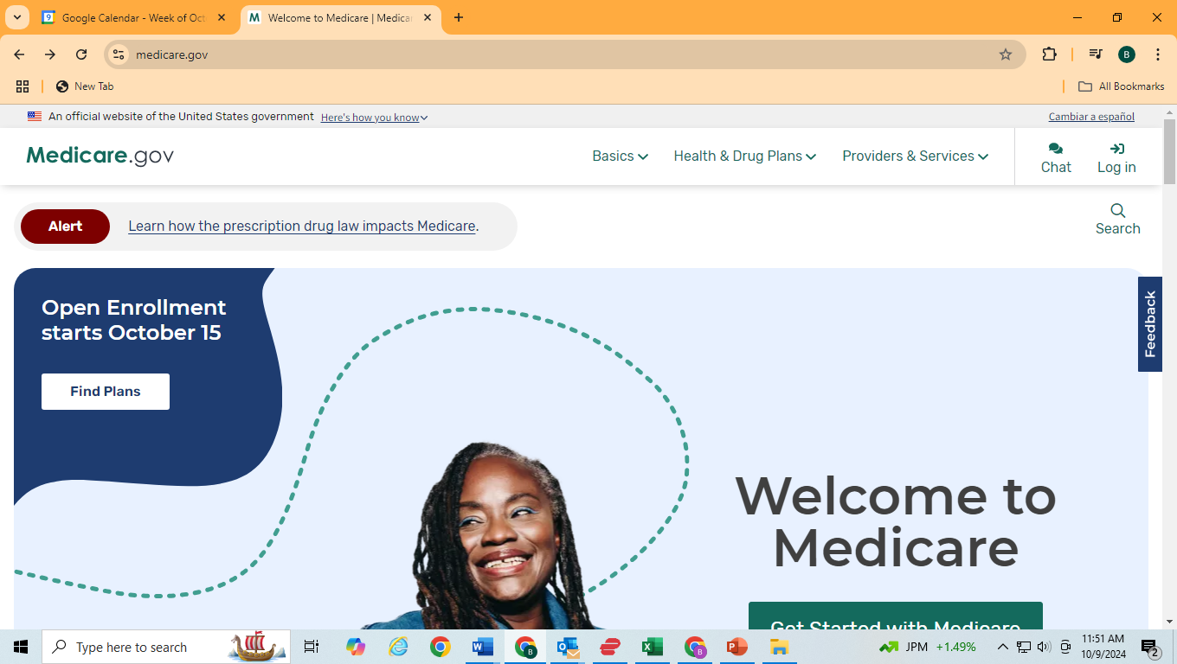

On the next page click on “Create an Account”

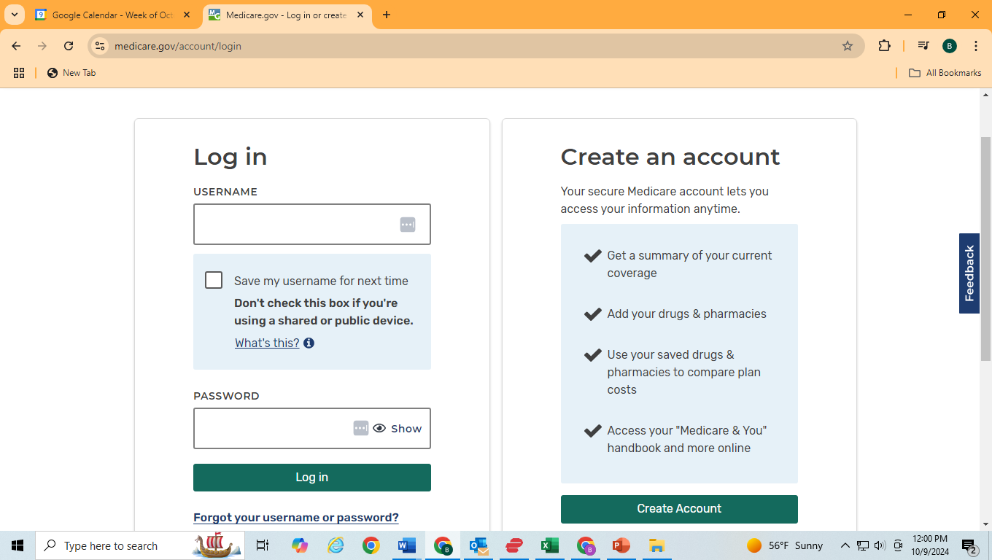

On the next page start entering your information.

Once you have done entering your info, you will need to set up a Username and Password:

If you would like you can send this information to us, and we will put it into your profile so that in case you lose it we will have it stored for you for future reference.

Once you have created your account then you can login then choose “Open all Options”

Now you will need to start entering in your medications.

Start typing the first 3-4 letters and a drop down of options will appear.

Then choose your medication, dosage and how many times a day. Then Click

When you finish entering in all your medications. Click.

Then choose your pharmacy options.

Then click “Done”

This will bring you to your choice of options for Prescription Drug Plans. Drill down into the details of the plan you are interested in to view the pricing and copays at the different pharmacies and a breakdown of monthly and yearly cost for your medications.

If you decide that you want to change your current plan, then click on “Enroll” and enter your information for that specific plan and then click “Submit” at the end and you will be enrolled into a new Prescription Drug Plan for the upcoming year.

