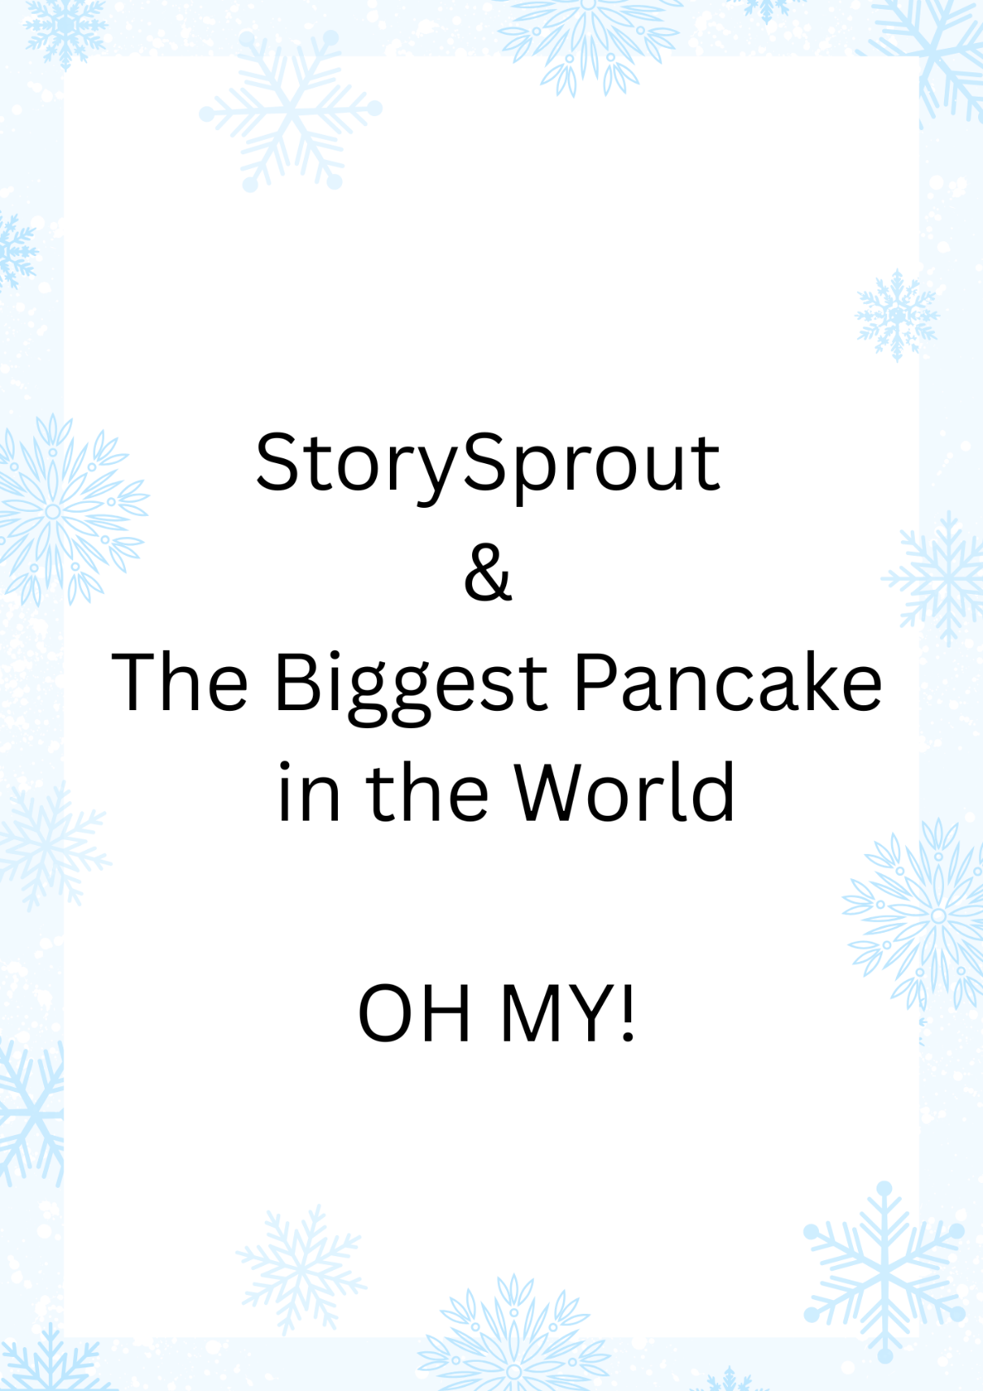

✨ StorySprout & the Biggest Pancake in the World ✨
Penn Yan • Birkett Mills & the Giant Griddle

Before the sun even blinked awake over Penn Yan, StorySprout fluttered toward the brick wall of Birkett Mills—a place she had known longer than any human alive.
Because StorySprout wasn’t just visiting history.
She remembered it.
She was older than Birkett Mills itself, older than the first grinding stones that turned buckwheat into flour, older even than the notion of calling this stretch of Main Street a village at all.
She had watched the mill rise, brick by brick, decade by decade.
Watched wagon wheels turn to tractors, lamps turn to lanterns, lanterns turn to electric glow.
And through it all, Birkett Mills remained the heart of Penn Yan—steady, storied, warm.
So when she perched atop the giant steel griddle anchored to the mill’s wall that frosty December morning—her tiny boots tapping the cold metal plate—her eyes sparkled with something more than nostalgia.
“Ahh,” she sighed, wings shimmering with memory,
“the biggest pancake in the whole wide world… I was there, you know.”
Snowflakes drifted lazily around her as she tucked her knees under her chin, letting the memory unfold like the scent of syrup drifting through a cozy kitchen.

🥞 The Day Penn Yan Made Pancake History
It wasn’t just a story she’d heard.
It was a moment she had lived.
Back in 1987 (which felt like only a sneeze ago to a centuries-old elf), Penn Yan decided to do something whimsical, bold, and downright delicious:
Make the world’s largest buckwheat pancake.
Birkett Mills, already famous for its buckwheat flour since the 1700s, rallied the whole village for the feat.
StorySprout remembered the giggles of early-morning excitement.
She remembered the clang of tools as the giant griddle—this very griddle—was bolted firmly into place.
She remembered the smell of fresh batter thick in the air, swirling with winter fog.
“Oh, the energy,” she murmured, placing a hand on the metal plate.
“It buzzed through the mill like a heartbeat.”
She had perched on the rim of the enormous griddle as the cooks poured in gallons upon gallons of batter—enough to feed a small village (which, incidentally, it nearly did).
When the crane lifted that giant pancake to flip it, StorySprout hovered in the air, holding her breath with the entire crowd.
And when it landed with a glorious, legendary:
FLOOOMP!
—she had laughed so hard her wings shook like jingle bells.
Children cheered.
Camera shutters clicked.
Steam rose like a warm ghost of breakfast.
And Penn Yan tucked a brand-new chapter into its storybook.
“That,” StorySprout whispered now, her eyes sparkling with ancient joy,
“was a day when ordinary people created extraordinary magic.”

🌱 A Sprout-Sized Reflection
Sitting atop the quiet griddle decades later, StorySprout pressed her palm gently against the steel.
“You held history,” she whispered.
“A breakfast dream bigger than itself.
A story people still smile about.”
She reached into her satchel and pulled out a tiny scroll, unrolling it with care. She wrote:
✨ “Stories don’t have to be small just because you are.
Some memories are meant to be giant.” ✨
She tucked the scroll beneath a seam in the frame—a secret for the curious, the imaginative, or the hungry-for-wonder.
With a final glance at the legendary griddle, StorySprout fluttered into the December sky, leaving behind a faint trail of sparkles and the soft scent of imagined syrup.
Some stories, after all, never grow old—
not even for an elf who’s older than the mill itself.

🌱 Sprout Scroll
“The Pancake as Big as a Story” ✨🥞
This morning I perched upon the great steel griddle at Birkett Mills,
the very one where Penn Yan cooked the biggest pancake the world had ever seen. 🍳❄️
I remember that day well… for I am older than the mill itself.
I watched the town gather, laughing and cheering,
as batter poured like a golden sunrise across the giant pan. 🌞✨
A crane flipped it with a mighty FLOOOMP!
and the whole village erupted in joy.
That pancake wasn’t just breakfast.
It was a moment when ordinary hands made extraordinary magic. 💛
And as I sat on the quiet griddle today,
I whispered a truth into the December air:
✨ “Stories don’t have to be small just because you are.
Some memories are meant to be giant.” ✨
May you always remember the joy of creating something big—
even if you’re little.
— StorySprout 🌱💫

