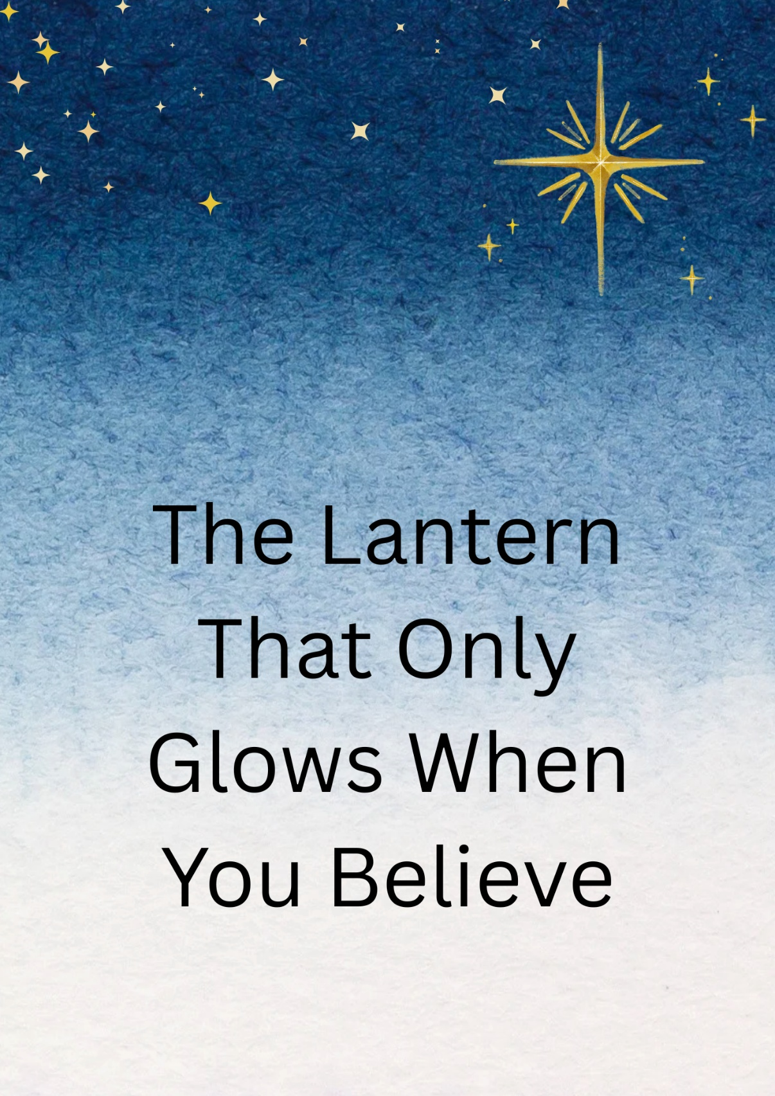

✨ The Lantern That Only Glows When You Believe ✨
A StorySprout Tale 🌱💫
Snow fell softly along the quiet edge of Keuka Lake, drifting down like a thousand tiny wishes. ❄️✨
The moon shone silver on the water, and the pines stood tall as if they were guarding something secret. 🌲🌙
StorySprout fluttered through the frosty air, her wings shimmering like crystal petals. 🧚‍♀️💫
She felt a tug in her heart — a familiar magic calling her toward the old lakeside path near a weather-worn cabin.
At the base of a snow-covered stump, half-buried in glittering white, she spotted it:
A tiny lantern, frosted but beautiful, its metal frame etched with swirling designs older than any human memory. 🕯️❄️
She brushed the snow away, revealing the words carved across the top:
✨ I Glow Only for Believers ✨
StorySprout smiled softly.
She remembered this lantern.
She had placed it here centuries ago, knowing one day someone would need it. 🌱💛
A quiet sigh drifted through the trees.
On a nearby stump sat a girl in a warm coat, her chin resting in her mittens, boots dangling above the snow. 🧣🧤
Her name was Lila, though StorySprout didn’t know that yet.
Her breath curled like little clouds in the cold air. 🌬️
StorySprout perched gently on the edge of her hood.
“What’s troubling your heart, Snowdrop?” she whispered. 🌱💬
Lila startled, then blinked in wonder.
“You… you’re real?” 😯
“As real as your feelings,” StorySprout said kindly. 💛
“Tell me.”
Lila looked down at the snow.
“I want to believe in magic. I really do. But all the other kids say I’m too old for that.” 😞
“They laugh when I talk about wishing and hoping and… believing.”
StorySprout’s wings drooped.
“Oh, my dear girl… belief isn’t something you outgrow. It grows with you.” 🌱💖
Lila shook her head.
“Then why doesn’t it feel real anymore?”
StorySprout held out the lantern, placing it gently in Lila’s hands. 🕯️🤲
“Because believing,” she said,
“isn’t something you see first.
It’s something you choose.”
Lila turned the lantern over.
“It’s broken,” she murmured. 😔
“No,” StorySprout said, hopping onto the handle.
“It’s waiting.” 🌟
The elf pointed to the world around them as if revealing hidden treasures:
❄️ A single snowflake landed perfectly in Lila’s mitten
🦉 A far-off owl hooted once, warm and low
🌊 The lake rippled in a perfect circle with no wind
💫 And something warm fluttered behind Lila’s ribs — a whisper of hope
“You feel it, don’t you?” StorySprout asked.
“That tiny glow inside? That’s where believing begins.” ✨💛
Lila’s eyes softened.
“Yes… but what if I’m wrong?”
“What if you’re right?” StorySprout replied with a grin. 😌🌱
Lila closed her eyes.
She breathed in the cold air — crisp, bright, full of possibility. 🌬️✨
And she let herself believe.
Not for proof.
Not for anyone else.
Just for her.
The lantern trembled. 🕯️💓
A faint spark flickered inside.
Lila gasped and held it closer. 😲
The flicker grew into a glow — soft at first, then brighter, warmer, filling the lantern like it was waking from a long sleep.
It glowed golden, then brilliant white, lighting the snowy path. ❄️🌟🕯️
“I did it,” Lila whispered.
“I believed.”
StorySprout touched her mitten gently. 🌱🤍
“No, Snowdrop. You remembered how.”
Lila hugged the lantern. 🤗🕯️
“Can I keep it?”
StorySprout nodded.
“It was always waiting for your hands.”
A soft jingle-bell note drifted across the lake as the lantern’s light fluttered against the night — a beacon of hope, courage, and belief. 🔔✨
As Lila headed home, the glow lighting her way, StorySprout watched from a pine branch high above, heart full and wings shimmering. 🌲💫
“For every child who wonders,” she whispered to the stars,
“there will always be a lantern waiting to shine.” ✨🌟
And with that, StorySprout soared into the snowy night, leaving behind a trail of sparkles—
a reminder that magic never leaves us.
We only need to believe. 🌱💫❄️

🌱 Sprout Scroll
“The Lantern That Only Glows When You Believe” ✨🕯️💛
Tonight I found a tiny lantern buried in the snow ❄️🕯️
near the quiet edge of Keuka Lake. 🌊✨
Across the top were the words:
✨ “I Glow Only for Believers.” ✨
A little girl named Lila held it gently in her mittens,
wishing she could still believe in magic. 😞🧤
So I showed her the quiet wonders around us:
❄️ a perfect snowflake,
🦉 an owl’s soft hoot,
🌲 the whisper of the pines,
💫 the warm flutter of hope inside her heart.
“Believing,” I told her,
“isn’t something you see first…
it’s something you choose.” 🌟🌱
Lila closed her eyes and dared to hope.
And the lantern glowed — softly, then brightly —
shining like a tiny sun in her hands. 🕯️✨
✨ When you choose to believe,
your light awakens too. ✨💛
— StorySprout 🌱💫

